组合模式
定义：将对象组成成树形结构，以表示“部分-整体”的层次结构，使得用户对单个对象和组合对象的使用具有一致性。

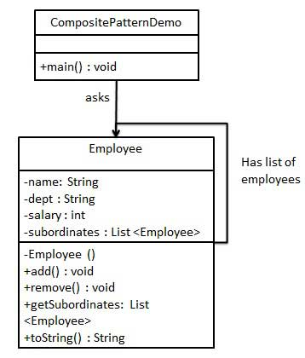

import java.util.ArrayList;
import java.util.List;
public class Employee {
private String name;
private String dept;
private int salary;
private List<Employee> subordinates;
//构造函数
public Employee(String name,String dept, int sal) {
this.name = name;
this.dept = dept;
this.salary = sal;
subordinates = new ArrayList<Employee>();
}
public void add(Employee e) {
subordinates.add(e);
}
public void remove(Employee e) {
subordinates.remove(e);
}
public List<Employee> getSubordinates(){
return subordinates;
}
public String toString(){
return ("Employee :[ Name : "+ name +", dept : "+ dept + ", salary :" + salary+" ]");
}
}

public class CompositePatternDemo {
public static void main(String[] args) {
Employee CEO = new Employee("John","CEO", 30000);
Employee headSales = new Employee("Robert","Head Sales", 20000);
Employee headMarketing = new Employee("Michel","Head Marketing", 20000);
Employee clerk1 = new Employee("Laura","Marketing", 10000);
Employee clerk2 = new Employee("Bob","Marketing", 10000);
Employee salesExecutive1 = new Employee("Richard","Sales", 10000);
Employee salesExecutive2 = new Employee("Rob","Sales", 10000);
CEO.add(headSales);
CEO.add(headMarketing);
headSales.add(salesExecutive1);
headSales.add(salesExecutive2);
headMarketing.add(clerk1);
headMarketing.add(clerk2);
//打印该组织的所有员工
System.out.println(CEO);
for (Employee headEmployee : CEO.getSubordinates()) {
System.out.println(headEmployee);
for (Employee employee : headEmployee.getSubordinates()) {
System.out.println(employee);
}
}
}
}

上面的定义不太好理解，我们直接从Android中用到的组合模式说起。我们知道，Android中View的结构是树形结构，每个ViewGroup包含一系列的View，而ViewGroup本身又是View。这是Android中非常典型的组合模式。

