享元模式
定义：使用享元对象有效地支持大量的细粒度对象。

享元模式我们平时接触真的很多，比如Java中的常量池，线程池等。主要是为了重用对象。
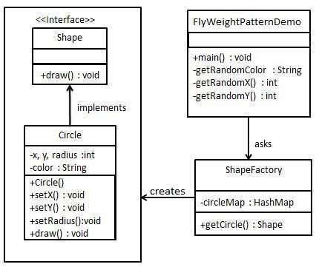
public interface Shape {
void draw();
}
public class Circle implements Shape {
private String color;
private int x;
private int y;
private int radius;
public Circle(String color){ this.color = color; }
public void setX(int x) { this.x = x; }
public void setY(int y) { this.y = y; }
public void setRadius(int radius) { this.radius = radius; }
@Override public void draw() {
System.out.println("Circle: Draw() [Color : " + color +", x : " + x +", y :" + y +", radius :" + radius);
}
}

import java.util.HashMap;
public class ShapeFactory {
private static final HashMap<String, Shape> circleMap = new HashMap<>();
public static Shape getCircle(String color) {
Circle circle = (Circle)circleMap.get(color);
if(circle == null) {
circle = new Circle(color);
circleMap.put(color, circle);
System.out.println("Creating circle of color : " + color);
}
return circle;
}
}

public class FlyweightPatternDemo {
private static final String colors[] = { "Red", "Green", "Blue", "White", "Black" }; public static void main(String[] args) {
for(int i=0; i < 20; ++i) {
Circle circle = (Circle)ShapeFactory.getCircle(getRandomColor()); circle.setX(getRandomX());
circle.setY(getRandomY());
circle.setRadius(100);
circle.draw();
}
}
private static String getRandomColor() {
return colors[(int)(Math.random()*colors.length)];
}
private static int getRandomX() {
return (int)(Math.random()*100 );
}
private static int getRandomY() {
return (int)(Math.random()*100);
}
}
Creating circle of color : Black
Circle: Draw() [Color : Black, x : 36, y :71, radius :100
Creating circle of color : Green
Circle: Draw() [Color : Green, x : 27, y :27, radius :100
Creating circle of color : White
Circle: Draw() [Color : White, x : 64, y :10, radius :100
Creating circle of color : Red
Circle: Draw() [Color : Red, x : 15, y :44, radius :100
Circle: Draw() [Color : Green, x : 19, y :10, radius :100
Circle: Draw() [Color : Green, x : 94, y :32, radius :100
Circle: Draw() [Color : White, x : 69, y :98, radius :100
Creating circle of color : Blue
Circle: Draw() [Color : Blue, x : 13, y :4, radius :100
Circle: Draw() [Color : Green, x : 21, y :21, radius :100
Circle: Draw() [Color : Blue, x : 55, y :86, radius :100
Circle: Draw() [Color : White, x : 90, y :70, radius :100
Circle: Draw() [Color : Green, x : 78, y :3, radius :100
Circle: Draw() [Color : Green, x : 64, y :89, radius :100
Circle: Draw() [Color : Blue, x : 3, y :91, radius :100
Circle: Draw() [Color : Blue, x : 62, y :82, radius :100
Circle: Draw() [Color : Green, x : 97, y :61, radius :100
Circle: Draw() [Color : Green, x : 86, y :12, radius :100
Circle: Draw() [Color : Green, x : 38, y :93, radius :100
Circle: Draw() [Color : Red, x : 76, y :82, radius :100
Circle: Draw() [Color : Blue, x : 95, y :82, radius :100
在Android哪里用到了享元模式呢？线程通信中的Message，每次我们获取Message时调用Message.obtain()其实就是从消息池中取出可重复使用的消息，避免产生大量的Message对象。

