适配器模式
定义：把一个类的接口变换成客户端所期待的另一个接口，从而使原本因接口不匹配而无法在一起工作的两个类能够在一起工作。

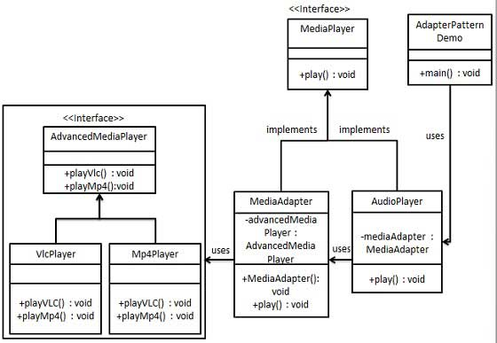

public interface MediaPlayer {
public void play(String audioType, String fileName);
}

public interface AdvancedMediaPlayer {
public void playVlc(String fileName);
public void playMp4(String fileName); 9
}

public class VlcPlayer implements AdvancedMediaPlayer{
@Override public void playVlc(String fileName) {
System.out.println("Playing vlc file. Name: "+ fileName);
}
@Override public void playMp4(String fileName) { //什么也不做 }
}

public class Mp4Player implements AdvancedMediaPlayer{
@Override public void playVlc(String fileName) { //什么也不做 }
@Override public void playMp4(String fileName) {
System.out.println("Playing mp4 file. Name: "+ fileName);
}
}

public class MediaAdapter implements MediaPlayer {
AdvancedMediaPlayer advancedMusicPlayer;
public MediaAdapter(String audioType){
if(audioType.equalsIgnoreCase("vlc") ){
advancedMusicPlayer = new VlcPlayer();
} else if (audioType.equalsIgnoreCase("mp4")){
advancedMusicPlayer = new Mp4Player();
}
}
@Override public void play(String audioType, String fileName) {
if(audioType.equalsIgnoreCase("vlc")){
advancedMusicPlayer.playVlc(fileName);
}else if(audioType.equalsIgnoreCase("mp4")){
advancedMusicPlayer.playMp4(fileName);
}
}
}

public class AudioPlayer implements MediaPlayer {
MediaAdapter mediaAdapter;
@Override public void play(String audioType, String fileName) {
//播放 mp3 音乐文件的内置支持
if(audioType.equalsIgnoreCase("mp3")){
System.out.println("Playing mp3 file. Name: "+ fileName);
} //mediaAdapter 提供了播放其他文件格式的支持
Else if(audioType.equalsIgnoreCase("vlc") || audioType.equalsIgnoreCase("mp4")){
mediaAdapter = new MediaAdapter(audioType);
mediaAdapter.play(audioType, fileName);
} else{
System.out.println("Invalid media. "+ audioType + " format not supported");
}
}
}

public class AdapterPatternDemo {
public static void main(String[] args) {
AudioPlayer audioPlayer = new AudioPlayer();
audioPlayer.play("mp3", "beyond the horizon.mp3");
audioPlayer.play("mp4", "alone.mp4");
audioPlayer.play("vlc", "far far away.vlc");
audioPlayer.play("avi", "mind me.avi");
}
}

Playing mp3 file. Name: beyond the horizon.mp3
Playing mp4 file. Name: alone.mp4
Playing vlc file. Name: far far away.vlc
Invalid media. avi format not supported

其实适配器模式很容易理解，我们在Android开发时也经常用到。比较典型的有ListView和RecyclerView。为什么ListView需要使用适配器呢？主要是，ListView只关心它的每个ItemView，而不关心这个ItemView具体显示的是什么。而我们的数据源存放的是要显示的内容，它保存了每一个ItemView要显示的内容。ListView和数据源之间没有任何关系，这时候，需要通过适配器，适配器提供getView方法给ListView使用，每次ListView只需提供位置信息给getView函数，然后getView函数根据位置信息向数据源获取对应的数据，根据数据返回不同的View。

