简介
2017年华科的复试由五部分组成（听力、专业笔试、上机、口语面试、专业面试）组成，但各部分占的比重和往年不同
往年：听力10%、专业笔试40%、上机20%、口语面试10%、专业面试20%
今年：听力15%、专业笔试40%、上机30%、口语面试5%、专业面试10%

英语听力
共15分，分为两部分，时间20分钟

Part 1（11分）
听录音填空
材料来源：把2016年6月的英语六级考试听力短文挖空后得到

It is usually agreed that a German Carl Benz built the first motor car in 1885. It was actually a ___1___ with a petrol motor ____2___. Soon, members of the Royal family and other wealthy people took up motoring as a sport. Many of the early cars had two seats. There were no petrol __3___ and few garages, so every driver had to be his own engineer for the frequent breakdowns. By 1905, cars began to look like cars of today, with head lamps, wind screen, rubber tyres and ____4____. Henry Ford’s Model T introduced in America in 1909 was cheaper because it was made on _____5____. It brought cars closer towards the reach of ordinary people. With the popularity of the car, registration became a __6___ in 1903 with the Motor Car Act. _____7____ tests were introduced in 1935. Today, the legal driving age for a car in the UK is 17. You are not allowed to drive a car ___8____ until you have passed a driving test. In ___9____, Britain celebrated the opening of its first motorway—the Preston Bypass. Until then, no one really understood what a motorway was, not even the laborers who were building it. The bypass held a new era in motor travel and was greeted with excitement and optimism. Service stations came with the motorway and the legend of the transport cafe was born. Of course, the service station has ___10____ greatly. But whether it’s an English-cooked breakfast or a coffee and a sandwich, one thing has remained the same: the ____11_____.

- tricycle
- at the rear
- pumps
- number plates
- the assembly line
- must
- Competency
- unsupervised
- 1958
- diversified
- prices

Part 2（4分）
听短文，然后听问题并选择相应的选项
材料来源：2013年4级听力原题

Donna Fredrick’s served with the Peace Corps for two years in Brazil. She joined the Peace Corps after she graduated from the college because she wanted to do something to help other people. She had been brought up on a farm, so the Peace Corps assigned her to a agricultural project. Before she went to Brazil, she studied Portuguese for three months. She also learnt a great deal about its history and culture. During her two years with the Peace Corps, Donna lived in a village in northeast Brazil. That part of Brazil is very dry and farming is often difficult there. Donna helped the people of the village to organise an arrigation project, and she also advised them on planting corps. They didn’t require much water. When Donna returned to the States, she couldn’t settle down. She tried several jobs, but they seemed very boring to her. She couldn’t get Brazil out of her mind. Finally, one day she got on an plane and went back to Brazil. She wasn’t sure what she’s going to do. She just wanted to be there. After a few weeks, Donna found a job as an English teacher, teaching five classes a day. Like most of the teachers, she doesn’t make much money. She shares a small apartment with another teacher. And she makes a little extra money by sending stories to newspapers in the States. Eventually she wants to quit teaching and work as a full-time journalist.
16. Why did Donna join the Peace Corps after she graduated from college?
17. What was Donna assigned to do in Brazil?
18. Why did Donna go back to Brazil once again?
19. How did Donna make extra money to support herself?

备注：个人做的时候明显觉得Part2比Part1容易很多

专业笔试
共40分，时间1个半小时
一、选择题十分（1分*10道）
二、写代码运行结果（2分*5道）
三、填空题（1分*9空）
- 结构化程序设计的三大模型是：
- MVC模型中的M、V、C分别指：
- 面向对象程序设计的三大特点：
四、填空题（2分*3空）
- 给一个树的前序中序遍历序列，要求写出后序遍历序列
- 给一个图，让写出圈复杂度
- 给一个自动机图，要求写出这个自动机能够识别含哪些子串的字符串
五、简答（5分）
谈谈软件工程和计算机科学 的区别

机考
共30分，时间1个半小时

上机环境：
今年的机考安排在计算中心（南六楼）四楼
那里的机子上有VS2010，VC，Turbo C，Java的IDE也有，别的没注意
学院准备了备用机，如果不幸你的机子是坏了的话也没关系，换一台就是

试题
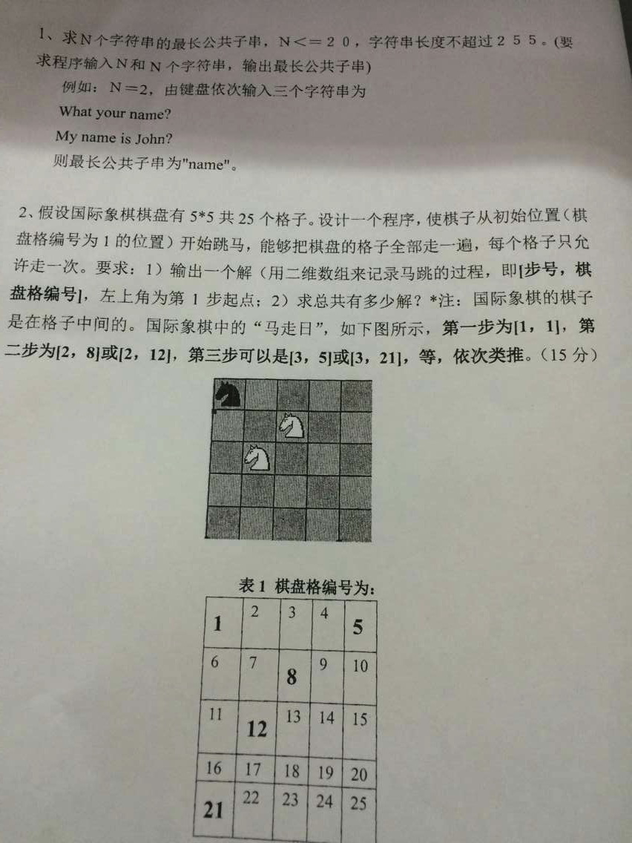
（照片是大群里找的，感谢那位同学...）
写完之后举手，会有人来评分，并会输几组数据来看看你的程序是否正确，最后你的代码要拷贝到学院提供的U盘里

专业面试、英语口语面试
见”2017-3(面试).doc”
提醒一下来年的同学，因为面试前老师要讲一下怎么填记录本，所以千万别迟到！

几句闲话
- 武汉天气变化很大，复试报道那天（3.10）还很暖和，今天（3.13）就非常冷，记得带好衣服
- 复试时间跨度很长，从3.10报到到3.15签订录取协议，外地的同学要在武汉住5天以上，做好准备吧，等待是漫长的。
- 住宿方面推荐华科内部的国际学术交流中心，位置就在校内，房源很抢手，提早点订吧
- 吃饭最实惠的就是去校内的食堂了，华科有很多食堂，去其中大一点的食堂办一张校内通用的消费卡（比学生吃饭的价格会高20%）就能在食堂用餐了

大家加油~

