2) Perform 5 data visualization tasks on the student performance dataset given in the link below (create 5 different visualizations). Explain what kind analysis has become easier with each of the visualizations.

Data link: <https://app.box.com/s/ji910ez3ycw137rw07xnhielxey7ww41>

**1 . Loading The Data :**



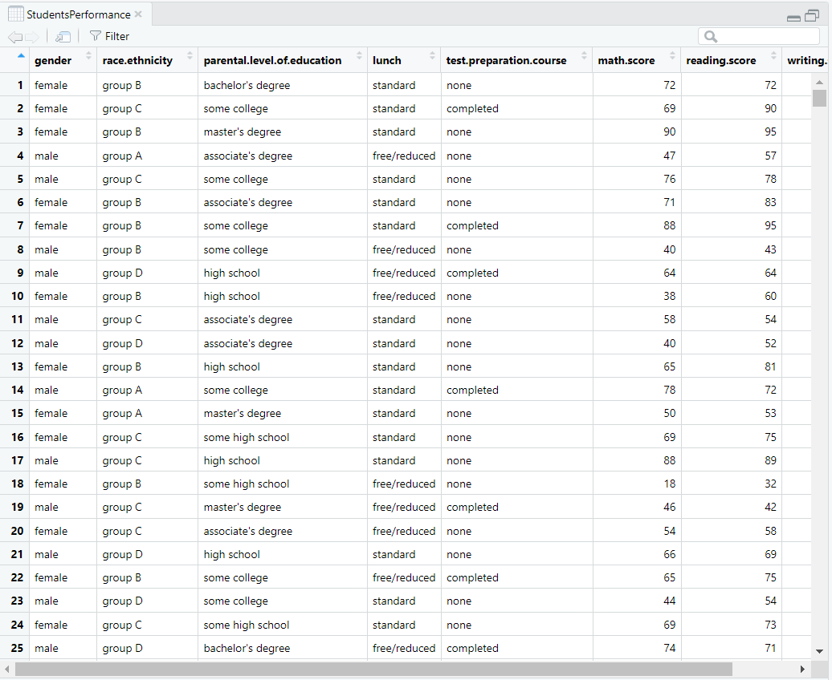

**2 . Exploring the Data :**

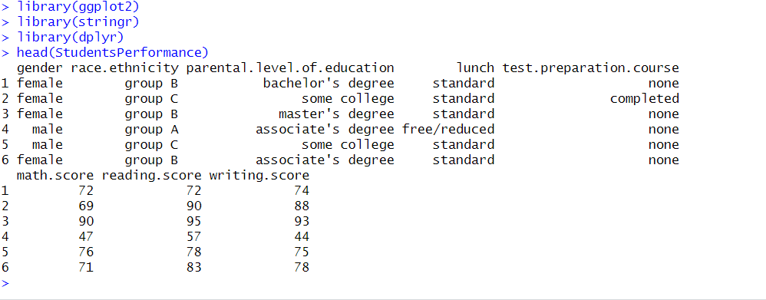

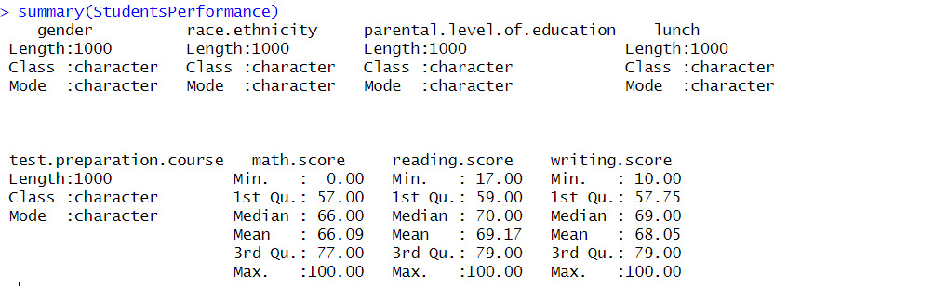

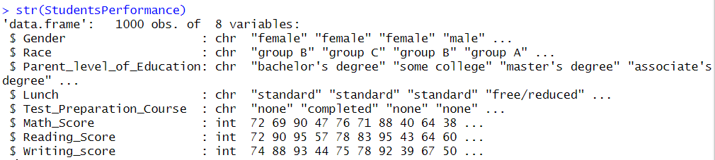

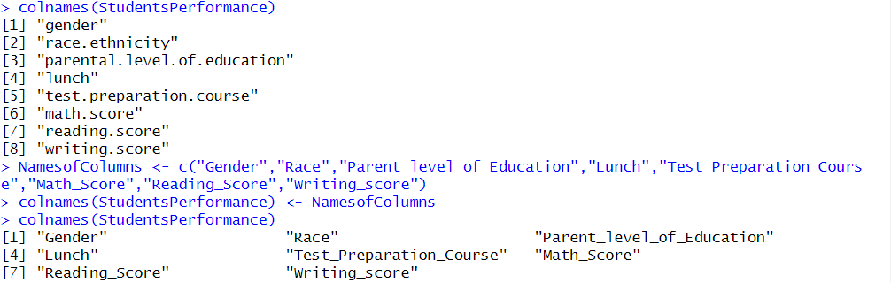

**3 . Data Visualization :**



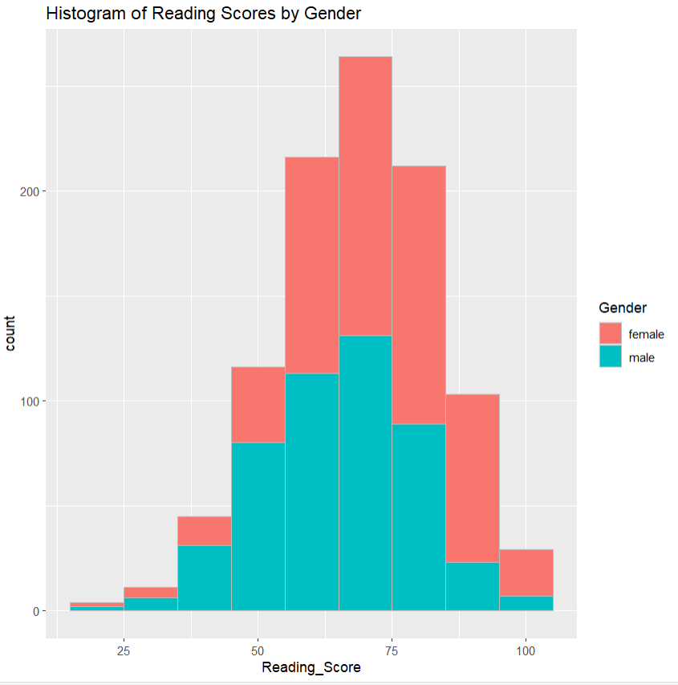

Analysis :

The histogram shows the distribution of reading scores among students and separates the bars according on gender. The height of each bar reflects the proportion of students who frequently fall within each range of reading scores, and each bar represents a range of reading scores (binwidth = 10).

The above plot has multiple purposes:

1) To get an overview/ idea regarding the reading score of the class which reflects the class performance as a whole. For example we can see that the majority of the grades for the students are concentrated in between 50 and 80, which gives an overall idea about the class performance.

2) We can also get the insight that by bifurcating the plot based on gender gives an idea how the gender impacted the grades. For example, there is a large portion concentrated in green towards the left which suggests that the lower scores are majorly assigned to males.



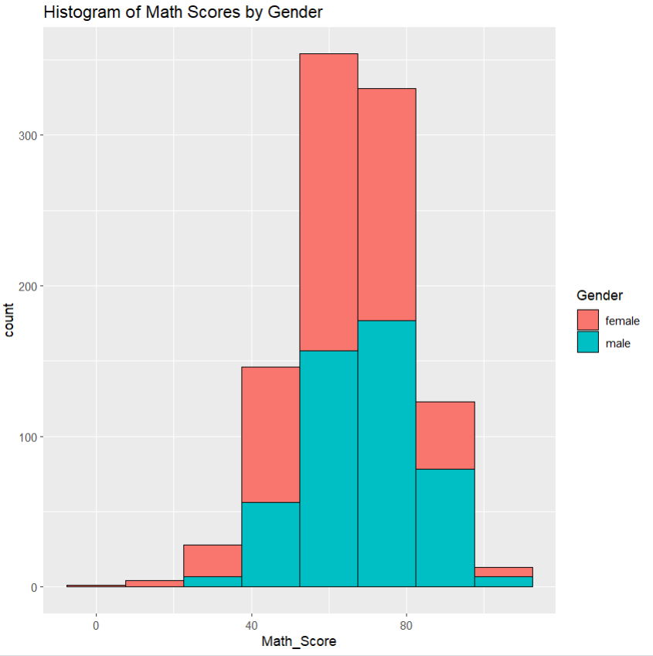

Analysis :

This histogram shows the gender-specific distribution of math results among students by filling in the bars in different colors for men and women. The height of each bar reflects the frequency of students falling inside that range of math scores, and each bar represents a particular range of math scores (binwidth = 15).

1) To get an overview/ idea regarding the math score of the class which reflects the class performance as a whole. For example we can see that the majority of the grades for the students are concentrated in between 50 and 70, which gives an overall idea about the class performance.

2) We can also get the insight that by bifurcating the plot based on gender gives an idea how the gender impacted the grades. For Example, The right part of the plot is majorly filled with green which suggests that males performed superior to the females in the Math section.



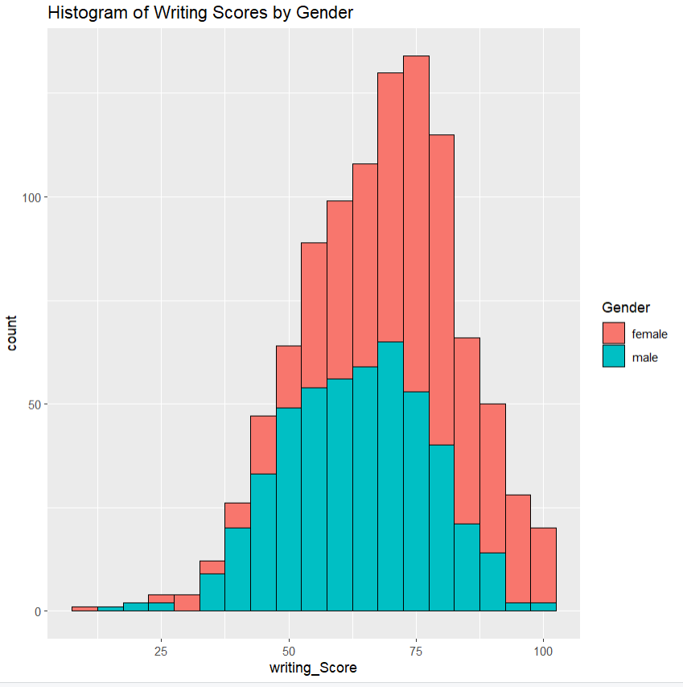

Analysis :

This histogram shows the gender-specific distribution of writing scores among students by filling in the bars in different colors for men and women. The height of each bar corresponds to the percentage of students who fall inside each range of writing scores, and each bar represents a range of scores (binwidth = 5).

1) To get an overview/ idea regarding the math score of the class which reflects the class performance as a whole. For example we can see that the majority of the grades for the students are concentrated in between 60 and 80, which gives an overall idea about the class performance.

2) We can also get the insight that by bifurcating the plot based on gender gives an idea how the gender impacted the grades. Writing scores are right skewed, also the writing scores are dominated by the females like the reading scores as the concentration of red is on the higher end for this plot.



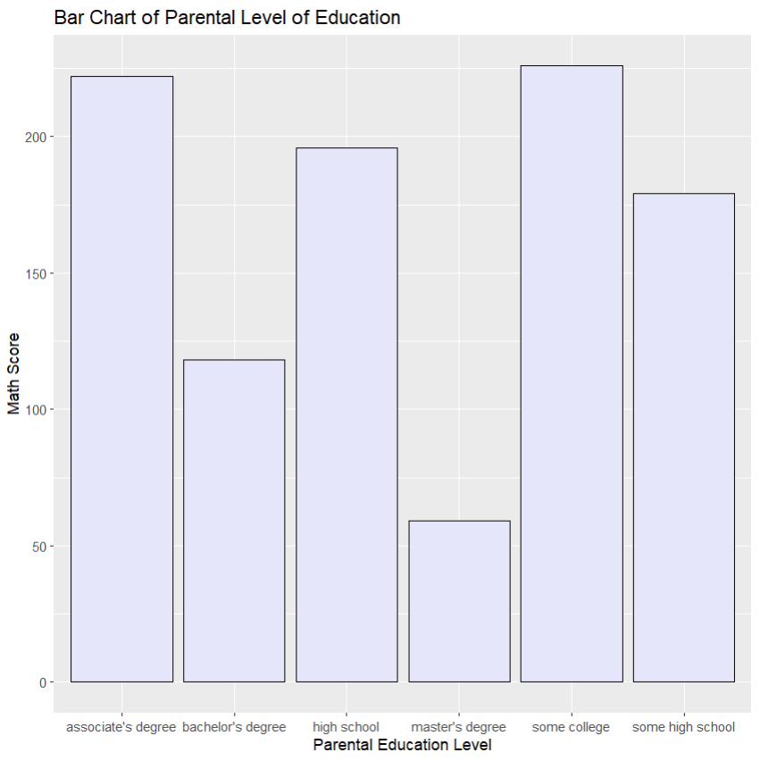

Analysis :

Based on various parental education levels, the distribution of math test results is shown in this bar graph. The height of each bar corresponds to the typical math score for students whose parents have that degree of education, and each bar reflects a particular parental education level.



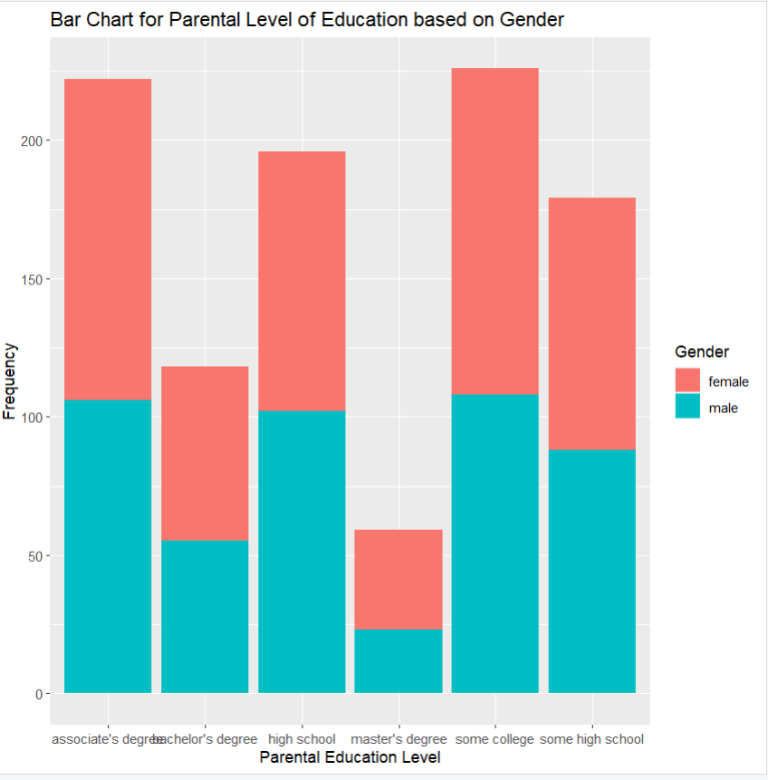

Analysis :

This stacked bar graph shows the parental education levels of the students and separates the bars by gender (stacking bars for men and women). Each bar represents a certain parental education level, and the height of each segment inside the bar indicates the proportion of pupils of a given gender enrolled at that level of education.