Po Second Brain — User Manual & Technical Concept Guide
Course Lab: LAB_BasicNetwork (1. Useful Functions · 2. IP/Network · 3. Biometric & Cryptographic Security)
Student Name: Pasinn Nitikornchairat
Student ID: 67992023
GitHub Repository: https://github.com/67992023-cmd/po-second-brain
Online User Manual (GitHub): https://github.com/67992023-cmd/po-second-brain/blob/main/USER_MANUAL.md
Local Mac URL (Touch ID, Face ID & Ollama): http://localhost:3000
Local Wi-Fi LAN Webhook URL (iPhone Sync): http://10.111.9.122:3000/api/health/webhook | Default Vault Passcode: admin123
1. Core Concept & System Architecture
Po Second Brain is a full-stack personal Life Ledger, Local AI Second Brain, and Network Security Hub built with zero third-party dependencies (Python 3 Standard Library + SQLite3 + Apple Human Interface Guidelines Liquid Glass UI). It unifies three core engineering pillars:
• Pillar 1 — Useful Everyday Functions & Second Brain AI: Integrates Work Calendar & Milestones, Apple Health (Sleep Recovery & Daily Calories/Protein), Personal Diary Library, and AES-256-CTR Password Vault into a single SQLite database connected to local Ollama (qwen2.5:7b) and Cloud Free-Tier APIs (Groq Llama 3.3 70B, Google Gemini 2.5 Flash, OpenRouter) with autonomous [ACTION: {...}] database execution and 1-click Undo.
• Pillar 2 — IP & Network Engineering (LAB_BasicNetwork): Provides live Client/Server IPv4 telemetry, macOS ifconfig interface inspection, ICMP Ping / TCP RTT & DNS Resolution diagnostics, a CIDR Subnet Firewall & Packet Simulator, and a real-time Security & Network Audit Log.
• Pillar 3 — On-Demand Biometric & Cryptographic Security: Everyday dashboard views open immediately without friction, while Protected Vaults (Diary Library, Password Vault, IP & Security) require MacBook Air M2 Touch ID (WebAuthn Passkeys), 192-Dimensional Sobel Gradient Webcam Face ID (strict 85.0% zero-mean structural threshold), or PBKDF2-HMAC-SHA256 Passcode (admin123).
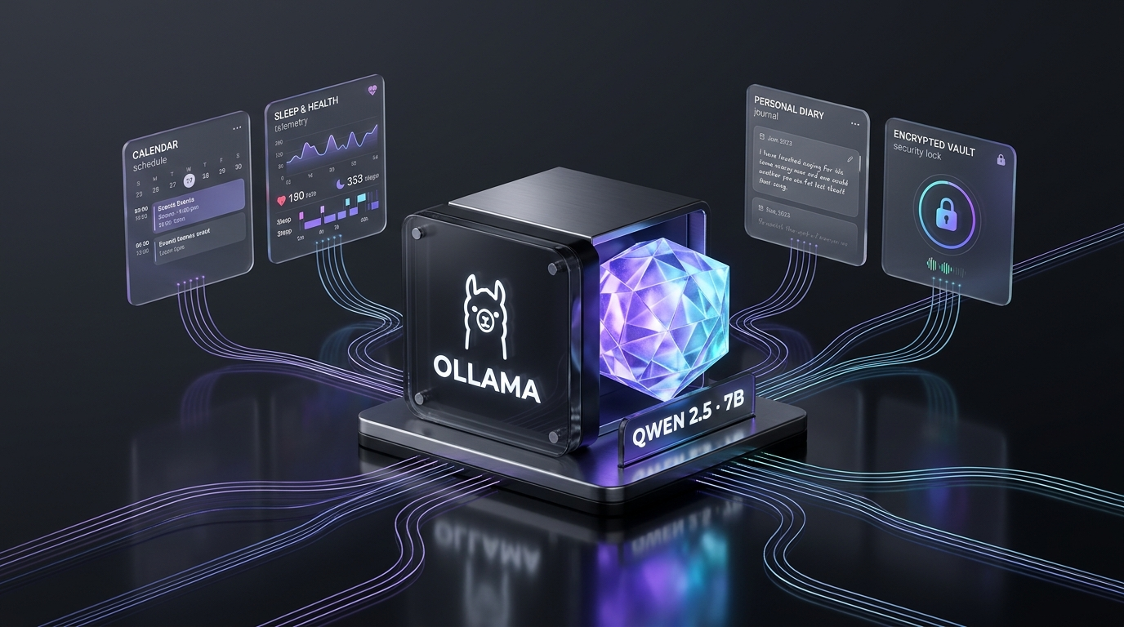
2. Screen-by-Screen Feature Walkthrough
2.1 Overview Summary Dashboard (Entry Page)
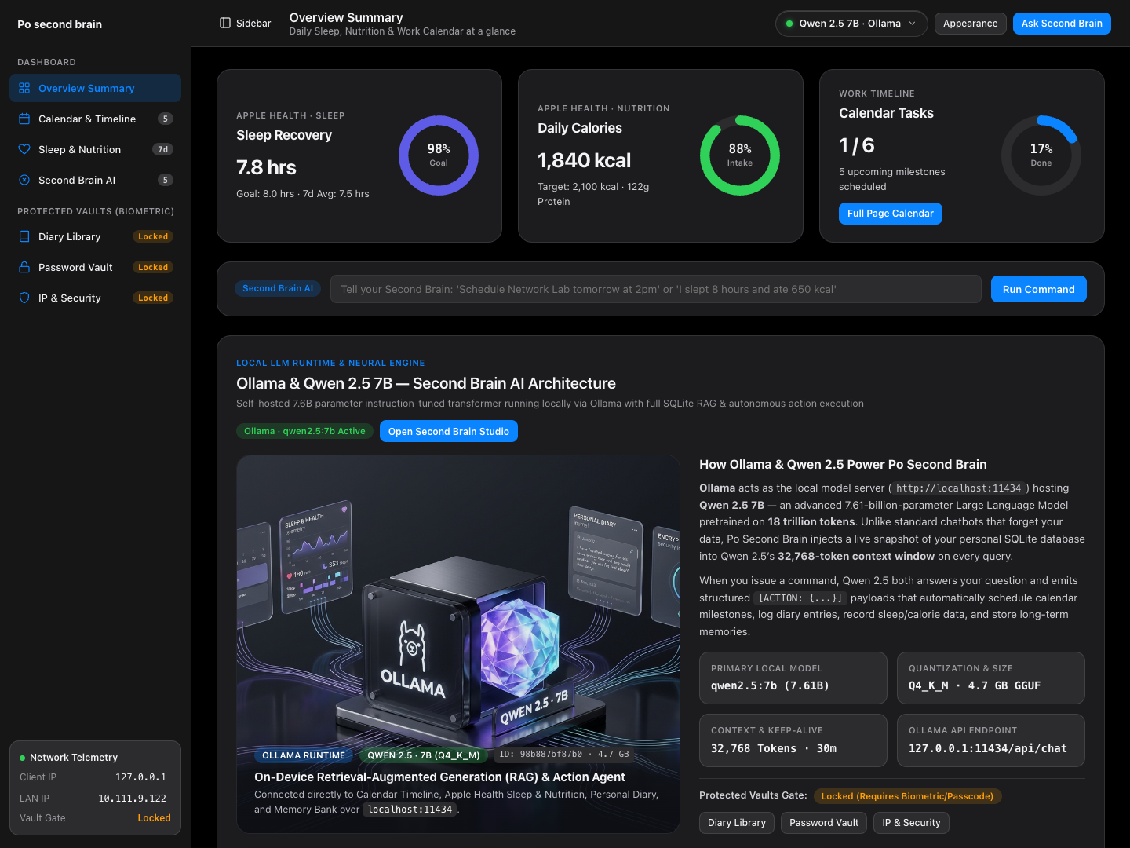
• Purpose: Serves as the clean entry dashboard inspired by Apple Health and macOS Sequoia, featuring the 'Po second brain' sidebar and top Liquid Glass toolbar.
• 3 Apple Donut Ring Charts: (1) Sleep Recovery (7.8 hrs / 98% of 8.0 hr goal), (2) Daily Calories (1,840 kcal / 88% of 2,100 kcal target & 122g Protein), and (3) Calendar Tasks (1 / 6 completed with a 1-click Full Page Calendar button).
• Quick Second Brain AI Command Bar: Execute natural-language commands such as 'Schedule Network Lab tomorrow at 2pm' or 'I slept 8 hours and ate 650 kcal' directly from the entry page.
• Ollama & Qwen 2.5 7B AI Model Showcase: Displays the local LLM architecture visual, model ID (qwen2.5:7b · 7.61B parameters · Q4_K_M 4.7 GB GGUF · 32,768 token context window), and local API endpoint (127.0.0.1:11434/api/chat).
2.2 Clean Liquid Glass AI Model Selector (Top Toolbar)
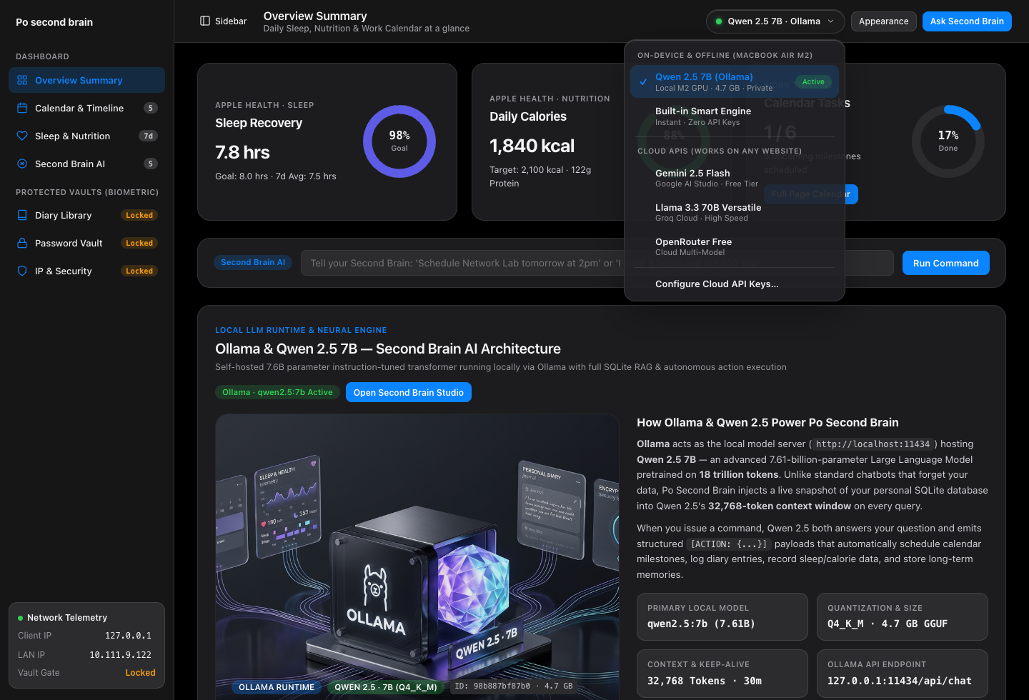
• Purpose: Provides a floating Apple Liquid Glass popover menu (backdrop-filter: blur(28px) saturate(190%)) in the top toolbar for instant 1-click AI model switching.
• On-Device & Offline (MacBook Air M2): Switch between Qwen 2.5 7B (Ollama) running 100% offline at localhost:11434, Auto Hybrid Router, and the Built-in Deterministic Smart Engine.
• Cloud Free-Tier APIs (For External Web Hosting): Switch to Google Gemini 2.5 Flash, Groq Llama 3.3 70B Versatile, or OpenRouter Free Models when the website is hosted online.
2.3 Full-Page Calendar & Work Timeline
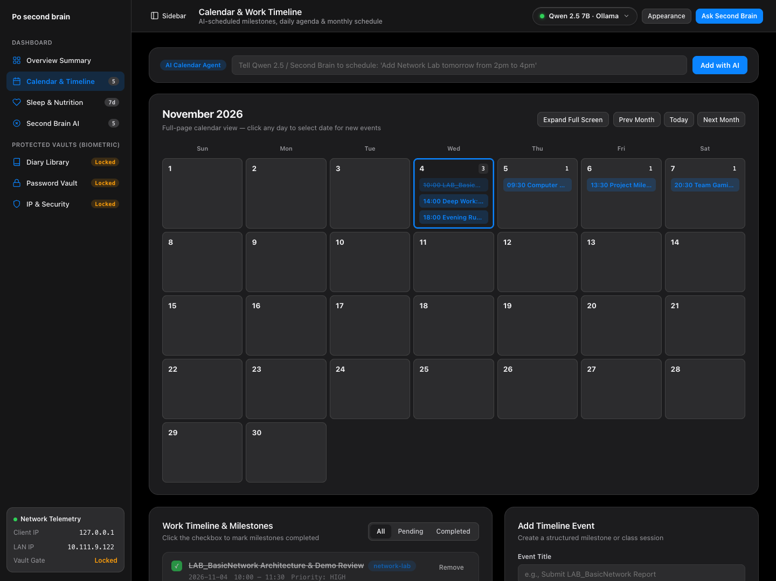
• Purpose: Full-width monthly schedule and milestone checklist with natural-language AI scheduling.
• AI Calendar Agent Bar: Type natural sentences ('Add Network Lab tomorrow from 2pm to 4pm') and Qwen 2.5 / Second Brain automatically extracts the date, start/end times, category, and priority.
• Full-Width Month Calendar & Full-Screen Mode: Spans 100% of the workspace width with tall day cells showing up to 4 event chips per day. Clicking 'Expand Full Screen' collapses the sidebar and bottom panels so the calendar fills the entire window.
2.4 Apple Health — Sleep & Nutrition Telemetry + iPhone Wi-Fi LAN Webhook
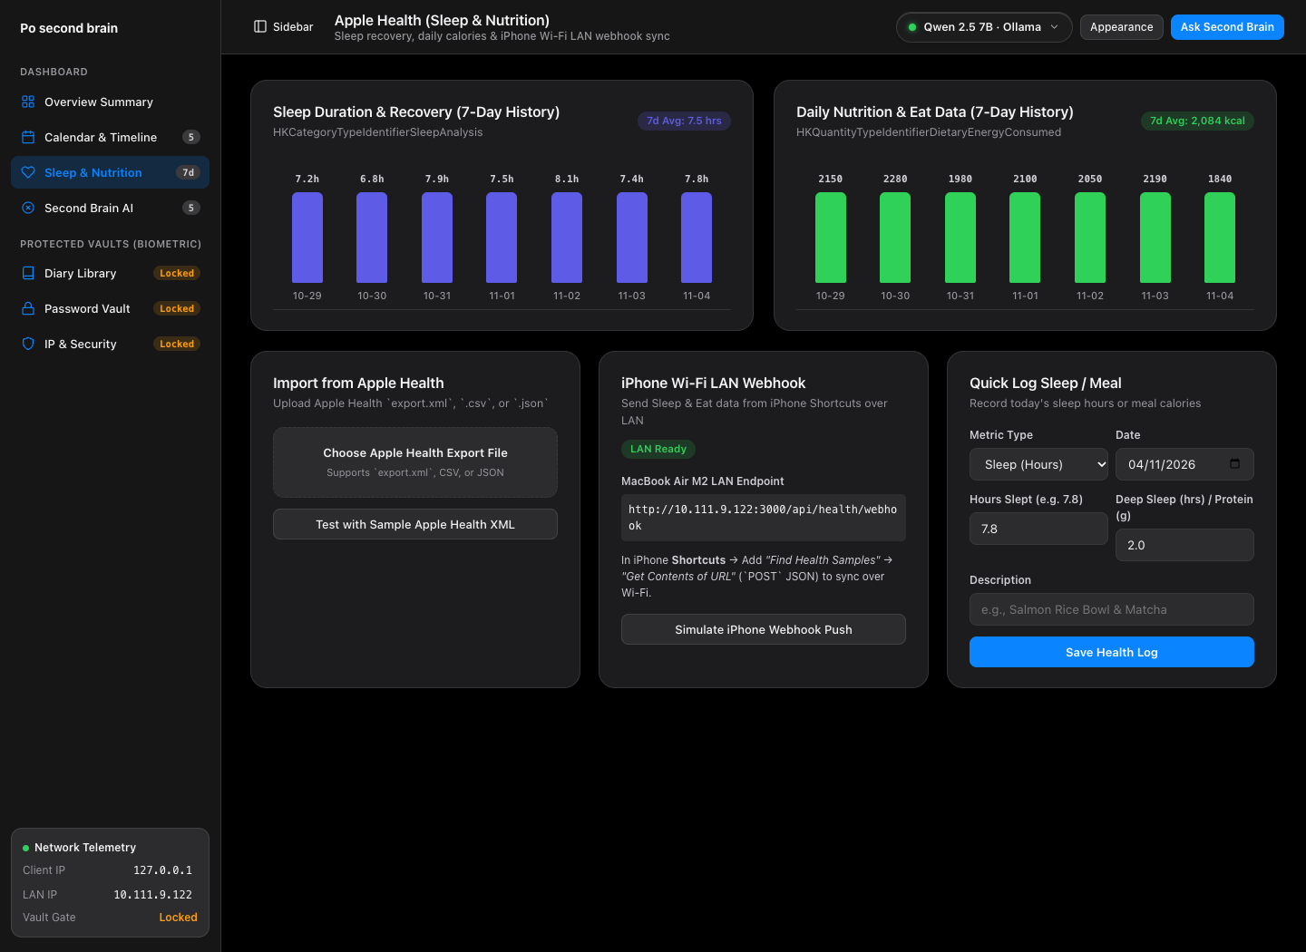
• Purpose: Tracks personal sleep recovery (hours & deep sleep) and daily nutrition (calories & protein grams) imported from Apple Health.
• Apple Health XML / CSV / JSON Importer: Parses Apple Health export.xml records (HKCategoryTypeIdentifierSleepAnalysis, HKQuantityTypeIdentifierDietaryEnergyConsumed, HKQuantityTypeIdentifierDietaryProtein) as well as CSV and JSON files.
• iPhone Shortcut Wi-Fi LAN Webhook (POST http://10.111.9.122:3000/api/health/webhook): Allows 1-tap automated syncing from an iPhone on the same Wi-Fi LAN via Apple Shortcuts.
2.5 Second Brain AI Studio — RAG Memory & Autonomous Action Agent
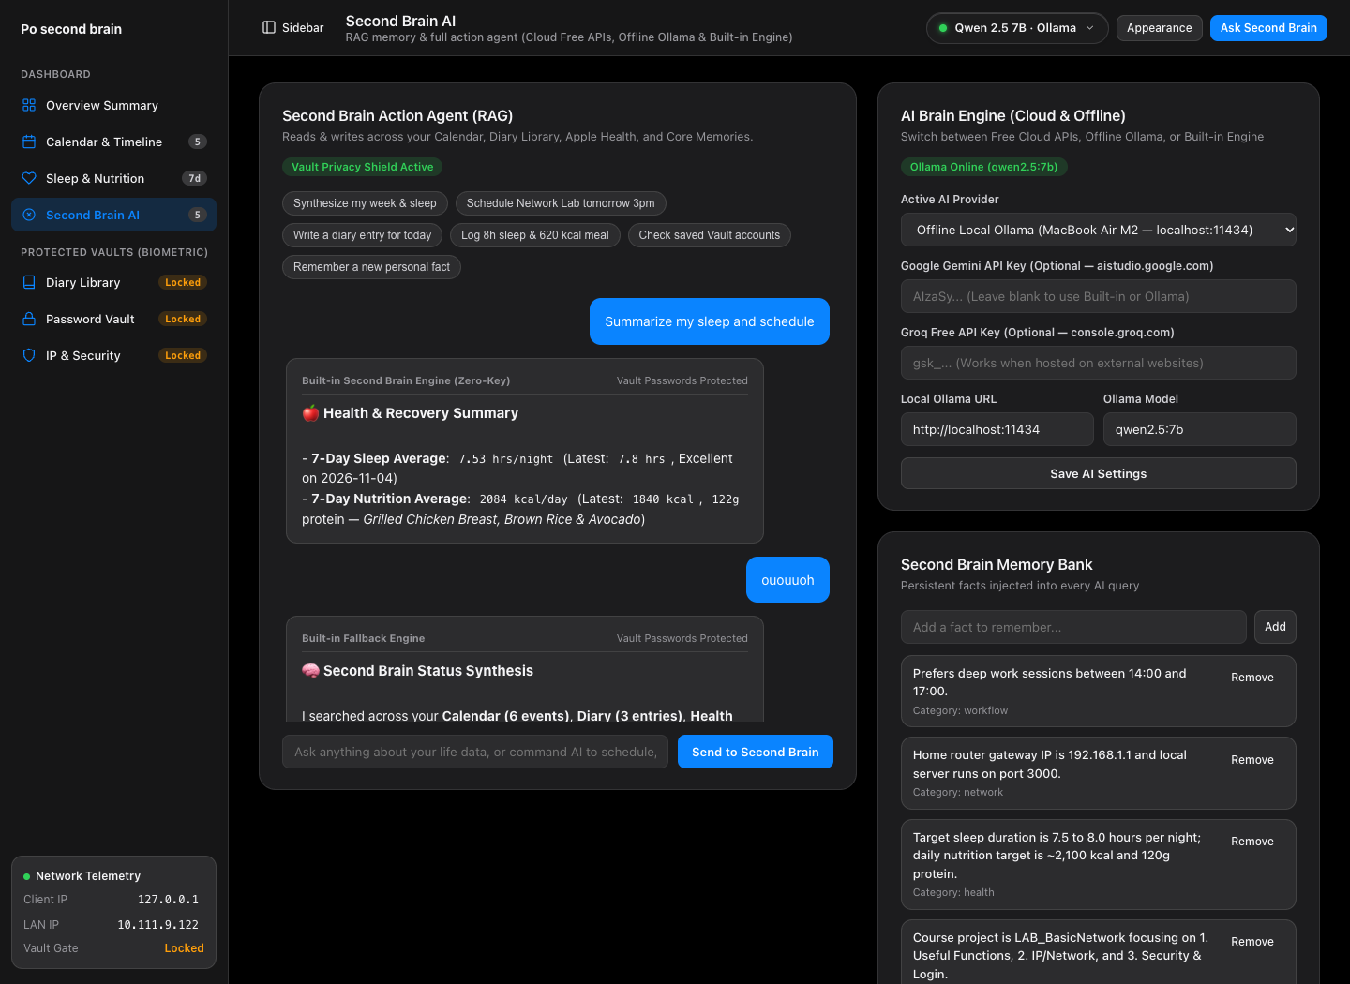
• Purpose: Conversational AI studio with full Retrieval-Augmented Generation (RAG) over your personal SQLite database.
• Cross-Domain RAG Context Injection: Automatically retrieves upcoming Calendar milestones, recent Diary entries, 7-day Sleep & Calorie averages, Core Memories, and privacy-redacted Password Vault metadata (AES-256-CTR ciphertexts are never sent to LLMs).
• Autonomous Database Actions & 1-Click Undo: Emits structured [ACTION: {...}] payloads (add_event, add_diary, log_health, add_memory) that mutate SQLite and render an Action Receipt with a 1-click Undo button.
2.6 On-Demand Biometric & Passcode Security Gate
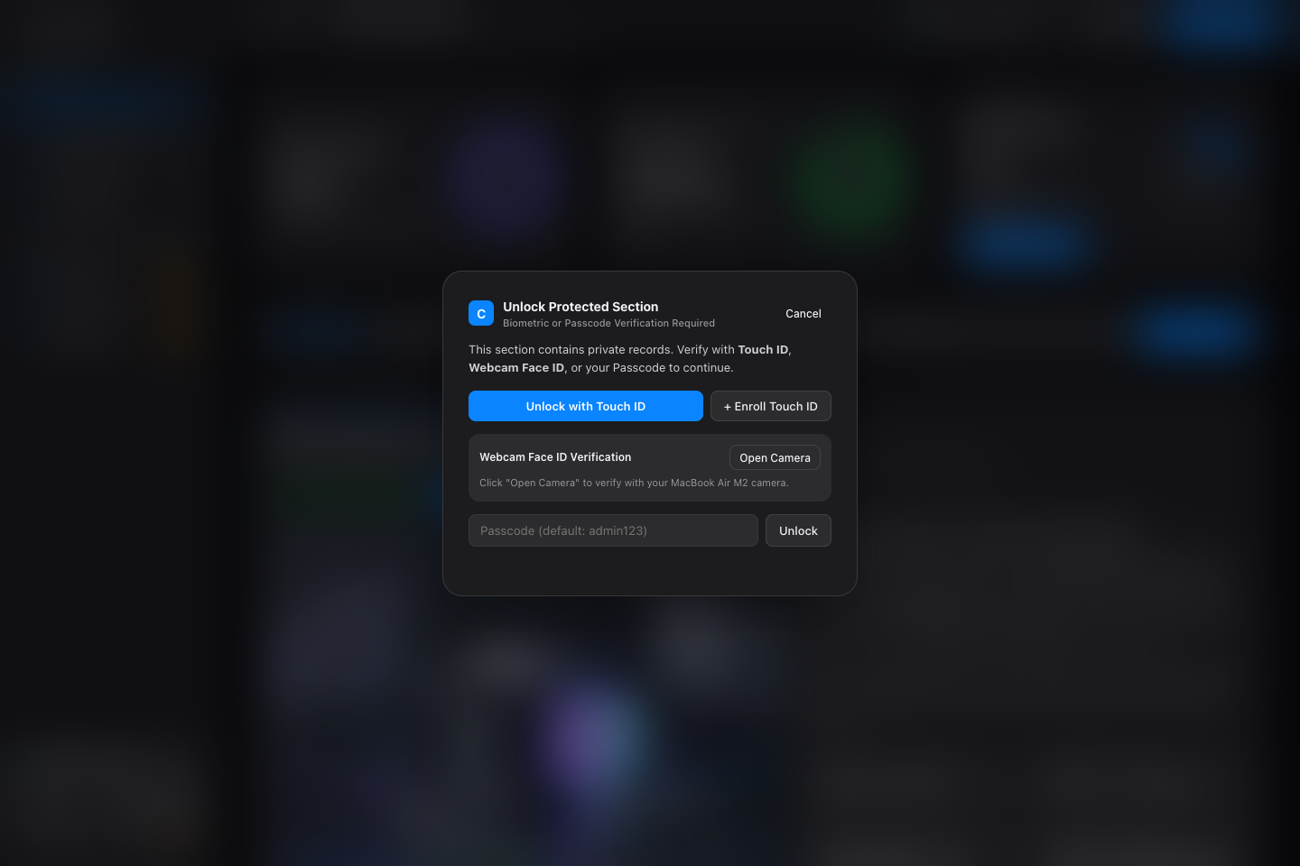
• Purpose: Selective security gate that triggers ONLY when opening Protected Sections (Diary Library, Password Vault, IP & Security), keeping daily views fast and frictionless.
• 1. MacBook Air M2 Touch ID (WebAuthn / FIDO2 Passkey): Hardware Secure Enclave fingerprint verification via navigator.credentials.
• 2. 192-Dimensional Sobel Gradient & Facial Geometry Face ID: Captures a 4-frame burst over 210ms from the central 32x48 facial oval and extracts 192 Z-score normalized features (64 facial topography zones, 64 horizontal/vertical Sobel edge gradients across eyes/nose/mouth, and 64 chromaticity/symmetry ratios).
• Strict Anti-Spoofing & Owner Threshold (>= 85.0%): Combines zero-mean Pearson correlation with L1/L2 distance penalties so the owner passes (~92%–99%) while a friend's face is rejected (HTTP 401 Unauthorized). Also hides the Enroll button on the lock screen once an owner profile is enrolled.
• 3. Master Passcode (PBKDF2-HMAC-SHA256): Verified using 120,000 iterations of SHA-256 with random salt and constant-time hmac.compare_digest (Default passcode: admin123).
2.7 Protected Personal Diary Library
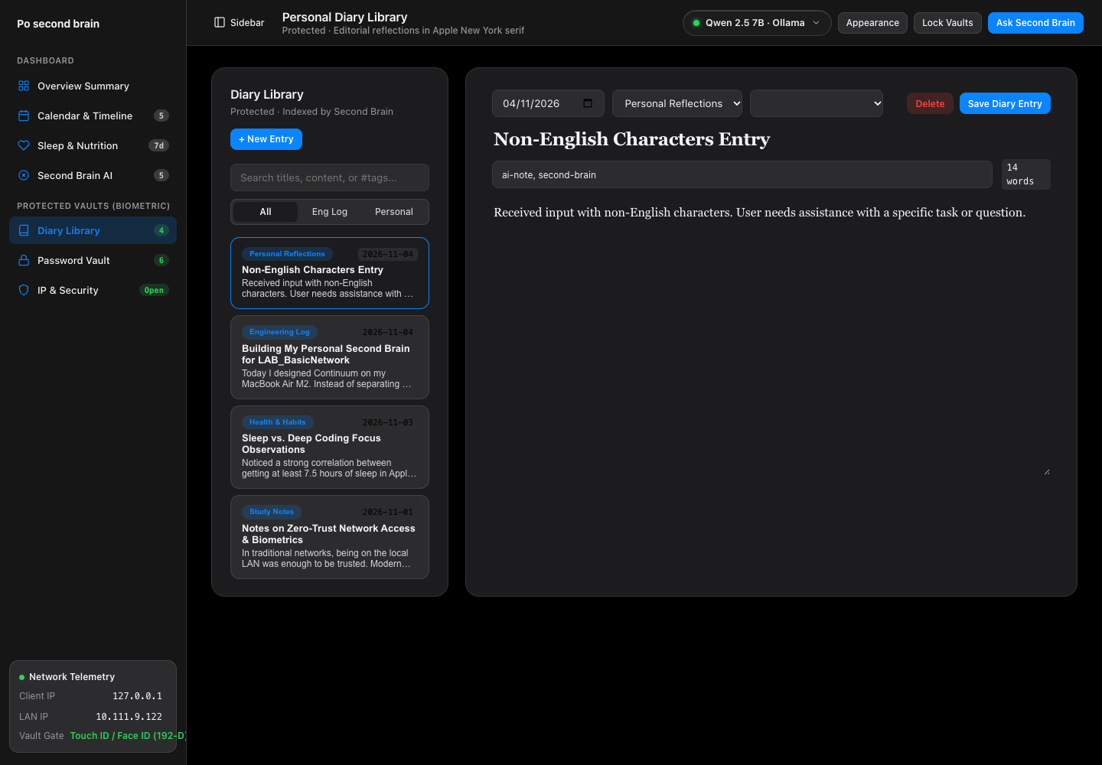
• Purpose: Distraction-free split-view notebook for personal reflections, network lab notes, and Second Brain ideas.
• Editorial Typography: Uses Apple's New York serif typeface (ui-serif, 'New York', Georgia, serif) with notebook filtering, mood tags, full-text search, and automatic indexing into the Second Brain RAG memory.
2.8 Protected Personal & Game Password Vault (AES-256-CTR)
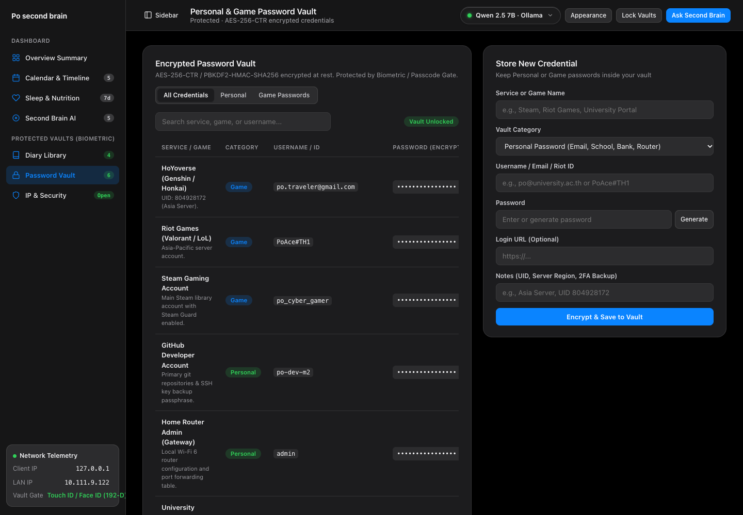
• Purpose: Encrypted credential manager for both Personal Accounts (GitHub, Apple ID, University Portal) and Game Accounts (Steam, Riot Games / Valorant, Hoyoverse).
• Cryptographic Architecture: Encrypts every secret at rest using a 256-bit key derived via PBKDF2-HMAC-SHA256 (100,000 iterations), a unique 16-byte random nonce, an HMAC-SHA256 CTR stream cipher, and a 16-byte HMAC authentication tag (enc:v1:...). Includes 1-click Reveal/Hide, Copy, and a 20-character CSPRNG generator.
2.9 Protected IP, Network & Subnet Firewall Lab (LAB_BasicNetwork)
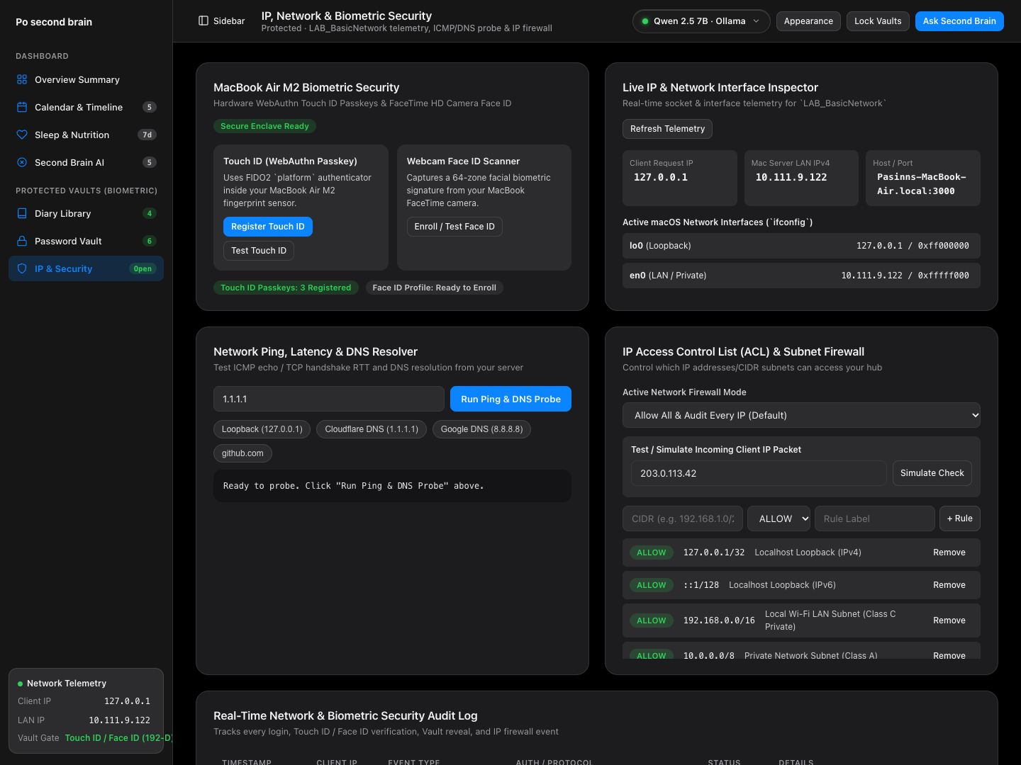
• Purpose: Complete networking and security laboratory fulfilling all LAB_BasicNetwork course objectives.
• Live IP & Network Interface Inspector: Displays Client IP (127.0.0.1), Server Wi-Fi LAN IPv4 (10.111.9.122), Hostname/Port (3000), and active macOS ifconfig interfaces (lo0 Loopback, en0 Private LAN).
• ICMP Ping, TCP Latency & DNS Resolver: Resolves hostnames (1.1.1.1, 8.8.8.8, github.com) to IPv4, measures DNS lookup latency in ms, and executes an ICMP ping / TCP RTT probe.
• IP Access Control List (ACL) & CIDR Subnet Firewall: Evaluates incoming IPs against CIDR rules (127.0.0.1/32, 192.168.0.0/16, 10.0.0.0/8, 203.0.113.0/24) with an interactive Packet Simulator and real-time Security & Network Audit Log.
3. Quick Start & Instructor Evaluation Guide
1. Clone Repository: git clone https://github.com/67992023-cmd/po-second-brain.git && cd po-second-brain
2. Start Server (Zero external dependencies): python3 server.py
3. Open in Browser: http://localhost:3000 (Default Passcode for Protected Vaults: admin123)
4. Optional Local LLM: ollama pull qwen2.5:7b && ollama serve

