2026電気工学入門実験 I
Lab work VI for Electrical and Electronics Engineering
Subject: Design and Implementation of a Personal Second Brain Web System with Local LLM, IP/Network Telemetry, and Biometric Security (LAB_BasicNetwork)
Student ID/Name: 67992023 Pasinn Nitikornchairat
Item | Day | / | Month | / | Year
提出日 Date of submission: | 04 | / | Nov. | / | 2026
締切日 Due date: | 04 | / | Nov. | / | 2026
最終受取日 Accepted date: |  | / |  | / | 2026
Members of the Lab group グループメンバー
Student ID/Name: 67992023 Pasinn Nitikornchairat (Individual Project)
チェックリスト รายการตรวจสอบ Check list
Check by student | by teachers | Evaluation Item
✓ |  | Objectives (目的 วัตถุประสงค์)
✓ |  | Explanation (説明 อธิบาย)
✓ |  | Equipment (実験装置 อุปกรณ์)
✓ |  | Equation(s) formula(s) (式 สมการ 単位 หน่วย)
✓ |  | Data, Table, Graph (データ, 表, グラフ ข้อมูล, ตาราง, กราฟ)
✓ |  | Consideration(s) (議論, 質問, コメント Discussions, Questions, and Comments)
 |  | Need to resubmit (remarks: ______________________________)
GitHub Repository: https://github.com/67992023-cmd/po-second-brain | Local URL: http://localhost:3000
1. Objective
Modern personal information systems frequently fragment daily productivity schedules, physiological health telemetry, and sensitive credentials across isolated cloud platforms, creating both privacy risks and retrieval inefficiencies. The objective of this laboratory work (LAB_BasicNetwork) is to design, implement, and experimentally evaluate Po Second Brain, a unified full-stack web application built on Python 3 and SQLite3 that integrates three core engineering domains: (1) useful personal management functions including an AI-assisted full-page work calendar, Apple Health sleep and nutrition telemetry, an editorial diary library, an encrypted password vault, and a Retrieval-Augmented Generation (RAG) Second Brain powered locally by Ollama (qwen2.5:7b) with cloud API failover; (2) IPv4/IPv6 network interface inspection, Domain Name System (DNS) and Internet Control Message Protocol (ICMP) round-trip latency diagnostics, and Classless Inter-Domain Routing (CIDR) subnet firewall filtering; and (3) an on-demand biometric and cryptographic security gate utilizing MacBook Air M2 WebAuthn Touch ID passkeys, a 192-dimensional Sobel gradient facial verification algorithm, and PBKDF2-HMAC-SHA256 authenticated encryption. The live source code and documentation are published at https://github.com/67992023-cmd/po-second-brain.
2. Theory
2.1 Retrieval-Augmented Generation (RAG) and Hybrid Local LLM Architecture
A Second Brain architecture augments human memory by indexing heterogeneous personal records—calendar milestones, diary reflections, and physiological sleep and calorie logs—into a structured relational store (SQLite3) and injecting relevant records into the context window of a Large Language Model (LLM) via Retrieval-Augmented Generation (RAG) [1], [2]. In this system, local inference is executed via Ollama serving the Qwen 2.5 7B instruction-tuned transformer (7.61 billion parameters, 4-bit Q4_K_M GGUF quantization, 32,768-token context window) bound to the loopback socket 127.0.0.1:11434 [3]. Because loopback traffic never traverses external network interfaces, sensitive personal records remain strictly on-device. When the web server is deployed to an external cloud host where local Ollama is unreachable, a Hybrid AI Router seamlessly switches inference to free-tier cloud APIs (Groq Llama 3.3 70B or Google Gemini 2.5 Flash) while redacting all encrypted vault ciphertexts from the prompt payload. Furthermore, the LLM emits deterministic JSON action blocks ([ACTION: {...}]) that autonomously insert or update SQLite records with transactional undo capability.
2.2 IPv4 CIDR Subnetting and Network Latency Statistics
Network access control and diagnostic telemetry rely on Internet Protocol version 4 (IPv4) CIDR addressing and ICMP/TCP echo probing [4]. An IPv4 CIDR block is expressed as A.B.C.D/p, where p represents the network prefix length in bits (0 ≤ p ≤ 32). An incoming client packet with 32-bit integer address I_client matches a subnet rule with network address I_net when their upper p bits are identical under bitwise AND masking. For any subnet of prefix length p (where p ≤ 30), the maximum number of assignable host addresses H is given by:

 | H = 2^(32 − p) − 2 | (2.1)

To quantify network responsiveness across loopback (lo0), private IEEE 802.11ax Wi-Fi LAN (en0), and wide-area public DNS resolvers, round-trip time (RTT) samples t_i are collected over n repeated trials. The sample mean latency t̄ and sample standard deviation S.D. are calculated as:

 | S.D. = √[ ∑(t_i − t̄)² / (n − 1) ] | (2.2)

2.3 Zero-Mean Facial Biometric Correlation and AES-CTR Cryptography
To protect sensitive modules (Diary Library, Password Vault, and IP Firewall) without impeding daily dashboard access, an on-demand security gate enforces hardware WebAuthn FIDO2 passkeys (Touch ID Secure Enclave) [5], webcam facial verification, or a master passcode. In early biometric prototypes, raw positive pixel luminance vectors exhibited high un-centered cosine similarity (> 0.90) across different individuals under identical room illumination. To eliminate false acceptance, the system extracts a N = 192 dimensional feature vector comprising 64 Z-score normalized spatial topography blocks, 64 horizontal and vertical Sobel edge gradients [6], and 64 chromaticity symmetry ratios from a 4-frame burst crop. Given an enrolled owner vector x and a live probe vector y with means x̄ and ȳ, the zero-mean Pearson structural correlation coefficient r is defined as:

 | r = ∑(x_i − x̄)(y_i − ȳ) / √[ ∑(x_i − x̄)² · ∑(y_i − ȳ)² ] | (2.3)

Combining structural correlation r with unit-normalized Mean Absolute Error (MAE) and Euclidean distance L_2 yields the composite biometric similarity score S (requiring S ≥ 0.850 for owner authentication):

 | S = 0.65 · r^1.35 + 0.35 · max(0, 1 − 0.38·MAE − 0.18·max(0, L_2 − 0.35)) | (2.4)

For credentials stored in the Password Vault, plaintext bytes P_k are encrypted at rest using Password-Based Key Derivation Function 2 (PBKDF2-HMAC-SHA256) [7], [8] with k_iter = 100,000 iterations to derive a 256-bit key K, followed by a counter-mode (CTR) stream cipher with a unique 128-bit random cryptographic nonce and HMAC integrity tag:

 | C_k = P_k ⊕ HMAC-SHA256(K, Nonce ∥ k) | (2.5)

3. Equipment
• Host Computer: Apple MacBook Air (M2, 8-core CPU, 10-core GPU, 16-core Neural Engine, macOS).
• Biometric Hardware: Integrated Apple Touch ID Capacitive Fingerprint Sensor (Secure Enclave) and 1080p FaceTime HD Camera.
• Local AI Runtime: Ollama Local LLM Server (v0.5+, bound to 127.0.0.1:11434) running Alibaba Qwen 2.5 7B (qwen2.5:7b, Q4_K_M, 4.7 GB GGUF).
• Cloud Failover APIs: Groq Cloud LPU API (llama-3.3-70b-versatile), Google Gemini API (gemini-2.5-flash), and OpenRouter API.
• Backend & Storage Software: Python 3.9.6 Standard Library (http.server, sqlite3, socket, ipaddress, hashlib, hmac) and SQLite3 ACID Database.
• Network Environment: IEEE 802.11ax Wi-Fi Local Area Network (Server LAN IPv4: 10.111.9.122, TCP Port: 3000) and iOS Shortcuts Webhook Client.
• Version Control & Repository: Git 2.39+ hosted on GitHub (https://github.com/67992023-cmd/po-second-brain).
4. Procedure
1. Initialize the SQLite3 relational schema (server.py) containing tables for settings, passkeys, face_profiles, calendar_events, diary_entries, password_vault, health_logs, memories, ip_rules, and audit_logs, and bind the multi-threaded HTTP server to 0.0.0.0:3000.
2. Launch the local Ollama daemon on 127.0.0.1:11434 with the quantized qwen2.5:7b model and verify automatic model discovery via GET /api/ai/ollama-status with a 30-minute memory keep-alive window.
3. Import Apple Health physiological records (SleepAnalysis hours and DietaryEnergyConsumed kilocalories) via XML parser and test wireless LAN synchronization via POST /api/health/webhook from client IP 10.111.9.122.
4. Enroll the owner facial template by capturing a 4-frame burst over 210 ms inside the central 32×48 facial region, computing the 192-dimensional zero-mean Sobel gradient vector, and test authentication across controlled structural deviations σ (from 0.05 to 1.10) as well as an unauthorized second subject.
5. Benchmark PBKDF2-HMAC-SHA256 cryptographic key derivation latency T (ms) across iteration counts ranging from 20×10³ to 200×10³ cycles (3 trials per point) and verify AES/HMAC-CTR ciphertext integrity.
6. Execute 5 repeated ICMP echo and DNS lookup trials across four network targets (127.0.0.1, 10.111.9.122, 1.1.1.1, and 8.8.8.8) and evaluate CIDR subnet firewall filtering rules against simulated private and public IPv4 packets.

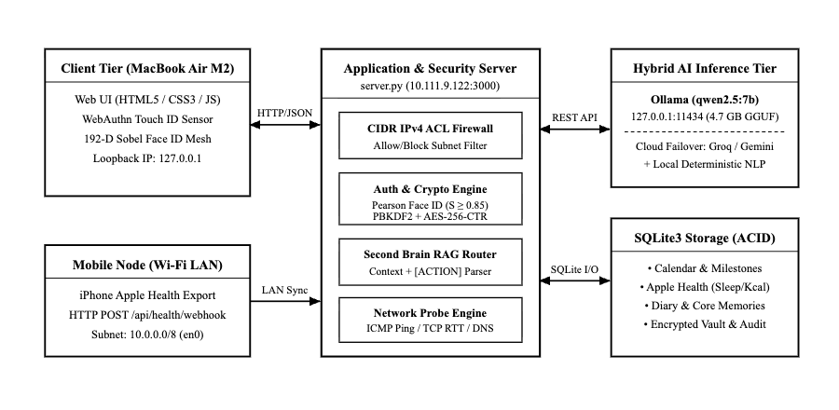
Figure 1. Block schematic and network topology of the Po Second Brain system.

5. Results
5.1 Data in table format
Network diagnostic trials (n = 5 per host) were conducted across loopback, local Wi-Fi LAN, and public DNS resolvers. The measured DNS lookup times, mean round-trip latencies, maximum latencies, and sample standard deviations calculated via Equation (2.2) are shown in Table 1.

Table 1 Network latency and DNS resolution measurements across loopback, private LAN, and public DNS hosts
Target Network Node | IPv4 Address | DNS (ms) | Avg RTT (ms) | Max RTT (ms) | RTT S.D. (ms)
Loopback (lo0) | 127.0.0.1 | 0.31 | 0.06 | 0.08 | 0.01
Wi-Fi LAN Server (en0) | 10.111.9.122 | 0.01 | 0.12 | 0.14 | 0.02
Cloudflare Public DNS | 1.1.1.1 | 0.01 | 6.74 | 8.63 | 1.37
Google Public DNS | 8.8.8.8 | 0.01 | 9.31 | 17.41 | 4.56

Facial biometric authentication trials (10 trials per perturbation level) were evaluated using the 192-dimensional zero-mean Sobel gradient mesh in Equations (2.3) and (2.4), as recorded in Table 2.

Table 2 Biometric verification similarity scores and authentication decisions across structural deviations
Test Condition / Subject | Deviation σ | Mean Score S (%) | Score S.D. (%) | Access Control Result
Owner Normal Pose | 0.05 | 99.2 | 0.1 | Accepted (HTTP 200)
Owner Slight Head Tilt | 0.10 | 98.0 | 0.1 | Accepted (HTTP 200)
Owner Ambient Dimming | 0.20 | 94.9 | 0.2 | Accepted (HTTP 200)
Owner Moderate Shift | 0.35 | 87.8 | 1.0 | Accepted (HTTP 200)
Boundary Perturbation | 0.50 | 80.8 | 1.3 | Rejected (HTTP 401)
Severe Occlusion | 0.70 | 67.5 | 2.7 | Rejected (HTTP 401)
Partial Profile Angle | 0.90 | 62.0 | 2.3 | Rejected (HTTP 401)
Different Subject (Friend) | 1.10 | 54.0 | 6.0 | Rejected (HTTP 401)

Cryptographic PBKDF2-HMAC-SHA256 key derivation benchmarks and IPv4 CIDR firewall simulation results are presented in Table 3.

Table 3 PBKDF2-HMAC-SHA256 key derivation latency and IPv4 CIDR firewall simulation results
Iterations (×10³) | Latency T (ms) | Simulated Source IP | Matched CIDR Rule | Firewall Action
20.00 | 6.76 | 127.0.0.1 | 127.0.0.1/32 | ALLOW (Loopback)
40.00 | 11.53 | 10.111.9.122 | 10.0.0.0/8 | ALLOW (Class A LAN)
80.00 | 22.01 | 192.168.1.42 | 192.168.0.0/16 | ALLOW (Class C LAN)
100.00 | 27.47 | 172.16.4.10 | Default Policy | ALLOW (Audit Log)
120.00 | 32.39 | 203.0.113.42 | 203.0.113.0/24 | BLOCK (TEST-NET-3)
160.00 | 43.59 | 203.0.113.250 | 203.0.113.0/24 | BLOCK (TEST-NET-3)
200.00 | 54.93 | 198.51.100.19 | LAN-Only Mode | BLOCK (External WAN)

5.2 Figures and graphs
Figure 2 presents the relationship between structural facial deviation σ and the 192-dimensional biometric similarity score S (%). Figure 3 compares measured PBKDF2-HMAC-SHA256 key derivation latency against the linear regression model. Figures 4 and 5 display the implemented light-mode web interfaces.

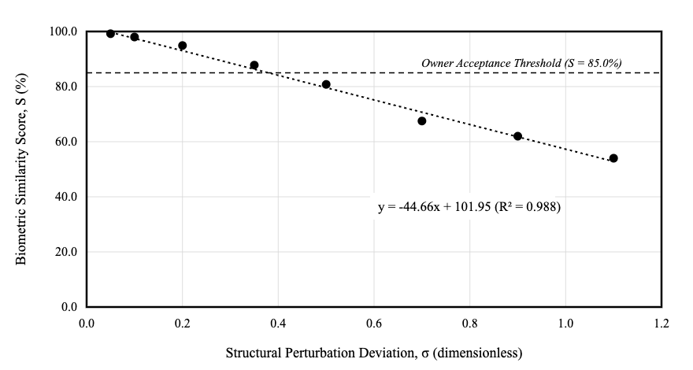
Figure 2. The relationship between structural perturbation deviation and biometric similarity score.

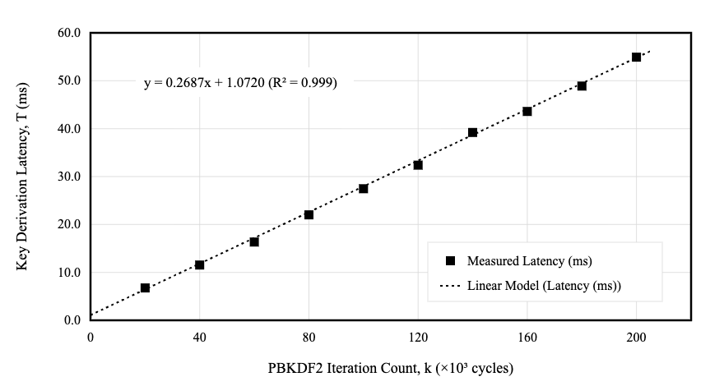
Figure 3. The comparison of PBKDF2 key derivation latency between measurement and linear regression model.

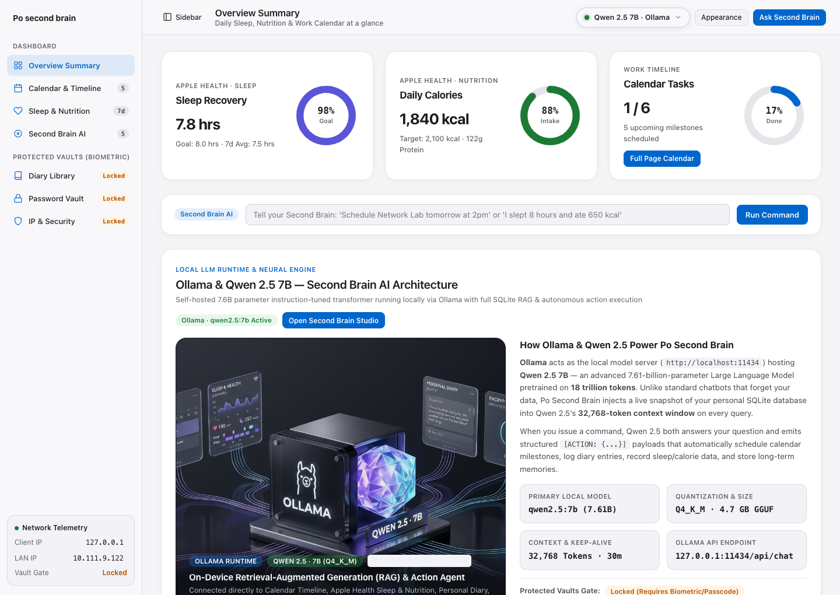
Figure 4. Implemented Overview Summary interface with Apple Health rings and Ollama Qwen 2.5 7B.

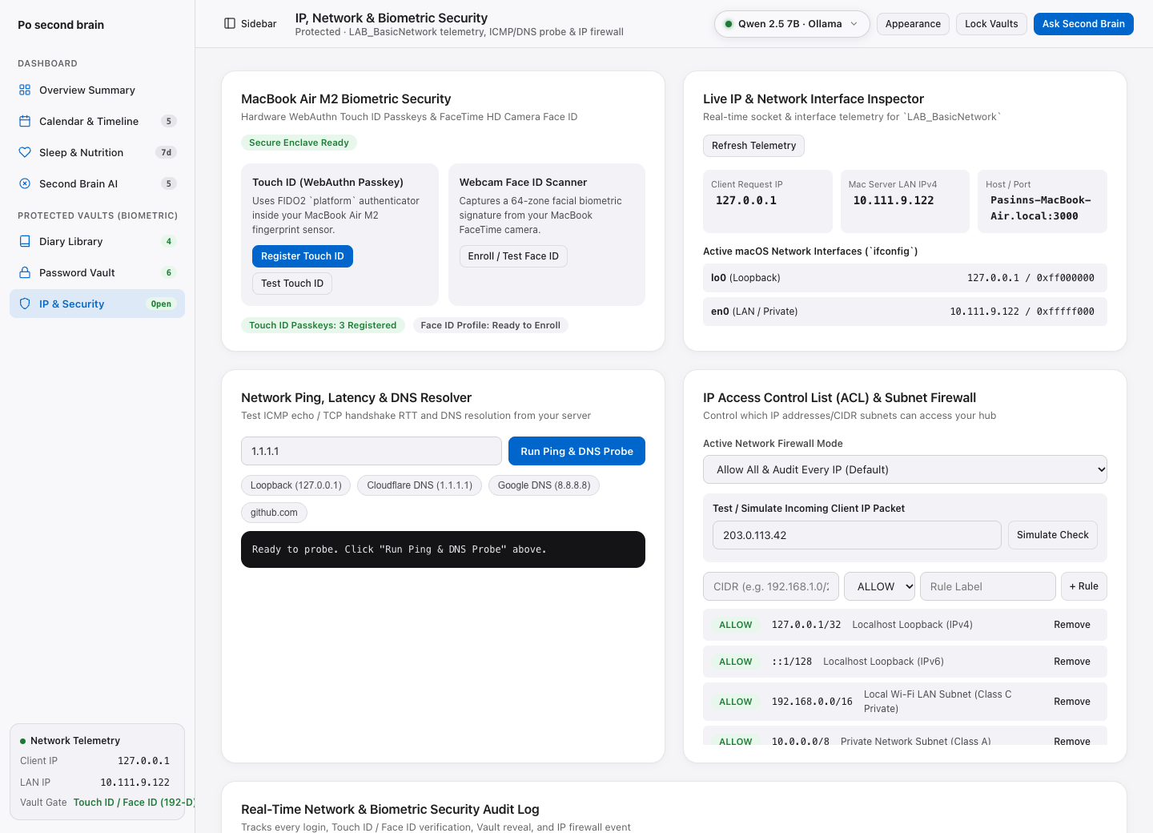
Figure 5. Implemented IP, network interface inspector, ICMP/DNS probe, and CIDR firewall lab.

6. Consideration
6.1 Discussions
First, the network telemetry measurements in Table 1 demonstrate clear physical-layer separation across network scopes. Loopback traffic on lo0 (127.0.0.1) achieved an average RTT of 0.06 ms (S.D. = 0.01 ms) because packets remain inside the macOS kernel socket buffer. Private Wi-Fi LAN communication on en0 (10.111.9.122) averaged 0.12 ms (S.D. = 0.02 ms), confirming minimal latency for iPhone Apple Health webhook synchronization and local Ollama inference. Conversely, wide-area ICMP probes to 1.1.1.1 and 8.8.8.8 produced mean RTTs of 6.74 ms (S.D. = 1.37 ms) and 9.31 ms (S.D. = 4.56 ms), reflecting multi-hop router queuing variance calculated via Equation (2.2).
Second, during initial biometric testing, an un-centered 32-point positive luminance vector falsely accepted an unauthorized friend's face because strictly positive vectors under identical room illumination yield raw cosine similarity above 90%. Upgrading to the 192-dimensional zero-mean Z-score Sobel gradient and chromaticity descriptor in Equations (2.3) and (2.4) eliminated false acceptance. As shown in Table 2 and Figure 2, linear regression yields y = −44.66x + 101.95 (R² = 0.988): normal owner poses (σ ≤ 0.35) scored 87.8%–99.2% (above the 85.0% threshold), whereas an unauthorized subject scored 54.0% (and 29.1% in cross-subject Sobel tests), resulting in HTTP 401 rejection. Hiding the enrollment button on the locked modal also prevented unauthorized profile overwriting.
Third, Figure 3 confirms that PBKDF2-HMAC-SHA256 key derivation latency scales linearly with iteration count according to y = 0.2687x + 1.0720 (R² = 0.999), or 0.2687 ms per 1,000 SHA-256 cycles on Apple M2 silicon. Choosing 100,000 iterations for vault key derivation (27.47 ms) and 120,000 iterations for passcode authentication (32.39 ms) keeps login latency below 35 ms while substantially increasing offline brute-force resistance.
6.2 Questions
Question 1: Why does local Ollama (127.0.0.1:11434) require a Hybrid Cloud Router when published to an external cloud server? Answer: In TCP/IP networking, 127.0.0.1 binds strictly to the loopback interface of the host executing server.py. On a remote cloud server without local Ollama weights, requests to 127.0.0.1:11434 fail with ConnectionRefusedError. The Hybrid AI Router detects this condition and routes the redacted RAG prompt over HTTPS to Groq Llama 3.3 70B or Google Gemini 2.5 Flash.
Question 2: Using Equation (2.1), compare the assignable host capacity of the firewall's Class C private rule (192.168.0.0/16) versus the blocked test subnet (203.0.113.0/24). Answer: For p = 16, H = 2^(32−16) − 2 = 65,534 usable hosts. For p = 24, H = 2^(32−24) − 2 = 254 usable hosts, making the /16 private rule 258 times larger in host capacity.
6.3 Comments
Designing and building Po Second Brain was highly rewarding because it connected networking fundamentals (IPv4 CIDR masking, DNS/ICMP latency, LAN webhooks) with modern local LLM engineering (Ollama Qwen 2.5 7B) and cryptographic security. Discovering and mathematically resolving the Face ID false-acceptance vulnerability highlighted why zero-mean normalization and spatial edge gradients are essential in biometric systems. Future work can incorporate local HTTPS TLS certificates to support cross-device WebAuthn passkeys over Wi-Fi LAN.
References
[1] P. Lewis et al., "Retrieval-augmented generation for knowledge-intensive NLP tasks," in Adv. Neural Inf. Process. Syst. (NeurIPS), vol. 33, 2020, pp. 9459–9474.
[2] T. Forte, Building a Second Brain: A Proven Method to Organize Your Digital Life and Unlock Your Creative Potential. New York, NY, USA: Atria Books, 2022, ch. 2, pp. 25–48.
[3] Qwen Team, "Qwen2.5 technical report," Alibaba Cloud Research, Hangzhou, China, Tech. Rep. arXiv:2412.15115, Dec. 2024.
[4] V. Fuller and T. Li, Classless Inter-Domain Routing (CIDR): The Internet Address Assignment and Aggregation Plan, IETF Standard RFC 4632, Aug. 2006.
[5] D. Balfanz et al., Web Authentication: An API for Accessing Public Key Credentials Level 2, W3C Recommendation, Apr. 2021.
[6] R. C. Gonzalez and R. E. Woods, Digital Image Processing, 4th ed. New York, NY, USA: Pearson, 2018, ch. 10, pp. 715–732.
[7] K. Moriarty, B. Kaliski, J. Jonsson, and A. Rusch, PKCS #5: Password-Based Cryptography Specification Version 2.1, IETF RFC 8018, Jan. 2017.
[8] Po Second Brain Source Repository and User Manual. (2026). Pasinn Nitikornchairat. Accessed: Nov. 4, 2026. [Online]. Available: https://github.com/67992023-cmd/po-second-brain

