**CITY OF GENERAL TRIAS COVID - 19 CASE BULLETIN as of ${date}**

**PORSYENTO NG NAMATAY**

**${d_p}**

**TOTAL DEATHS**

**${d_t}**

Unvaccinated: **${vdu}**

Partial: **${vdp}**

Full: **${vdf}**

Booster: **${vdb}**

**PORSYENTO NG GUMALING**

**${r_p}**

**TOTAL NG GUMALING**

**${r_t}**

Unvaccinated: **${vru}**

Partial: **${vrp}**

Full: **${vrf}**

Booster: **${vrb}**

**PORSYENTO NG AKTIBONG KASO**

**${c_p}**

**TOTAL NG AKTIBONG KASO**

**${c_t}**

Unvaccinated: **${vcu}**

Partial: **${vcp}**

Full: **${vcf}**

Booster: **${vcb}**

**MGA BAGONG NAMATAY**

**${d_n}**

**MGA BAGONG GUMALING**

**${r_n}**

**BAGONG KASO**

**${c_n}**

|  |  |  |  |  |
| --- | --- | --- | --- | --- |
| **BARANGAY** | **CONFIRMED** | **ACTIVE** | **DEATH** | **RECOVERED** |
| **ALINGARO** | **${bc1}** | **${ba1}** | **${bd1}** | **${br1}** |
| **ARNALDO POB. (BGY. 7)** | **${bc2}** | **${ba2}** | **${bd2}** | **${br2}** |
| **BACAO I** | **${bc3}** | **${ba3}** | **${bd3}** | **${br3}** |
| **BACAO II** | **${bc4}** | **${ba4}** | **${bd4}** | **${br4}** |
| **BAGUMBAYAN POB. (BGY. 5)** | **${bc5}** | **${ba5}** | **${bd5}** | **${br5}** |
| **BICLATAN** | **${bc6}** | **${ba6}** | **${bd6}** | **${br6}** |
| **BUENAVISTA I** | **${bc7}** | **${ba7}** | **${bd7}** | **${br7}** |
| **BUENAVISTA II** | **${bc8}** | **${ba8}** | **${bd8}** | **${br8}** |
| **BUENAVISTA III** | **${bc9}** | **${ba9}** | **${bd9}** | **${br9}** |
| **CORREGIDOR POB. (BGY. 10)** | **${bc10}** | **${ba10}** | **${bd10}** | **${br10}** |
| **DULONG BAYAN POB. (BGY. 3)** | **${bc11}** | **${ba11}** | **${bd11}** | **${br11}** |
| **GOV. FERRER POB. (BGY. 1)** | **${bc12}** | **${ba12}** | **${bd12}** | **${br12}** |
| **JAVALERA** | **${bc13}** | **${ba13}** | **${bd13}** | **${br13}** |
| **MANGGAHAN** | **${bc14}** | **${ba14}** | **${bd14}** | **${br14}** |
| **NAVARRO** | **${bc15}** | **${ba15}** | **${bd15}** | **${br15}** |
| **NINETY SIXTH POB. (BGY. 8)** | **${bc16}** | **${ba16}** | **${bd16}** | **${br16}** |
| **PANUNGYANAN** | **${bc17}** | **${ba17}** | **${bd17}** | **${br17}** |
| **PASONG CAMACHILE I** | **${bc18}** | **${ba18}** | **${bd18}** | **${br18}** |
| **PASONG CAMACHILE II** | **${bc19}** | **${ba19}** | **${bd19}** | **${br19}** |
| **PASONG KAWAYAN I** | **${bc20}** | **${ba20}** | **${bd20}** | **${br20}** |
| **PASONG KAWAYAN II** | **${bc21}** | **${ba21}** | **${bd21}** | **${br21}** |
| **PINAGTIPUNAN** | **${bc22}** | **${ba22}** | **${bd22}** | **${br22}** |
| **PRINZA POB. (BGY. 9)** | **${bc23}** | **${ba23}** | **${bd23}** | **${br23}** |
| **SAMPALUCAN POB. (BGY. 2)** | **${bc24}** | **${ba24}** | **${bd24}** | **${br24}** |
| **SAN FRANCISCO** | **${bc25}** | **${ba25}** | **${bd25}** | **${br25}** |
| **SAN GABRIEL POB. (BGY. 4)** | **${bc26}** | **${ba26}** | **${bd26}** | **${br26}** |
| **SAN JUAN I** | **${bc27}** | **${ba27}** | **${bd27}** | **${br27}** |
| **SAN JUAN II** | **${bc28}** | **${ba28}** | **${bd28}** | **${br28}** |
| **SANTA CLARA** | **${bc29}** | **${ba29}** | **${bd29}** | **${br29}** |
| **SANTIAGO** | **${bc30}** | **${ba30}** | **${bd30}** | **${br30}** |
| **TAPIA** | **${bc31}** | **${ba31}** | **${bd31}** | **${br31}** |
| **TEJERO** | **${bc32}** | **${ba32}** | **${bd32}** | **${br32}** |
| **VIBORA POB. (BGY. 6)** | **${bc33}** | **${ba33}** | **${bd33}** | **${br33}** |
| **TOTAL** | **${bct}** | **${bat}** | **${bdt}** | **${brt}** |

|  |  |  |
| --- | --- | --- |
| **BARANGAY** | **SUSPECTED** | **PROBABLE** |
| **ALINGARO** | **${bs1}** | **${bp1}** |
| **ARNALDO POB. (BGY. 7)** | **${bs2}** | **${bp2}** |
| **BACAO I** | **${bs3}** | **${bp3}** |
| **BACAO II** | **${bs4}** | **${bp4}** |
| **BAGUMBAYAN POB. (BGY. 5)** | **${bs5}** | **${bp5}** |
| **BICLATAN** | **${bs6}** | **${bp6}** |
| **BUENAVISTA I** | **${bs7}** | **${bp7}** |
| **BUENAVISTA II** | **${bs8}** | **${bp8}** |
| **BUENAVISTA III** | **${bs9}** | **${bp9}** |
| **CORREGIDOR POB. (BGY. 10)** | **${bs10}** | **${bp10}** |
| **DULONG BAYAN POB. (BGY. 3)** | **${bs11}** | **${bp11}** |
| **GOV. FERRER POB. (BGY. 1)** | **${bs12}** | **${bp12}** |
| **JAVALERA** | **${bs13}** | **${bp13}** |
| **MANGGAHAN** | **${bs14}** | **${bp14}** |
| **NAVARRO** | **${bs15}** | **${bp15}** |
| **NINETY SIXTH POB. (BGY. 8)** | **${bs16}** | **${bp16}** |
| **PANUNGYANAN** | **${bs17}** | **${bp17}** |
| **PASONG CAMACHILE I** | **${bs18}** | **${bp18}** |
| **PASONG CAMACHILE II** | **${bs19}** | **${bp19}** |
| **PASONG KAWAYAN I** | **${bs20}** | **${bp20}** |
| **PASONG KAWAYAN II** | **${bs21}** | **${bp21}** |
| **PINAGTIPUNAN** | **${bs22}** | **${bp22}** |
| **PRINZA POB. (BGY. 9)** | **${bs23}** | **${bp23}** |
| **SAMPALUCAN POB. (BGY. 2)** | **${bs24}** | **${bp24}** |
| **SAN FRANCISCO** | **${bs25}** | **${bp25}** |
| **SAN GABRIEL POB. (BGY. 4)** | **${bs26}** | **${bp26}** |
| **SAN JUAN I** | **${bs27}** | **${bp27}** |
| **SAN JUAN II** | **${bs28}** | **${bp28}** |
| **SANTA CLARA** | **${bs29}** | **${bp29}** |
| **SANTIAGO** | **${bs30}** | **${bp30}** |
| **TAPIA** | **${bs31}** | **${bp31}** |
| **TEJERO** | **${bs32}** | **${bp32}** |
| **VIBORA POB. (BGY. 6)** | **${bs33}** | **${bp33}** |
| **TOTAL** | **${bst}** | **${bpt}** |

|  |  |
| --- | --- |
| **CITY OF GENERAL TRIAS LIGTAS COVID-19 FACILITY** | |
| ADMITTED IN THE ISOLATION FACILITY LIGTAS COVID GENTRI | **${facility_one}** |
| A. OVAL |
| ON STRICT HOME QUARANTINE | **${hq}** |
|
|
| ADMITTED IN THE HOSPITAL / OTHER ISOLATION FACILITY | **${o_hosp}** |

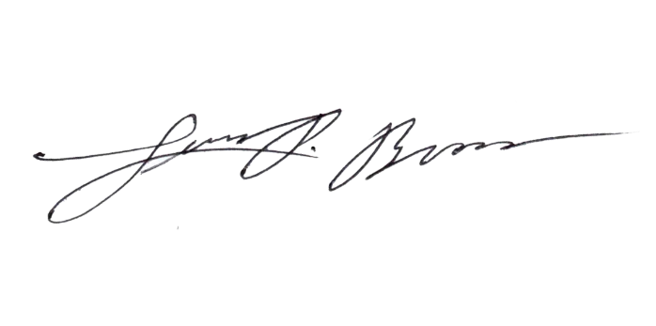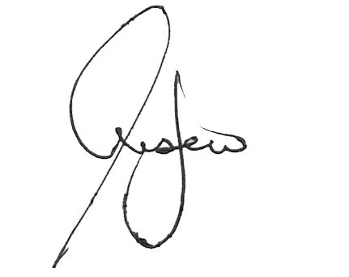

Prepared by:

**CHRISTIAN JAMES HISTORILLO**

Encoder

Noted by:

**LUIS P. BROAS, RN, RPh, MAN**

Nurse II/CESU Head

Approved by:

**JONATHAN P. LUSECO, MD**  
City Health Officer II

**${c_t}**

**ACTIVE CASES**

**ACTIVE CASES BREAKDOWN**

**LATE NA**

**KASO**

**${c_l}**

**MGA LATE REPORT NA GUMALING**

**${r_l}**

*Source: City Epidemiology and surveillance Unit, BHERT, DOH, UP-NIH, RITM, Ospital ng Imus and La Salle Lab results

**COVID-19 Hotline**

**0919-066 4324**

**0919-066 4325**

**DOH MEMORANDUM No 2020-00439 “Omnibus Interim Guidelines on Prevention, Detection, Isolation, Treatment and Reintegration Strategies for COVID-19”** issued last October 6, 2020

Under the general guideline section M#3

“Asymptomatic immunocompetent individuals who test PCR positive (+) and remained asymptomatic for at least 10 days from the date of specimen collection can discontinue isolation after 10 days and be tagged as a recovered confirmed case without need for further testing, provided a licensed medical doctor certifies or clears the patients”.

This is the New Format of Reporting as prescribed by DOH based on Administrative Circular Order No. 2020-0013

**KABUUANG BILANG NG KASO ${gt_cases}**

**ASYMPTOMATIC**

${as} (${as_p})

**MILD**

${mi} (${mi_p})

**MODERATE**

${mo} (${mo_p})

**SEVERE**

${se} (${se_p})

**CRITICAL**

${cr} (${cr_p})

**STAY AT HOME, PRACTICE SOCIAL DISTANCING AND WASH YOUR HAND REGULARLY**

**SUSPECTED CASES**

* May lagnat, ubo o hirap sa paghinga at kabilang sa isa sa mga nasa ibaba:
* Edad 60 taon at pataas
* Mayroong iba pang sakit
* Mayroong maselan na pagbubuntis
* Health worker
* Mayroon kang influenza-like illness: lagnat (38C) at ubo/ pananakit ng lalamunan at kabilang sa isa sa mga nasa ibaba:
* Naglakbay o nanirahan sa isang lugar na may ulat ng local na transmisyon ng sakit na COVID-19 sa loob ng 14 na araw bago nagsimula ang mga sintomas.
* Nagkaroon ng close contact sa isang CONFIRMED o PROBABLE kaso ng COVID-19 sa loob ng 14 na araw bago nagsimula ang mga sintomas.
* Nagkaroon ng biglaang karamdaman sa baga na may malubhang sintomas na hindi matukoy ang kadahilanan at kinakaingang ma-ospital

**PROBABLE CASES**

* Ikaw ay SUSPECT patient at:
* Hindi tiyak ang resulta ng testing
* Ginawa ang iyong test sa hindi opisyal na laboratory na gumagawa ng RT-PCR test
* Hindi nagawa ang testing sa ano mang kadahilanan.

**CONFIRMED CASES**

* Ang iyong result sa RT-PCR testing ay POSITIBO sa COVID-19