**CITY OF GENERAL TRIAS COVID - 19 CASE BULLETIN as of May 09, 2023**

**PORSYENTO NG NAMATAY**

**1.1%**

**TOTAL DEATHS**

**249**

Unvaccinated: **246**

Partial: **1**

Full: **2**

Booster: **0**

**PORSYENTO NG GUMALING**

**98.7%**

**TOTAL NG GUMALING**

**21,649**

Unvaccinated: **14,812**

Partial: **535**

Full: **5,152**

Booster: **1,150**

**PORSYENTO NG AKTIBONG KASO**

**0.2%**

**TOTAL NG AKTIBONG KASO**

**33**

Unvaccinated: **10**

Partial: **1**

Full: **10**

Booster: **12**

**MGA BAGONG NAMATAY**

**0**

**MGA BAGONG GUMALING**

**5**

**BAGONG KASO**

**3**

|  |  |  |  |  |
| --- | --- | --- | --- | --- |
| **BARANGAY** | **CONFIRMED** | **ACTIVE** | **DEATH** | **RECOVERED** |
| **ALINGARO** | **236** | **0** | **2** | **234** |
| **ARNALDO POB. (BGY. 7)** | **98** | **1** | **1** | **96** |
| **BACAO I** | **516** | **1** | **7** | **508** |
| **BACAO II** | **401** | **2** | **6** | **393** |
| **BAGUMBAYAN POB. (BGY. 5)** | **133** | **0** | **2** | **131** |
| **BICLATAN** | **1,702** | **5** | **19** | **1,678** |
| **BUENAVISTA I** | **627** | **1** | **11** | **615** |
| **BUENAVISTA II** | **539** | **0** | **8** | **531** |
| **BUENAVISTA III** | **678** | **1** | **8** | **669** |
| **CORREGIDOR POB. (BGY. 10)** | **95** | **0** | **1** | **94** |
| **DULONG BAYAN POB. (BGY. 3)** | **76** | **0** | **2** | **74** |
| **GOV. FERRER POB. (BGY. 1)** | **42** | **0** | **0** | **42** |
| **JAVALERA** | **469** | **0** | **3** | **466** |
| **MANGGAHAN** | **1,051** | **1** | **9** | **1,041** |
| **NAVARRO** | **2,800** | **2** | **9** | **2,789** |
| **NINETY SIXTH POB. (BGY. 8)** | **50** | **0** | **0** | **50** |
| **PANUNGYANAN** | **217** | **0** | **3** | **214** |
| **PASONG CAMACHILE I** | **1,356** | **0** | **12** | **1,344** |
| **PASONG CAMACHILE II** | **1,886** | **4** | **32** | **1,850** |
| **PASONG KAWAYAN I** | **315** | **0** | **10** | **305** |
| **PASONG KAWAYAN II** | **1,753** | **3** | **19** | **1,731** |
| **PINAGTIPUNAN** | **488** | **0** | **5** | **483** |
| **PRINZA POB. (BGY. 9)** | **73** | **0** | **3** | **70** |
| **SAMPALUCAN POB. (BGY. 2)** | **126** | **0** | **0** | **126** |
| **SAN FRANCISCO** | **3,223** | **2** | **38** | **3,183** |
| **SAN GABRIEL POB. (BGY. 4)** | **100** | **0** | **0** | **100** |
| **SAN JUAN I** | **267** | **1** | **4** | **262** |
| **SAN JUAN II** | **285** | **2** | **6** | **277** |
| **SANTA CLARA** | **204** | **0** | **3** | **201** |
| **SANTIAGO** | **1,331** | **4** | **9** | **1,318** |
| **TAPIA** | **322** | **2** | **3** | **317** |
| **TEJERO** | **336** | **1** | **13** | **322** |
| **VIBORA POB. (BGY. 6)** | **137** | **1** | **1** | **135** |
| **TOTAL** | **21,932** | **34** | **249** | **21,649** |

|  |  |  |
| --- | --- | --- |
| **BARANGAY** | **SUSPECTED** | **PROBABLE** |
| **ALINGARO** | **0** | **0** |
| **ARNALDO POB. (BGY. 7)** | **0** | **0** |
| **BACAO I** | **1** | **0** |
| **BACAO II** | **0** | **0** |
| **BAGUMBAYAN POB. (BGY. 5)** | **0** | **0** |
| **BICLATAN** | **1** | **2** |
| **BUENAVISTA I** | **0** | **0** |
| **BUENAVISTA II** | **0** | **1** |
| **BUENAVISTA III** | **0** | **0** |
| **CORREGIDOR POB. (BGY. 10)** | **0** | **1** |
| **DULONG BAYAN POB. (BGY. 3)** | **0** | **0** |
| **GOV. FERRER POB. (BGY. 1)** | **0** | **0** |
| **JAVALERA** | **0** | **0** |
| **MANGGAHAN** | **0** | **2** |
| **NAVARRO** | **0** | **2** |
| **NINETY SIXTH POB. (BGY. 8)** | **0** | **0** |
| **PANUNGYANAN** | **0** | **0** |
| **PASONG CAMACHILE I** | **0** | **2** |
| **PASONG CAMACHILE II** | **0** | **3** |
| **PASONG KAWAYAN I** | **0** | **0** |
| **PASONG KAWAYAN II** | **0** | **2** |
| **PINAGTIPUNAN** | **0** | **1** |
| **PRINZA POB. (BGY. 9)** | **1** | **3** |
| **SAMPALUCAN POB. (BGY. 2)** | **0** | **0** |
| **SAN FRANCISCO** | **0** | **6** |
| **SAN GABRIEL POB. (BGY. 4)** | **0** | **0** |
| **SAN JUAN I** | **0** | **0** |
| **SAN JUAN II** | **0** | **0** |
| **SANTA CLARA** | **0** | **0** |
| **SANTIAGO** | **0** | **2** |
| **TAPIA** | **0** | **1** |
| **TEJERO** | **0** | **0** |
| **VIBORA POB. (BGY. 6)** | **0** | **0** |
| **TOTAL** | **3** | **28** |

|  |  |
| --- | --- |
| **CITY OF GENERAL TRIAS LIGTAS COVID-19 FACILITY** | |
| ADMITTED IN THE ISOLATION FACILITY LIGTAS COVID GENTRI | **0** |
| A. OVAL |
| ON STRICT HOME QUARANTINE | **30** |
|
|
| ADMITTED IN THE HOSPITAL / OTHER ISOLATION FACILITY | **3** |

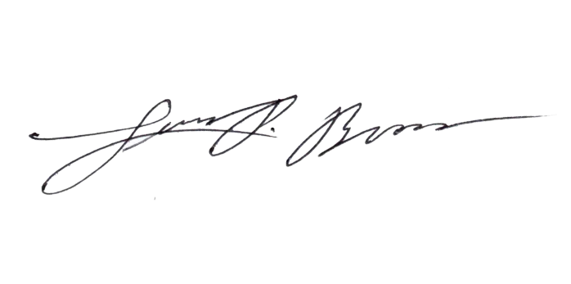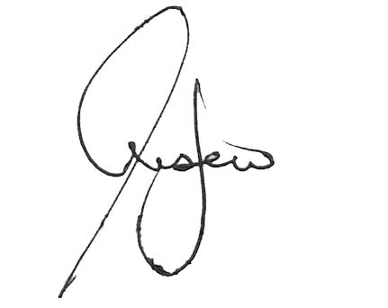

Prepared by:

**CHRISTIAN JAMES HISTORILLO**

Encoder

Noted by:

**LUIS P. BROAS, RN, RPh, MAN**

Nurse II/CESU Head

Approved by:

**JONATHAN P. LUSECO, MD**  
City Health Officer II

**33**

**ACTIVE CASES**

**ACTIVE CASES BREAKDOWN**

**LATE NA**

**KASO**

**7**

**MGA LATE REPORT NA GUMALING**

**0**

*Source: City Epidemiology and surveillance Unit, BHERT, DOH, UP-NIH, RITM, Ospital ng Imus and La Salle Lab results

**COVID-19 Hotline**

**0919-066 4324**

**0919-066 4325**

**DOH MEMORANDUM No 2020-00439 “Omnibus Interim Guidelines on Prevention, Detection, Isolation, Treatment and Reintegration Strategies for COVID-19”** issued last October 6, 2020

Under the general guideline section M#3

“Asymptomatic immunocompetent individuals who test PCR positive (+) and remained asymptomatic for at least 10 days from the date of specimen collection can discontinue isolation after 10 days and be tagged as a recovered confirmed case without need for further testing, provided a licensed medical doctor certifies or clears the patients”.

This is the New Format of Reporting as prescribed by DOH based on Administrative Circular Order No. 2020-0013

**KABUUANG BILANG NG KASO 21,931**

**ASYMPTOMATIC**

9 (27.3%)

**MILD**

24 (72.7%)

**MODERATE**

0 (0%)

**SEVERE**

0 (0%)

**CRITICAL**

0 (0%)

**STAY AT HOME, PRACTICE SOCIAL DISTANCING AND WASH YOUR HAND REGULARLY**

**SUSPECTED CASES**

* May lagnat, ubo o hirap sa paghinga at kabilang sa isa sa mga nasa ibaba:
* Edad 60 taon at pataas
* Mayroong iba pang sakit
* Mayroong maselan na pagbubuntis
* Health worker
* Mayroon kang influenza-like illness: lagnat (38C) at ubo/ pananakit ng lalamunan at kabilang sa isa sa mga nasa ibaba:
* Naglakbay o nanirahan sa isang lugar na may ulat ng local na transmisyon ng sakit na COVID-19 sa loob ng 14 na araw bago nagsimula ang mga sintomas.
* Nagkaroon ng close contact sa isang CONFIRMED o PROBABLE kaso ng COVID-19 sa loob ng 14 na araw bago nagsimula ang mga sintomas.
* Nagkaroon ng biglaang karamdaman sa baga na may malubhang sintomas na hindi matukoy ang kadahilanan at kinakaingang ma-ospital

**PROBABLE CASES**

* Ikaw ay SUSPECT patient at:
* Hindi tiyak ang resulta ng testing
* Ginawa ang iyong test sa hindi opisyal na laboratory na gumagawa ng RT-PCR test
* Hindi nagawa ang testing sa ano mang kadahilanan.

**CONFIRMED CASES**

* Ang iyong result sa RT-PCR testing ay POSITIBO sa COVID-19