|  |  |  |
| --- | --- | --- |
| **TOTAL CASES RECORDED** | | |
| **${tcases}** | | |
| **Completed**  ${tcasesc} | **Incomplete**  ${tcasesi} | **Died**  ${tcasesd} |

|  |  |  |  |  |  |  |
| --- | --- | --- | --- | --- | --- | --- |
| **Age Group** | **M** | **F** | **Category** | | **Age** | |
| <1 | ${ag1m} | ${ag1f} | Category 1 | ${ct1} | 15 y/o & below | ${age1} |
| 1 – 10 | ${ag2m} | ${ag2f} | Category 2 | ${ct2} | 15 y/o above | ${age2} |
| 11 – 20 | ${ag3m} | ${ag3f} | Category 3 | ${ct3} | **Biting Animal** | |
| 21 – 30 | ${ag4m} | ${ag4f} | **Total** | **${ctt}** | Pet Dog | ${pd} |
| 31 – 40 | ${ag5m} | ${ag5f} | **Bite Type** | | Stray Dog | ${sd} |
| 41 – 50 | ${ag6m} | ${ag6f} | Scratch | ${bs} | Pet Cat | ${pc} |
| 51 – 60 | ${ag7m} | ${ag7f} | Bite | ${bb} | Stray Cat | ${sc} |
| > 60 | ${ag8m} | ${ag8f} | **Total** | **${bt}** | Others | ${oth} |

|  |  |
| --- | --- |
| **Animal Vaccinated Status** | |
| Animal Vaccinated | ${avc} |
| Animal Not Vaccinated | ${anv} |

|  |  |  |  |
| --- | --- | --- | --- |
| **Barangay** | **M** | **F** | **Total** |
| ALINGARO | ${bgm1} | ${bgf1} | ${bgt1} |
| ARNALDO POB. (BGY. 7) | ${bgm2} | ${bgf2} | ${bgt2} |
| BACAO I | ${bgm3} | ${bgf3} | ${bgt3} |
| BACAO II | ${bgm4} | ${bgf4} | ${bgt4} |
| BAGUMBAYAN POB. (BGY. 5) | ${bgm5} | ${bgf5} | ${bgt5} |
| BICLATAN | ${bgm6} | ${bgf6} | ${bgt6} |
| BUENAVISTA I | ${bgm7} | ${bgf7} | ${bgt7} |
| BUENAVISTA II | ${bgm8} | ${bgf8} | ${bgt8} |
| BUENAVISTA III | ${bgm9} | ${bgf9} | ${bgt9} |
| CORREGIDOR POB. (BGY. 10) | ${bgm10} | ${bgf10} | ${bgt10} |
| DULONG BAYAN POB. (BGY. 3) | ${bgm11} | ${bgf11} | ${bgt11} |
| GOV FERRER POB. (BGY. 1) | ${bgm12} | ${bgf12} | ${bgt12} |
| JAVALERA | ${bgm13} | ${bgf13} | ${bgt13} |
| MANGGAHAN | ${bgm14} | ${bgf14} | ${bgt14} |
| NAVARRO | ${bgm15} | ${bgf15} | ${bgt15} |
| NINETY SIXTH POB. (BGY. 8) | ${bgm16} | ${bgf16} | ${bgt16} |
| PANUNGYANAN | ${bgm17} | ${bgf17} | ${bgt17} |
| PASONG CAMACHILE I | ${bgm18} | ${bgf18} | ${bgt18} |
| PASONG CAMACHILE II | ${bgm19} | ${bgf19} | ${bgt19} |
| PASONG KAWAYAN I | ${bgm20} | ${bgf20} | ${bgt20} |
| PASONG KAWAYAN II | ${bgm21} | ${bgf21} | ${bgt21} |
| PINAGTIPUNAN | ${bgm22} | ${bgf22} | ${bgt22} |
| PRINZA POB. (BGY. 9) | ${bgm23} | ${bgf23} | ${bgt23} |
| SAMPALUCAN POB. (BGY. 2) | ${bgm24} | ${bgf24} | ${bgt24} |
| SAN FRANCISCO | ${bgm25} | ${bgf25} | ${bgt25} |
| SAN GABRIEL POB. (BGY. 4) | ${bgm26} | ${bgf26} | ${bgt26} |
| SAN JUAN I | ${bgm27} | ${bgf27} | ${bgt27} |
| SAN JUAN II | ${bgm28} | ${bgf28} | ${bgt28} |
| SANTA CLARA | ${bgm29} | ${bgf29} | ${bgt29} |
| SANTIAGO | ${bgm30} | ${bgf30} | ${bgt30} |
| TAPIA | ${bgm31} | ${bgf31} | ${bgt31} |
| TEJERO | ${bgm32} | ${bgf32} | ${bgt32} |
| VIBORA POB. (BGY. 6) | ${bgm33} | ${bgf33} | ${bgt33} |
| **GRAND TOTAL** | **${bgmg}** | **${bgfg}** | **${bgtt}** |



Prepared by:

**JANZEN CARL D. QUION**  
Encoder

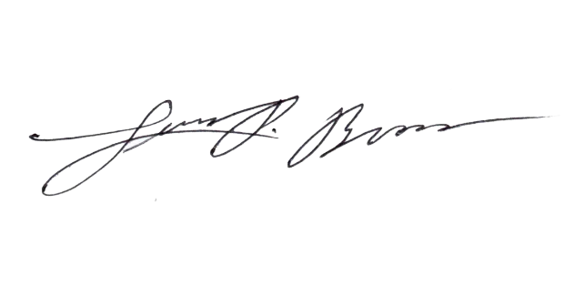

Approved by:  
  
  
**LUIS P. BROAS, RN, RPh, MAN**

Nurse II/CESU Head/ABTC Coordinator

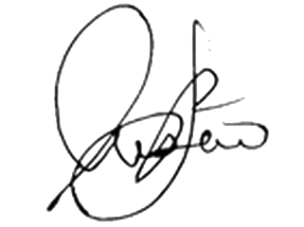

Noted by:  
  
  
**JONATHAN P. LUSECO, MD**  
City Health Officer II