**LETTER OF ACCEPTANCE**

TO WHOM IT MAY CONCERN:

This is to certify **${GCHECK}. ${PATIENT_NAME}** is a resident of **${PATIENT_ADDRESS}.** The City Government of General Trias, Cavite as their DOMICILE will be travelling from **${TRAVEL_TO}** due to PANDEMIC Corona Virus (COVID-19). Provided that he / she shall comply with the following:

1. Strict compliance to **Home Quarantine/Isolation Facility protocol for 21 days (if immunocompromised) or 14 days** **(if partial/unvaccinated) or 7 days (if fully vaccinated)** which means that he / she **shall not be allowed to go out of his house**.
2. He will be **checked daily** for any symptoms of disease by the BHERT or any representative of the City Health or Barangay officials
3. Compliance with the rules and regulations promulgated by the City Government.

This certificate is issued for record and reference purposes.

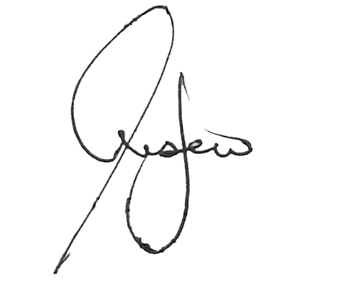Issued this ${CURR_DATE} at Office of the City Health Officer, City of General Trias, Cavite.

**JONATHAN P. LUSECO, MD**

City Health Officer II

City of General Trias