${clone_block}

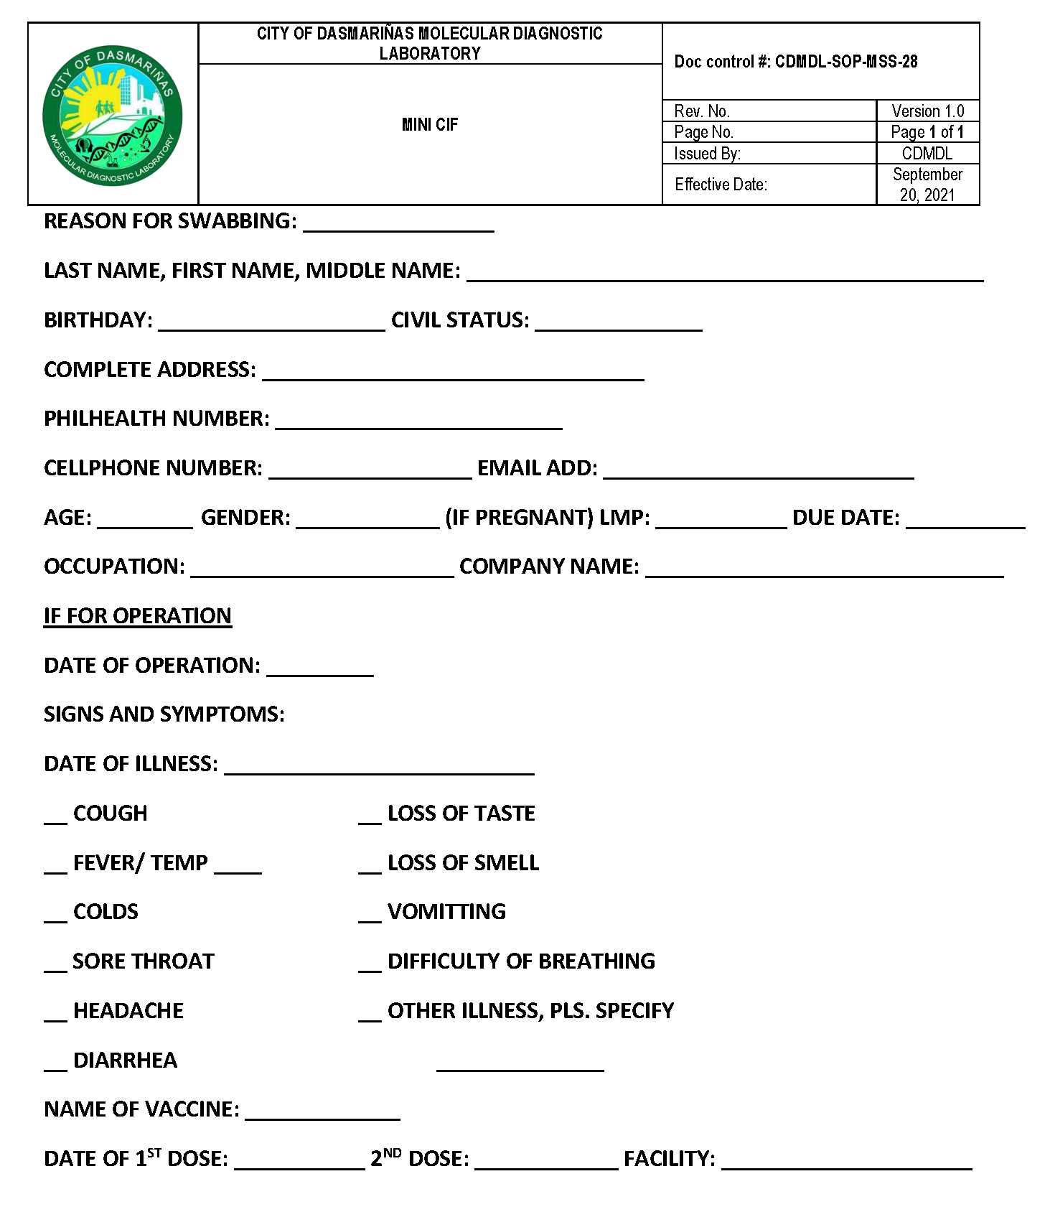

#55444

${reason}

GENERAL TRIAS, CAVITE

PFIZER BIONTECH



N/A

✔

✔

10/07/2021

09/09/2021

${onsetofillness}

${companyname}

${occupation}

${lmp}

${sex}

${age}

${email}

${cellphone}

${philhealth}

${complete_address}

${cs}

${name}

${/clone_block}

 

Annex “E”

Certificate of classification of Priority Groups and Actual Charges for SARS-Cov-2 Test and Instruction for the Facility

This certificate (original, photocopy or printed scanned copy) together with other supporting documents should be filed within sixty (60) calendar days from the date of specimen collection for all filed claims for SARS-CoV-2 testing package.

Date

To PhilHealth:

This is to certify that based on our records, ,

**${name}**

Patient’s last name, first name, name extension, middle name

who belongs to priority group ___ based on the current DOH applicable testing guidelines and protocol, was tested SARS-CoV-2 at  **CITY OF DASMARIÑAS MOLECULAR DIAGNOSTIC LABORATORY**

Name of PhilHealth accredited SARS-CoV-2 testing laboratory/HCP

on and incurred the following charges:

**${swabdate}**

Date/s of specimen collection (mm/dd/yyyy)

Place a (✓) in the appropriate tick box

* No charge to patient
* If with actual charges, indicate the following:

|  |  |
| --- | --- |
| Item | Amount (Php) |
| Total actual charges |  |
| Amount after application of discounts/deductions (senior citizen persons with disability, guarantee letter, etc.) |  |
| PhilHealth benefit package amount |  |

Official receipt no./s _ _

**DAYLE DANIEL G. SORVETO, RMT**

Signature over printed name of the authorized testing laboratory/HCP representative

**CHIEF MEDICAL TECHNOLOGIST**

Designation of the authorized testing laboratory/HCP representative Date signed Conforme:

${printedname}

Signature over printed name of the member/patient/ authorized representative Date signed

|  |  |
| --- | --- |
| Relationship of the representative to member/patient | * Spouse ☐ Child ☐ Others, * Siblings ☐ Parent, specify |
| Reason for signing on behalf of the member/patient | * Patient is incapacitated * Other reasons: |

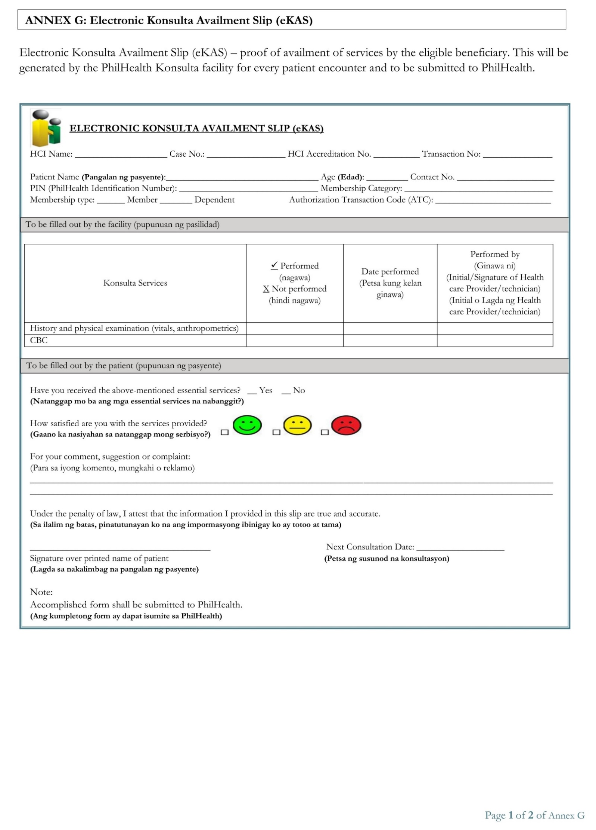

✔

✔

**BERTIS, PATRICIA MAY CADSAWAN**

✔

✔

✔

**BERTIS, PATRICIA MAY CADSAWAN**

08-025918936-9

09695239653

37

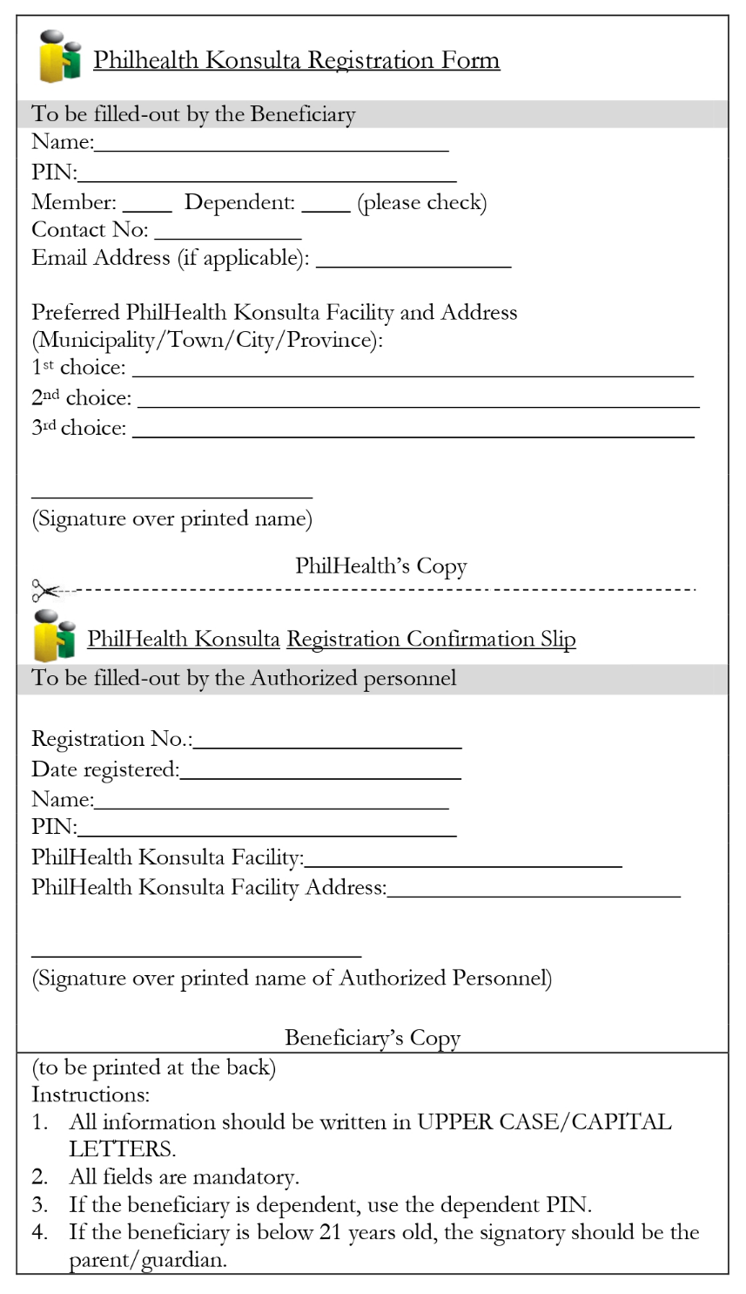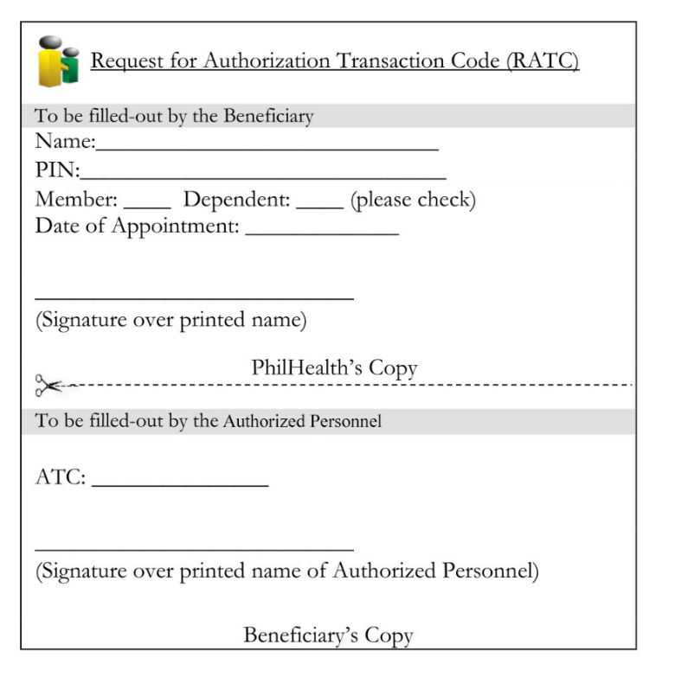

✔

✔

✔

**BERTIS, PATRICIA MAY CADSAWAN**

BERTIS, PATRICIA MAY CADSAWAN

BERTIS, PATRICIA MAY CADSAWAN

BERTIS, PATRICIA MAY CADSAWAN

✔

✔

✔

✔

✔

09695239653

08-025918936-9

CITY HEALTH OFFICE, CITY OF GENERAL TRIAS, CAVITE

VON CARLOS V. IBAÑEZ

09/04/2023

08-025918936-9

✔

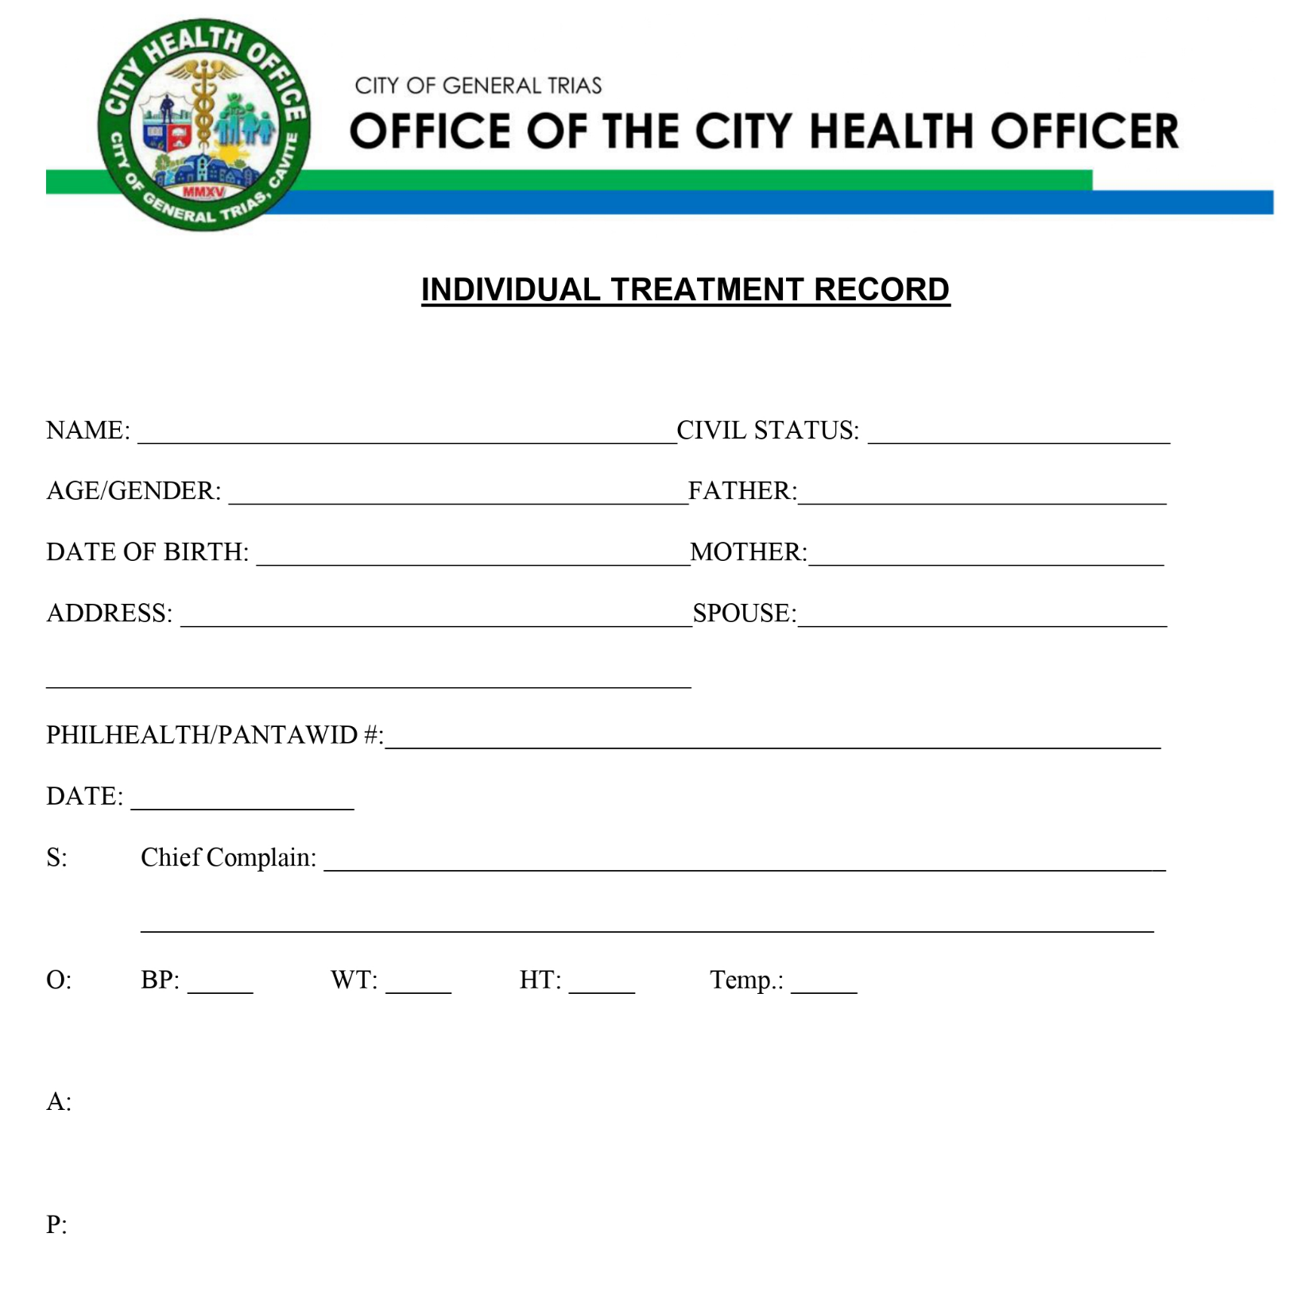

BRGY. MANGGAHAN, GENERAL TRIAS, CAVITE

123, STATELAND VIEW

08-025918936-9

09/04/2023

37 / FEMALE

11/10/1985

MARRIED

**BERTIS, PATRICIA MAY CADSAWAN**