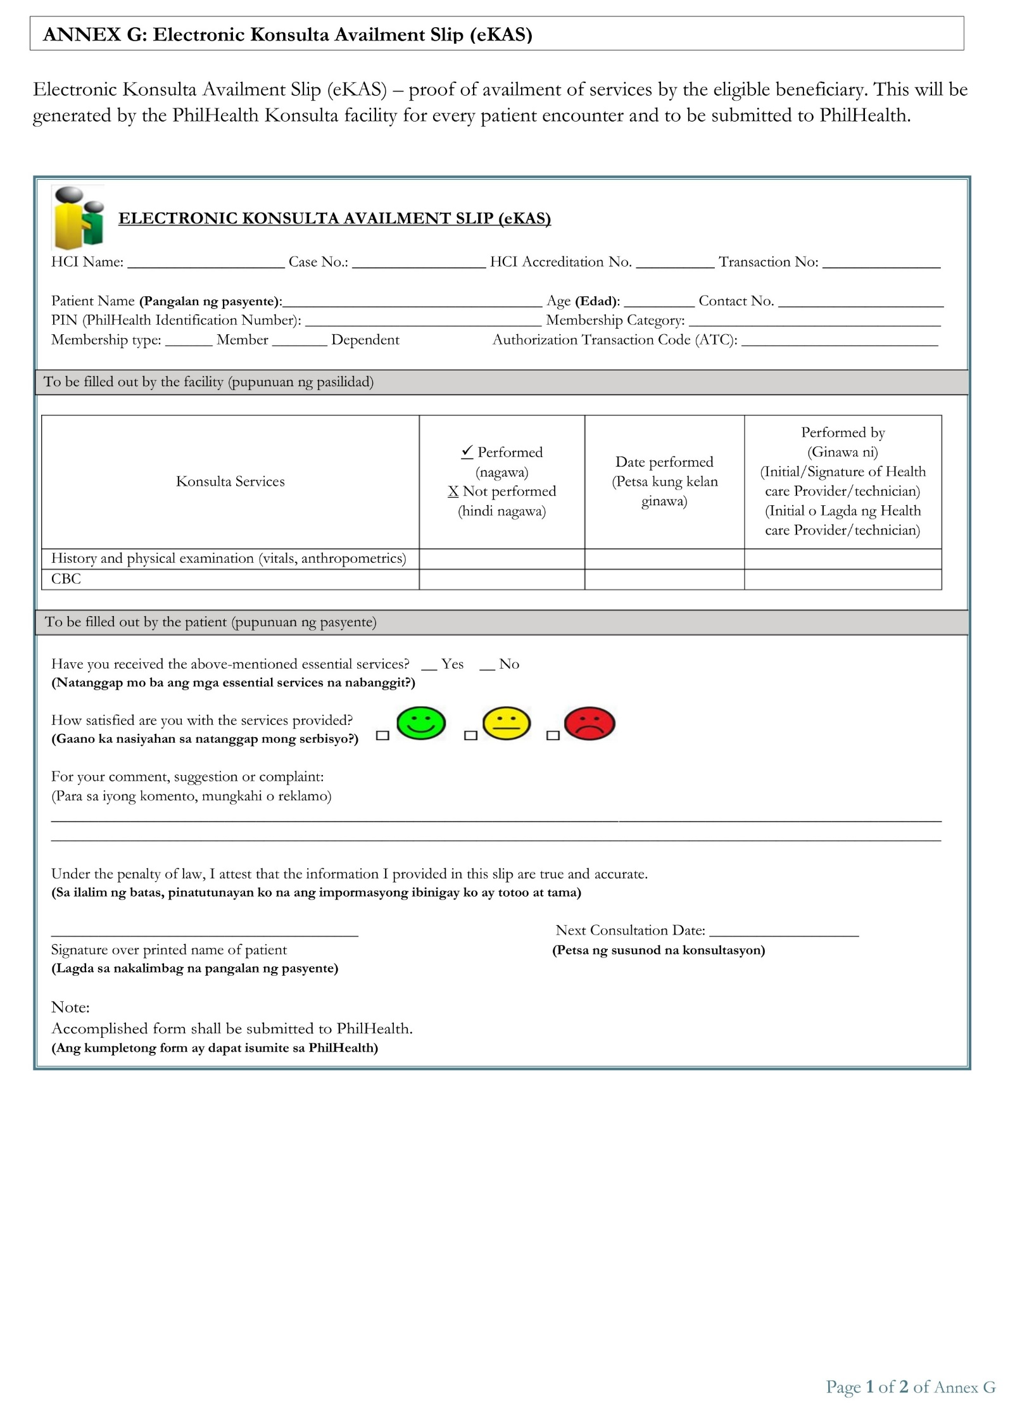

${p_age}

${p_name}

**✔**

**CHO GENERAL TRIAS**

${p_contact}

**✔**

${s_name}

${isd}

${ism}

${p_philhealth}

**P41034597**

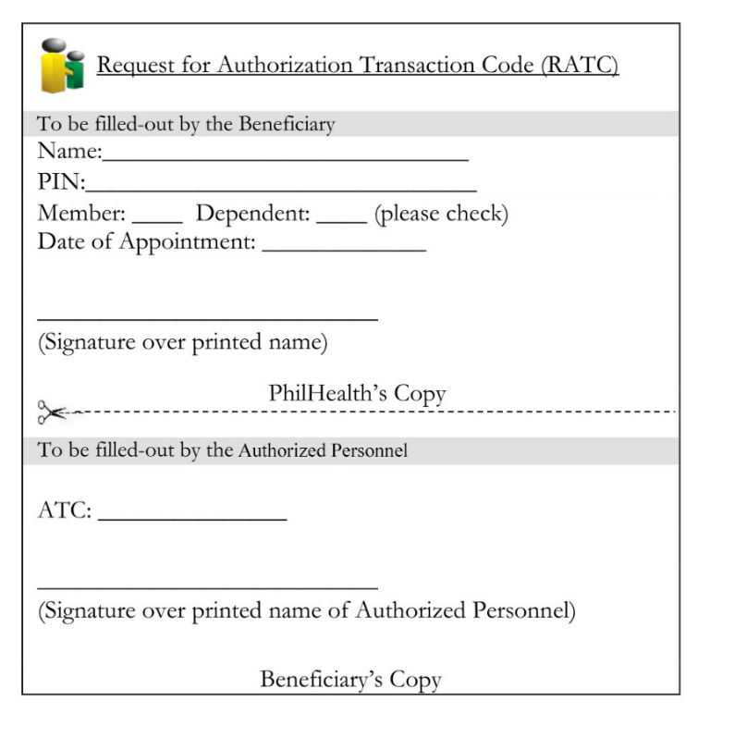

DOB: ${dob} ${dob_parent}

${s_name}

${case_date}

**✔**

${isd}

${ism}

${p_philhealth}

${p_name}

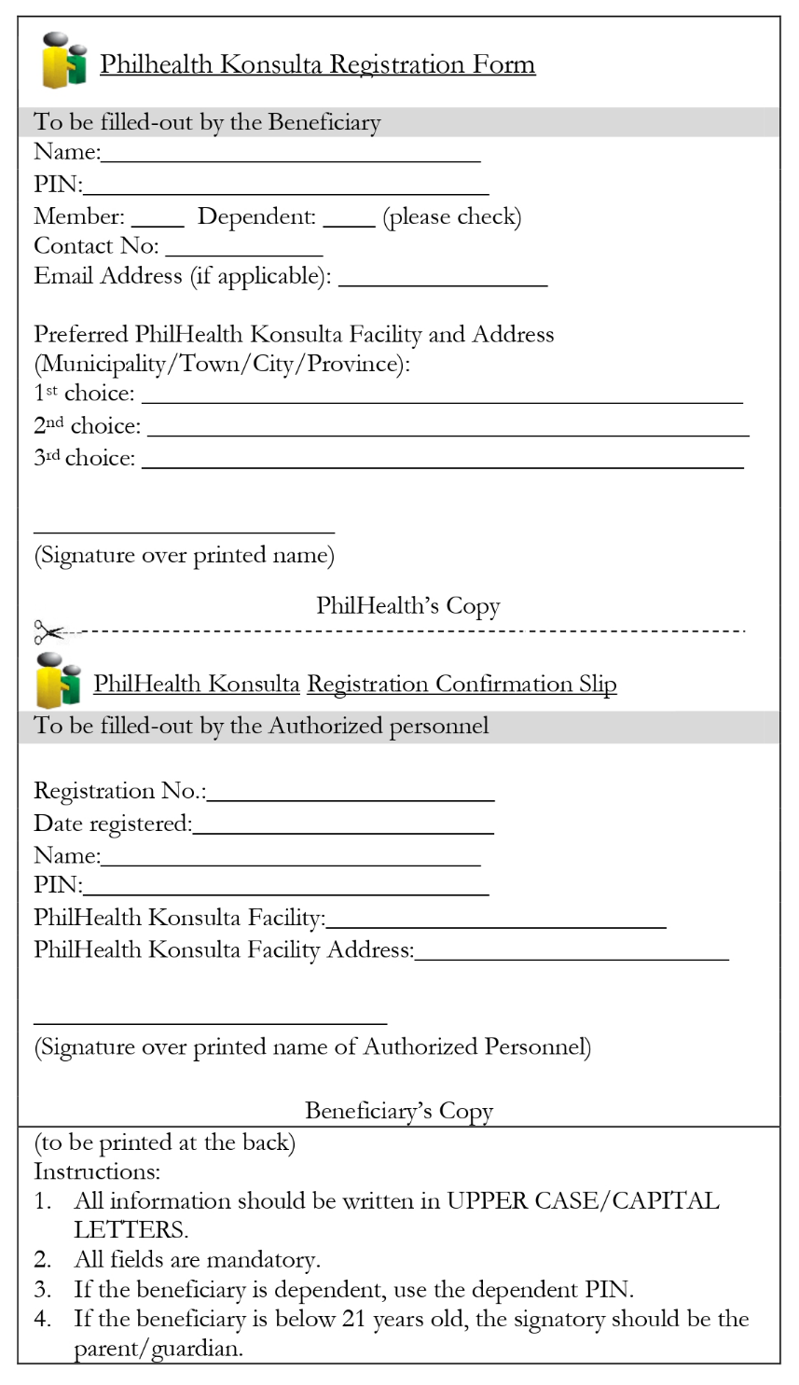Annex C

${s_name}

CITY HEALTH OFFICE – GENERAL TRIAS

${p_philhealth}

${p_name}

${p_contact}

${isd}

${ism}

**✔**