Daniel Preller

Assignment 7.2

8 June 2025

Original program:

City and country test:

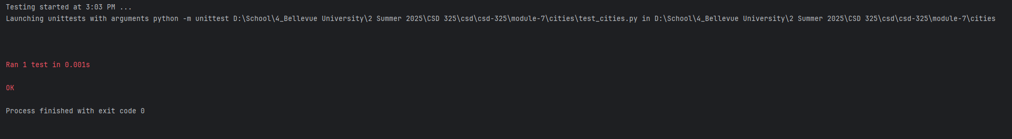

Failed population parameter:

Successful population parameter:

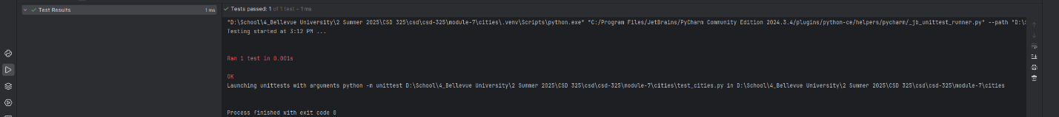

Failed language parameter:

Successful language parameter:



Final Output:

