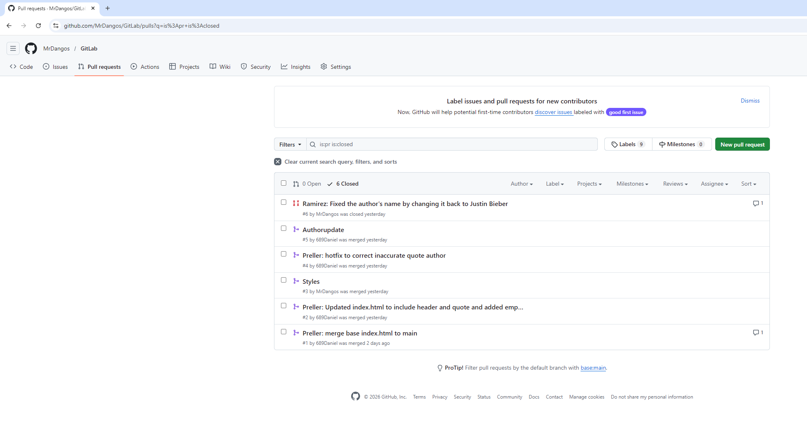
Daniel Preller
https://github.com/MrDangos/GitLab
GitHub username: 689Daniel
20 February 2026
Assignment 10.2

