Project: Module 4.2 Assignment – Test Plan
Course: CSD380 DevOps
Description: For this assignment, you will be drafting a test plan based on the business requirements presented in the “Todo Business Requirements” document (linked below). The test plan must include at least 5 functional tests and those tests must encompass the requirements in the document.
Date: 2026/01/11
To complete the test case plan, fill out the information for Project, Course, Description and Date in the header below.
.
TABLE OF CONTENTS
Access Website Using Standard URL 3
View List of ToDo Items 4
Create a New Todo Item 6
Prevent Empty Todo Submission 7
Delete a Todo Item 9

For each test, the developer should: provide a test description, a test objective, the developer name and date tested. For each step, fill out the actions to be taken and describe the expected results, and indicate yes or no for each step depending upon the result. The peer tester should provide their name, date tested, indicate yes or no for each step depending upon the result, and a screenshot (thumbnail) of the result.

Test 1 | Access Website Using Standard URL
 | Test Objective: Allow users to visit the website through https://buwebdev.github.io/todo/ | Developer:  Date tested: Jackson<2026/01/11> | Peer tester: Daniel Preller  Date tested: 2026/01/15
Step | Action | Expected results: | Developer pass/fail | Tester pass/fail  + Screenshot
1 | Open a web browser | Browser open | yes | Yes
2 | Go to https://buwebdev.github.io/todo/ | Link works | yes | Yes  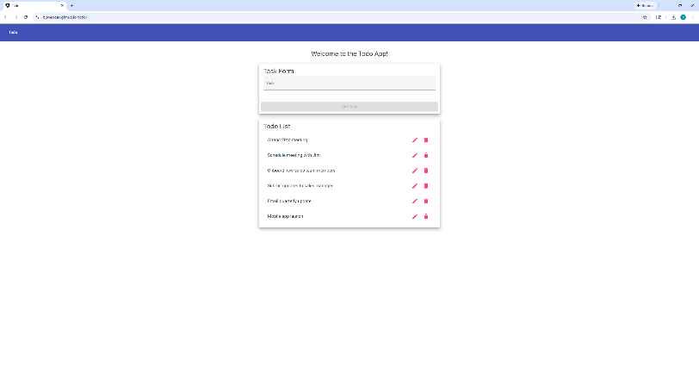
3 | Confirm pages load | Page loads correctly | yes | Yes
4 | Refresh the window | Page continues to work | yes | Yes  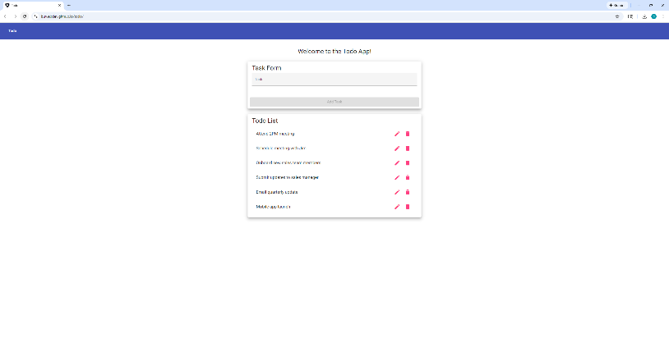
Comments | The page loads as expected. However, there is a lot of empty space when displaying the page on large monitors. Increasing the maximum width of the todo list and task form could help resolve this.

Test 2 | View List of ToDo Items
 | Test Objective: View a list of todo tasks | Developer:  Date tested: Jackson <2026/01/11> | Peer tester: Daniel Preller  Date tested: 2026/01/15
Step | Action | Expected results: | Developer pass/fail | Tester pass/fail
1 | Load the Todo homepage | Homepage loads and displays | yes | Yes  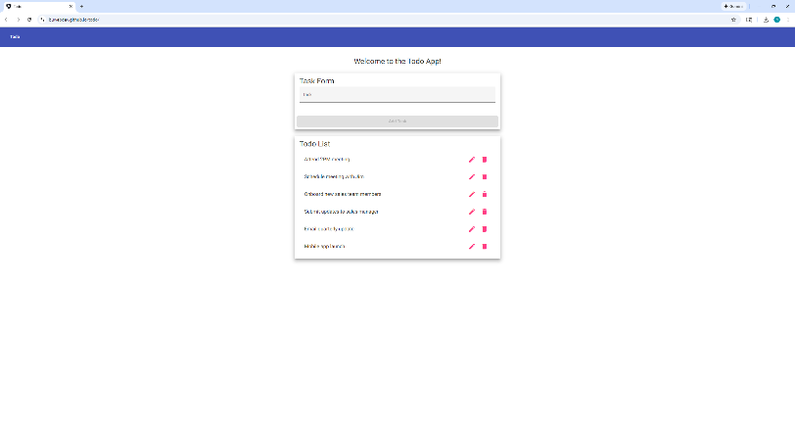
2 | Observe the todo list | List is visible and easy to access | yes | Yes
Comments | The list is visible and easy to access. However, having the list default to real-life examples may be confusing or counterintuitive for some users. Having default tasks as something like “<new tasks will appear here>” may be a viable alternative.

Test 3 | Create a New Todo Item
 | Test Objective: | Developer:  Date tested: Jackson <2026/01/11> | Peer tester: Daniel Preller  Date tested: 2026/01/15
Step | Action | Expected results: | Developer pass/fail | Tester pass/fail
1 | Click inside the Todo input field | Allows for typing | yes | Yes  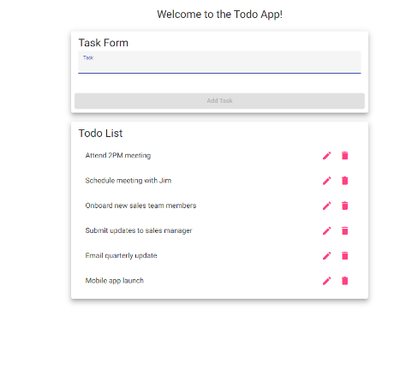
2 | Enter a task | Text is taken | yes | Yes  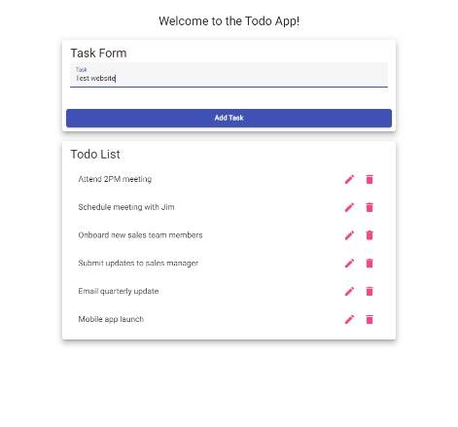
3 | Press Add Task | New item is created | yes | Yes  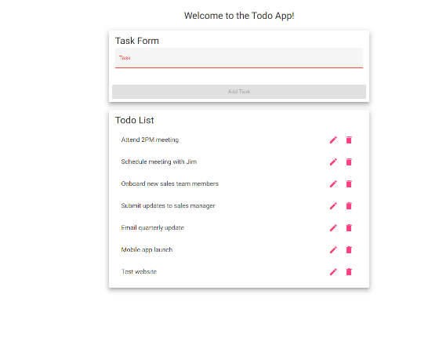
Comments | New task is created successfully. However, after entering a new task, the task form turns red, indicating an input error. It may be better to have it revert to the default gray instead of the error red.

Test 4 | Prevent Empty Todo Submission
 | Test Objective: Prevent users from submitting a task form without entering a todo item | Developer:  Date tested: Jackson <2026/01/11> | Peer tester: Daniel Preller  Date tested: 2026/01/15
Step | Action | Expected results: | Developer pass/fail | Tester pass/fail
1 | Click inside the Todo input field | Allows for typing | yes | Yes  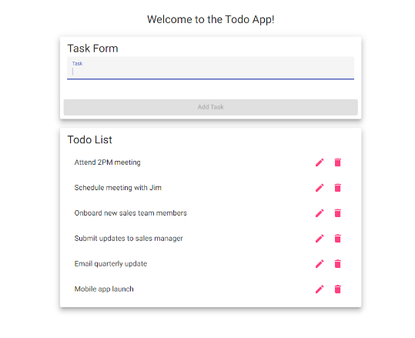
2 | Leave the input field empty | Input field empty | yes | Yes
3 | Try to Add Task | Doesn’t let you press the button | yes | Yes  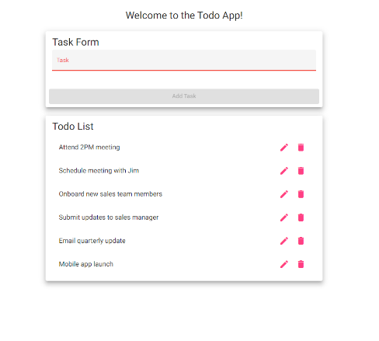
Comments | The form correctly prevents blank tasks from being added. Tasks of three or fewer characters are also prevented from being entered. This limit prevents most users from adding tasks accidentally, but it could inhibit users using shorthand task names.

Test 5 | Delete a Todo Item
 | Test Objective: Delete todo task item | Developer:  Date tested: Jackson <2026/01/11> | Peer tester: Daniel Preller  Date tested: 2026/01/15
Step | Action | Expected results: | Developer pass/fail | Tester pass/fail
1 | Locate an existing Todo item | Find items on list | yes | Yes  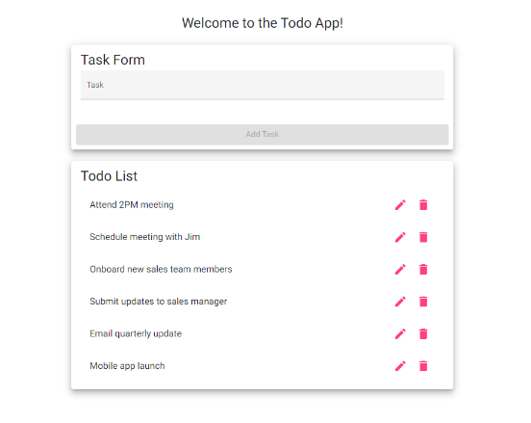
2 | Click the delete (X) button | Todo item is deleted | yes | Yes  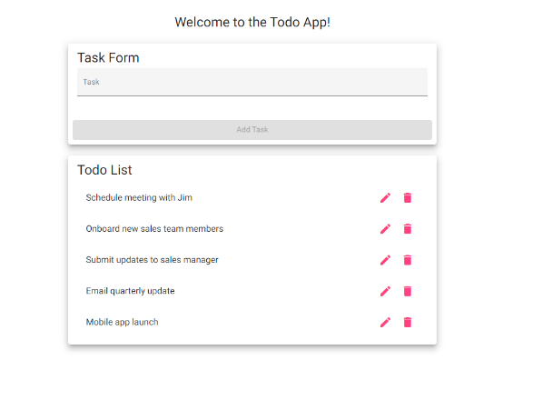
Comments | Task is correctly deleted. For users not familiar with the common meanings of icons (such as a trashcan meaning delete), a tooltip could possibly be added on hover to clarify the button’s function.

