Daniel Preller
10 June 2026
Assignment 1

Java/Eclipse screenshot:
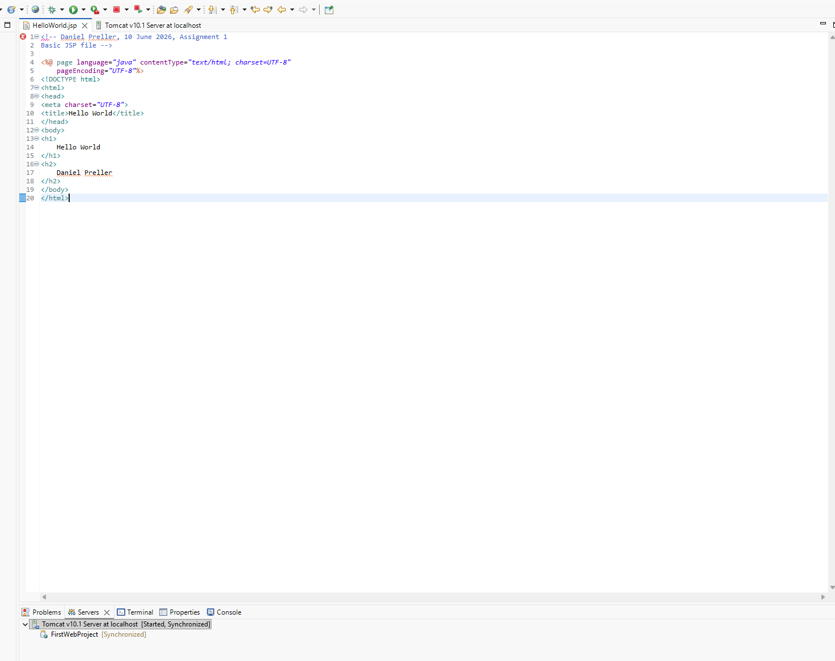
Tomcat/JSP File screenshot:
