Visualizations

* + - Analysis On Overall Sustainability On No Poverty(goal 1)

<https://us1.ca.analytics.ibm.com/bi/?perspective=explore&pathRef=.my_folders%2Fsustainability%2Bproject%2Fvisualization%2Bon%2Boverall%2Bgoal%2Bon%2Bno%2Bpoverty&subView=model0000018c8b943fa8_00000000>

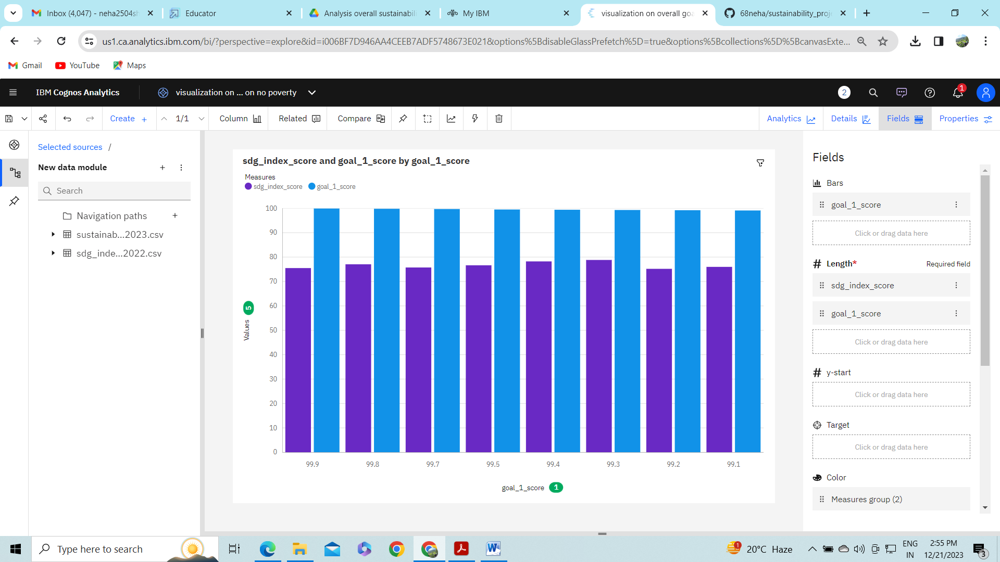

* + - Analysis Overall Sustainability On Quality Education(goal 4)

<https://us1.ca.analytics.ibm.com/bi/?perspective=explore&pathRef=.my_folders%2Fsustainability%2Bproject%2Fvisualization%2Bon%2Boverall%2Bgoal%2Bon%2Bno%2Bpoverty&subView=model0000018c8bb2c987_00000000>

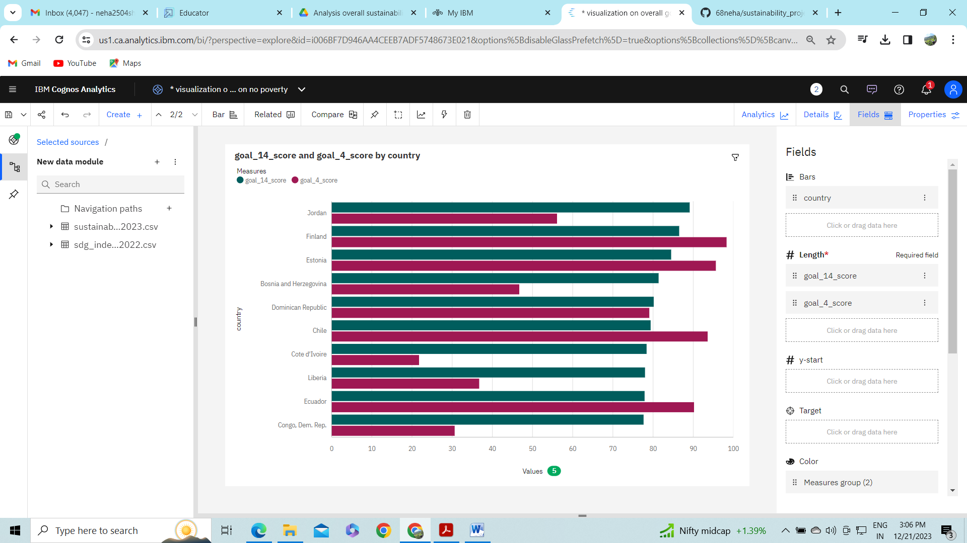

* + - Analysis On Overall Sustainability Life Below Water(goal 14)
    - <https://us1.ca.analytics.ibm.com/bi/?perspective=explore&pathRef=.my_folders%2Fsustainability%2Bproject%2Fvisualization%2Bon%2Boverall%2Bgoal%2Bon%2Bno%2Bpoverty&subView=model0000018c8bbd48cb_00000000>

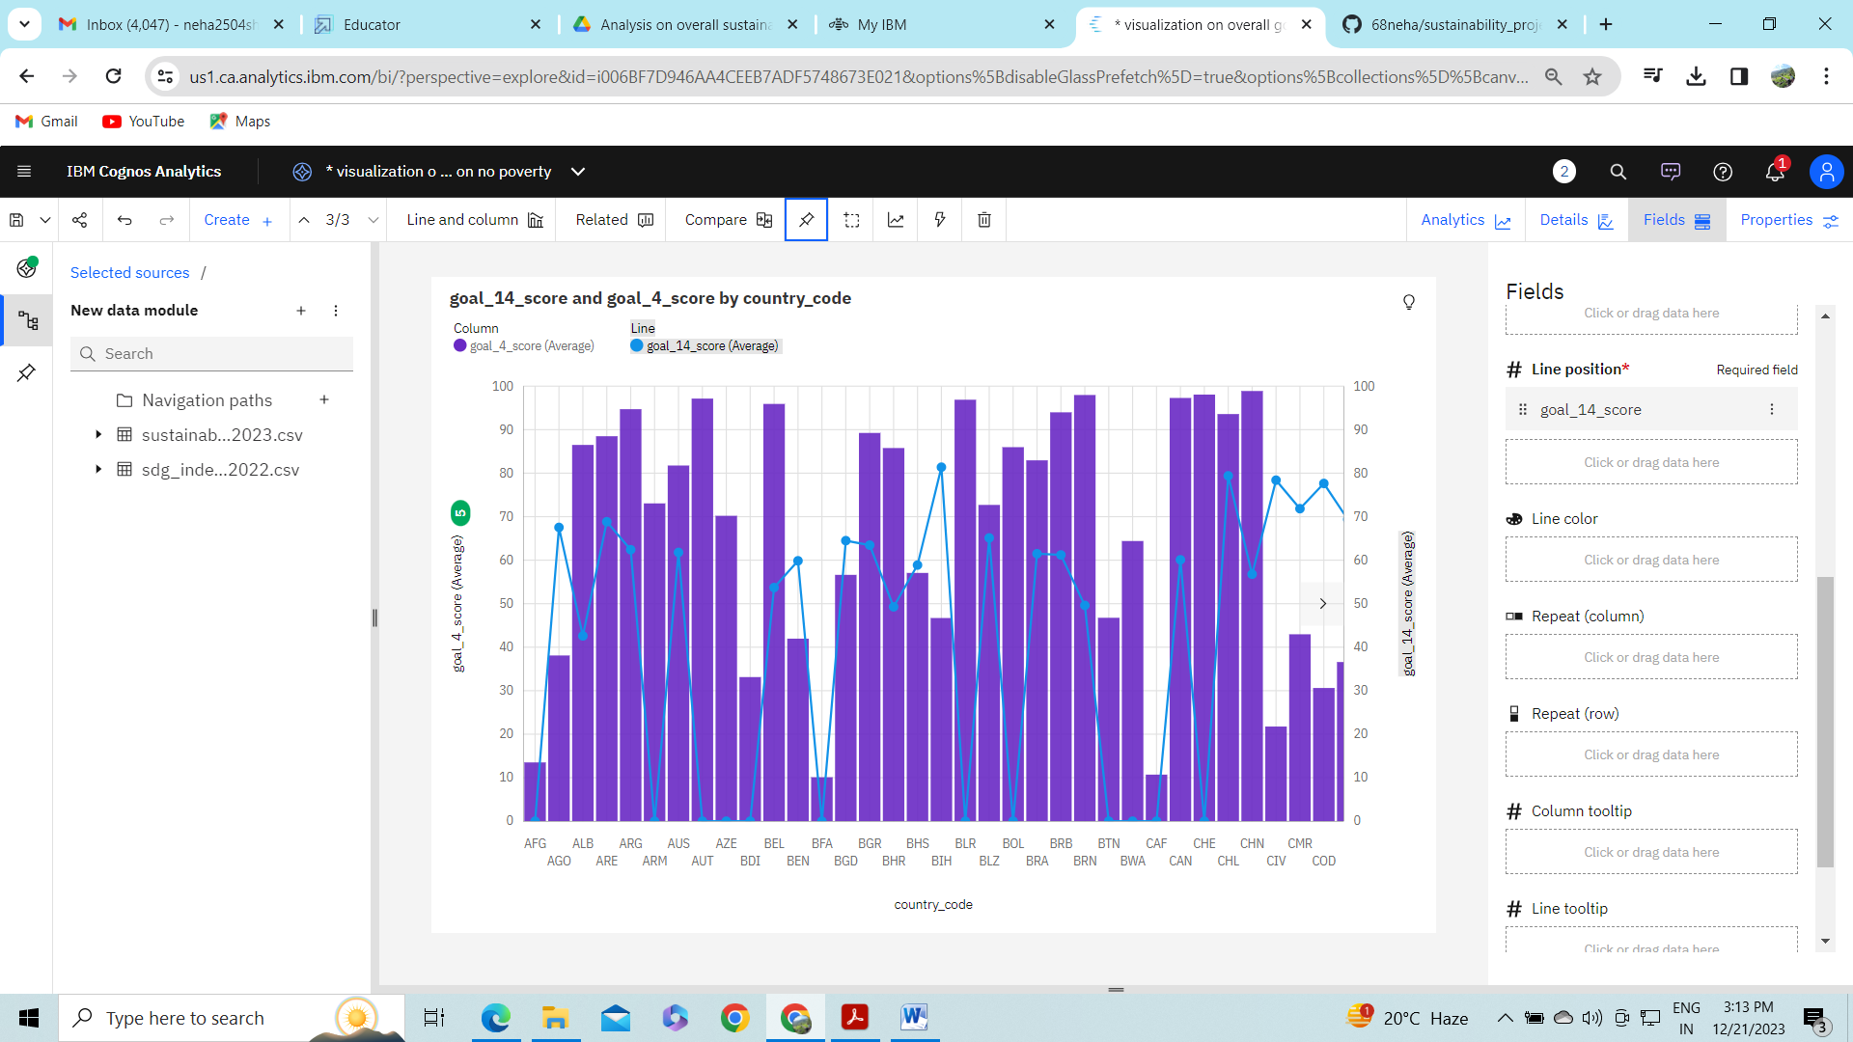

* + - Analysis On Overall Sustainability Partnerships For The Goals(goal 17)
    - <https://us1.ca.analytics.ibm.com/bi/?perspective=explore&pathRef=.my_folders%2Fsustainability%2Bproject%2Fvisualization%2Bon%2Boverall%2Bgoal%2Bon%2Bno%2Bpoverty&subView=model0000018c8bc4462f_00000000>
    - 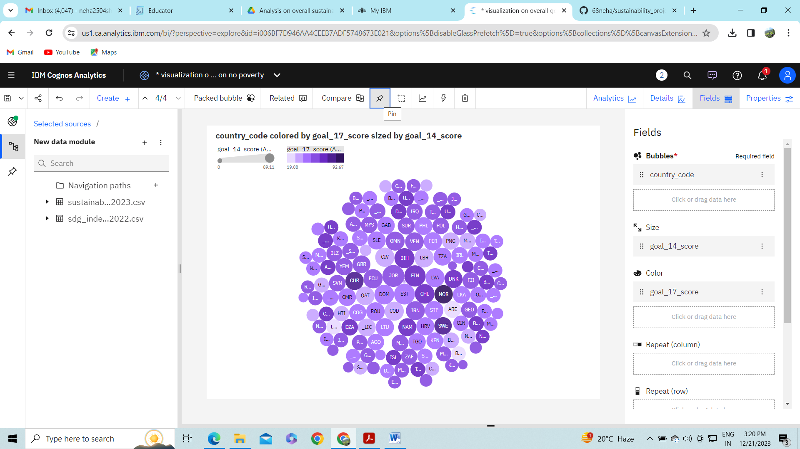
    - Analysis On Overall Sustainability Reduced Inequalities(goal 10)

<https://us1.ca.analytics.ibm.com/bi/?perspective=explore&pathRef=.my_folders%2Fsustainability%2Bproject%2Fvisualization%2Bon%2Boverall%2Bgoal%2Bon%2Bno%2Bpoverty&subView=model0000018c8bcae3da_00000003>

* + - 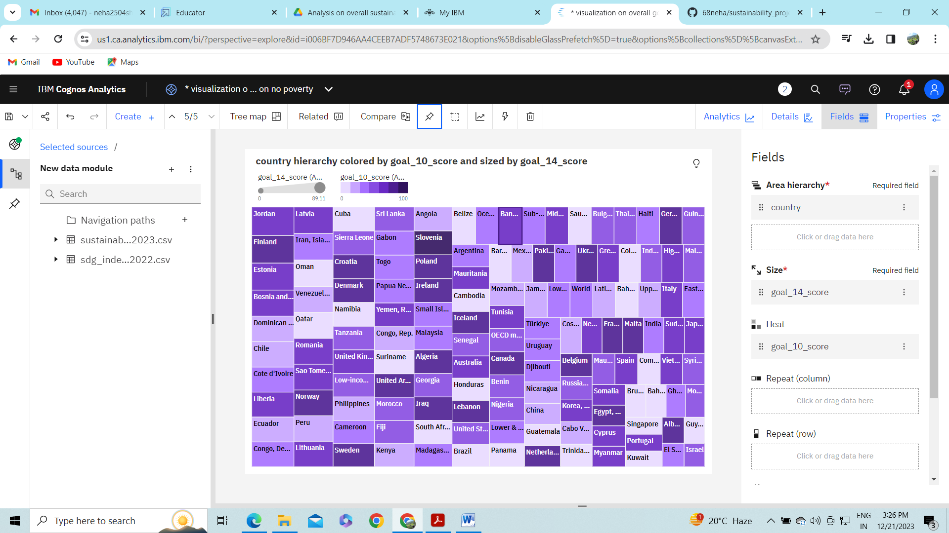
    - Analysis On Overall Sustainability Industry, Innovation And Infrastructure(goal_9)

<https://us1.ca.analytics.ibm.com/bi/?perspective=explore&pathRef=.my_folders%2Fsustainability%2Bproject%2Fvisualization%2Bon%2Boverall%2Bgoal%2Bon%2Bno%2Bpoverty&subView=model0000018c8bd00bea_00000003>

* + 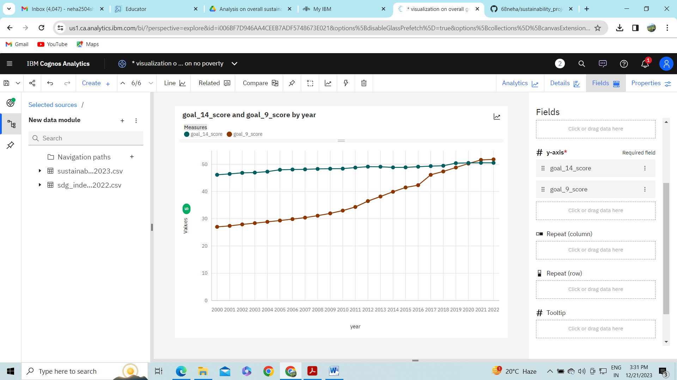
    - Analysis On Overall Sustainability Life On Land(goal_15)
  + <https://us1.ca.analytics.ibm.com/bi/?perspective=explore&pathRef=.my_folders%2Fsustainability%2Bproject%2Fvisualization%2Bon%2Boverall%2Bgoal%2Bon%2Bno%2Bpoverty&subView=model0000018c8bd3baca_00000004>
  + 