EBU6304 Software Engineering Group Project
2025–26
Group number | TBC
member 1 | QM no: 231225959 | Name: Dongting Ge
member 2 | QM no: 231225926 | Name: Jie Gao
member 3 | QM no: 231225753 | Name: Yihang Dong
member 4 | QM no: 231225948 | Name: Yibo Wang
member 5 | QM no: 231225845 | Name: Kerui Wang
member 6 | QM no: 231225937 | Name: Yanzhou Wang

First report

1. Requirements

1.1 Project context and scope definition
The project brief defines a Teaching Assistant recruitment system for three core actors: TA applicant, Module Organiser (MO) and administrator. Our first task was to convert these abstract roles into a realistic end-to-end workflow while respecting the non-negotiable coursework constraints: the software must be a stand-alone Java application or a lightweight Servlet/JSP system; data must be stored in simple text formats rather than a database; and the final product should demonstrate selected core functions through incremental Agile delivery.
Based on the uploaded handout, user-story draft, product backlog and low-fidelity prototype, we defined the minimum viable recruitment loop as: (1) a TA builds a structured profile and uploads a CV, (2) the TA browses vacancies and submits an application, (3) the MO publishes jobs, reviews applicants and updates status, and (4) the administrator monitors recruitment progress and manages exported data/logs. Advanced filtering, abnormal-account handling and AI matching were deliberately deferred because they improve efficiency but do not create the first demonstrable business value.
Actor | Main need addressed | Representative backlog/prototype evidence
TA applicant | Manage profile data once, upload CV, apply efficiently and track feedback. | TA001–TA005; prototype pages 2–5.
MO | Publish positions, review applicants and update decisions in one place. | MO001–MO003; prototype pages 8–11.
Admin | See recruitment status globally, export records and follow up unfilled vacancies. | AD002–AD004; prototype pages 6–8.

1.2 Fact-finding techniques used
Technique | How it was applied | Why it was suitable | Main outputs
Document analysis | Read the handout and report template first to extract actors, staged deliverables, technical constraints and marking expectations. | The brief is intentionally high-level, so constraint analysis was the fastest way to avoid building the wrong scope. | Role list, mandatory tech restrictions, report structure and initial scope boundary.
Role-based story writing | Used the TA story draft and backlog spreadsheet to convert needs into testable user stories with acceptance criteria. | User stories suit Agile planning because they keep attention on user value rather than screens alone. | 18 backlog items across TA, MO and Admin roles, all ready for prioritisation.
Low-fidelity prototyping | Reviewed the 11-page prototype to validate navigation, screen grouping and data hand-offs before coding. | A sketch prototype is quick to change and ideal for clarifying workflow uncertainty early. | Role-separated screen flow covering entry, dashboard, job posting, application and review.
Asynchronous discussion review | Used the chat record as evidence of ongoing discussion, file sharing and revision alignment inside the team. | This provided lightweight continuous feedback between workshop sessions and kept decisions traceable. | Clarified screen changes, deliverable preparation and follow-up revisions.
These techniques were intentionally lightweight. At this stage the biggest risk was misunderstanding the workflow, not implementing sophisticated algorithms. Therefore the team preferred fast feedback loops: derive stories, sketch screens, review them, then refine acceptance criteria and sprint scope. This matches Agile principles of incremental discovery and continuous revision.

1.3 Consolidated requirements and scope decisions
In-scope core slice: structured applicant profile, CV upload, vacancy browsing/application, MO job publishing and applicant review, plus basic admin visibility/export functions. This is the smallest slice that still demonstrates the system’s primary value.

The functional requirements are role-specific but tightly connected. TA-side stories capture applicant data and application progress; MO-side stories create vacancies and update decisions; Admin-side stories provide oversight and simple operational control. Every core story in the backlog already carries acceptance criteria, which means the requirements are not just descriptive but directly testable.
The non-functional and project constraints are equally important to scope. The brief explicitly forbids database use, so persistence assumptions were kept file-based (CSV/JSON/TXT/XML). We also treated explainability as a requirement: AI-supported matching was not placed in the first core increment because it depends on high-quality structured applicant data and would need transparent reasoning rather than black-box output.

1.4 Iteration plan
The backlog is treated as a living planning artefact. After consolidating the stage-one evidence, we grouped stories into four delivery-oriented sprints aligned with the teaching schedule and assessment checkpoints.
Sprint | Focus | Candidate stories | Expected outcome
Sprint 1  (Weeks 3–4) | Validate the core recruitment path and confirm file-based data structures. | TA001–TA004, MO001–MO003, AD002. | Backlog + prototype validated; first runnable workflow skeleton and persistence design.
Sprint 2  (Weeks 5–6) | Add control, feedback and policy-related functions around the core path. | TA005–TA006, MO004, AD001, AD003. | Improved notifications, editable vacancies, workload/policy support and version 2 demo.
Sprint 3  (Weeks 7–8) | Improve efficiency, auditability and search convenience. | TA007–TA009, AD004–AD005. | Filtering, logs, abnormal-account handling and usability improvements.
Sprint 4  (Weeks 9–12) | Hardening, testing, documentation and final packaging. | Integration, regression tests, user manual, demo preparation. | Release-ready submission package and final acceptance testing support.
A story is considered done only when its acceptance criteria are checked, the relevant local text files can be created/read correctly, and the code/UI changes are merged through the team workflow. This keeps iteration planning tied to demonstrable evidence rather than only design intention.

1.5 Prioritisation method
We used MoSCoW prioritisation and then checked each story against dependency, user value and technical risk. A story could only be labelled Must have if removing it would break the end-to-end recruitment loop or materially weaken the first demonstration. This produced a backlog of 10 Must-have, 4 Should-have and 4 Could-have stories (45 story points in total).
Priority | Decision rule | Examples from backlog
Must have | Required for a meaningful demo of the recruitment workflow or compliance-critical visibility. | TA001–TA005, MO001–MO003, AD001–AD002.
Should have | Important improvements, but a manual workaround still exists in the short term. | TA006, MO004, AD003, AD004.
Could have | Useful efficiency or hardening features that can be deferred without breaking the core loop. | TA007–TA009, AD005; AI matching deferred to later work.

1.6 Estimation method
We estimated work using story points (1, 2, 3, 5) rather than hours. The team compared stories against each other and considered five factors: screen breadth, validation complexity, local file I/O, cross-role dependency, and uncertainty. This keeps estimates relative and stable even when implementation details evolve.
Scale | Typical effort | Example stories | Why that estimate is reasonable
1 pt | Very small | AD003 export filter option | Limited logic on top of existing data structures, low uncertainty.
2 pts | Small feature | TA005 application statement; MO003 status marking | Single workflow extension with clear acceptance rules and modest dependencies.
3 pts | Medium feature | TA002 CV upload; TA003 job overview; MO001 publish jobs | Multi-field interface behaviour plus file validation or structured write/read operations.
5 pts | Large / uncertain | TA001 comprehensive profile | Broad data model, repeated fields, stronger validation and more persistence logic.
Overall, the stage-one outputs translate the brief into a traceable, realistic and role-balanced plan. The report, backlog and prototype now support the next Agile step: implementing the core recruitment loop incrementally while keeping scope controlled and evidence visible.

2. Supporting material
No formal external interview or survey file was provided in the uploaded materials. Therefore the evidence section below focuses on the artefacts that actually exist: the coursework brief, the report template, the TA story draft, the backlog spreadsheet, the prototype PDF, the group discussion screenshot and the README. This keeps the appendix truthful, traceable and directly auditable.

Appendix A. Requirement source matrix
ID | Source artefact | What it contributed | Used in this report for
S1 | EBU6304 Group Project Handout (pp. 2–8). | Actors, mandatory technical restrictions, staged assessments, Agile expectations and AI caution. | Scope definition, constraints, sprint plan and prioritisation rationale.
S2 | First Brief Report Template. | Required report structure: fact-finding, iteration plan, prioritisation, estimation and supporting material. | Section headings and evidence organisation.
S3 | userstory_of_TA.docx. | Expanded TA-side needs such as profile, CV, browsing, application and status tracking. | TA functional requirements and backlog wording.
S4 | Product backlog spreadsheet. | Story IDs, priorities, acceptance criteria, story points and planned work items. | Backlog statistics, MoSCoW summary and estimation examples.
S5 | Low-fidelity prototype PDF (11 pages). | Role-separated screen flow for TA, MO and Admin. | Workflow validation and prototype evidence pages.
S6 | Group discussion screenshot. | Asynchronous requirement review, file sharing and progress confirmation. | Evidence of iterative discussion and internal feedback loops.
S7 | README.md. | QM IDs and GitHub usernames visible in the current project files. | Cover-sheet placeholders and repository evidence.

Appendix B. Backlog overview and traceability
The current backlog contains 18 stories worth 45 story points. The distribution shows that the TA journey carries the greatest modelling effort, which is appropriate because it feeds every later MO/Admin workflow.
View | Category | Stories | Story points | Interpretation
By role | TA | 9 | 24 | Applicant data capture and application progress dominate the value stream.
By role | MO | 4 | 10 | Enough scope to publish jobs and close the review loop.
By role | AD | 5 | 11 | Governance and visibility remain intentionally lightweight in the first phase.

Priority | Stories | Story points | Interpretation
Must have | 10 | 29 | Most points sit in the core slice so the end-to-end workflow can be demonstrated early.
Should have | 4 | 8 | Important quality-of-use improvements planned after the minimal loop exists.
Could have | 4 | 8 | Convenience and hardening functions reserved for later capacity.

Requirement theme | Evidence source(s) | Backlog stories | Prototype evidence
Role-based entry and routing | S1, S5 | TA / MO / AD role separation | Prototype page 1
TA profile and CV submission | S3, S4, S5 | TA001–TA002 | Prototype pages 3–4
Browse/apply for vacancies | S1, S3, S4, S5 | TA003, TA005 | Prototype pages 2–3
Status tracking and notifications | S3, S4, S5 | TA004, TA006, MO003 | Prototype pages 4–5 and 11
MO job publication and review | S1, S4, S5 | MO001–MO003 | Prototype pages 9–10
Admin visibility/export/logging | S1, S4, S5 | AD002–AD004 | Prototype pages 6–8

Appendix C. Prototype evidence
The prototype screens below were used as working evidence during requirement refinement. They show that the team moved from abstract user stories to concrete, role-specific flows before implementation.
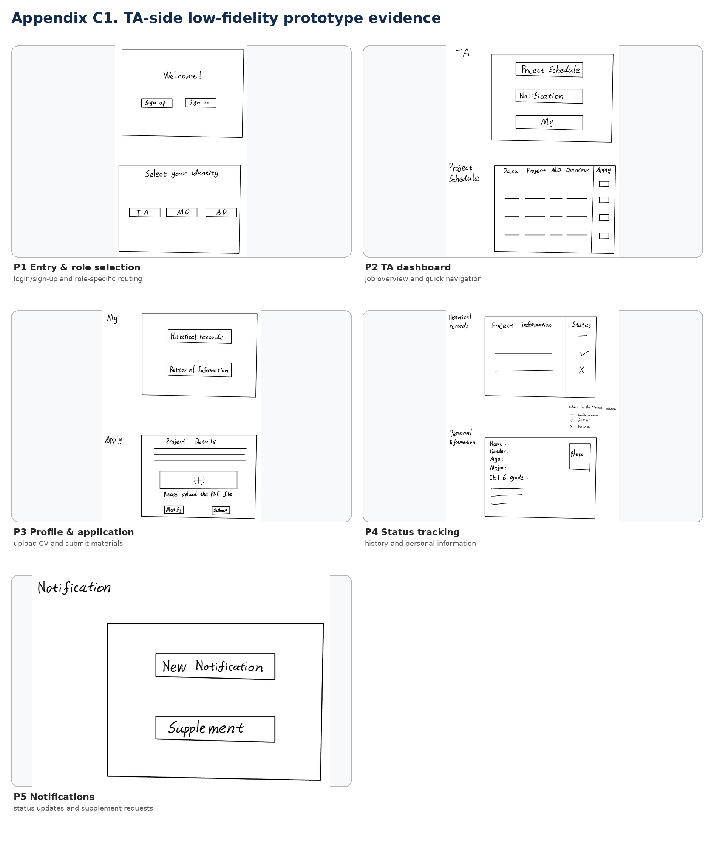
Figure C1. TA-side prototype pages validating entry, dashboard, profile, application, status and notification flow.
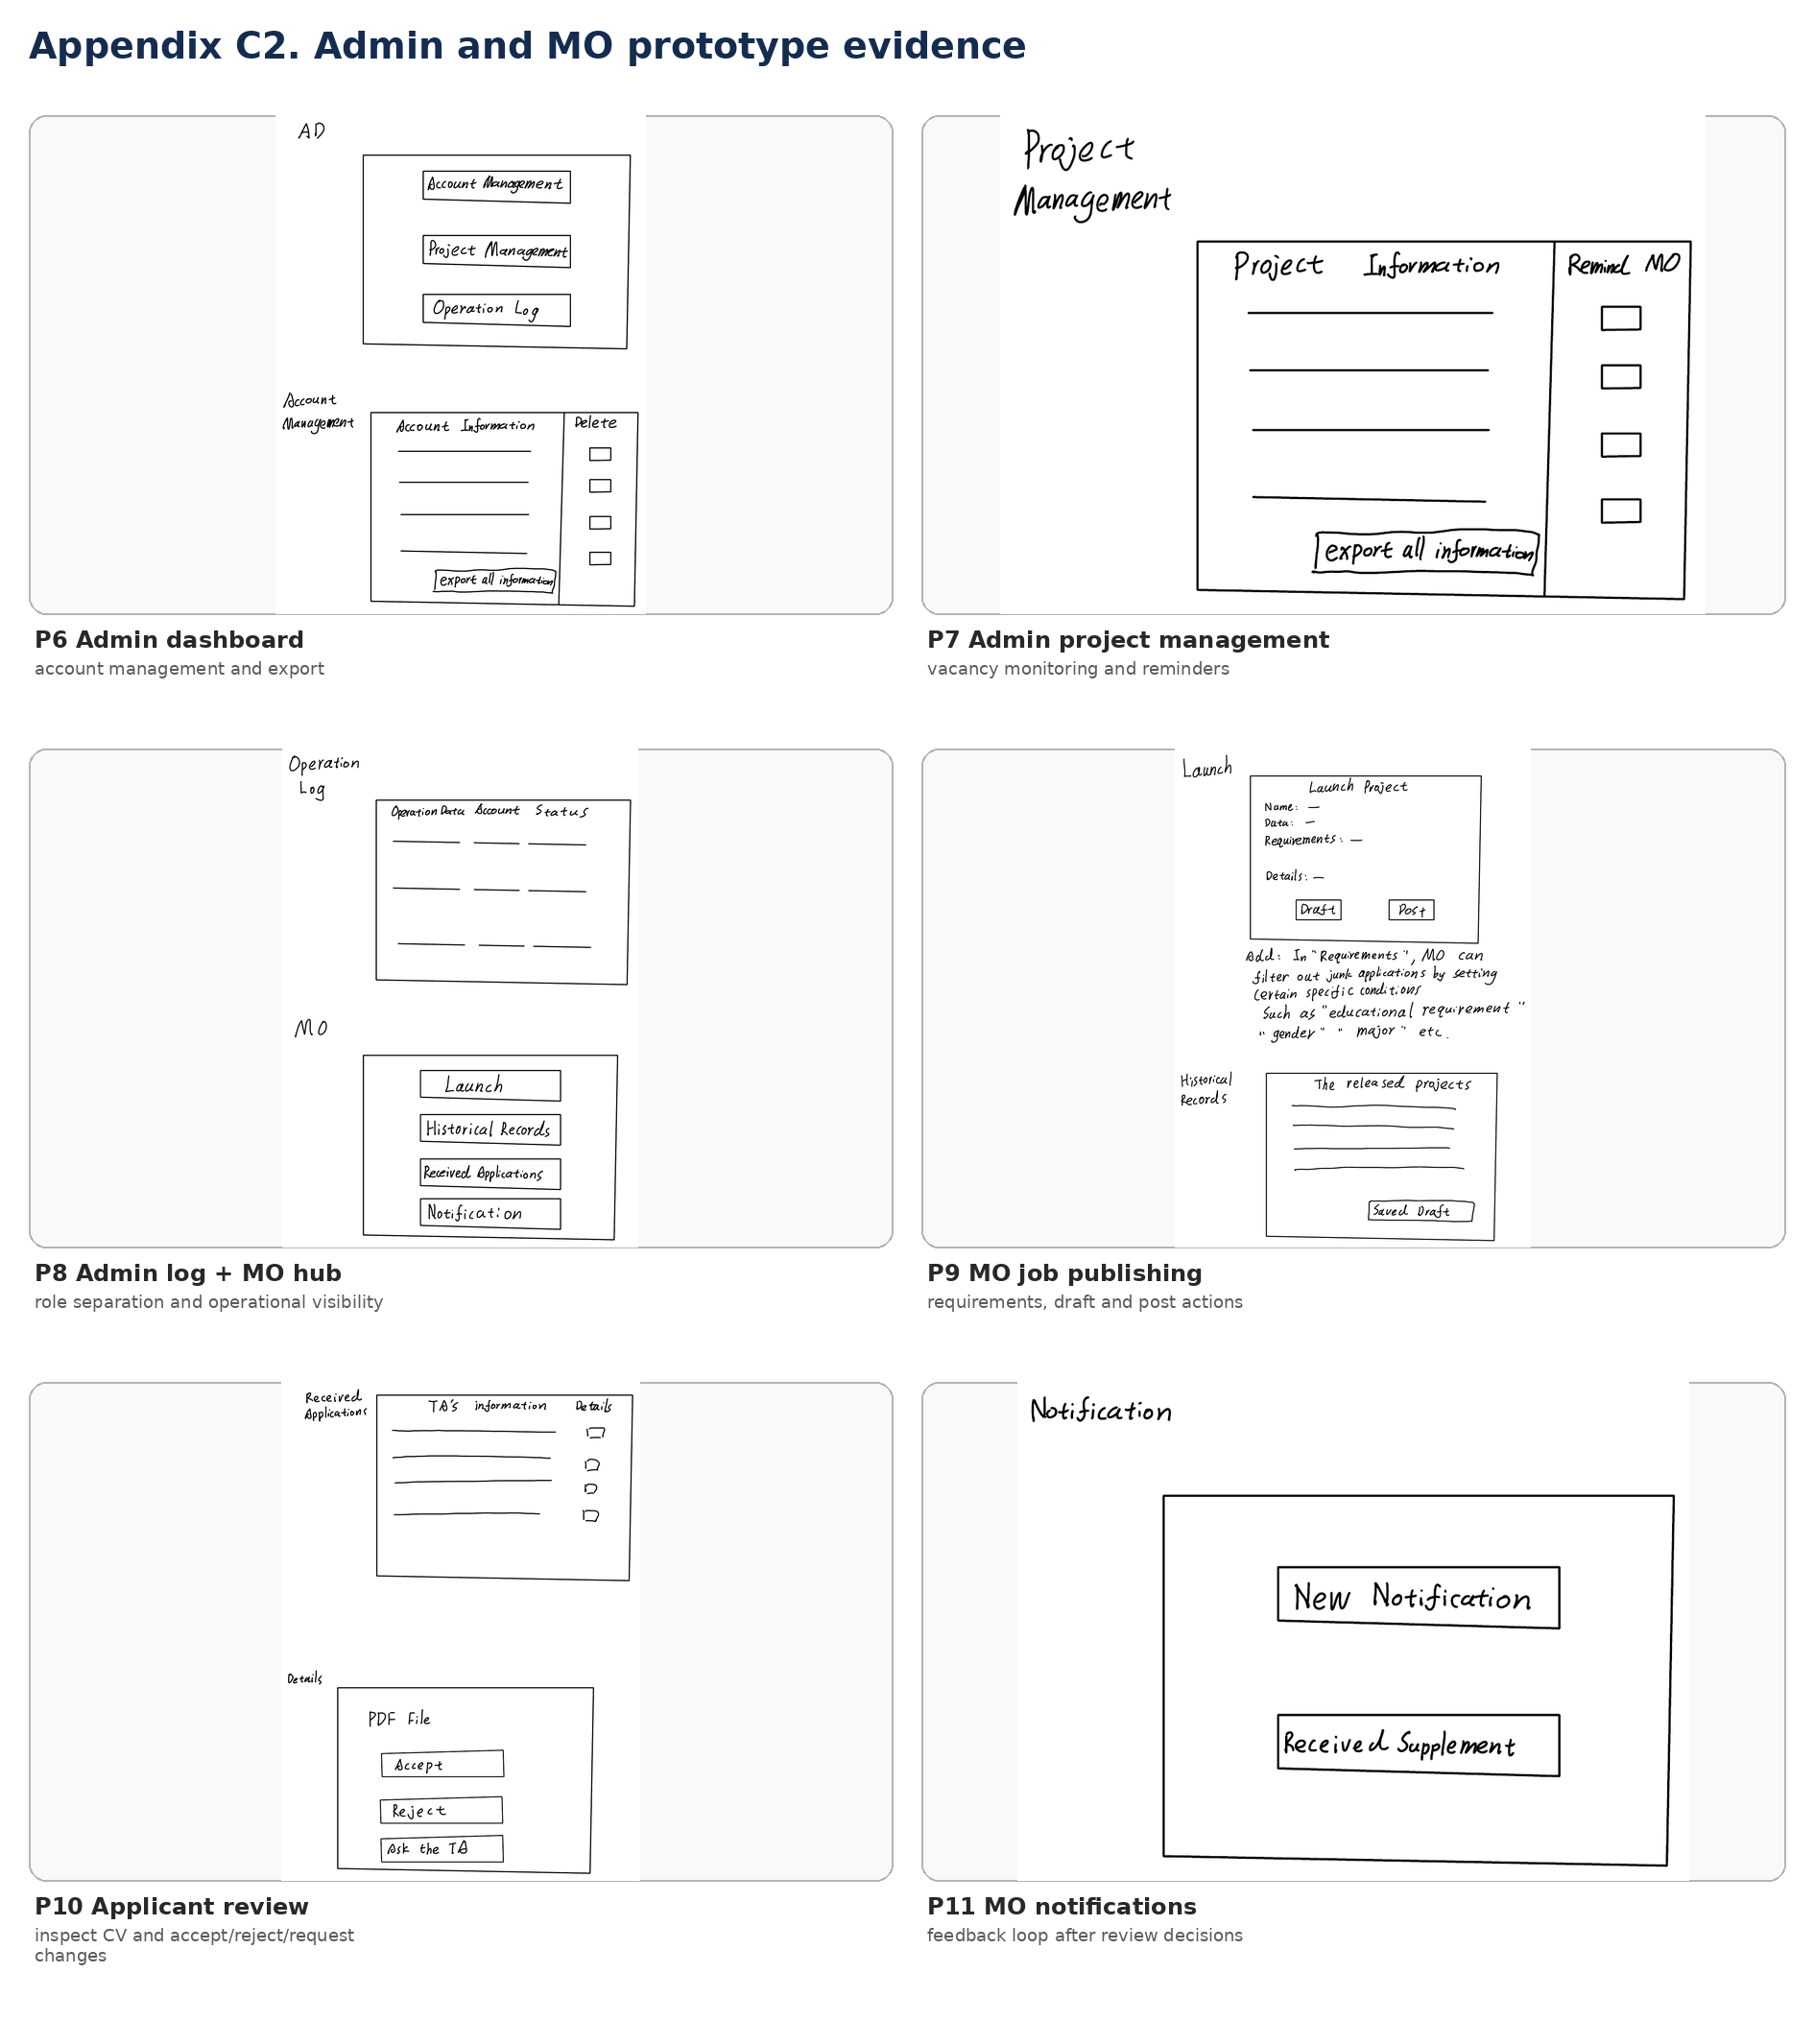
Figure C2. Admin and MO prototype pages validating account/project management, job publishing, applicant review and feedback loop.

Appendix D. Group discussion evidence
The chat record is included as evidence of iterative team communication rather than as a formal research instrument. It demonstrates that requirements and deliverables were reviewed asynchronously between working sessions, with files shared, revisions acknowledged and progress confirmed.
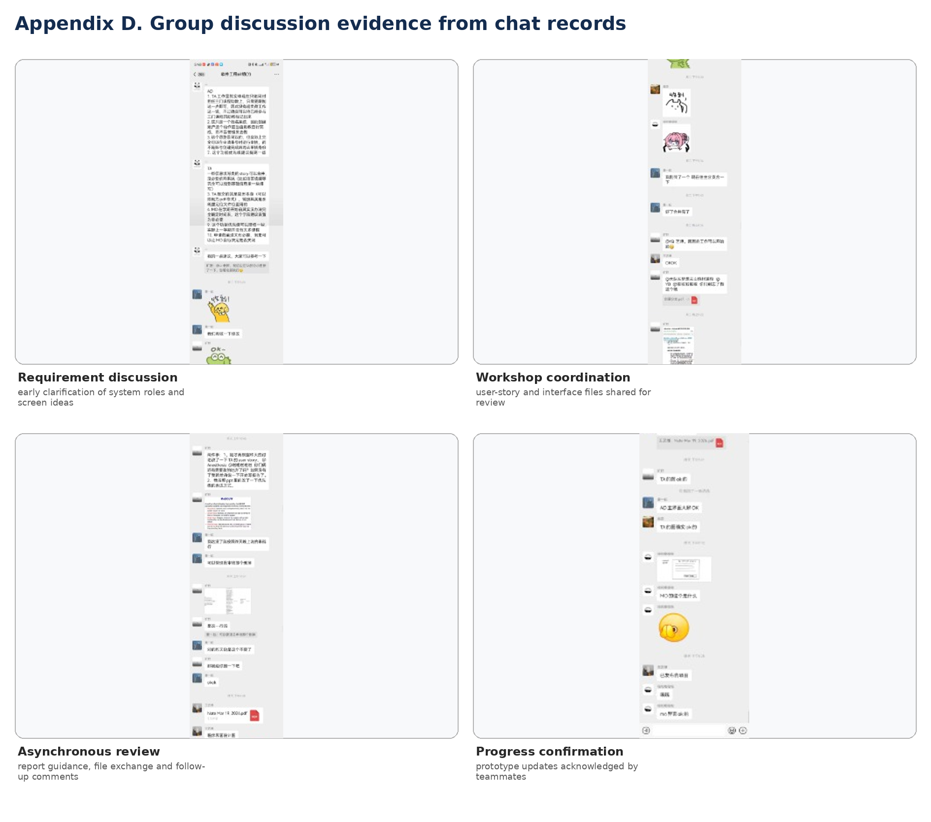
Figure D1. Selected chat-record excerpts showing requirement discussion, workshop coordination, asynchronous review and progress confirmation.
Observed evidence | What it supports
Shared documents/files | The team exchanged prototype/report-related files during preparation rather than working in isolation.
Requirement discussion messages | Scope and screen behaviour were discussed iteratively, consistent with Agile discovery.
Follow-up acknowledgements | Team members confirmed updates and kept momentum between synchronous sessions.
Recorded discussion evidence | The appendix provides support for the report’s claim that requirements were refined continuously.

