BOSWAR
A campaign builder brought to you by =69.GIAP=
Version: 0.1

BOSWAR 1
A campaign builder brought to you by =69.GIAP= 1
Version: 0.1 1
1Installation 3
1.1Prerequisites 3
1.2Install the core Database 3
1.3Install the Website 3
1.4Sanity checks 4
1.4.1 Log on 4
1.4.2User Management – Administrator Role 5

Installation

Prerequisites
To install BOSWAR the following things are required:
- MySQL
- Webserver
- PHP
This document does not cover a guide how to install MySQL, a Webserver and PHP. There can be multiple sources found in the www.

Install the core Database
The boswar_db is the core of the BOSWAR campaign builder. The first step to install it is to restore the database to your MySQL environment.
MySql\boswar_db.sql
Next we create database user to connect to this database. The same user will be used in the connection file of the BOSWAR Website.
MySql\create_boswar_hq_user.sql
Next we load a couple of example databases so we can do sanity checks on BOSWAR.
MySql\exampleCampaigns\1916.sql ...bloody_april.sql ... flanders_eagles.sql ...skies_of_the_empires.sql
Now we add an additional database user just for the campaign databases. This user has reduced rights and is used to improve security.
MySql\create_rofwar_campaign_user.sql

Install the Website
To install the BOSWAR website please load the folder called BOSWAR into your htdocs directory.
htdocs\Website\BosWar
Then place the connect_db.php file into the same directory.
htdocs\connect_db.php
For a better understanding of the process, please have a look at Figure 1.
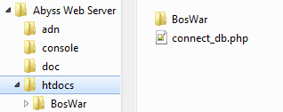
Figure 1
The connect_db.php file holds the connection information the website requires to access the database tables.
Initially the content looks like this:
<?php
# Connect on 'localhost' (with configured default port) for user 'boswar_hq'
# with password 'boswar_password' to database 'boswar_db'.
$dbc = mysqli_connect
( 'localhost' , 'boswar_hq', 'boswar_password', 'boswar_db' )
OR die
( mysqli_connect_error() ) ;
# Set encoding to match PHP script encoding.
mysqli_set_charset( $dbc , 'utf8' ) ;
?>
This information matches the user we created in chapter 1.2.

Sanity checks
It is vital to perform a couple of sanity checks to ensure everything is connecting properly. Please follow the following chapters step by step and in case you run into problems contact STENKA, TUSHKA or MYATA and ask for help. Make sure the problem is properly documented using screenshots and a step by step guide to recreate the problem.

Log on
There are already 3 users stored in the database. The first test is to log on with each of them and ensure they have the correct role assigned.
Open the Browser of your choice (please avoid IE!) and connect to the following site:
localhost/BosWar/index.php
Of course this will only work if you do the test on the webserver. If you would like to test from a different environment you have to ensure accessibility of the webserver and exchange localhost with the appropriate domain, DNS name or IP address!
You should be presented with a nice selection screen.
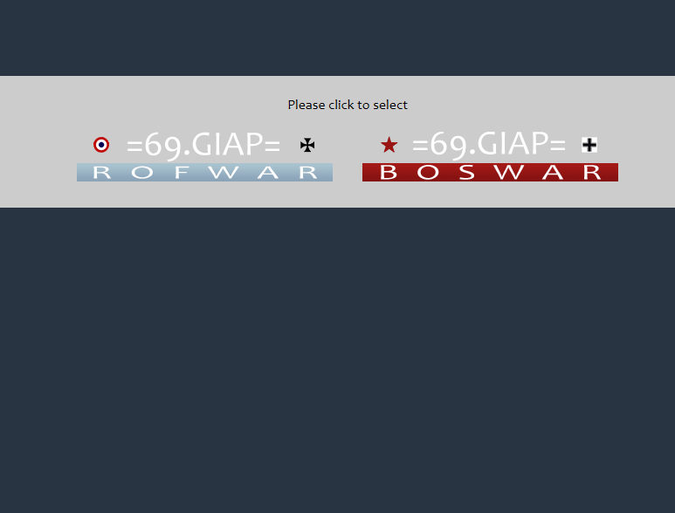
Figure 2
Click on the left link. This brings you to the first screen of the ROFWAR campaign planner.
Click the  button and use the following information to log on:
User: viewer
Password: manager
After clicking LOG IN this should bring you to the page CampaignSelect.php but unfortunately this user has no right other than logging in. On the left in the grey horizontal bar you see your user name and this user’s role. Remember this as we will shortly check this with two additional users.

Figure 3
Now click the  button which brings you back to the first screen.
Let’s repeat this using the following information:
User: commander
Password: manager
Now CampaignSelect.php looks different and you have a new option in the left window and an additional button in the center screen though there is nothing to select yet. On the left you can now see different information. This user owns a commander role.
Logout and log in again using:
User: admin
Password: manager
We get the same page but this time it looks completely different. Looking to the left you can see that this user is administrator.
Log out again.
If you were able to successfully run through the three tests we ensure that the database connection to the boswar_db can be established without problems.

User Management – Administrator Role
Let’s have a look what an administrator can manipulate. Log on as admin using the same credentials as before and click on the 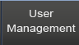 button. You entered the User Management which is used to assign a registered user a new role, assign him to a coalition or reset his password. In this console you can also delete a selected user.
Let’s have a detailed look at the console:
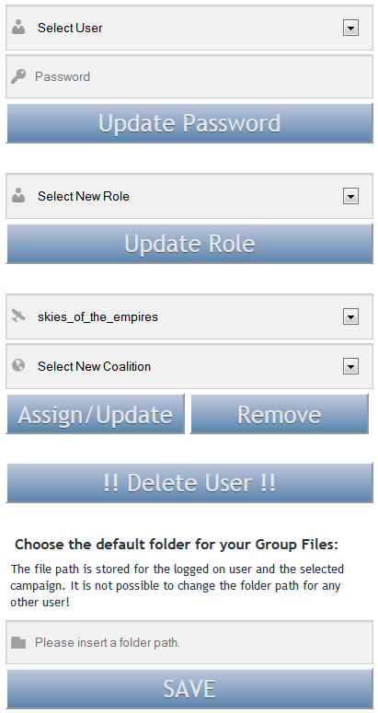

Test Case 1 – Update Password
Select the user named ‘commander’ from the drop down. You will realize that a new window appears to the right of the form. This window displays a summary of the selected users’ settings. The more rights a user has and the more campaigns a user is assigned to, the more information will be in this window.
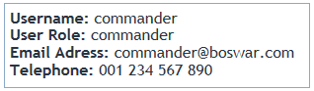
Figure 4
Enter a new password and hit Update Password.
The next page displays what you just did. Of course it does not display the password in clear text. The new password is stored encrypted in the boswar_db database. Test if it worked properly by logging off and logging on using the commander user with the new password.

Test Case 2 – Update Role
Log on as admin and navigate to the User Management console. Select the user ‘viewer’ from the dropdown and select the commander role from the Select New Role dropdown.
Click Update Role and you get an appropriate feedback on the next page.
Log off and log on with the user viewer. The user should now have the commander role assigned instead of the viewer role.
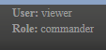
Figure 5

Test Case 3 – Assign a Campaign and a Coalition to a User
Log on as admin and navigate to the User Management console. Select the ‘commander’ role. The campaign dropdown only shows campaigns that are in an active state.
More details about campaign states later.
You can choose out of 2 active campaigns at the moment:
- skies_of_the_empires
- 1916
Select skies_of_the_empires and then select Entente from the Coalitions dropdown.
Click on the Assign/Update button. You get appropriate feedback as expected and we can start to test the result.
Get back to the User Management page and select the commander user once more. Now the user details window reflects that the user commander is now assigned to the campaign. Additionally it reflects the coalition the user is in this campaign.
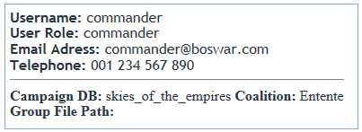
Figure 6
Log off and log on with the commander user. You now can see the Skies of the Empires campaign on the CampaignSelect.php page.
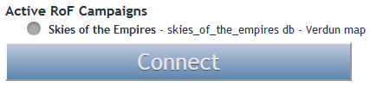
Figure 7
Log on as admin once more and remove the Skies of the Empires campaign from the user commander by selecting the user, selecting the campaign and clicking Remove. If you get back and select the c commander once more the details window reflects the user is no longer assigned to this campaign.

Test Case 4 – Register and Delete user
On the first screen of the website click on . The following form will be shown:
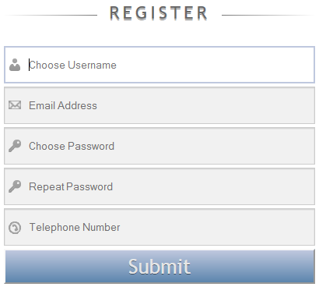
After clicking Submit you get feedback about success of creation and can no log in with the new user. Doing this you will see that the user was created as viewer.
Log off and log on as user admin. In the User Management console select the newly created user and click on Delete User.
Log off and try to log on with the user you registered before. It will not work as the user is deleted out of the boswar_db.

Test Case 5 – Store Group File Path for a user
Log on as admin and navigate to the User Management console.
Assign the user admin to the Skies of the Empires campaign on the Entente coalition. Navigate back to the console and reselect admin. Select the Skies of the Empires campaign and insert a path to a folder in the Input field of the form. Then click on Save. The system will assign the path out of the input field to the Skies of the Empires campaign as you are assigned to it.
Check this by selecting the admin user once more from the drop down. The user details reflect the process worked.
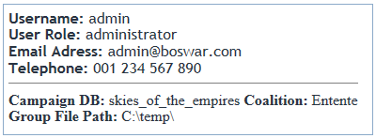
Figure 8
The last backslash in the folder path is added from the system automatically

