

ITSFT-506-2308-Cross Platform Development

B Sc (Hons) in Software Development

B Sc (Hons) in Creative Computing

Name and Surname: | Lara Valentino
Class: | SWD 6.2A
Application Description | This will be a note taking app. The user will be able to jot
down notes and view individual notes. The user will also be able to add an image to the
notes and change the background colour.

R&U1 – Accessibility Evaluation (2 marks)
Tool User | Semantics
- Submit screenshots or output showing results.
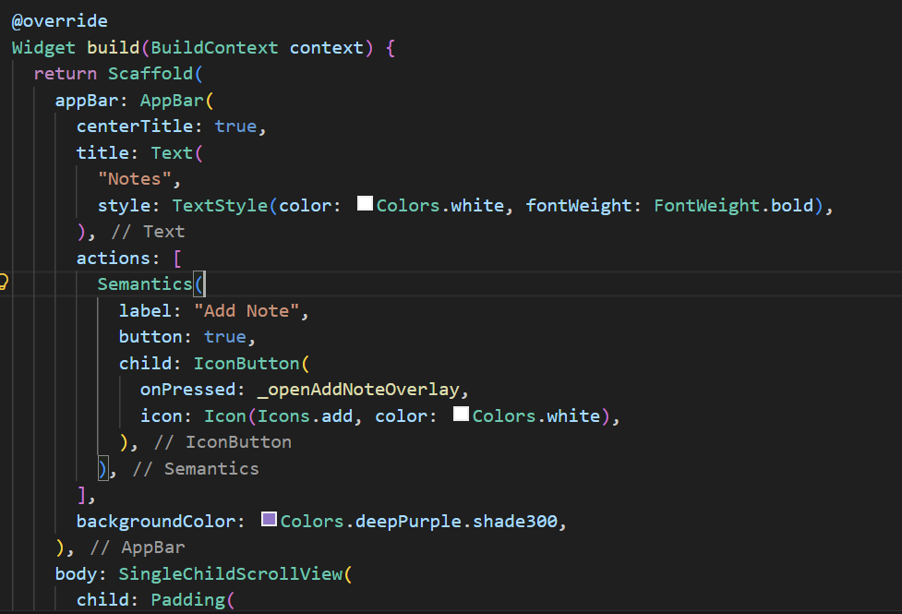

E&C2 – Cross-Platform UI Design (8 marks)
Tool Used | Wireframe.cc
Fimga Url (or equivalent) if availble – input vle if uploaded on vl | https://wireframe.cc/Kmrqat,  https://wireframe.cc/TXF4Ch

Screent shot of each screen:
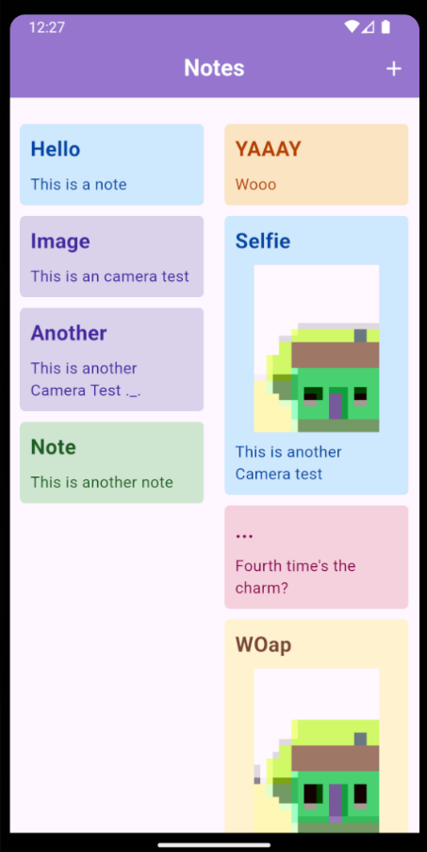
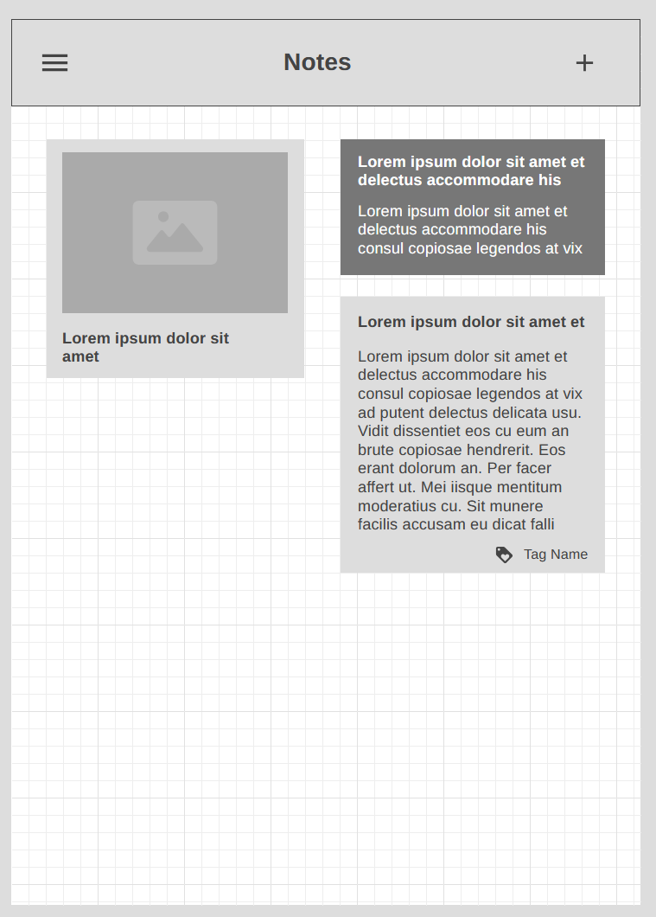
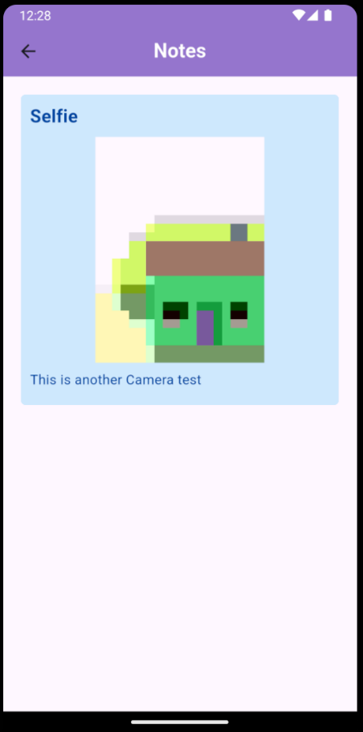
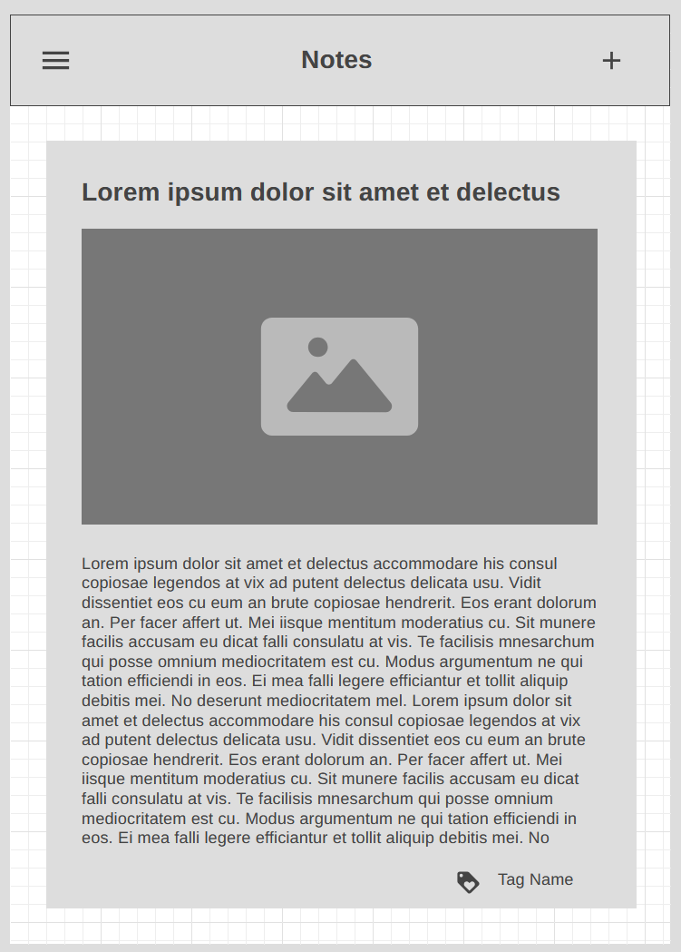

E&C3 – Performance Analysis & Optimisation (6 marks)
Describe what issue was identified and why do you think that happens

I noticed that there was a higher Jank (slower frame) – the red bars – when an image was
Being loaded. This could spike more if they’re being loaded form the disk rather than
From memory, as it takes longer to decode and render.
A way to reduce this is to cache images (the most important ones if there is a lot in the
App) at the start of the application to avoid larger frame drops during the running of the
Application.

Submit a Screenshot of DevTools before optimisation
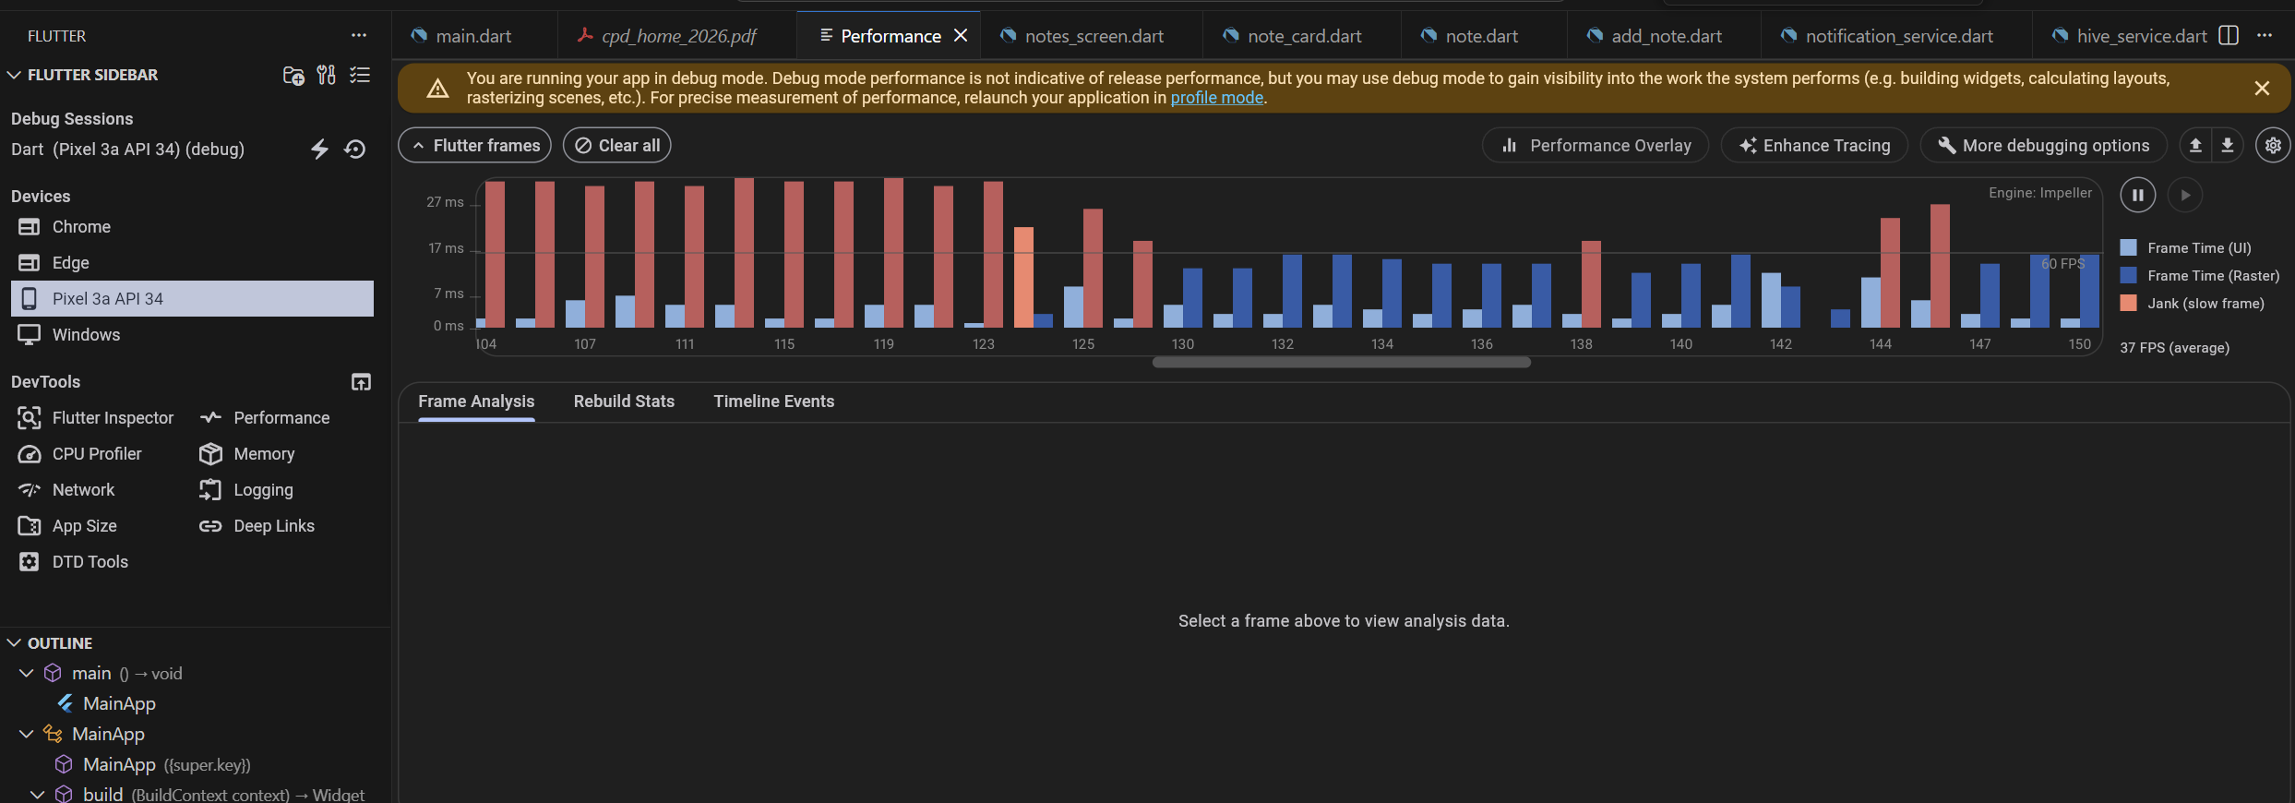

R&U3 – Device-Specific Feature (6 marks)
Feature implemented | Camera

Submit the Code snippet where this was used (screenshot)
This is in the add_note.dart file
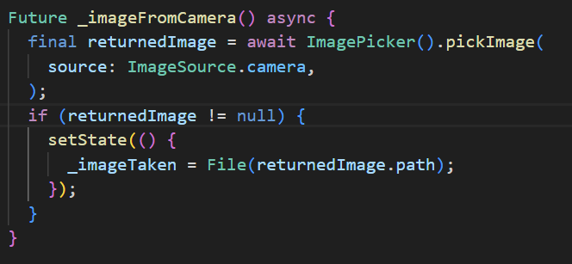
Submit a screenshot of feature working on device/emulator
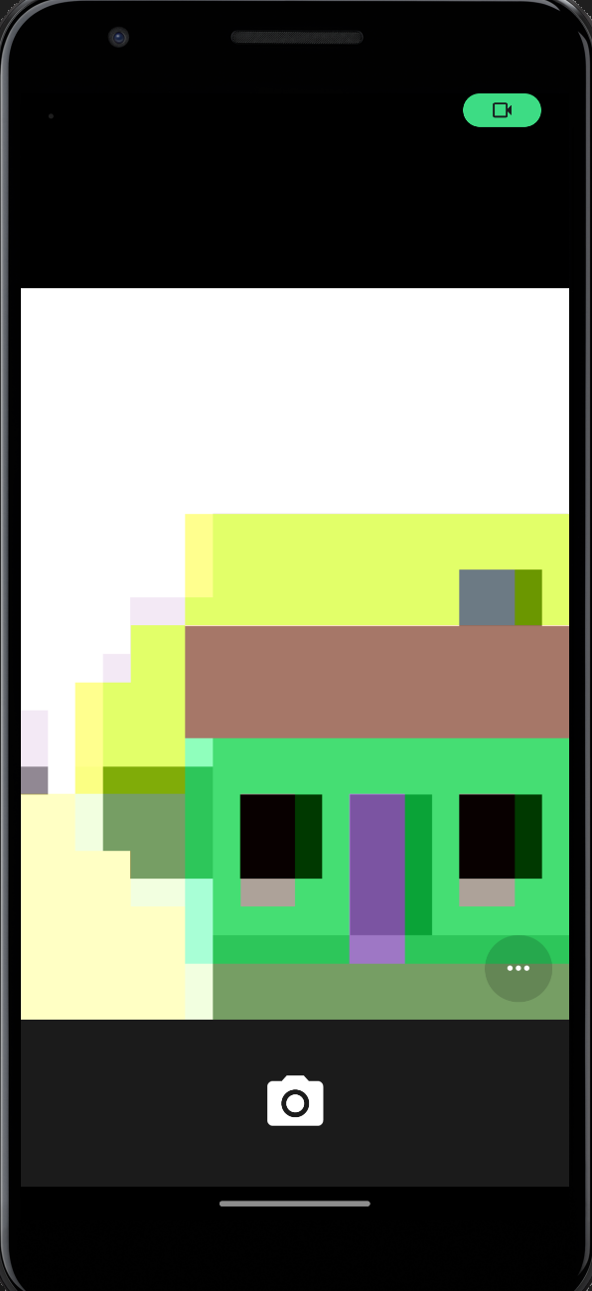

R&U4, A&A3– Native Platform Functionality (RU4 6 marks, AA3 6 Marks)
Functionality Selected | Local Persistent Storage using Hive
Why was this chosen? | I wanted the notes added to stay there
How does it fit the app’s context | The user can add the notes they want. When they leave the app and come back, the notes should stay there

A&A4 – Notifications / Background Services (6 marks)
Submit a screenshot of notification firing
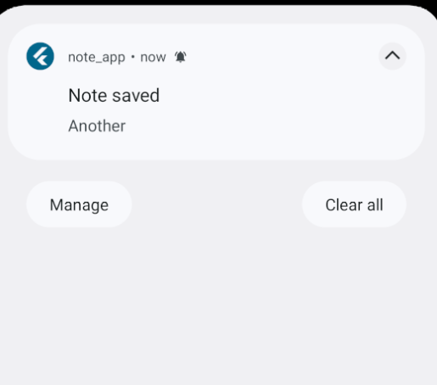

Code snippet triggering it (screenshot of code)
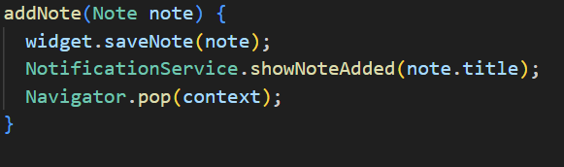

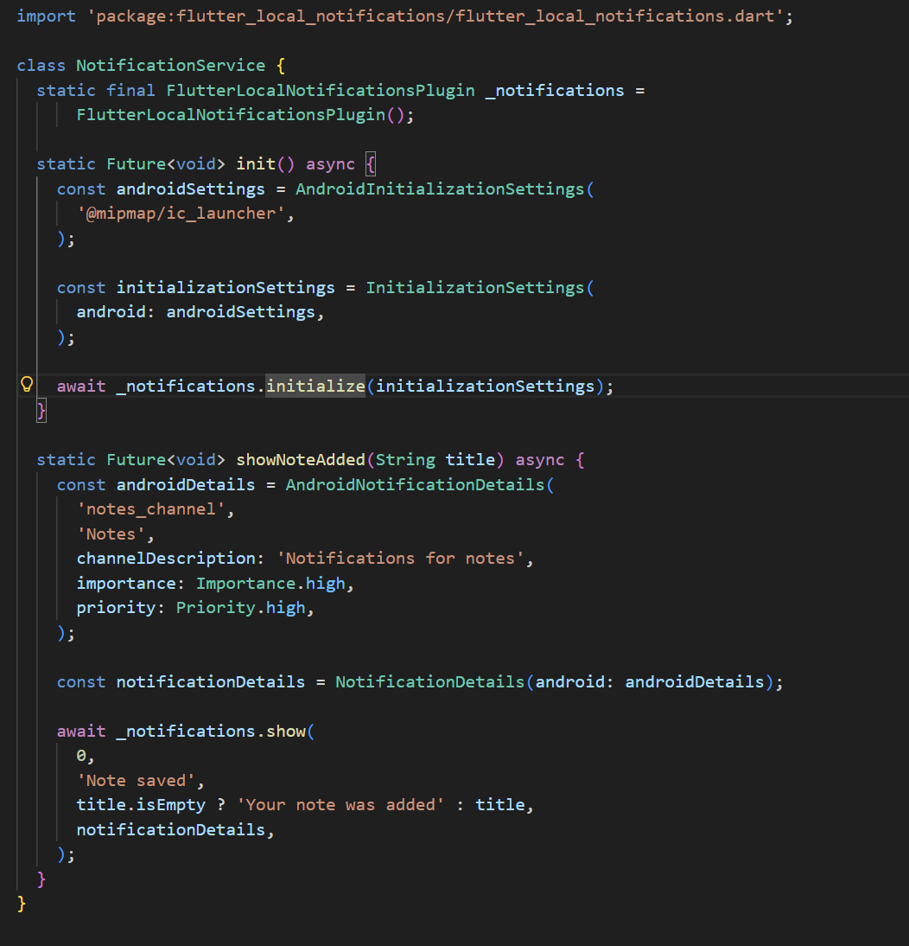

R&U5 – Version Control with Git (6 marks)
Git Url | https://github.com/6Blues/CPD-Home-SWD62A.git

Screen shot of commits
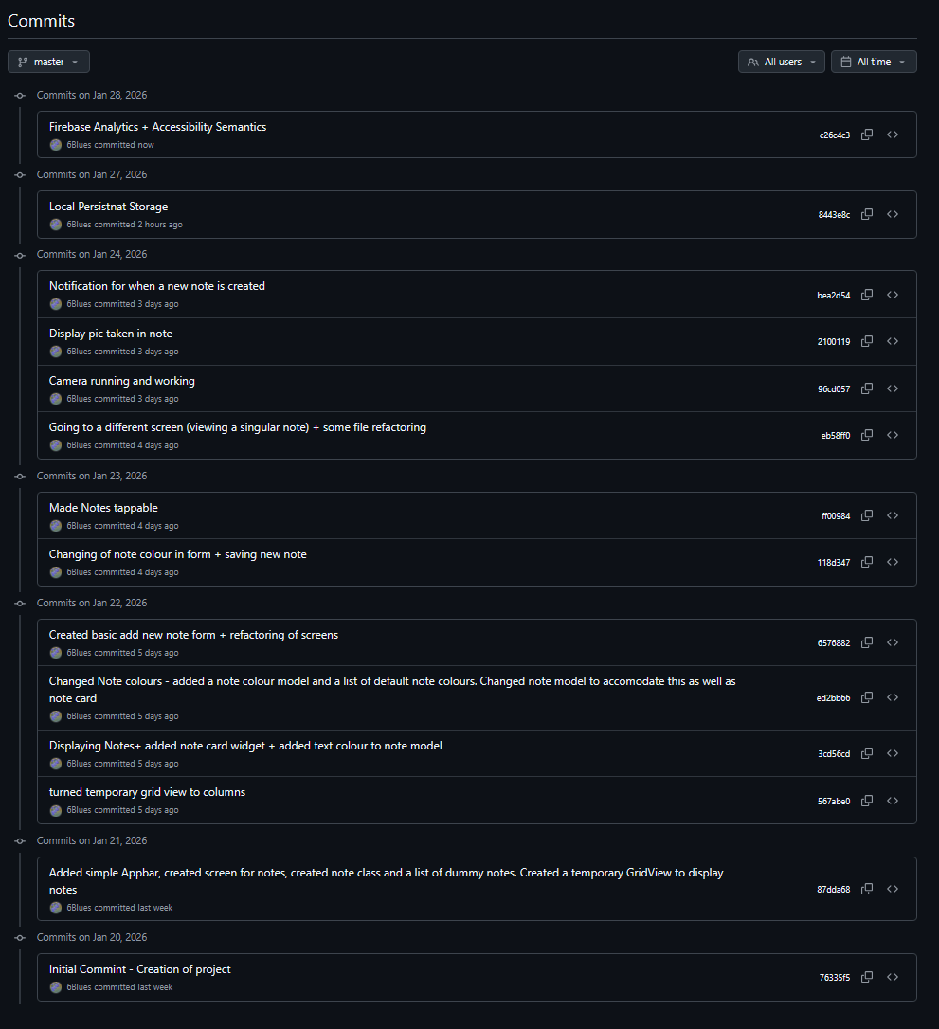

R&U6 – Analytics & Monitoring (8 marks)
Submit a screenshot of analytics dashboard
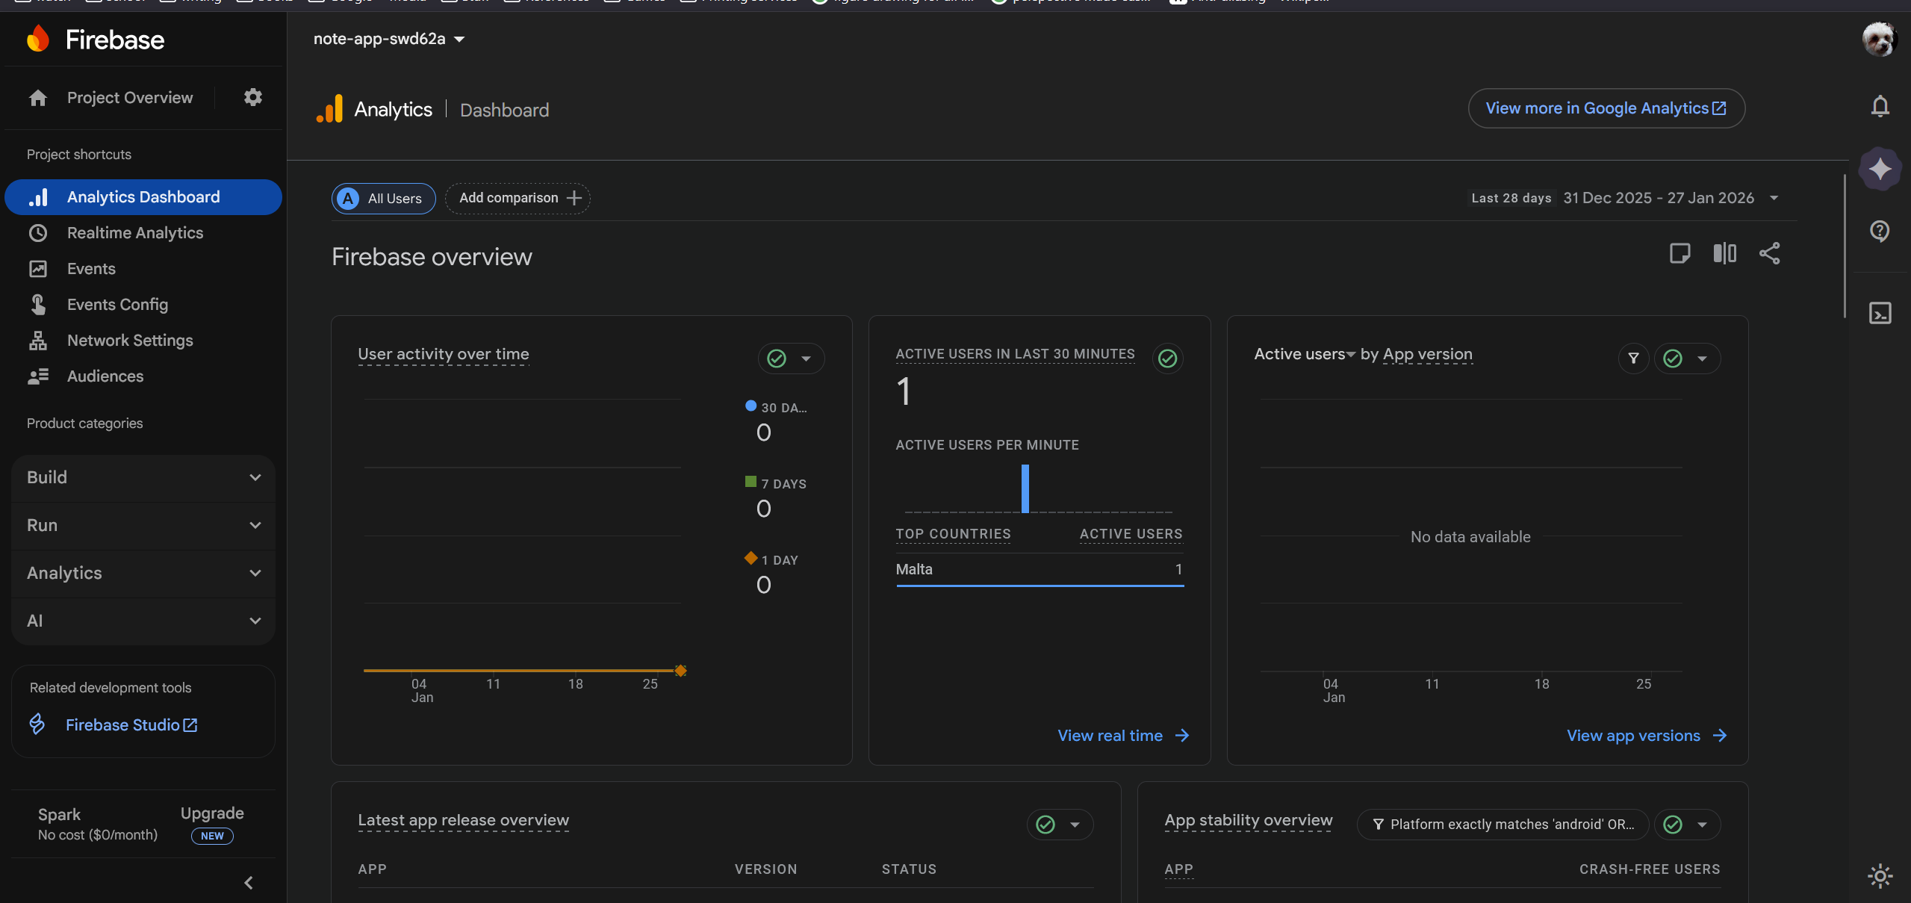

R&U7 – Updates & Maintenance Planning (8 marks)
Feature 1 | The user being able to edit a note – needing to add a key to each note as it doesn’t have one yet.
Feature 2 | The user being able to delete a note – needing to add a key to each note as it doesn’t have one yet.
Feature 3 | The user being able to change the order of notes to their liking. This would require either an order field or a list of id’s in the order of the notes.

A&A5 – CI/CD Pipeline (8 marks)

Brief description of GitHub Actions workflow | An automated process that executes one or more actions. They can be triggered by events within or outside the repository, a predefined schedule, or manually.
Its role in CI/CD. | Workflows can do the building, testing, and deployment into the production environment. These are required in a CI/CD

Code with descriptions
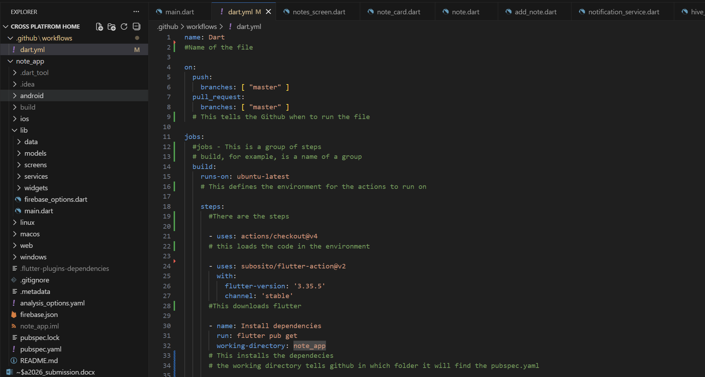
(Descriptions are in the comments)

