**↠PHANTOM Central Hub↞**

**Approved by: Senior Ranks from TR | Phantom**

Written by former Phantom MR, Adrián Martín Vázquez (A.K.A PacoAlmodovar).

■▬▬▬▬▬▬▬▬**【INDEX】**▬▬▬▬▬▬▬▬■

[#1] - Project description

[#2] - Project goals

[#3] – Client Group description

[#4] – Client Requirements

[#5] – Personas

■▬▬▬▬▬▬▬▬**【/INDEX】**▬▬▬▬▬▬▬▬■

# **[#1] - Project description**

**This project centralizes the interest and activity of the members from a Roleplay group on a single website, where they can find information about events, Unit of the Week, clips, combat strategies from training events, tutorials, and guides to become the stealthiest unit... In short, it’s a website that gathers all the information about this group, which is currently scattered across Discord chats, Roblox groups, and other social medias.**

**It will serve as an index for all types of information related to the roleplay and will be helpful for the PHANTOM units (members). Additionally, it will include uniforms, private training facility servers, gamepass offers for the main game, and commissions to keep the site active.**

■▬▬▬▬▬▬▬▬▬▬▬▬▬▬▬▬▬▬▬▬▬▬■

■

# **[#2] - Project goals**

**Apart from the description, this page has a purpose to recruit more people too, because the roleplay group wants more and more activity as it said on the description. So, the objective is to attract more people to the main roleplay game (assuming this page gains a good number of searches on browsers). The main goal is to increase the division's popularity, activity, and professionalism, as well as that of the game itself.**

* **Measures to be taken to achieve this:**

**In addition to the things said on the description…**

**To make this possible, the page will have a tactical or military design, in line with the theme of the division, aimed at attracting people between 17 and 30 years old who can join and enjoy the content. Additionally, descriptions will be taken seriously, and there will be a strong promotional effort encouraging visitors to become new members of the group. The units will also be encouraged to spread this promotion on forums connected to the page.**

**The focus will be on newcomers visiting the site. For this reason, the Main Page will include explanations, the lore/history of the roleplay, promotional content, and reviews from other players about the game and the roleplay group.**

■▬▬▬▬▬▬▬▬▬▬▬▬▬▬▬▬▬▬▬▬▬▬■

■

# **[#3] – Client Group description**

**>>** **Roleplay description: PHANTOM is, at its best, a covert task force that undertakes important missions to maintain the safety of City-17. They specialize in reconnaissance, infiltration, and assassination. Whatever they do, they do it quickly and without being seen.**

**PHANTOM doesn’t charge into battle or stay in the backlines, waiting for the perfect shot. They slip through their enemies undetected. They hunt down contraband, infiltrate heavily fortified anti-civil hideouts, relay confidential information, and assassinate dangerous targets—all with professionalism and discipline.**

**>>** **Group description: PHANTOM is a divisional group within the main community "The Robine." As described above, this group operates behind the scenes to ensure the safety of the community, sending data and information to other divisions or to the main community's senior or developer ranks.**

**We are also a clan-based group that competes in tournaments with other clans from the RCL (Roblox Combat League). We do all of this to gain recognition for our community and to become one of the greatest among other Roblox communities.**

■▬▬▬▬▬▬▬▬▬▬▬▬▬▬▬▬▬▬▬▬▬▬■

■

# **[#4] – Client Requirements**

**Our SRs (Senior Ranks) from “The Robine” specify the content they want to add to the page. They have also provided me with some posts to start with. The following sections contain a variety of items that are listed:**

**>> HOME PAGE: This main page of the entire site will contain promotional material to encourage people to join the division, as well as explanations of what we do and other elements to attract you to our roleplay group. At the bottom of the page, there will be links to some of the sections you can explore within the site.**

**>> Announcements: This is an aside section that reports announcements posted by Senior Ranks through various channels regarding new regulations or updates for the community and the benefit of the Phantom group. This section is controlled exclusively by SRs and is divided into "versions." Additionally, announcements from the game developers will also be posted here.**

**>> Information: This is a footer section for visitors who may need more details before deciding to join. It serves as a reference for other documents where people can download or view additional information on external pages not directly related to the website. These documents explain important aspects of the group, such as rules, links to our game, and more.**

**>> Events: In this section, there will be events scheduled by Higher Ranks for both current and former PHANTOM units to help boost activity.**

**>> PEP (Phantom Entrance Program): This is a sub-page of the main events page. Here, visitors can apply to join the division. If selected, they will be redirected to another page where they must attend their first Tryout, which is a training event for newcomers. This event helps determine whether the applicant will be accepted or not.**

**>> PTEP (Phantom Tactician Entrance Program): This is a sub-page of the main events page, where units ranked as Tacticians will be selected to undergo a variety of tests to prove their worthiness for the new rank of GHOST, which is part of the MR (Medium Ranks).**

**>> Activity Sweeps: This page will showcase the best performer of the week, along with a section to congratulate the new units, which will be a subsection of this main section. It will also include a compilation of points earned by each unit each week, as well as those that have not met their quotas.**

**>> Promotions: This is a subsection of the main Activity Sweeps page. It will contain the names of the new units that have joined the division, as well as schedules for entry into the PEP.**

**>> WoF (Wall of Fame): This is a subsection of the main Activity Sweeps page. It will feature the unit, HR, or MR of the week, along with some promotional content to increase popularity.**

**>> Community: This page serves as a forum for any unit or visitor, allowing them to engage in discussions and create various types of group chats.**

**>> Polls: This is a subsection of the main Community page, where HRs, SRs, and Devs can create polls for all visitors or units to vote on as either YES or NO.**

**>> Request: This is a subsection of the main Community page, where units or visitors can submit requests for the improvement of the website or the entire group.**

**>> Tutorials: This is a subsection of the main Community page. As the name suggests, these are guides created by MR+ ranks to teach units and visitors how to be a good PHANTOM. This section is also helpful for newcomers to understand how the roleplay division works in-game.**

**>> Shop: This section includes a list of gamepasses for the game, uniforms, items, and much more that you can purchase, like microtransactions.**

**In summary, the PHANTOM website covers a wide range of content to disseminate information about the roleplay group, including promotions, announcements, and community posts organized into sections and pages. Starting with the main one, the home page will feature promotional content, an explanation of what the PHANTOM group is, and links to other sections such as announcements, which will include updates from Senior Ranks (SRs), and an information section with important documents regarding group rules. Scheduled events will encourage activity among current and former units, while programs like the PEP and PTEP will assist current units and new members in integrating and ranking up. The site will also include a community forum for discussions, a request section for feedback, tutorials for newcomers, and a shop featuring microtransactions for in-game items.**

* **IDEA: Personalized Recognition and Achievement System (PRAS): Personalized Recognition and Achievement System (PRAS): Implement a system that allows members to earn and display medals/badges based on their participation and contributions to the community, such as a Medal of Service or a Badge of Beta Tester for the Phantom | Holo game. These achievements could be showcased on an external page where users can see a list of their earned badges, with colored badges (excluding negative colors) indicating what they have achieved. Additionally, there would be an option to share these badges on Twitter or other social media platforms to make the system more competitive.**

■▬▬▬▬▬▬▬▬▬▬▬▬▬▬▬▬▬▬▬▬▬▬■

■

# **[#5] – Personas**

***Next Page↠***

PERSONA nº1

PERSONA nº2

PERSONA nº3

■▬▬▬▬▬▬▬▬▬▬▬▬▬▬▬▬▬▬▬▬▬▬■

■

# **[#6] – Research on Competitors**

**An addition of the Discord channels from the community group on the website should be good because they can see what it’s about each channel and know the community  
**

**Also, the website can have a map where our base and spawn point is located in the game of The Robine C17 of Roblox with an addition of picture angles from the Holo and its parts.**

**Here’s a picture from the website competitor:**

**On the picture it shows the bases of the military group of the roleplay game Arma 3 (the map is not real, it is extracted from the game), with information if you click on it.**

**Phantom also has a map from the main Roleplay game The Robine City 17 that is shown below:**

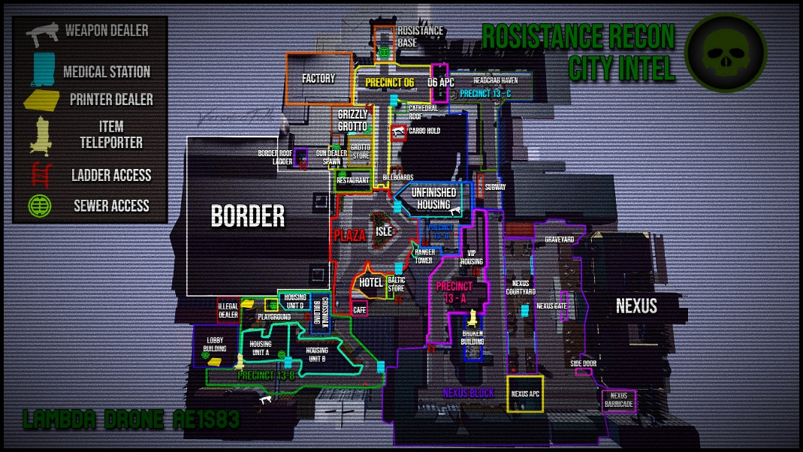

**Phantom group needs pictures from their Holo because there’s not lots of information about it.**

**The Discord channels integration can be done by copy paste or with a puglin which is the correct option.**