**↠PHANTOM Central Hub↞**

**Approved by: Senior Ranks from TR | Phantom**

Written by former Phantom MR, Adrián Martín Vázquez (A.K.A PacoAlmodovar).

■▬▬▬▬▬▬▬▬**【INDEX】**▬▬▬▬▬▬▬▬■

[#1] - Project description

[#2] - Project goals

[#3] – Client Group description

[#4] – Client Requirements

[#5] – Personas

[#6] – Research on Competitors

■▬▬▬▬▬▬▬▬**【/INDEX】**▬▬▬▬▬▬▬▬■

# **[#1] - Project description**

**This project centralizes the interests and activities of the members of a Roleplay group on a single website, where they can find information about events, Unit of the Week, clips, combat strategies from training events, tutorials, and guides on becoming the stealthiest unit. In short, it’s a website that gathers all the information about this group, which is currently scattered across Discord chats, Roblox groups, and other social media platforms.**

**It will serve as an index for all types of information related to the roleplay and will be helpful for PHANTOM units (members). Additionally, it will include a link to view their uniforms and access their private training facility game (**[***HOLO***](https://www.roblox.com/games/6727543635/PHANTOM-Holo)**).**

■▬▬▬▬▬▬▬▬▬▬▬▬▬▬▬▬▬▬▬▬▬▬■

■

# **[#2] - Project goals**

**The project's purpose is to recruit more people, as the roleplay group desires increased activity. Therefore, the main goal is to boost the division's popularity, activity, and professionalism, as well as that of the game itself.**

* **Measures to be taken to achieve this:**

**To make this possible, the website will spread propaganda through ads on various platforms, as well as on the Home Page. Once a visitor with interest clicks on "visit our website," they will be directed to a page with a tactical or military design that aligns with the division's theme (Home Page ➜ About Us), drawing them into the website's topic.**

**Additionally, descriptions will be crafted professionally, and there will be a strong promotional effort to encourage visitors to join the group through videos, tutorials, guides, and forums. Notifications will pop up for those who register or log in to the website with the user registration system, and optional email adverts will be available for those who subscribe.**

**As mentioned, the primary focus will be on newcomers visiting the site. For this reason, the Home Page will include not only propaganda and ads, but also explanations of what Phantom is, the lore/history of the roleplay, promotional content, and reviews from other players about the game and the roleplay group.**

**To conclude, Phantom will add more sections where they can find events, Unit of the Week, clips, courses for new LUA developers in the Holo, links to the uniforms and games, etcetera.**

**With these measures and advertisement on different platforms, Phantom aims to attract an audience of 16 years old to 30 years old who enjoy stealth military content, who help increasing the** **average number of active players to a 15% more than it was in July which it was 100 players active on the Roleplay Game City-17, also Phantom wants to increase their community members too for more activity, from 25 members to 50 members at least, and more developers that want to work on their games for a reasonable price, they want to increase their developers from 3 that it is right now, to 10 and make a group of 5 working on the Roleplay games, and other 5 working on the HOLO.**

■▬▬▬▬▬▬▬▬▬▬▬▬▬▬▬▬▬▬▬▬▬▬■

■

# **[#3] – Client Group description**

**PHANTOM is a divisional subgroup of a larger open community called “The Robine”. PHANTOM, however, is a private group that requires specific criteria to be met for recruitment or invitation. This group functions as a clan and participates in Roblox Combat League (RCL) tournaments, where they win prizes in money or Robux (the virtual currency from Roblox that can be converted to real money). They also engage in roleplay games within the main community, "The Robine". In these games (such as** [***City-17***](https://www.roblox.com/games/509062192/CORE-UPDATE-CITY-17)**,** [***City Reborn***](https://www.roblox.com/games/17835552135/C17-City-Reborn)**, and** [***Downtown RP***](https://www.roblox.com/games/125278189013070/Downtown-RP)**), PHANTOM operates as a Stealth Task Force, acting as "spies”. Also, there are a few of their members who are developers of one of these games and the private training facility of Phantom (HOLO). They program in LUA which is a language for sandbox games.**

**They also spread propaganda for both their divisional group (PHANTOM) and the main community (The Robine) to gain recognition within the broader Roblox community.**

**Their philosophy revolves around their motto: “Strike when they least expect it!” This applies not only for roleplay purposes but also as a strategy to maintain their community by seizing any opportunity that comes their way and turning it into reality. This is how they envision making this website a reality. And is how they wanted to prevail on the future.**

**[*This was all extracted from a meeting with the commander and owner of Phantom AdabWhen, and his Vice-commanders, tepigater and IamdeadX_XdaedmaI*]**

■▬▬▬▬▬▬▬▬▬▬▬▬▬▬▬▬▬▬▬▬▬▬■

■

# **[#4] – Client Requirements**

**Our SRs (Senior Ranks) from “The Robine” specify the content they want to add to the page. They have also provided me with some posts to start with. The following sections contain a variety of items that are listed:**

**>> HOME PAGE: This main page of the entire site will contain promotional material to encourage people to join the division, as well as explanations of what we do and other elements to attract you to our roleplay group. At the bottom of the page, there will be links to some of the sections you can explore within the site.**

**>> Announcements: This is an aside section that reports announcements posted by Senior Ranks through various channels regarding new regulations or updates for the community and the benefit of the Phantom group. This section is controlled exclusively by SRs and is divided into "versions." Additionally, announcements from the game developers will also be posted here.**

**>> Information: This is a footer section for visitors who may need more details before deciding to join. It serves as a reference for other documents where people can download or view additional information on external pages not directly related to the website. These documents explain important aspects of the group, such as rules, links to our game, and more.**

**>> Events: In this section, there will be events scheduled by Higher Ranks for both current and former PHANTOM units to help boost activity.**

**>> PEP (Phantom Entrance Program): This is a sub-page of the main events page. Here, visitors can apply to join the division. If selected, they will be redirected to another page where they must attend their first Tryout, which is a training event for newcomers. This event helps determine whether the applicant will be accepted or not.**

**>> PTEP (Phantom Tactician Entrance Program): This is a sub-page of the main events page, where units ranked as Tacticians will be selected to undergo a variety of tests to prove their worthiness for the new rank of GHOST, which is part of the MR (Medium Ranks).**

**>> Activity Sweeps: This page will showcase the best performer of the week, along with a section to congratulate the new units, which will be a subsection of this main section. It will also include a compilation of points earned by each unit each week, as well as those that have not met their quotas.**

**>> Promotions: This is a subsection of the main Activity Sweeps page. It will contain the names of the new units that have joined the division, as well as schedules for entry into the PEP.**

**>> WoF (Wall of Fame): This is a subsection of the main Activity Sweeps page. It will feature the unit, HR, or MR of the week, along with some promotional content to increase popularity.**

**>> Community: This page serves as a forum for any unit or visitor, allowing them to engage in discussions and create various types of group chats.**

**>> Polls: This is a subsection of the main Community page, where HRs, SRs, and Devs can create polls for all visitors or units to vote on as either YES or NO.**

**>> Request: This is a subsection of the main Community page, where units or visitors can submit requests for the improvement of the website or the entire group.**

**>> Tutorials: This is a subsection of the main Community page. As the name suggests, these are guides created by MR+ ranks to teach units and visitors how to be a good PHANTOM. This section is also helpful for newcomers to understand how the roleplay division works in-game.**

**>> Developers Media: This is a subsection of the main Community page. This one is a forum only made for developers, inside they divide the tasks to optimize work and create an endearing atmosphere between developers.**

**>> User Registration System: A way for a user to register inside a website and see more info about them, as at what time is an event and more data that a guest (not logged) can’t see.**

**In summary, the PHANTOM website covers a wide range of content to disseminate information about the roleplay group, including promotions, announcements, and community posts organized into sections and pages. Starting with the main one, the home page will feature promotional content, an explanation of what the PHANTOM group is, and links to other sections such as announcements, which will include updates from Senior Ranks (SRs), and an information section with important documents regarding group rules. Scheduled events will encourage activity among current and former units, while programs like the PEP and PTEP will assist current units and new members in integrating and ranking up. The site will also include a community forum for discussions, a request section for feedback, tutorials for newcomers and a developer’s forum, and a registration system that will work for the next idea that is explained below.**

* **IDEA: Personalized Recognition and Achievement System (PRAS): Personalized Recognition and Achievement System (PRAS): Implement a system that allows users to earn and display medals/badges based on their participation and contributions to the community, such as a Medal of Service or a Badge of Beta Tester for the Phantom | Holo game. These achievements could be showcased on an external page where users can see a list of their earned badges, with coloured badges (excluding negative colours) indicating what they have achieved. Additionally, there would be an option to share these badges on Twitter or other social media platforms to make the system more competitive.**

■▬▬▬▬▬▬▬▬▬▬▬▬▬▬▬▬▬▬▬▬▬▬■

■

# **[#5] – Personas**

***Next Page↠***

PERSONA nº1

PERSONA nº2

PERSONA nº3

■▬▬▬▬▬▬▬▬▬▬▬▬▬▬▬▬▬▬▬▬▬▬■

■

# **[#6] – Research on Competitors**

**A thing Phantom liked about his competitors was the addition of a plugin to see the community channels, this could be useful for newcomers to see how each channel folder is aligned to not get lost inside the maze of channels. Also explaining what each channel is about.**

**As you can see below this is how our competitor has their information on TeamSpeak channels (same as Discord) on the aside section of the website. We can do the same and embed this information in the aside of the Phantom website**

**Another thing we liked about our competitors is that they show a map of their game (Arma 3) with a marking point of where a base is located, with info about it**

**Here’s a picture from the website competitor:**

**Phantom wants this competitor’s idea on their website because it shows how the map is made, what each area is called and information about if you can go to the said area or not, or if it is dangerous, etcetera. Also has a map from the main Roleplay game The Robine City 17 that is shown below:**

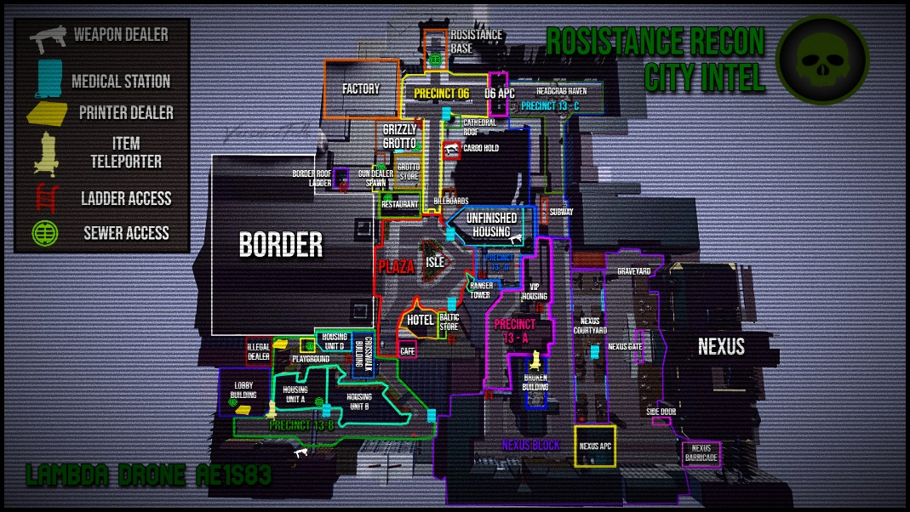

**We can add this map picture and make plugins to show information about every area on the about us page of the website.**

**The Discord channels integration can be done with a plugin on copy paste on the aside section of the website as I said before.**