**问题一、**

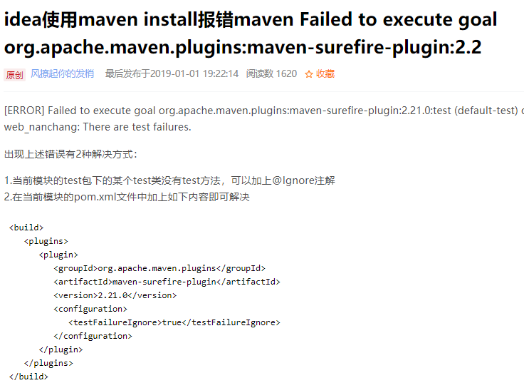

**Springboot正确打包成jar如下：**

<**build**>  
 <**finalName**>personal_blog</**finalName**>  
 <**plugins**>  
 <**plugin**>  
 <**groupId**>org.apache.maven.plugins</**groupId**>  
 <**artifactId**>maven-surefire-plugin</**artifactId**>  
 <**version**>2.21.0</**version**>  
 <**configuration**>  
 <**testFailureIgnore**>true</**testFailureIgnore**>  
 </**configuration**>  
 </**plugin**>  
 <**plugin**>  
 <**groupId**>org.springframework.boot</**groupId**>  
 <**artifactId**>spring-boot-maven-plugin</**artifactId**>  
 </**plugin**>  
 </**plugins**>  
</**build**>

**即**

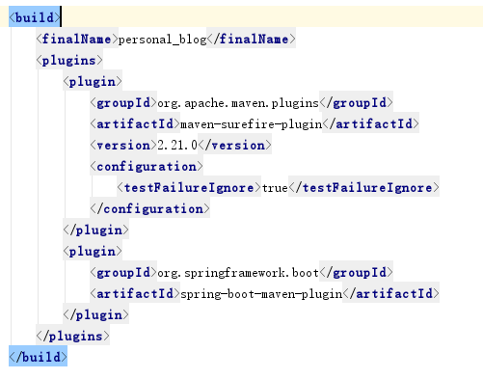

# https://img-blog.csdn.net/20180712134805855?watermark/2/text/aHR0cHM6Ly9ibG9nLmNzZG4ubmV0L0xpbmppbmdrZTMy/font/5a6L5L2T/fontsize/400/fill/I0JBQkFCMA==/dissolve/70问题二：SpringMVC(war)和Springboot项目打包成jar包后运行错误"Error resolving template "/index", template might not exist or ......"解决

**我们把返回模板名字前的"/"线去掉即可:**

