NAME: TALHA AYYAZ
REGISTRATION NO: 04072313005

MAD LAB_3 SCREENSHOTS

STEP-1:
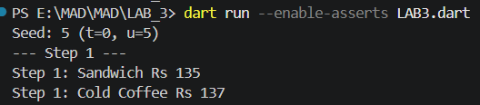

STEP-2:


STEP-3:

STEP-4:

STEP-5:

STEP-6:

STEP-7:
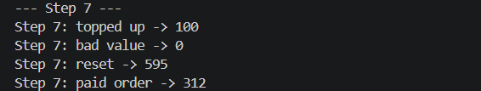
STEP-8:
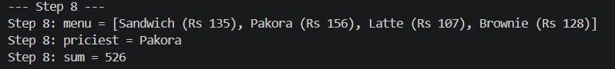
STEP-9:
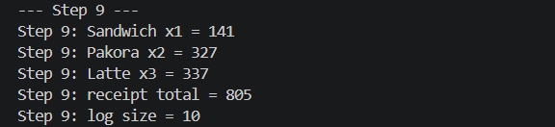
STEP-10:


FULL OUTPUT:
