Our topic: Gender and Age prediction.

Introduction:

The problem is in predicting The Gender and Age of a person according to cropped image of face. In recent years, there has been significant progress in this area due to development of video monitoring systems all over the world (such as Sergek).

Literature Review:

Dataset: <https://www.kaggle.com/datasets/jangedoo/utkface-new>

Pretrained Model: <https://github.com/aswintechguy/Deep-Learning-Projects>

Today we have a plethora of large datasets with people faces. We decided to use UTKFace Datasets. It contains cropped images of people in pretty good quality.

During investigation of this topic we found interesting module Deep Face that is able to recognize: age, gender, emotion and even race of the person on photo.

<https://pypi.org/project/deepface/>

Current work:

Firstly, we created some lists

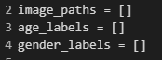

Then we split the age and gender from the path to this file

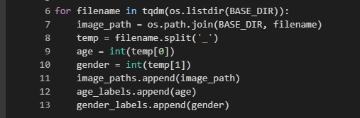

Created DataFrame and filled it with information

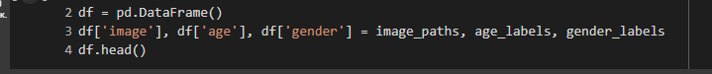

Then we extracted features, resized it to 128/128

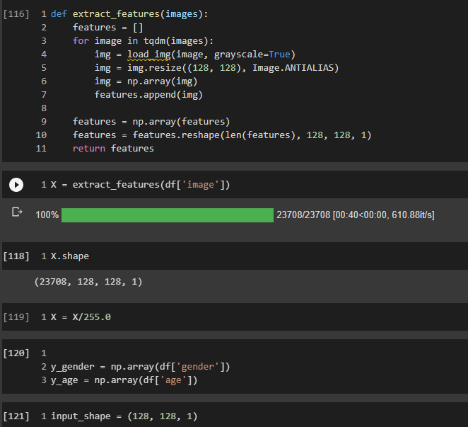

We used ready-made model

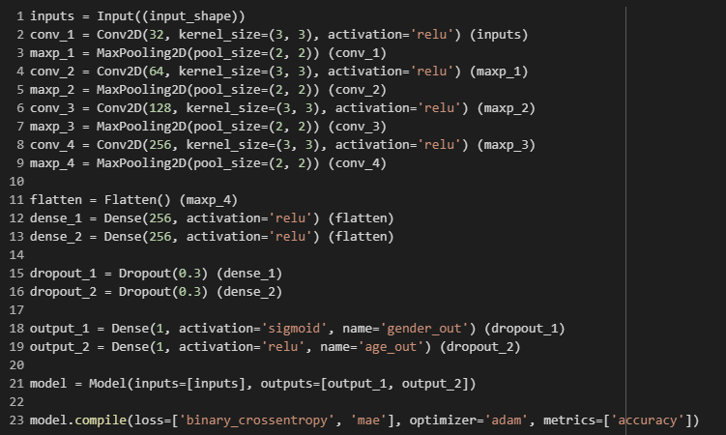

Then plotted the graph (function were taken from assignment 2)

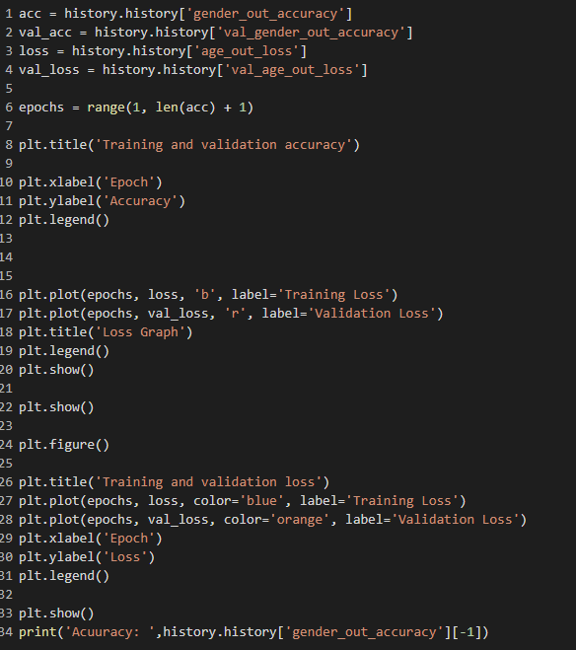

Got these graphs

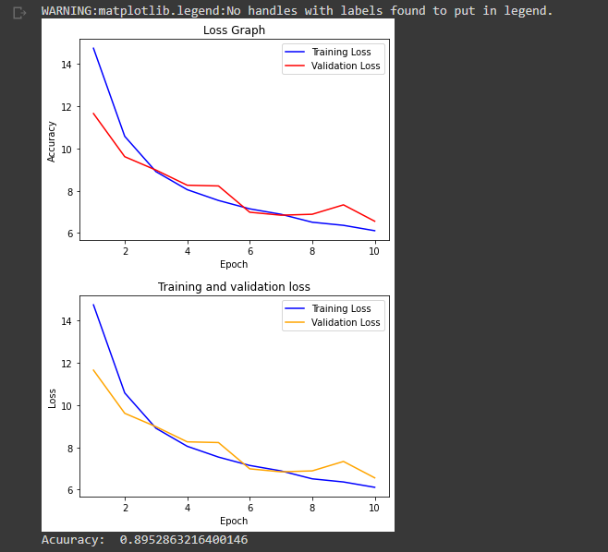

With accuracy = 89%

For final step we made a function that randomly gets image index from DataFrame,

Predicts age and gender,

Compares with original age and gender,

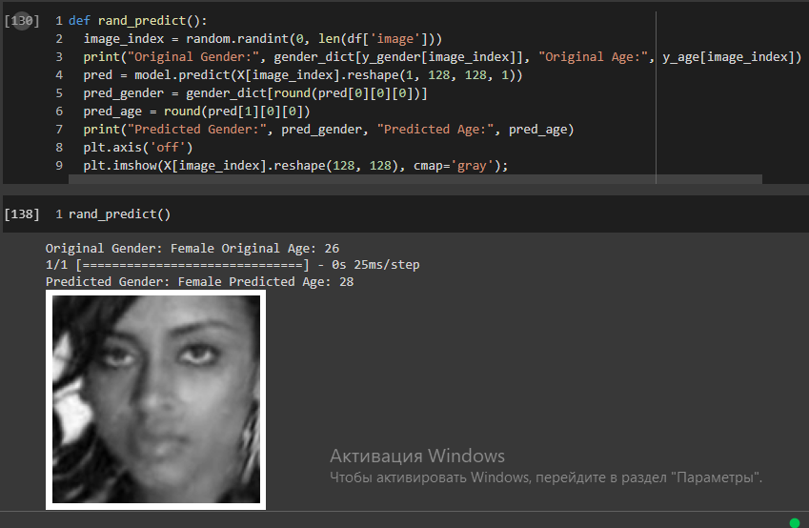

Methods

The dataset contained photos that were named this way:

‘age’_‘gender’_‘ethnicity’

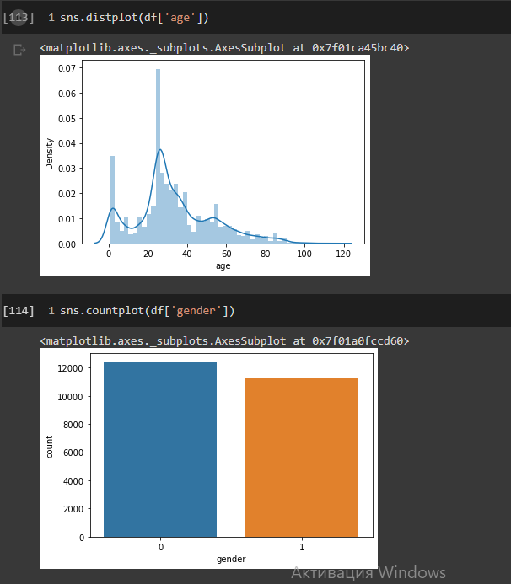

We can find that this set contains equally divided on males and females and majority of the photos belongs to 26-year-olds

Results

By using this command, images of representatives of different genders have been displayed as a result.

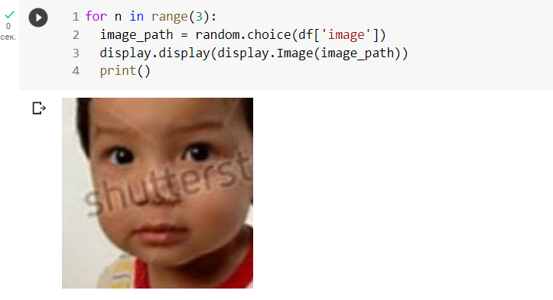

The usage of “prediction” command helped us to illustrate man’s image and predict possible data about him.

