■ Description of the ML models you used with some theory  
 ○ Results

By using this command, images of representatives of different genders have been displayed as a result.

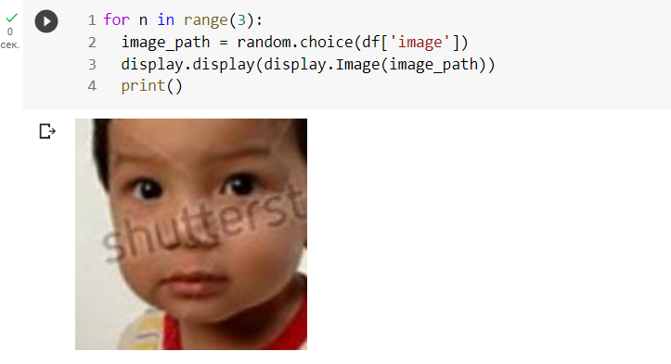

The usage of “prediction” command helped us to illustrate man’s image and predict possible data about him.

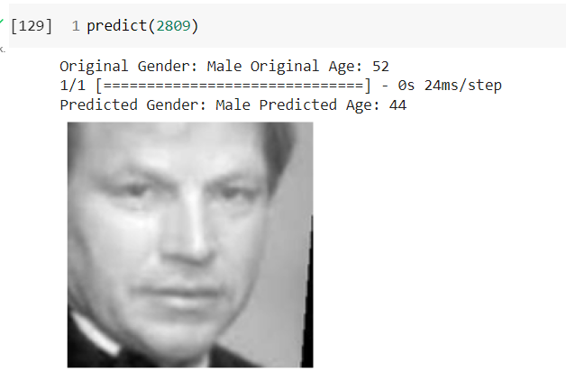

The “rand_predict()” command has generated woman’s image and predicted her age.

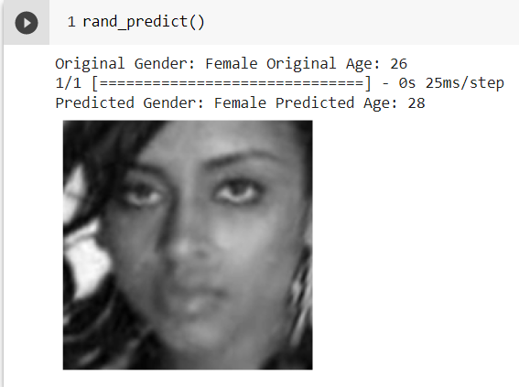

As a result, we have received the model of predicting age and gender of individual, at the same time the image has been displayed as an output. The main goal of the achievement of a task has been reached, our accuracy was 92%, it allows user to predict specific information with high level of precision.