JAMES EINOSUKE STANTON  
19TH OCTOBER 2017

GAME TITLE



ANDROID  
ESRB Teen 13+

CONCEPT OVERVIEW

**SILENT KNIGHT** is a **3D MOBILE DUNGEON CRAWLER**, portraying the escape of a lone knight trapped in an unfamiliar dungeon. Fighting monsters, navigating obstacles and solving puzzles, **TETSUO** presses onwards an upwards towards what he believes to be the exit. Will he escape? Will he run out of time? Or will he become just another victim of his mysterious prison? It’s up to **YOU** to decide.

Playing as Tetsuo, the player must explore consecutive procedurally generated ‘dungeons’ while attempting to clear each zone within the allocated time. While the monsters, obstacles and puzzles become more challenging between levels, **TETSUO** also increases in power through stat increases and ability progression.

During each level, the player handles ability usage (including special attacks that require charging up, gained by successfully defeating challenges) and jumping. Different monsters, obstacles and puzzles all stand between the player and the end of the level, and the player must bypass a combination of these to progress. At the end of the final level, a boss will try one last time to stop **TETSUO** from escaping the dungeon.

UNIQUE SELLING POINTS  
5 procedurally generated levels  
Race against the clock or die trying  
Dynamic, hack and slash combat  
Variety of traps and obstacles  
Gain strength and abilities as you play  
Use a combination of skill, wit and brute force to progress  
Compete with your friends via Google Play Leaderboards

SIMILAR COMPETETIVE PRODUCTS  
Nonstop Knight  
Diablo 3  
Dungeon Siege II  
Rogue Legacy

GANTT CHART LINK

[CLICK HERE](https://drive.google.com/file/d/0B86BRDvukOfjSjlPb0hDZWFTZ1U/view?usp=sharing)

MOSCOW ANALYSIS

|  |  |
| --- | --- |
| MUST HAVE | SHOULD HAVE |
| Google Play Leaderboards integration  Block based procedurally 3D world with JRPG aesthetic  5 different enemy types + 1 scripted boss  3 unique offensive abilities  5 different puzzles and obstacles  UI showing ability power, time and combat information Auto-pathed passive locomotion  On screen controls | Fully animated, textured models  Baked Lighting Basic storyline delivery with scripted cutscenes  Defensive and utility abilities (double jumps, guarding etc.)  Built in unobtrusive advertisements  Link to my website  Classic RPG soundtrack (royalty free)  Full Localisation for Japanese and English |

|  |  |
| --- | --- |
| COULD HAVE | WON’T HAVE |
| Configuration options for sound, graphics etc. SFX made by me  Multiple playable characters Unlockable cosmetic items  Distinction between paid / free version Jukebox system for music selection | High poly models  High resolution textures  Voice acting Video cutscenes Persistent progression  Analytics |

MOCK UP IMAGE

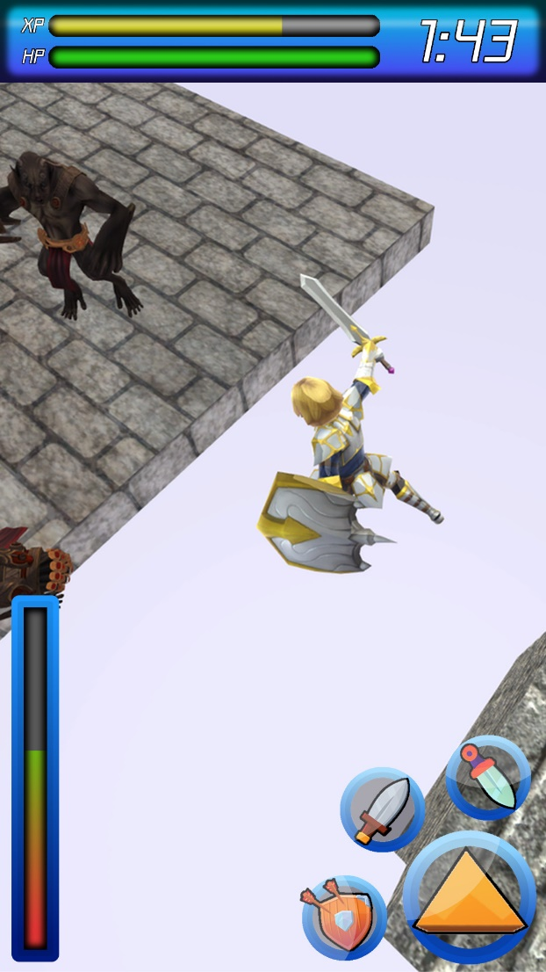

References

1. https://esrb.org (2012). *ESRB Ratings* [online] Available at: <https://goo.gl/ewgL7T> [Accessed 12/10/2017].
2. Rogers, S. (2015). *Level Up! The Guide to Great Video Game Design*. 2nd ed. Somerset: Wiley.
3. https://smartsheet.com (2015). *How to use the Gantt chart Excel template* [online] Available at <https://goo.gl/RdXFZa> [Accessed 14/10/2017].
4. Agarwal, A (2015). Digital Inspiration [blog]. *Find the Date When a Web Page was First Published on the Internet*. Available at: <https://goo.gl/oEadzn> [Accessed 13/10/2017].
5. http://sgr.blog.jp (2015). *6 Things you should never do when designing mobile UI/UX* (In Japanese) [online] Available at: <https://goo.gl/CTYKHh> [Accessed 19/10/2017].