1. **Write about the Sagemaker instance you created, including a justification of why you chose the instance type you did.**

* 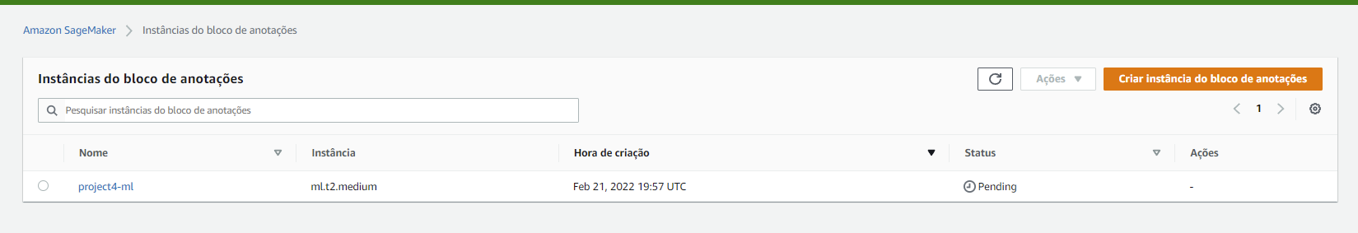 I have chosen the “ml.t2.medium” instance type for Notebook instance because for completing the execution of this particular project’s jupyter notebooks we do not need a very computationally powerful CPU and high RAM. But We will need to keep this notebook instance in “in Service” status for a long time while we are working on the project So, avoid high costs we should select a notebook that is low in per hour cost and also offers reasonably good CPU and RAM.

1. **Upload data into my S3**

The dog breed dataset for this was uploaded to a newly created S3 bucket, successfully.