**Task 3**

1. **Knowledge Discovery in Databases (KDD) Process**

**The Knowledge Discovery in Databases (KDD) process refers to the overall framework for discovering useful knowledge from data. It includes multiple stages, starting from raw data handling to extracting meaningful patterns. The main stages of KDD are:**

1. **Data Selection: Choosing relevant data from multiple sources.**
2. **Data Preprocessing: Cleaning the data by handling missing values, noise, and inconsistencies to ensure data quality.**
3. **Data Transformation: Normalizing, aggregating, and constructing features suitable for modeling.**
4. **Data Mining: Applying machine learning or statistical techniques to extract meaningful patterns.**
5. **Interpretation/Evaluation: Making sense of the discovered patterns, validating findings, and translating them into actionable insights.**

**In this project, we followed the KDD process by carefully selecting, cleaning, transforming, and analyzing Bitcoin historical data to prepare it for accurate predictive modeling.**

## Missing Value Handling Strategy

**In our Bitcoin price prediction project, we observed significant missing values in the btc_trade_volume attribute. After a detailed gap analysis, we identified seven major gaps, ranging from small (3 days) to extremely large (367 days). Based on this, we designed a two-step missing value handling strategy that respects the time-series nature of the data:**

**First, we applied a 22-day moving average to the btc_trade_volume attribute to interpolate missing values whenever sufficient historical data was available. By setting the window to 22 days, we ensured that missing periods of up to approximately 3 weeks could be realistically smoothed based on local temporal behavior. This approach preserves short-term trends and volatility patterns critical for time-series forecasting.**

**Second, for longer or consecutive gaps where moving averages could not be calculated (especially gaps exceeding 3 weeks or where too much data was missing), we used a forward-fill technique. Forward-fill logically propagates the last known valid value forward, maintaining temporal continuity without introducing unrealistic artificial smoothing.**

**This combined strategy — moving average for small gaps and forward fill for large gaps — allowed us to balance realism and completeness in the dataset. It ensures that all missing values are handled effectively while minimizing distortion of Bitcoin's dynamic behavior over time.**

## Normalization of Selected Features

**Following the completion of missing value handling, we performed feature normalization to prepare the data for modeling. We applied the Z-transformation (statistical normalization) method to the selected predictor attributes. This normalization technique centers each attribute around a mean of zero and scales to a unit variance, ensuring consistent feature scaling across the dataset.**

**The following attributes were normalized:**

* **btc_trade_volume**
* **btc_n_transactions**
* **btc_estimated_transaction_volume_usd**
* **btc_difficulty**
* **btc_hash_rate**
* **btc_miner_revenue**
* **btc_transaction_fees**
* **btc_total_bitcoins**
* **btc_market_cap**

**The target variable btc_market_price was preserved in its original scale to maintain interpretability during prediction. Z-transformation normalization was chosen to make the dataset more robust against the influence of outliers while maintaining the integrity of underlying distributions.**

## Visualization and Outlier Analysis

**After normalization, we visually inspected the dataset to detect the presence of outliers and analyze the distribution of features. Three types of visualizations were generated:**

* **Histograms: Showed that most features are centered around zero as expected after Z-transformation, with some attributes exhibiting right-skewed distributions.**
* **Scatter Plots: Illustrated feature behavior over time, highlighting increasing activity and transaction values as Bitcoin adoption grew. No sudden inconsistencies were detected.**
* **Boxplots: Revealed that while several attributes have natural outliers (long whiskers), these are consistent with expected volatility in financial markets such as Bitcoin.**

**Since no unrealistic or corrupted outliers were identified, we decided to retain all observations without removing or capping any values, ensuring the integrity of the real-world behavior reflected in the dataset.**

## Observations from the Visualizations

**1. Histogram:**

* **Most attributes are tightly clustered around 0, which is expected after Z-transformation ✅.**
* **Some attributes have a long right tail (positive side), which is normal for Bitcoin transactional data (spikes happen).**

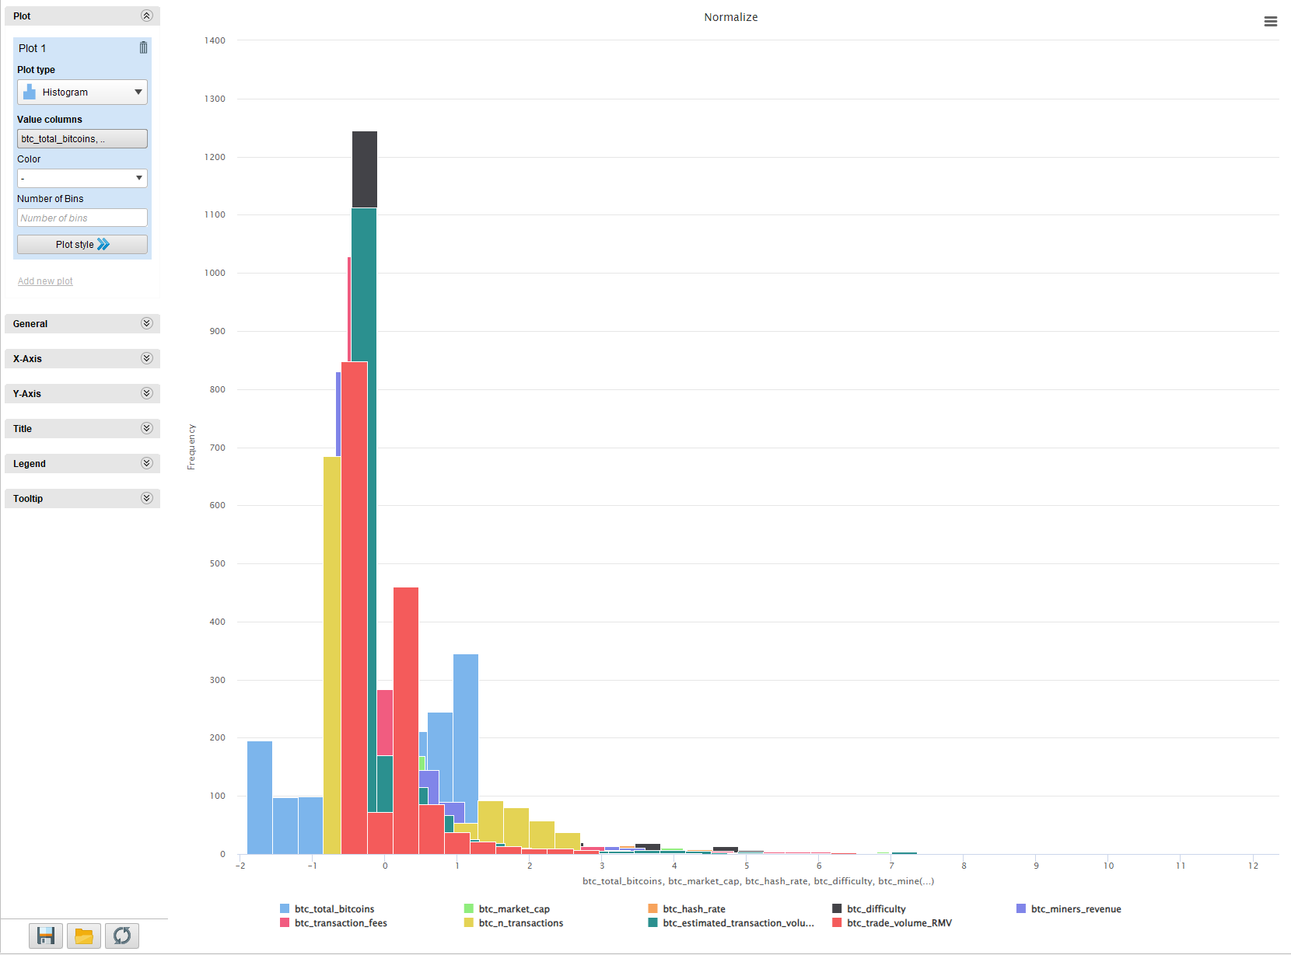

**2. Scatter Plot:**

* **Some scatter spread is visible especially after 2012–2013 — you can see the explosion in activity (volume, transactions, etc.) as Bitcoin became more popular.**
* **No sudden weird "jumps" or "holes" — ✅ good clean dataset overall.**

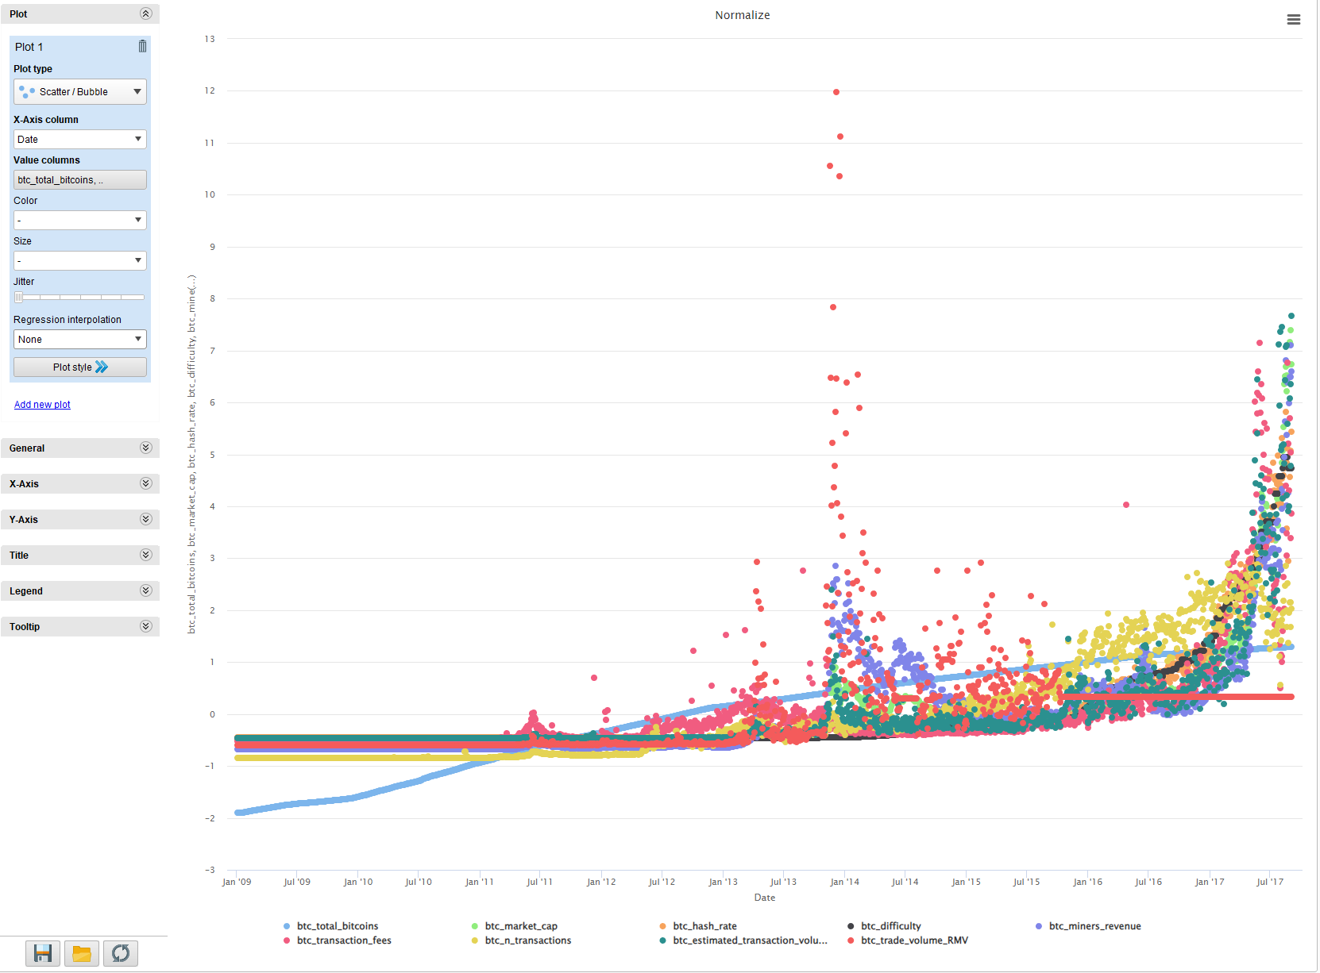

**3. Boxplot:**

* **Boxplots show that some attributes have extremely tall whiskers — meaning:**
  + **There are natural outliers (real financial market behavior).**
  + **Bitcoin is volatile — so this is expected.**
* **There are no crazy isolated outliers way outside the whiskers (like points at 20–30 units away) — ✅ so we don't need to forcibly remove any values.**

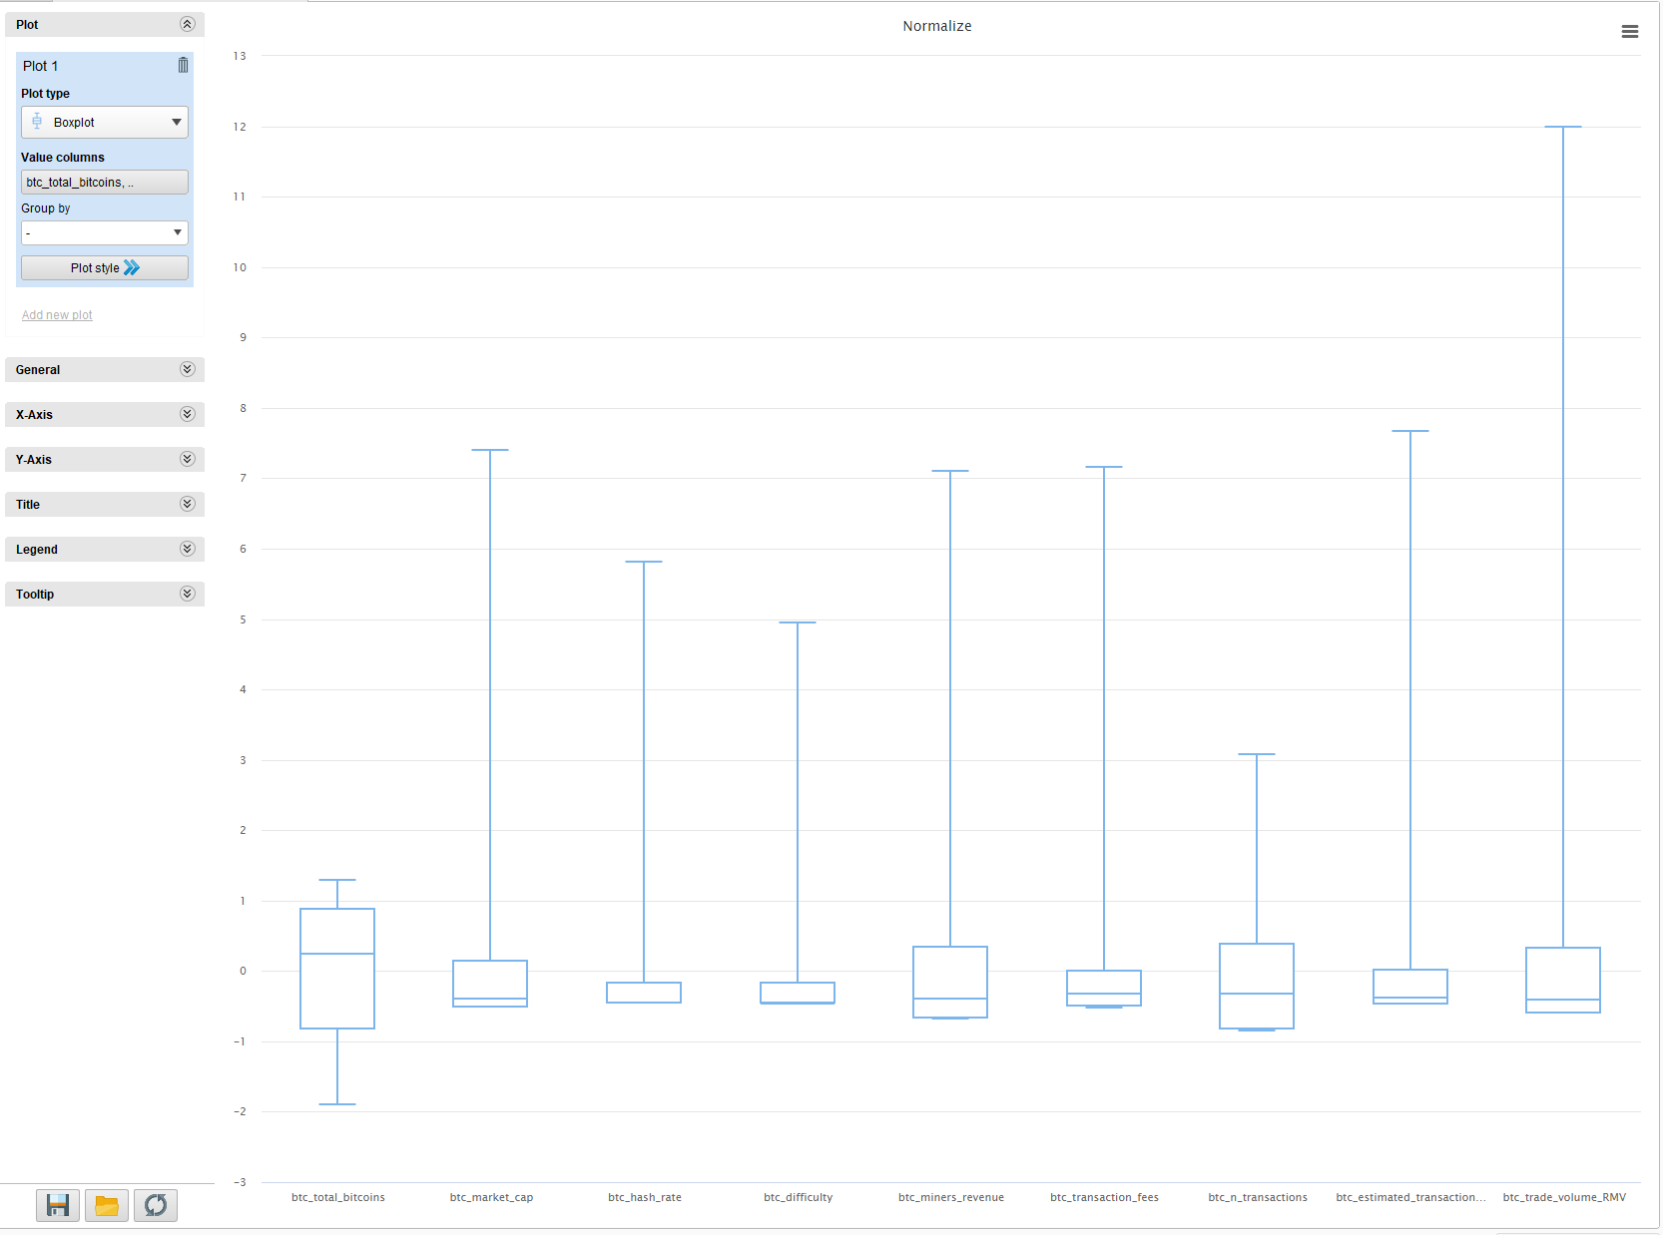

## ****PCA Visualization Explanation****

**After applying Principal Component Analysis (PCA) on the normalized dataset, the dimensionality was reduced from nine original attributes to four principal components. A scatter plot was created to visualize the distribution of examples along the first two principal components (PC1 and PC2).**

**The scatter plot revealed the main patterns in the dataset, capturing the majority of the variance using only two axes. Some natural clusters and spread trends were visible, indicating that the primary variance directions were successfully captured during dimensionality reduction.**

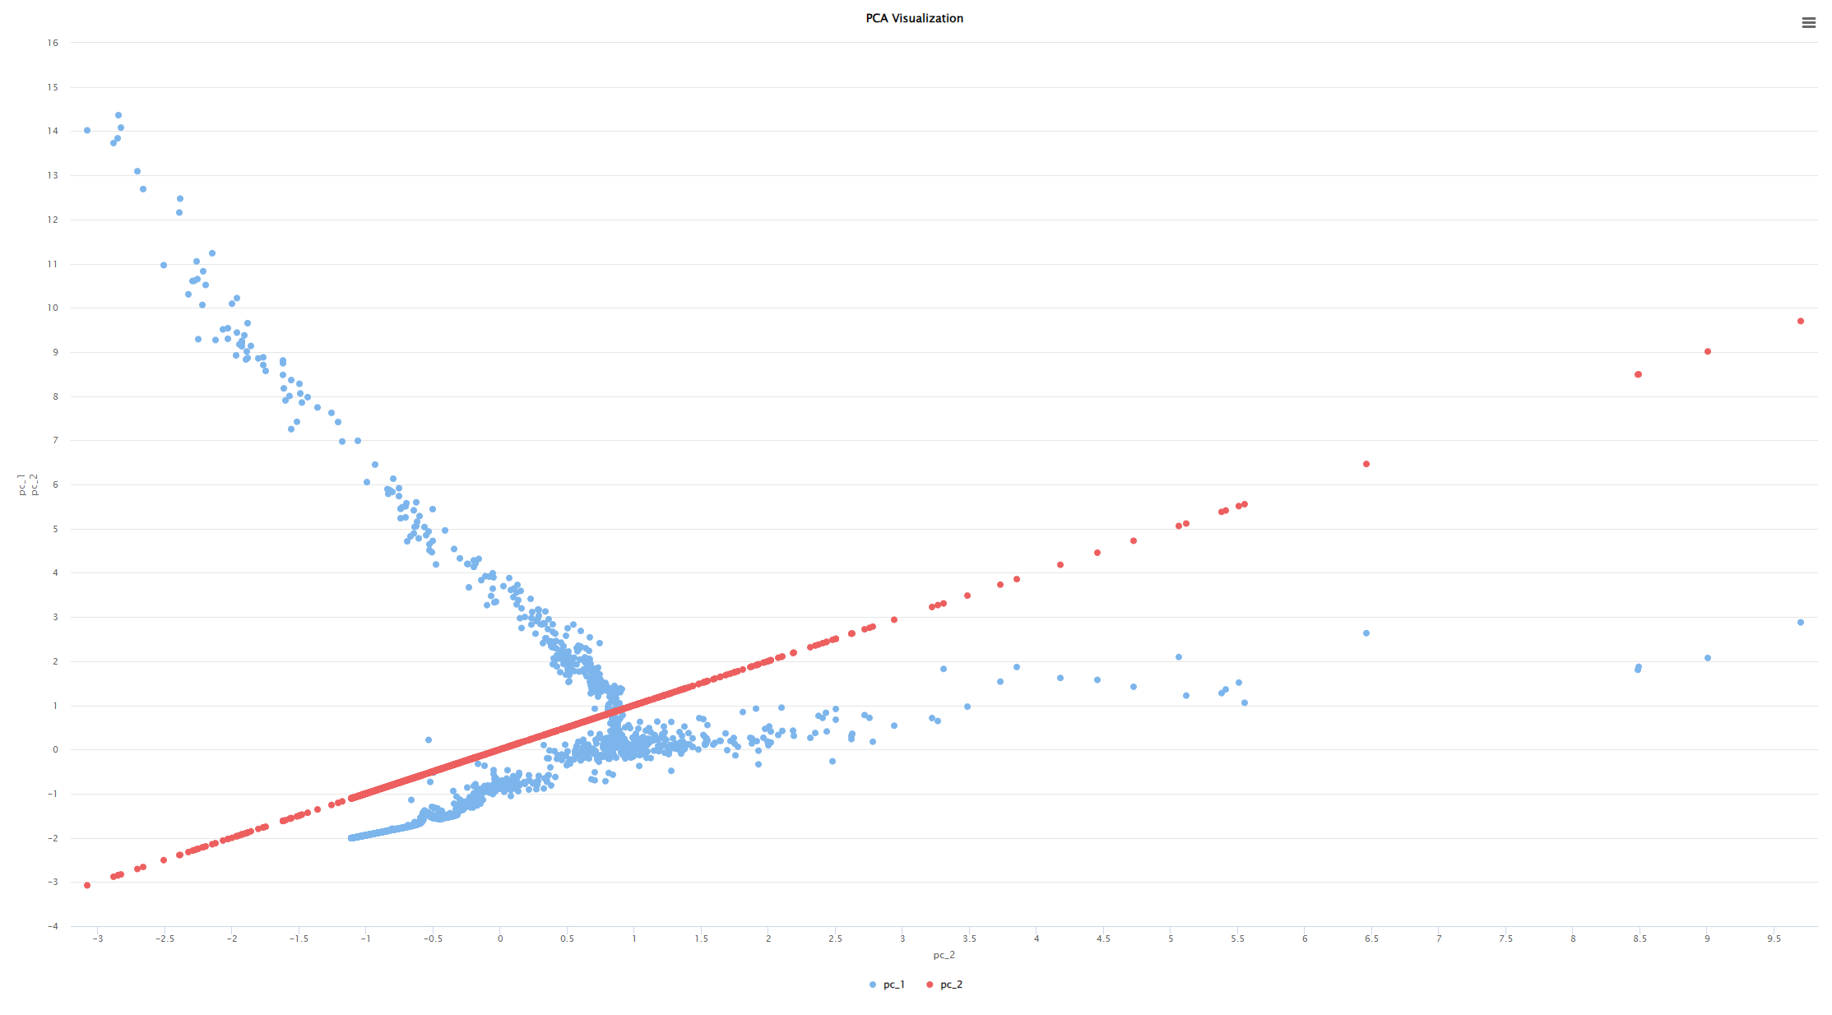

## ****Comparison of Initial and Preprocessed Data****

**Initially, the Bitcoin dataset contained missing values, uneven feature scales, and potential redundancies, making it unsuitable for direct modeling. After careful preprocessing, the data quality was significantly improved.**

**Missing values in key attributes, such as btc_trade_volume, were intelligently handled through a hybrid approach of moving averages and forward-fill techniques, ensuring no data loss while maintaining temporal consistency. Normalization was applied using Z-transformation, centering numeric attributes around a mean of zero and unit variance to standardize the scales across features.**

**Principal Component Analysis (PCA) was performed as a dimensionality reduction technique to explore the variance structure of the dataset. Visualization of the first two principal components confirmed that the majority of meaningful patterns in the original data were captured effectively in a reduced space.**

**Overall, the preprocessed dataset is now clean, normalized, free of missing values, and suitable for effective modeling and analysis, while preserving the critical real-world behavior observed in Bitcoin market data.**

## Task 3: Preprocessing — Final Summary

**In Task 3, we carefully prepared the Bitcoin dataset for modeling by addressing missing values, normalization, dimensionality reduction, and outlier detection. The following steps were completed:**

1. **Knowledge Discovery in Databases (KDD) Process Explanation:  
   We began by following the KDD process, which involves data selection, preprocessing, transformation, data mining, and interpretation. This structured approach ensured a systematic preparation of the Bitcoin dataset for analysis.**
2. **Missing Value Handling:  
   Missing values in the btc_trade_volume attribute were addressed using a hybrid two-step approach. We first applied a 22-day moving average to interpolate small gaps, preserving local trends. Remaining missing values, particularly in larger gaps, were filled using forward-fill (previous value propagation), ensuring temporal continuity without introducing artificial patterns.**
3. **Feature Selection:  
   Attributes were carefully reviewed and selected based on their relevance to Bitcoin price prediction. Non-informative or redundant attributes were excluded to streamline the dataset and avoid unnecessary noise.**
4. **Normalization:  
   Selected numeric features were normalized using Z-transformation (statistical normalization), centering them around a mean of zero and scaling them to unit variance. This step ensures consistent feature scaling, improving model training efficiency and stability.**
5. **Visualization and Outlier Analysis:  
   Histograms, scatter plots, and boxplots were generated to visually inspect the dataset. While natural outliers were observed due to Bitcoin's volatility, no unrealistic or erroneous data points were found. As a result, no outliers were removed, preserving the real-world behavior of Bitcoin markets.**
6. **Dimensionality Reduction (PCA):  
   Principal Component Analysis (PCA) was applied to the normalized dataset to reduce dimensionality and capture the major variance patterns in fewer synthetic features. The first two principal components (PC1 and PC2) were visualized through scatter plots, confirming that the primary information of the original dataset was effectively retained.**
7. **Comparison of Initial vs Preprocessed Data:  
   After preprocessing, the dataset transitioned from a noisy, inconsistent state to a clean, normalized, and variance-optimized form. The original dataset contained missing values and uneven scaling, whereas the preprocessed version is complete, standardized, and ready for modeling, while still preserving meaningful patterns and natural behaviors observed in Bitcoin market dynamics.**

**Through these steps, we ensured the dataset is clean, well-structured, and fully prepared for feature engineering and modeling in the next phases of the project.**

## Operator Flow Explanation for Task 3

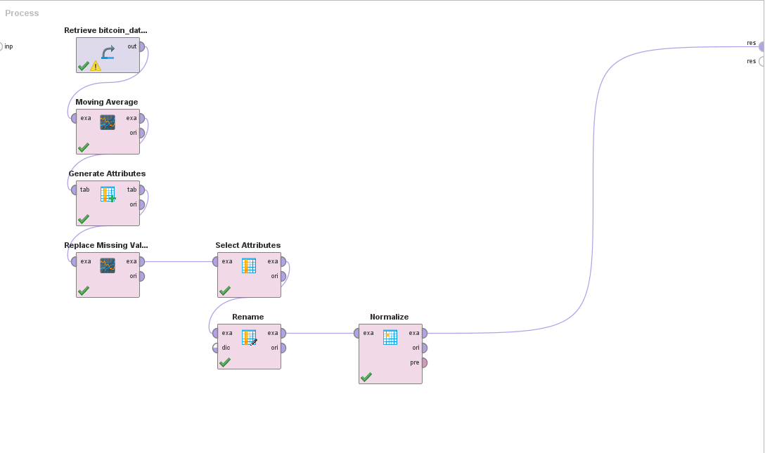

**1-📂 Retrieve (Retrieve bitcoin_dataset)**

* **Purpose: Load the original Bitcoin dataset into the process.**
* **Why: This is where all the raw data comes from.**

**2-📈 Moving Average**

* **Purpose: Create a smoothed version of btc_trade_volume by calculating a 22-day moving average.**
* **Why: To fill small missing gaps using real historical patterns.**

**3-🧮 Generate Attributes**

* **Purpose: Create a new column that uses the moving average to replace missing values, but keeps original values when available.**
* **Why: Combine original values and moving averages into one clean feature.**

**4-🔁 Replace Missing Values**

* **Purpose: Fill any remaining missing values in the btc_trade_volume column by using the previous known value (forward fill).**
* **Why: To make sure there are no missing values left, especially in large gaps.**

**5-📋 Select Attributes**

* **Purpose: Choose only the important columns we want to keep (like btc_market_price, btc_trade_volume, etc.).**
* **Why: Remove temporary or unnecessary columns and clean the dataset for next steps.**

**6-✏️ Rename**

* **Purpose: Rename the final filled volume column (e.g., btc_trade_volume_RMV) to a clean name (btc_trade_volume).**
* **Why: Standardize column names so it's clear and easier for modeling later.**

**7-📏 Normalize**

* **Purpose: Apply Z-transformation to selected numeric columns to center them around 0 and scale them to unit variance (standard deviation = 1).**
* **Why: Helps models treat all features fairly, and improves model learning and stability.**

**📚 Answer 2: What if we used Moving Average on large gaps (40–367 days)?**

👉 It would **fail badly** or give **wrong artificial values**.

Why?

* In large gaps, the previous 22 days (or even 50 days) are often missing too.
* **Moving Average would either:**
  + Fail to calculate (no enough non-missing points).
  + Calculate a meaningless value based on unrelated points far back in time.
* It would **fabricate fake gradual movements** in long empty periods where Bitcoin might have actually spiked, crashed, or done nothing at all.

✅ **Forward Fill** in long gaps simply says:

"I don't know new information, so I’ll repeat the last known situation."

This is **much more honest and safer** in data science.