BankFlow
Software Design Document
Version 1.0
April 2026

Table of Contents

1. Introduction
This document specifies the software design of BankFlow, a configurable banking case orchestration platform. BankFlow enables authorized users to design banking case flows visually, create live cases against those flows, route work between operators and teams, enforce approvals and SLA deadlines, and maintain a full audit trail of every significant action. It is intended for developers, database administrators, reviewers, and anyone responsible for extending or maintaining the system.
The design described here is the low-level companion to the BankFlow Product Requirements Document. It covers the target architecture, the relational data model, the runtime orchestration model, the reusable node library, the use cases that exercise the platform end to end, and the graphical user interface that operators, approvers, supervisors, and administrators use day to day.
BankFlow owns the case lifecycle. The platform is the source of truth for cases, human tasks, approvals, escalations, SLA deadlines, and audit events. An n8n automation worker is used only for automation and integration nodes (for example notifications, external API calls, and data enrichment). This separation is the most important architectural decision in the system and is reflected throughout this document.

1.1 Scope
The MVP described in this document supports end-to-end case orchestration for five banking use cases: AML alert review, payment exception handling, KYC refresh, dormant account flagging, and regulatory report generation. The platform is designed so that additional case types can be added by authoring new case flows in the visual builder, without modifying application code.

2. System Architecture
BankFlow is deployed as a small set of cooperating services. A React frontend communicates with an Express backend over REST. The backend persists state to PostgreSQL through Prisma, invokes an n8n automation worker for system-level actions, and stores supporting documents on a shared file volume. Two lightweight scheduler services run inside the backend: an SLA scheduler that detects overdue tasks and triggers escalations, and an intake scheduler that evaluates case flow schedules and creates scheduled cases at their configured cadence.

2.1 High-Level Architecture
The high-level architecture diagram summarizes how users reach the system, which services are involved, and how case state flows between them. BankFlow always owns case state; n8n is called only when a node requires automation support.
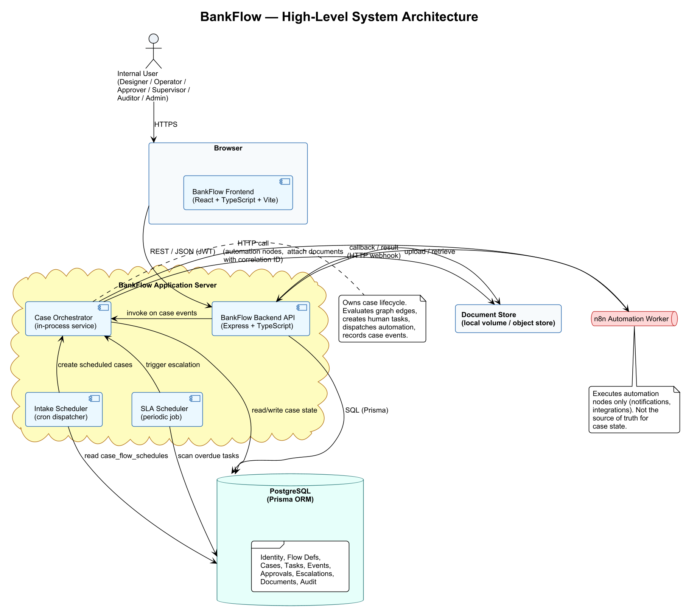
Figure 1 — BankFlow High-Level System Architecture

2.2 Backend Component Structure
Inside the backend, responsibilities are split across three layers. The API layer exposes HTTP routes organized by resource (flows, cases, tasks, approvals, documents, dashboard, admin). The service layer contains domain services that own reads and writes for each resource and delegate to the runtime when case state must advance. The runtime layer contains the case orchestrator, per-node executors, the SLA and intake schedulers, and the automation client that calls n8n with correlation identifiers.
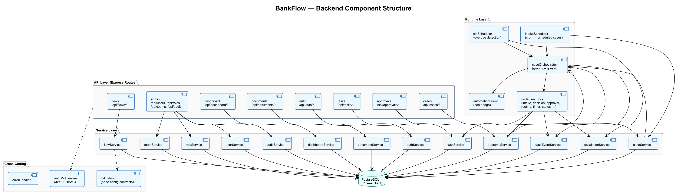
Figure 2 — Backend Component Structure

2.3 Correlation Between BankFlow and n8n
Every call from BankFlow to n8n carries a correlation object containing the case identifier, the case flow version, the node key, the case event identifier, and (when relevant) the task identifier. When n8n completes an automation action, it posts the result back to a BankFlow callback endpoint along with the same correlation identifiers. The backend writes the result to the exact case event that triggered it. This avoids the common mistake of looking up the most recent execution and attributing an unrelated result to the current case.

3. Database Design
The BankFlow database is organized into four logical groupings: Identity and Access, Case Flow Definition, Case Runtime, and Audit. All tables live in a single Postgres schema managed by Prisma. The diagram below shows the entity model, including all primary keys, foreign key relationships, and the grouping of entities by concern.

3.1 Enhanced Entity Relationship Diagram
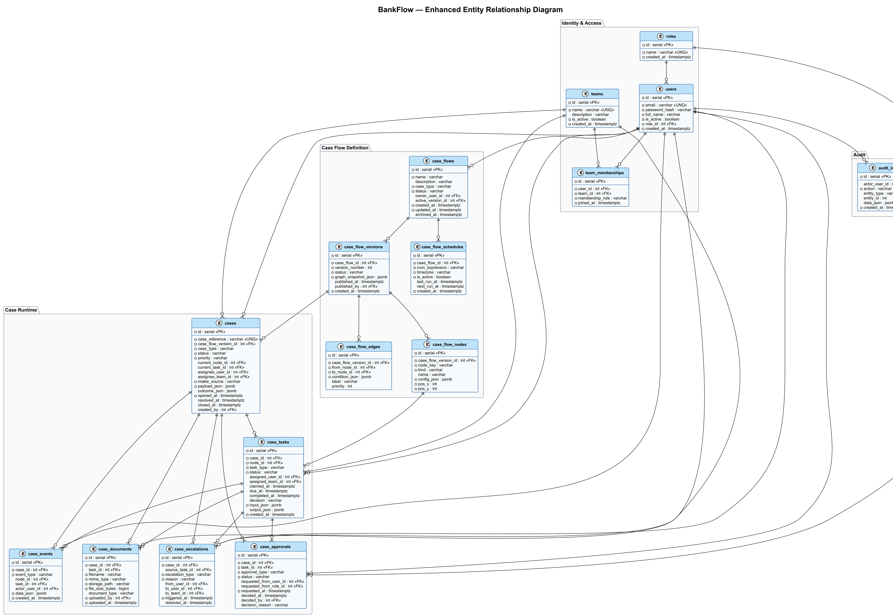
Figure 3 — BankFlow Enhanced Entity Relationship Diagram

3.2 Tables and Views Structure
The sections below document each table in the order they appear in the ERD. Views defined on top of these tables are documented at the end of the section.

Inventory
- Identity & Access: roles, users, teams, team_memberships
- Case Flow Definition: case_flows, case_flow_versions, case_flow_nodes, case_flow_edges, case_flow_schedules
- Case Runtime: cases, case_tasks, case_approvals, case_escalations, case_events, case_documents
- Audit: audit_logs
- Views: v_active_cases_by_queue, v_overdue_tasks, v_pending_approvals, v_case_timeline

Table: roles
Purpose | Defines the named roles that can be assigned to users (for example Admin, Designer, Operator, Approver, Supervisor, Auditor).
When it's written | Seeded on installation; occasionally extended by administrators to model new banking-operations personas.

Columns
Column | Type | Null | Default | Key | Notes
id | serial | NO |  | PK
name | varchar | NO |  | UNQ | Role display name
created_at | timestamptz | NO | now()

Constraints
- UNIQUE (name)
Indexes
- — (unique constraint covers lookups)
Relationships
- Parent of: users.role_id, case_approvals.requested_from_role_id

Table: users
Purpose | Internal user accounts that authenticate to BankFlow and perform operational work. Each user holds a single role.
When it's written | Created by administrators; activation status toggled when a user joins or leaves.

Columns
Column | Type | Null | Default | Key | Notes
id | serial | NO |  | PK
email | varchar | NO |  | UNQ | Case-sensitive unique
password_hash | varchar | NO |  |  | bcrypt hash
full_name | varchar | NO
is_active | boolean | NO | true
role_id | int | NO |  | FK → roles.id
created_at | timestamptz | NO | now()

Constraints
- UNIQUE (email)
- FK (role_id) → roles.id ON DELETE RESTRICT
Indexes
- idx_users_role_id on (role_id)
Relationships
- Parent of: case_flows.owner_user_id, cases.assignee_user_id / created_by, case_tasks.assigned_user_id, case_approvals.decided_by / requested_from_user_id, case_escalations.from_user_id / to_user_id, case_events.actor_user_id, case_documents.uploaded_by, audit_logs.actor_user_id, team_memberships.user_id, case_flow_versions.published_by

Table: teams
Purpose | Operational groupings such as AML analyst teams, payment operations teams, compliance teams, and approval authorities. Cases and tasks can be routed to a team rather than a named user.
When it's written | Created and maintained by administrators as the operations organization evolves.

Columns
Column | Type | Null | Default | Key | Notes
id | serial | NO |  | PK
name | varchar | NO |  | UNQ
description | varchar | YES
is_active | boolean | NO | true
created_at | timestamptz | NO | now()

Constraints
- UNIQUE (name)
Relationships
- Parent of: team_memberships.team_id, cases.assignee_team_id, case_tasks.assigned_team_id, case_escalations.to_team_id

Table: team_memberships
Purpose | Associates users with teams. A user can belong to multiple teams and hold a team-scoped membership role (for example member, lead, approver).
When it's written | Modified when users join, leave, or change team responsibilities.

Columns
Column | Type | Null | Default | Key | Notes
id | serial | NO |  | PK
user_id | int | NO |  | FK → users.id
team_id | int | NO |  | FK → teams.id
membership_role | varchar | NO | 'member' |  | member / lead / approver
joined_at | timestamptz | NO | now()

Constraints
- UNIQUE (user_id, team_id)
Indexes
- idx_tm_user on (user_id)
- idx_tm_team on (team_id)
Relationships
- Child of: users, teams

Table: case_flows
Purpose | A reusable case flow definition (for example AML Alert Review). Each case flow can have multiple versions; only one is active at a time. The active version is the one that new cases start on.
When it's written | Created by designers and updated as processes change; archived when retired.

Columns
Column | Type | Null | Default | Key | Notes
id | serial | NO |  | PK
name | varchar | NO
description | varchar | YES
case_type | varchar | NO |  |  | aml_alert, payment_exception, kyc_refresh, dormant_account, regulatory_report, ...
status | varchar | NO | 'draft' |  | draft / published / archived
owner_user_id | int | YES |  | FK → users.id
active_version_id | int | YES |  | FK → case_flow_versions.id | Deferred FK to resolve circular reference
archived_at | timestamptz | YES
created_at | timestamptz | NO | now()
updated_at | timestamptz | NO | now()
Indexes
- idx_case_flows_owner on (owner_user_id)
- idx_case_flows_status on (status)
Relationships
- Parent of: case_flow_versions, case_flow_schedules

Table: case_flow_versions
Purpose | An immutable snapshot of a case flow's graph at publish time. New cases reference a specific version, so edits to a flow do not disturb in-flight cases.
When it's written | Inserted when a designer publishes a flow; existing versions are never modified.

Columns
Column | Type | Null | Default | Key | Notes
id | serial | NO |  | PK
case_flow_id | int | NO |  | FK → case_flows.id
version_number | int | NO |  |  | Monotonic per case_flow_id
status | varchar | NO | 'draft' |  | draft / published / retired
graph_snapshot_json | jsonb | NO | '{}' |  | Materialized graph for fast load
published_at | timestamptz | YES
published_by | int | YES |  | FK → users.id
created_at | timestamptz | NO | now()

Constraints
- UNIQUE (case_flow_id, version_number)
Indexes
- idx_cfv_flow on (case_flow_id)
- idx_cfv_status on (status)
Relationships
- Parent of: case_flow_nodes, case_flow_edges, cases

Table: case_flow_nodes
Purpose | Nodes of a flow version's graph. Each node has a kind (for example case_intake, decision, approval, routing, notification, timer_sla) and a kind-specific configuration payload.
When it's written | Written when a flow version is published or when the version snapshot is materialized.

Columns
Column | Type | Null | Default | Key | Notes
id | serial | NO |  | PK
case_flow_version_id | int | NO |  | FK → case_flow_versions.id
node_key | varchar | NO |  |  | Stable identifier used by edges and runtime
kind | varchar | NO |  |  | case_intake, data_capture, approval, decision, routing, notification, document_upload, logger, integration, timer_sla, status_update, escalation
name | varchar | YES
config_json | jsonb | NO | '{}' |  | Kind-specific config; validated on save
pos_x | int | NO | 0
pos_y | int | NO | 0

Constraints
- UNIQUE (case_flow_version_id, node_key)
Indexes
- idx_cfn_version on (case_flow_version_id)
Relationships
- Parent of: case_flow_edges.from_node_id / to_node_id, case_tasks.node_id, case_events.node_id, cases.current_node_id

Table: case_flow_edges
Purpose | Directed edges between nodes. An edge may carry a condition used by the orchestrator to choose between branches (for example at a decision node).
When it's written | Written when a flow version is published.

Columns
Column | Type | Null | Default | Key | Notes
id | serial | NO |  | PK
case_flow_version_id | int | NO |  | FK → case_flow_versions.id
from_node_id | int | NO |  | FK → case_flow_nodes.id
to_node_id | int | NO |  | FK → case_flow_nodes.id
condition_json | jsonb | NO | '{}' |  | Evaluated by decision node executor
label | varchar | YES |  |  | For example 'approve' / 'reject'
priority | int | NO | 0 |  | Order of evaluation when multiple edges match

Constraints
- CHECK (from_node_id <> to_node_id)
Indexes
- idx_cfe_version on (case_flow_version_id)
- idx_cfe_from on (from_node_id)
- idx_cfe_to on (to_node_id)
Relationships
- Child of: case_flow_versions, case_flow_nodes (as from / to)

Table: case_flow_schedules
Purpose | Cron schedules attached to case flows that support scheduled intake (for example KYC refresh cycles, dormant account scans, regulatory report deadlines). The intake scheduler service evaluates these on a recurring loop.
When it's written | Created by designers when they enable scheduled intake on a flow; disabled when the schedule should pause.

Columns
Column | Type | Null | Default | Key | Notes
id | serial | NO |  | PK
case_flow_id | int | NO |  | FK → case_flows.id
cron_expression | varchar | NO |  |  | Standard five-field cron
timezone | varchar | NO | 'UTC' |  | IANA timezone identifier
is_active | boolean | NO | true
last_run_at | timestamptz | YES
next_run_at | timestamptz | YES |  |  | Recomputed each tick
created_at | timestamptz | NO | now()
Indexes
- idx_cfs_active_next on (is_active, next_run_at)
Relationships
- Child of: case_flows

Table: cases
Purpose | Live instances of a case flow. A case has a lifecycle status, a current node, a current task, an assignee (user or team), and a payload that accumulates as the case progresses.
When it's written | Created when a case is initiated through manual intake, API intake, or the intake scheduler; updated throughout the case lifecycle.

Columns
Column | Type | Null | Default | Key | Notes
id | serial | NO |  | PK
case_reference | varchar | NO |  | UNQ | Human-friendly reference, for example AML-2026-000123
case_flow_version_id | int | NO |  | FK → case_flow_versions.id
case_type | varchar | NO |  |  | Denormalized from flow for fast filtering
status | varchar | NO | 'intake' |  | intake / in_review / pending_action / pending_approval / escalated / resolved / closed / cancelled
priority | varchar | NO | 'normal' |  | low / normal / high / urgent
current_node_id | int | YES |  | FK → case_flow_nodes.id | Denormalized pointer
current_task_id | int | YES |  | FK → case_tasks.id | Denormalized pointer
assignee_user_id | int | YES |  | FK → users.id
assignee_team_id | int | YES |  | FK → teams.id
intake_source | varchar | NO |  |  | manual / api / scheduled
payload_json | jsonb | NO | '{}' |  | Case data accumulated during processing
outcome_json | jsonb | YES |  |  | Final decision and outcome details
opened_at | timestamptz | NO | now()
resolved_at | timestamptz | YES
closed_at | timestamptz | YES
created_by | int | YES |  | FK → users.id

Constraints
- UNIQUE (case_reference)
- CHECK (assignee_user_id IS NULL OR assignee_team_id IS NULL OR assignee_user_id IS NOT NULL AND assignee_team_id IS NOT NULL)
Indexes
- idx_cases_status on (status)
- idx_cases_assignee_user on (assignee_user_id)
- idx_cases_assignee_team on (assignee_team_id)
- idx_cases_type_status on (case_type, status)
- idx_cases_opened_at on (opened_at)
Relationships
- Parent of: case_tasks, case_events, case_approvals, case_escalations, case_documents

Table: case_tasks
Purpose | A unit of human or automated work required for a case to progress. Human tasks have claim / complete / reassign semantics; automation tasks are created and resolved by the orchestrator.
When it's written | Created by the orchestrator when a node demands work; updated as the task is claimed, completed, or escalated.

Columns
Column | Type | Null | Default | Key | Notes
id | serial | NO |  | PK
case_id | int | NO |  | FK → cases.id
node_id | int | NO |  | FK → case_flow_nodes.id
task_type | varchar | NO |  |  | human_review / approval / data_capture / document_upload / automation
status | varchar | NO | 'pending' |  | pending / assigned / claimed / completed / rejected / cancelled / overdue
assigned_user_id | int | YES |  | FK → users.id
assigned_team_id | int | YES |  | FK → teams.id
claimed_at | timestamptz | YES
due_at | timestamptz | YES |  |  | Populated by timer / SLA nodes
completed_at | timestamptz | YES
decision | varchar | YES |  |  | Captured from approval and decision outcomes
input_json | jsonb | NO | '{}' |  | Input snapshot at task creation
output_json | jsonb | YES |  |  | User-supplied or automation-supplied output
created_at | timestamptz | NO | now()
Indexes
- idx_tasks_case on (case_id)
- idx_tasks_status on (status)
- idx_tasks_assigned_user on (assigned_user_id)
- idx_tasks_assigned_team on (assigned_team_id)
- idx_tasks_due on (due_at) WHERE status IN ('pending','assigned','claimed')
Relationships
- Child of: cases, case_flow_nodes, users, teams

Table: case_approvals
Purpose | Records the request and outcome of a supervisor or approver decision. Each approval is tied to a single approval task on a case.
When it's written | Created when the orchestrator enters an approval node; resolved when the approver approves or rejects.

Columns
Column | Type | Null | Default | Key | Notes
id | serial | NO |  | PK
case_id | int | NO |  | FK → cases.id
task_id | int | NO |  | FK → case_tasks.id
approval_type | varchar | NO |  |  | For example sar_filing, payment_action, override
status | varchar | NO | 'requested' |  | requested / approved / rejected / expired
requested_from_user_id | int | YES |  | FK → users.id
requested_from_role_id | int | YES |  | FK → roles.id
requested_at | timestamptz | NO | now()
decided_at | timestamptz | YES
decided_by | int | YES |  | FK → users.id
decision_reason | varchar | YES
Indexes
- idx_approvals_case on (case_id)
- idx_approvals_status on (status)
- idx_approvals_requested_user on (requested_from_user_id)
Relationships
- Child of: cases, case_tasks, users, roles

Table: case_escalations
Purpose | Record of an escalation event on a case, whether triggered automatically by SLA breach or manually by an operator or supervisor.
When it's written | Created by the SLA scheduler or by a manual escalation action; resolved when the escalation target takes ownership and works the case.

Columns
Column | Type | Null | Default | Key | Notes
id | serial | NO |  | PK
case_id | int | NO |  | FK → cases.id
source_task_id | int | YES |  | FK → case_tasks.id
escalation_type | varchar | NO |  |  | sla_breach / manual / risk_change
reason | varchar | NO
from_user_id | int | YES |  | FK → users.id
to_user_id | int | YES |  | FK → users.id
to_team_id | int | YES |  | FK → teams.id
triggered_at | timestamptz | NO | now()
resolved_at | timestamptz | YES
Indexes
- idx_esc_case on (case_id)
- idx_esc_to_user on (to_user_id)
- idx_esc_to_team on (to_team_id)
- idx_esc_triggered on (triggered_at)
Relationships
- Child of: cases, case_tasks, users, teams

Table: case_events
Purpose | Immutable business events that make up the case timeline. Every state change, task transition, approval decision, escalation, and automation result produces one or more case events.
When it's written | Appended by the orchestrator, node executors, and automation callbacks. Never updated or deleted.

Columns
Column | Type | Null | Default | Key | Notes
id | serial | NO |  | PK
case_id | int | NO |  | FK → cases.id
event_type | varchar | NO |  |  | case_opened, task_created, task_claimed, task_completed, approval_requested, approval_approved, approval_rejected, case_escalated, automation_started, automation_completed, status_changed, case_resolved, case_closed
node_id | int | YES |  | FK → case_flow_nodes.id
task_id | int | YES |  | FK → case_tasks.id
actor_user_id | int | YES |  | FK → users.id | Null for system-generated events
data_json | jsonb | NO | '{}' |  | Event payload including correlation ids
created_at | timestamptz | NO | now()
Indexes
- idx_events_case_created on (case_id, created_at)
- idx_events_type on (event_type)
Relationships
- Child of: cases, case_tasks, case_flow_nodes, users

Table: case_documents
Purpose | Metadata for documents attached to a case. Files live on a shared volume or object store; this table records who uploaded the document, its type, and the case or task it belongs to.
When it's written | Created on document upload; never mutated (documents are versioned by new rows).

Columns
Column | Type | Null | Default | Key | Notes
id | serial | NO |  | PK
case_id | int | NO |  | FK → cases.id
task_id | int | YES |  | FK → case_tasks.id
filename | varchar | NO
mime_type | varchar | NO
storage_path | varchar | NO |  |  | Relative to the configured document root
file_size_bytes | bigint | NO
document_type | varchar | YES |  |  | For example id_document, transaction_proof, regulatory_evidence
uploaded_by | int | NO |  | FK → users.id
uploaded_at | timestamptz | NO | now()
Indexes
- idx_docs_case on (case_id)
- idx_docs_task on (task_id)
Relationships
- Child of: cases, case_tasks, users

Table: audit_logs
Purpose | Administrative and security audit trail for actions that do not map to a specific case (for example user creation, role changes, flow publication, configuration edits).
When it's written | Written on authentication events and on administrative CRUD operations. Case-level activity is captured in case_events, not here.

Columns
Column | Type | Null | Default | Key | Notes
id | serial | NO |  | PK
actor_user_id | int | YES |  | FK → users.id | Null for system actions
action | varchar | NO |  |  | For example USER_CREATED, FLOW_PUBLISHED, LOGIN_FAILED
entity_type | varchar | YES
entity_id | int | YES
data_json | jsonb | YES
created_at | timestamptz | NO | now()
Indexes
- idx_audit_actor on (actor_user_id)
- idx_audit_entity on (entity_type, entity_id)
- idx_audit_created on (created_at)
Relationships
- Child of: users

Views
The following views are defined on top of the core tables to support dashboard queries and reduce client-side aggregation.
View: v_active_cases_by_queue
Counts active (non-closed, non-cancelled) cases grouped by team assignment and case status. Powers the supervisor dashboard.
CREATE OR REPLACE VIEW v_active_cases_by_queue AS
SELECT
t.id AS team_id,
t.name AS team_name,
c.case_type,
c.status,
COUNT(*) AS case_count
FROM cases c
LEFT JOIN teams t ON t.id = c.assignee_team_id
WHERE c.status NOT IN ('closed', 'cancelled')
GROUP BY t.id, t.name, c.case_type, c.status;
View: v_overdue_tasks
Surfaces tasks past their due date, with the owning case and assignee details.
CREATE OR REPLACE VIEW v_overdue_tasks AS
SELECT
ct.id AS task_id,
ct.case_id,
c.case_reference,
c.case_type,
ct.task_type,
ct.due_at,
ct.status,
ct.assigned_user_id,
ct.assigned_team_id,
now() - ct.due_at AS overdue_by
FROM case_tasks ct
JOIN cases c ON c.id = ct.case_id
WHERE ct.due_at IS NOT NULL
AND ct.due_at < now()
AND ct.status IN ('pending', 'assigned', 'claimed', 'overdue');
View: v_pending_approvals
Lists approvals currently awaiting a decision, ordered by request time.
CREATE OR REPLACE VIEW v_pending_approvals AS
SELECT
a.id AS approval_id,
a.case_id,
c.case_reference,
c.case_type,
a.approval_type,
a.requested_from_user_id,
a.requested_from_role_id,
a.requested_at
FROM case_approvals a
JOIN cases c ON c.id = a.case_id
WHERE a.status = 'requested'
ORDER BY a.requested_at ASC;
View: v_case_timeline
Joins case events to actor details for rendering the case detail timeline.
CREATE OR REPLACE VIEW v_case_timeline AS
SELECT
e.case_id,
e.id AS event_id,
e.event_type,
e.node_id,
e.task_id,
e.actor_user_id,
u.full_name AS actor_name,
e.data_json,
e.created_at
FROM case_events e
LEFT JOIN users u ON u.id = e.actor_user_id
ORDER BY e.case_id, e.created_at ASC;

3.3 Database Code
The full DDL for BankFlow is reproduced below. It matches the entities documented in section 3.2 and is the starting point for the Prisma schema.
CREATE TABLE roles (
id serial PRIMARY KEY,
name varchar NOT NULL UNIQUE,
created_at timestamptz NOT NULL DEFAULT now()
);

CREATE TABLE users (
id serial PRIMARY KEY,
email varchar NOT NULL UNIQUE,
password_hash varchar NOT NULL,
full_name varchar NOT NULL,
is_active boolean NOT NULL DEFAULT true,
role_id int NOT NULL REFERENCES roles(id) ON DELETE RESTRICT,
created_at timestamptz NOT NULL DEFAULT now()
);
CREATE INDEX idx_users_role_id ON users(role_id);

CREATE TABLE teams (
id serial PRIMARY KEY,
name varchar NOT NULL UNIQUE,
description varchar,
is_active boolean NOT NULL DEFAULT true,
created_at timestamptz NOT NULL DEFAULT now()
);

CREATE TABLE team_memberships (
id serial PRIMARY KEY,
user_id int NOT NULL REFERENCES users(id) ON DELETE CASCADE,
team_id int NOT NULL REFERENCES teams(id) ON DELETE CASCADE,
membership_role varchar NOT NULL DEFAULT 'member',
joined_at timestamptz NOT NULL DEFAULT now(),
UNIQUE (user_id, team_id)
);
CREATE INDEX idx_tm_user ON team_memberships(user_id);
CREATE INDEX idx_tm_team ON team_memberships(team_id);

CREATE TABLE case_flows (
id serial PRIMARY KEY,
name varchar NOT NULL,
description varchar,
case_type varchar NOT NULL,
status varchar NOT NULL DEFAULT 'draft',
owner_user_id int REFERENCES users(id) ON DELETE SET NULL,
active_version_id int,
archived_at timestamptz,
created_at timestamptz NOT NULL DEFAULT now(),
updated_at timestamptz NOT NULL DEFAULT now()
);
CREATE INDEX idx_case_flows_owner ON case_flows(owner_user_id);
CREATE INDEX idx_case_flows_status ON case_flows(status);

CREATE TABLE case_flow_versions (
id serial PRIMARY KEY,
case_flow_id int NOT NULL REFERENCES case_flows(id) ON DELETE CASCADE,
version_number int NOT NULL,
status varchar NOT NULL DEFAULT 'draft',
graph_snapshot_json jsonb NOT NULL DEFAULT '{}',
published_at timestamptz,
published_by int REFERENCES users(id) ON DELETE SET NULL,
created_at timestamptz NOT NULL DEFAULT now(),
UNIQUE (case_flow_id, version_number)
);
CREATE INDEX idx_cfv_flow ON case_flow_versions(case_flow_id);
CREATE INDEX idx_cfv_status ON case_flow_versions(status);

ALTER TABLE case_flows
ADD CONSTRAINT fk_case_flows_active_version
FOREIGN KEY (active_version_id) REFERENCES case_flow_versions(id) ON DELETE SET NULL;

CREATE TABLE case_flow_nodes (
id serial PRIMARY KEY,
case_flow_version_id int NOT NULL REFERENCES case_flow_versions(id) ON DELETE CASCADE,
node_key varchar NOT NULL,
kind varchar NOT NULL,
name varchar,
config_json jsonb NOT NULL DEFAULT '{}',
pos_x int NOT NULL DEFAULT 0,
pos_y int NOT NULL DEFAULT 0,
UNIQUE (case_flow_version_id, node_key)
);
CREATE INDEX idx_cfn_version ON case_flow_nodes(case_flow_version_id);

CREATE TABLE case_flow_edges (
id serial PRIMARY KEY,
case_flow_version_id int NOT NULL REFERENCES case_flow_versions(id) ON DELETE CASCADE,
from_node_id int NOT NULL REFERENCES case_flow_nodes(id) ON DELETE CASCADE,
to_node_id int NOT NULL REFERENCES case_flow_nodes(id) ON DELETE CASCADE,
condition_json jsonb NOT NULL DEFAULT '{}',
label varchar,
priority int NOT NULL DEFAULT 0,
CHECK (from_node_id <> to_node_id)
);
CREATE INDEX idx_cfe_version ON case_flow_edges(case_flow_version_id);
CREATE INDEX idx_cfe_from ON case_flow_edges(from_node_id);
CREATE INDEX idx_cfe_to ON case_flow_edges(to_node_id);

CREATE TABLE case_flow_schedules (
id serial PRIMARY KEY,
case_flow_id int NOT NULL REFERENCES case_flows(id) ON DELETE CASCADE,
cron_expression varchar NOT NULL,
timezone varchar NOT NULL DEFAULT 'UTC',
is_active boolean NOT NULL DEFAULT true,
last_run_at timestamptz,
next_run_at timestamptz,
created_at timestamptz NOT NULL DEFAULT now()
);
CREATE INDEX idx_cfs_active_next ON case_flow_schedules(is_active, next_run_at);

CREATE TABLE cases (
id serial PRIMARY KEY,
case_reference varchar NOT NULL UNIQUE,
case_flow_version_id int NOT NULL REFERENCES case_flow_versions(id) ON DELETE RESTRICT,
case_type varchar NOT NULL,
status varchar NOT NULL DEFAULT 'intake',
priority varchar NOT NULL DEFAULT 'normal',
current_node_id int REFERENCES case_flow_nodes(id) ON DELETE SET NULL,
current_task_id int,
assignee_user_id int REFERENCES users(id) ON DELETE SET NULL,
assignee_team_id int REFERENCES teams(id) ON DELETE SET NULL,
intake_source varchar NOT NULL,
payload_json jsonb NOT NULL DEFAULT '{}',
outcome_json jsonb,
opened_at timestamptz NOT NULL DEFAULT now(),
resolved_at timestamptz,
closed_at timestamptz,
created_by int REFERENCES users(id) ON DELETE SET NULL
);
CREATE INDEX idx_cases_status ON cases(status);
CREATE INDEX idx_cases_assignee_user ON cases(assignee_user_id);
CREATE INDEX idx_cases_assignee_team ON cases(assignee_team_id);
CREATE INDEX idx_cases_type_status ON cases(case_type, status);
CREATE INDEX idx_cases_opened_at ON cases(opened_at);

CREATE TABLE case_tasks (
id serial PRIMARY KEY,
case_id int NOT NULL REFERENCES cases(id) ON DELETE CASCADE,
node_id int NOT NULL REFERENCES case_flow_nodes(id) ON DELETE RESTRICT,
task_type varchar NOT NULL,
status varchar NOT NULL DEFAULT 'pending',
assigned_user_id int REFERENCES users(id) ON DELETE SET NULL,
assigned_team_id int REFERENCES teams(id) ON DELETE SET NULL,
claimed_at timestamptz,
due_at timestamptz,
completed_at timestamptz,
decision varchar,
input_json jsonb NOT NULL DEFAULT '{}',
output_json jsonb,
created_at timestamptz NOT NULL DEFAULT now()
);
CREATE INDEX idx_tasks_case ON case_tasks(case_id);
CREATE INDEX idx_tasks_status ON case_tasks(status);
CREATE INDEX idx_tasks_assigned_user ON case_tasks(assigned_user_id);
CREATE INDEX idx_tasks_assigned_team ON case_tasks(assigned_team_id);
CREATE INDEX idx_tasks_due ON case_tasks(due_at)
WHERE status IN ('pending','assigned','claimed');

ALTER TABLE cases
ADD CONSTRAINT fk_cases_current_task
FOREIGN KEY (current_task_id) REFERENCES case_tasks(id) ON DELETE SET NULL;

CREATE TABLE case_approvals (
id serial PRIMARY KEY,
case_id int NOT NULL REFERENCES cases(id) ON DELETE CASCADE,
task_id int NOT NULL REFERENCES case_tasks(id) ON DELETE CASCADE,
approval_type varchar NOT NULL,
status varchar NOT NULL DEFAULT 'requested',
requested_from_user_id int REFERENCES users(id) ON DELETE SET NULL,
requested_from_role_id int REFERENCES roles(id) ON DELETE SET NULL,
requested_at timestamptz NOT NULL DEFAULT now(),
decided_at timestamptz,
decided_by int REFERENCES users(id) ON DELETE SET NULL,
decision_reason varchar
);
CREATE INDEX idx_approvals_case ON case_approvals(case_id);
CREATE INDEX idx_approvals_status ON case_approvals(status);
CREATE INDEX idx_approvals_requested_user ON case_approvals(requested_from_user_id);

CREATE TABLE case_escalations (
id serial PRIMARY KEY,
case_id int NOT NULL REFERENCES cases(id) ON DELETE CASCADE,
source_task_id int REFERENCES case_tasks(id) ON DELETE SET NULL,
escalation_type varchar NOT NULL,
reason varchar NOT NULL,
from_user_id int REFERENCES users(id) ON DELETE SET NULL,
to_user_id int REFERENCES users(id) ON DELETE SET NULL,
to_team_id int REFERENCES teams(id) ON DELETE SET NULL,
triggered_at timestamptz NOT NULL DEFAULT now(),
resolved_at timestamptz
);
CREATE INDEX idx_esc_case ON case_escalations(case_id);
CREATE INDEX idx_esc_to_user ON case_escalations(to_user_id);
CREATE INDEX idx_esc_to_team ON case_escalations(to_team_id);
CREATE INDEX idx_esc_triggered ON case_escalations(triggered_at);

CREATE TABLE case_events (
id serial PRIMARY KEY,
case_id int NOT NULL REFERENCES cases(id) ON DELETE CASCADE,
event_type varchar NOT NULL,
node_id int REFERENCES case_flow_nodes(id) ON DELETE SET NULL,
task_id int REFERENCES case_tasks(id) ON DELETE SET NULL,
actor_user_id int REFERENCES users(id) ON DELETE SET NULL,
data_json jsonb NOT NULL DEFAULT '{}',
created_at timestamptz NOT NULL DEFAULT now()
);
CREATE INDEX idx_events_case_created ON case_events(case_id, created_at);
CREATE INDEX idx_events_type ON case_events(event_type);

CREATE TABLE case_documents (
id serial PRIMARY KEY,
case_id int NOT NULL REFERENCES cases(id) ON DELETE CASCADE,
task_id int REFERENCES case_tasks(id) ON DELETE SET NULL,
filename varchar NOT NULL,
mime_type varchar NOT NULL,
storage_path varchar NOT NULL,
file_size_bytes bigint NOT NULL,
document_type varchar,
uploaded_by int NOT NULL REFERENCES users(id) ON DELETE RESTRICT,
uploaded_at timestamptz NOT NULL DEFAULT now()
);
CREATE INDEX idx_docs_case ON case_documents(case_id);
CREATE INDEX idx_docs_task ON case_documents(task_id);

CREATE TABLE audit_logs (
id serial PRIMARY KEY,
actor_user_id int REFERENCES users(id) ON DELETE SET NULL,
action varchar NOT NULL,
entity_type varchar,
entity_id int,
data_json jsonb,
created_at timestamptz NOT NULL DEFAULT now()
);
CREATE INDEX idx_audit_actor ON audit_logs(actor_user_id);
CREATE INDEX idx_audit_entity ON audit_logs(entity_type, entity_id);
CREATE INDEX idx_audit_created ON audit_logs(created_at);

4. Software Design
This section describes how BankFlow orchestrates work at runtime. It begins with a consolidated table of use cases, then covers the case lifecycle, illustrates each use case with an activity diagram, shows the key backend interactions as sequence diagrams, and finally describes the deployment model.

4.1 Use Case Narratives
The table below lists the MVP use cases that exercise every significant feature of BankFlow. Each row identifies the actors, preconditions, postconditions, main scenario, and the entities touched. Use cases with an asterisk are scheduler-driven: a person becomes involved only when the automated path hits an exception.
Use Case | Actors | Description / Goal | Preconditions | Postconditions | Referenced Entities
UC-1: AML Alert Review | AML Analyst  Supervisor | Review an AML alert, record findings, and either close as false positive or escalate for supervisor approval of further action. | Alert payload received from AML source.  Analyst team queue exists. | Case closed with recorded decision.  Case events capture full timeline. | cases, case_tasks  case_approvals  case_events  case_documents
UC-2: Payment Exception Handling | Payment Operator  Approver | Review a failed or exceptional payment, decide a resolution (retry, reverse, correct, reject), and obtain approval when above threshold. | Exception payload received from payments system. | Resolution executed and recorded.  Case closed. | cases, case_tasks  case_approvals  case_events
UC-3: KYC Refresh * | Intake Scheduler (automated)  KYC Analyst (exception only) | Identify customers due for KYC re-verification, contact them, ingest documents, run checks, and close clean cases automatically. Humans handle non-response or risk-profile changes. | Case flow has an active schedule.  Customer directory available. | Customer KYC record updated or escalated.  Case closed. | case_flow_schedules  cases, case_tasks  case_events  case_documents
UC-4: Dormant Account Flagging * | Intake Scheduler (automated)  Compliance Officer (reporting path only) | Scan accounts for inactivity, notify customers, reset the flag on response, or restrict and queue for regulatory reporting on silence. | Case flow has an active schedule.  Core banking access configured. | Account reset, or restricted with regulator report submitted.  Case closed. | case_flow_schedules  cases, case_tasks  case_escalations  case_events
UC-5: Regulatory Report Generation * | Intake Scheduler (automated)  Compliance Analyst (error path only) | On a reporting deadline, pull the data, validate it, compile the report, and submit. Humans are engaged only when validation fails. | Reporting deadline reached (cron). | Report submitted and receipt recorded.  Case closed. | case_flow_schedules  cases, case_tasks  case_events  case_documents

4.2 Case Lifecycle
Every case in BankFlow moves through a shared lifecycle regardless of case type. The state diagram below shows the legal transitions between statuses. Statuses that appear in filters and dashboards map directly to the column shown for each state.
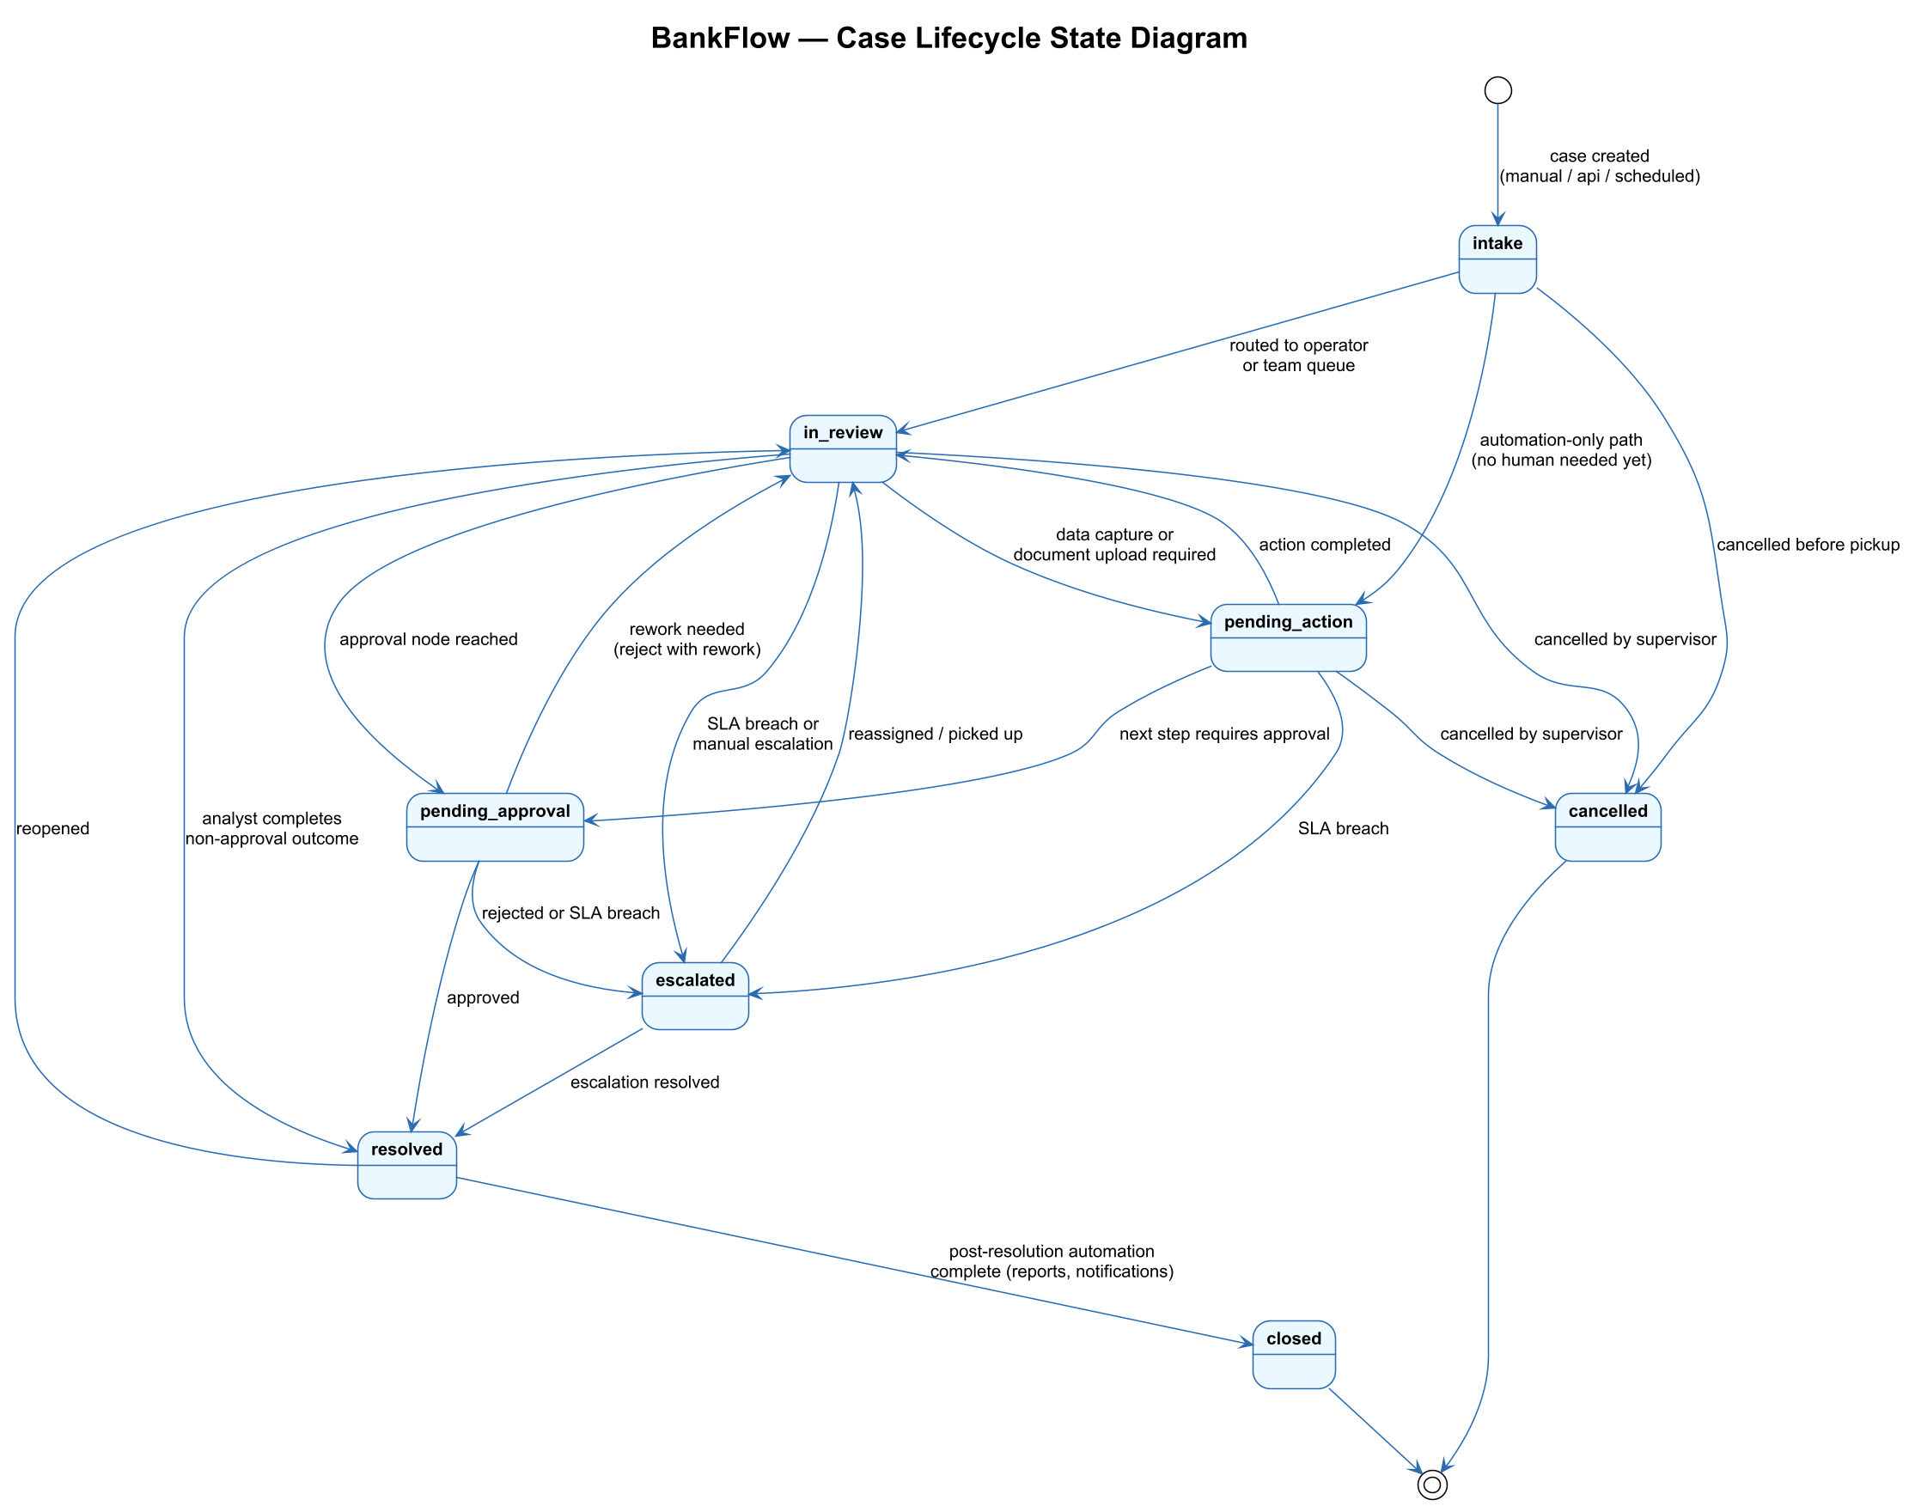
Figure 4 — Case Lifecycle State Diagram

4.3 Activity Diagrams
Each MVP use case is described below as an activity diagram. Swimlanes separate the actors responsible for each step, making it clear where automation runs, where a human is needed, and where the exception paths join back into the main flow.

4.3.1 UC-1: AML Alert Review
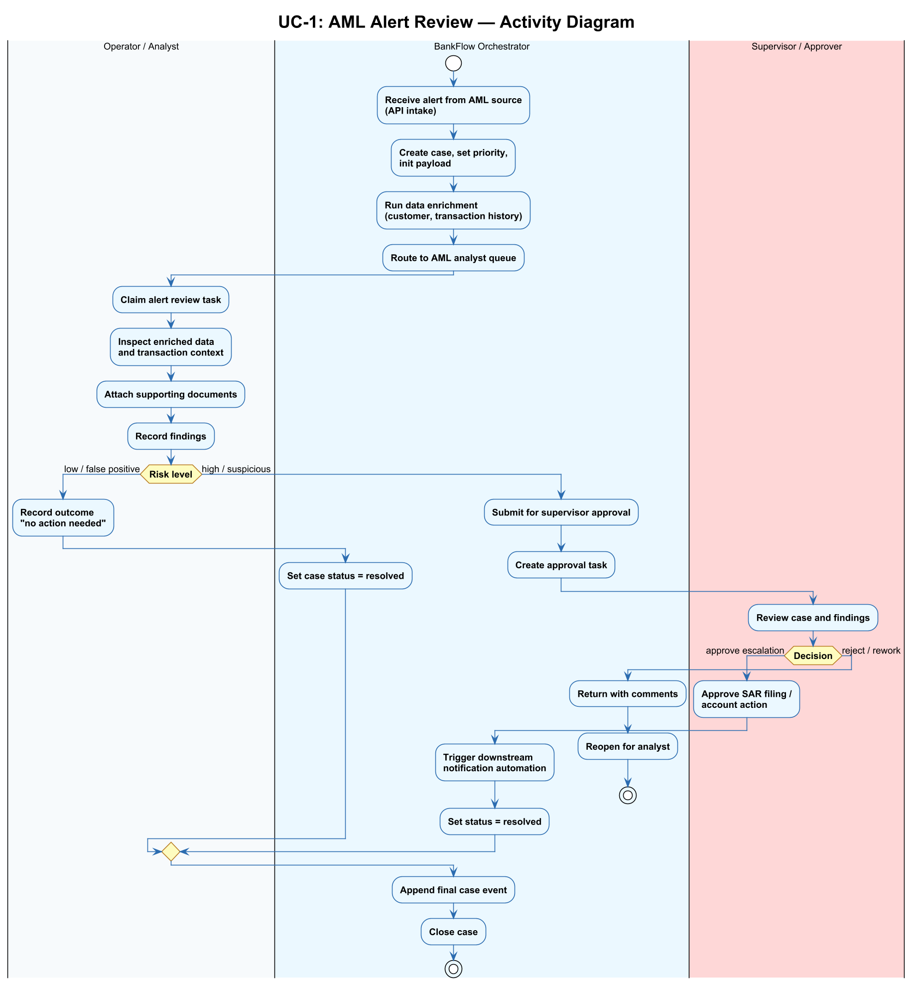
Figure 5 — AML Alert Review Activity Diagram

4.3.2 UC-2: Payment Exception Handling
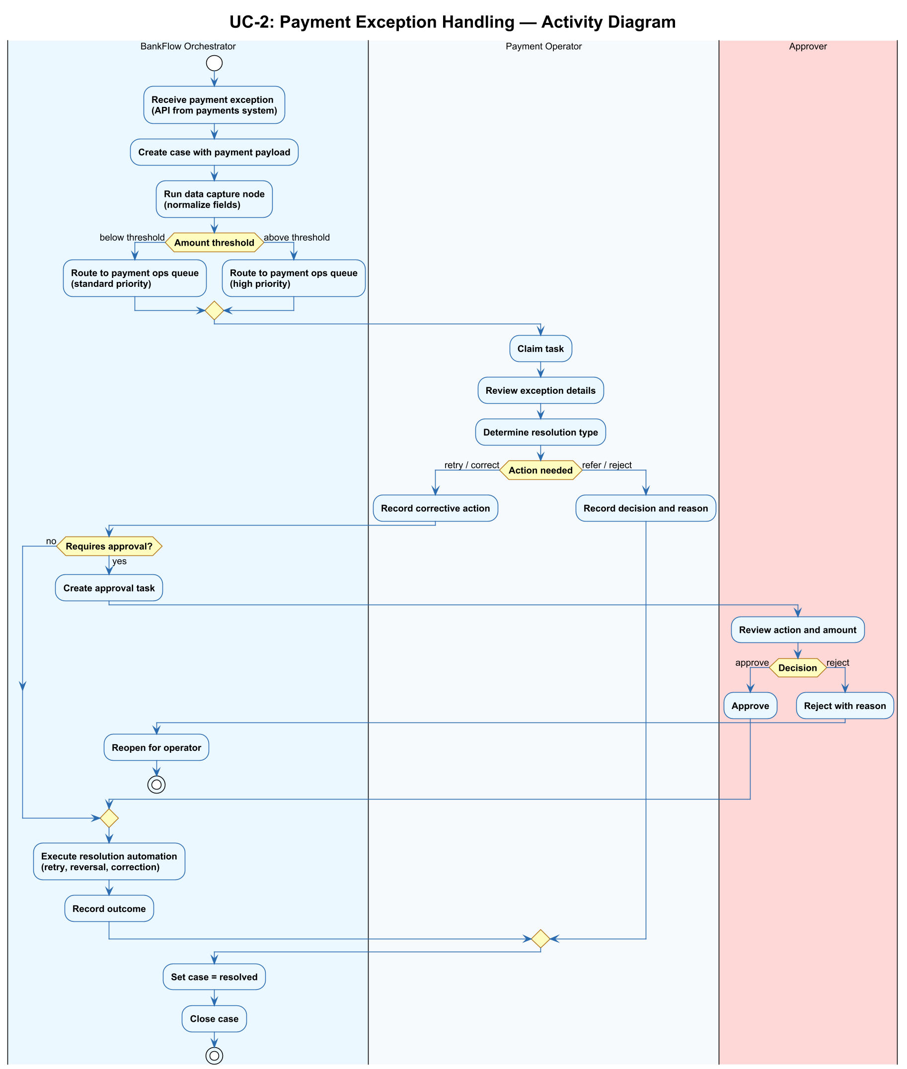
Figure 6 — Payment Exception Handling Activity Diagram

4.3.3 UC-3: KYC Refresh
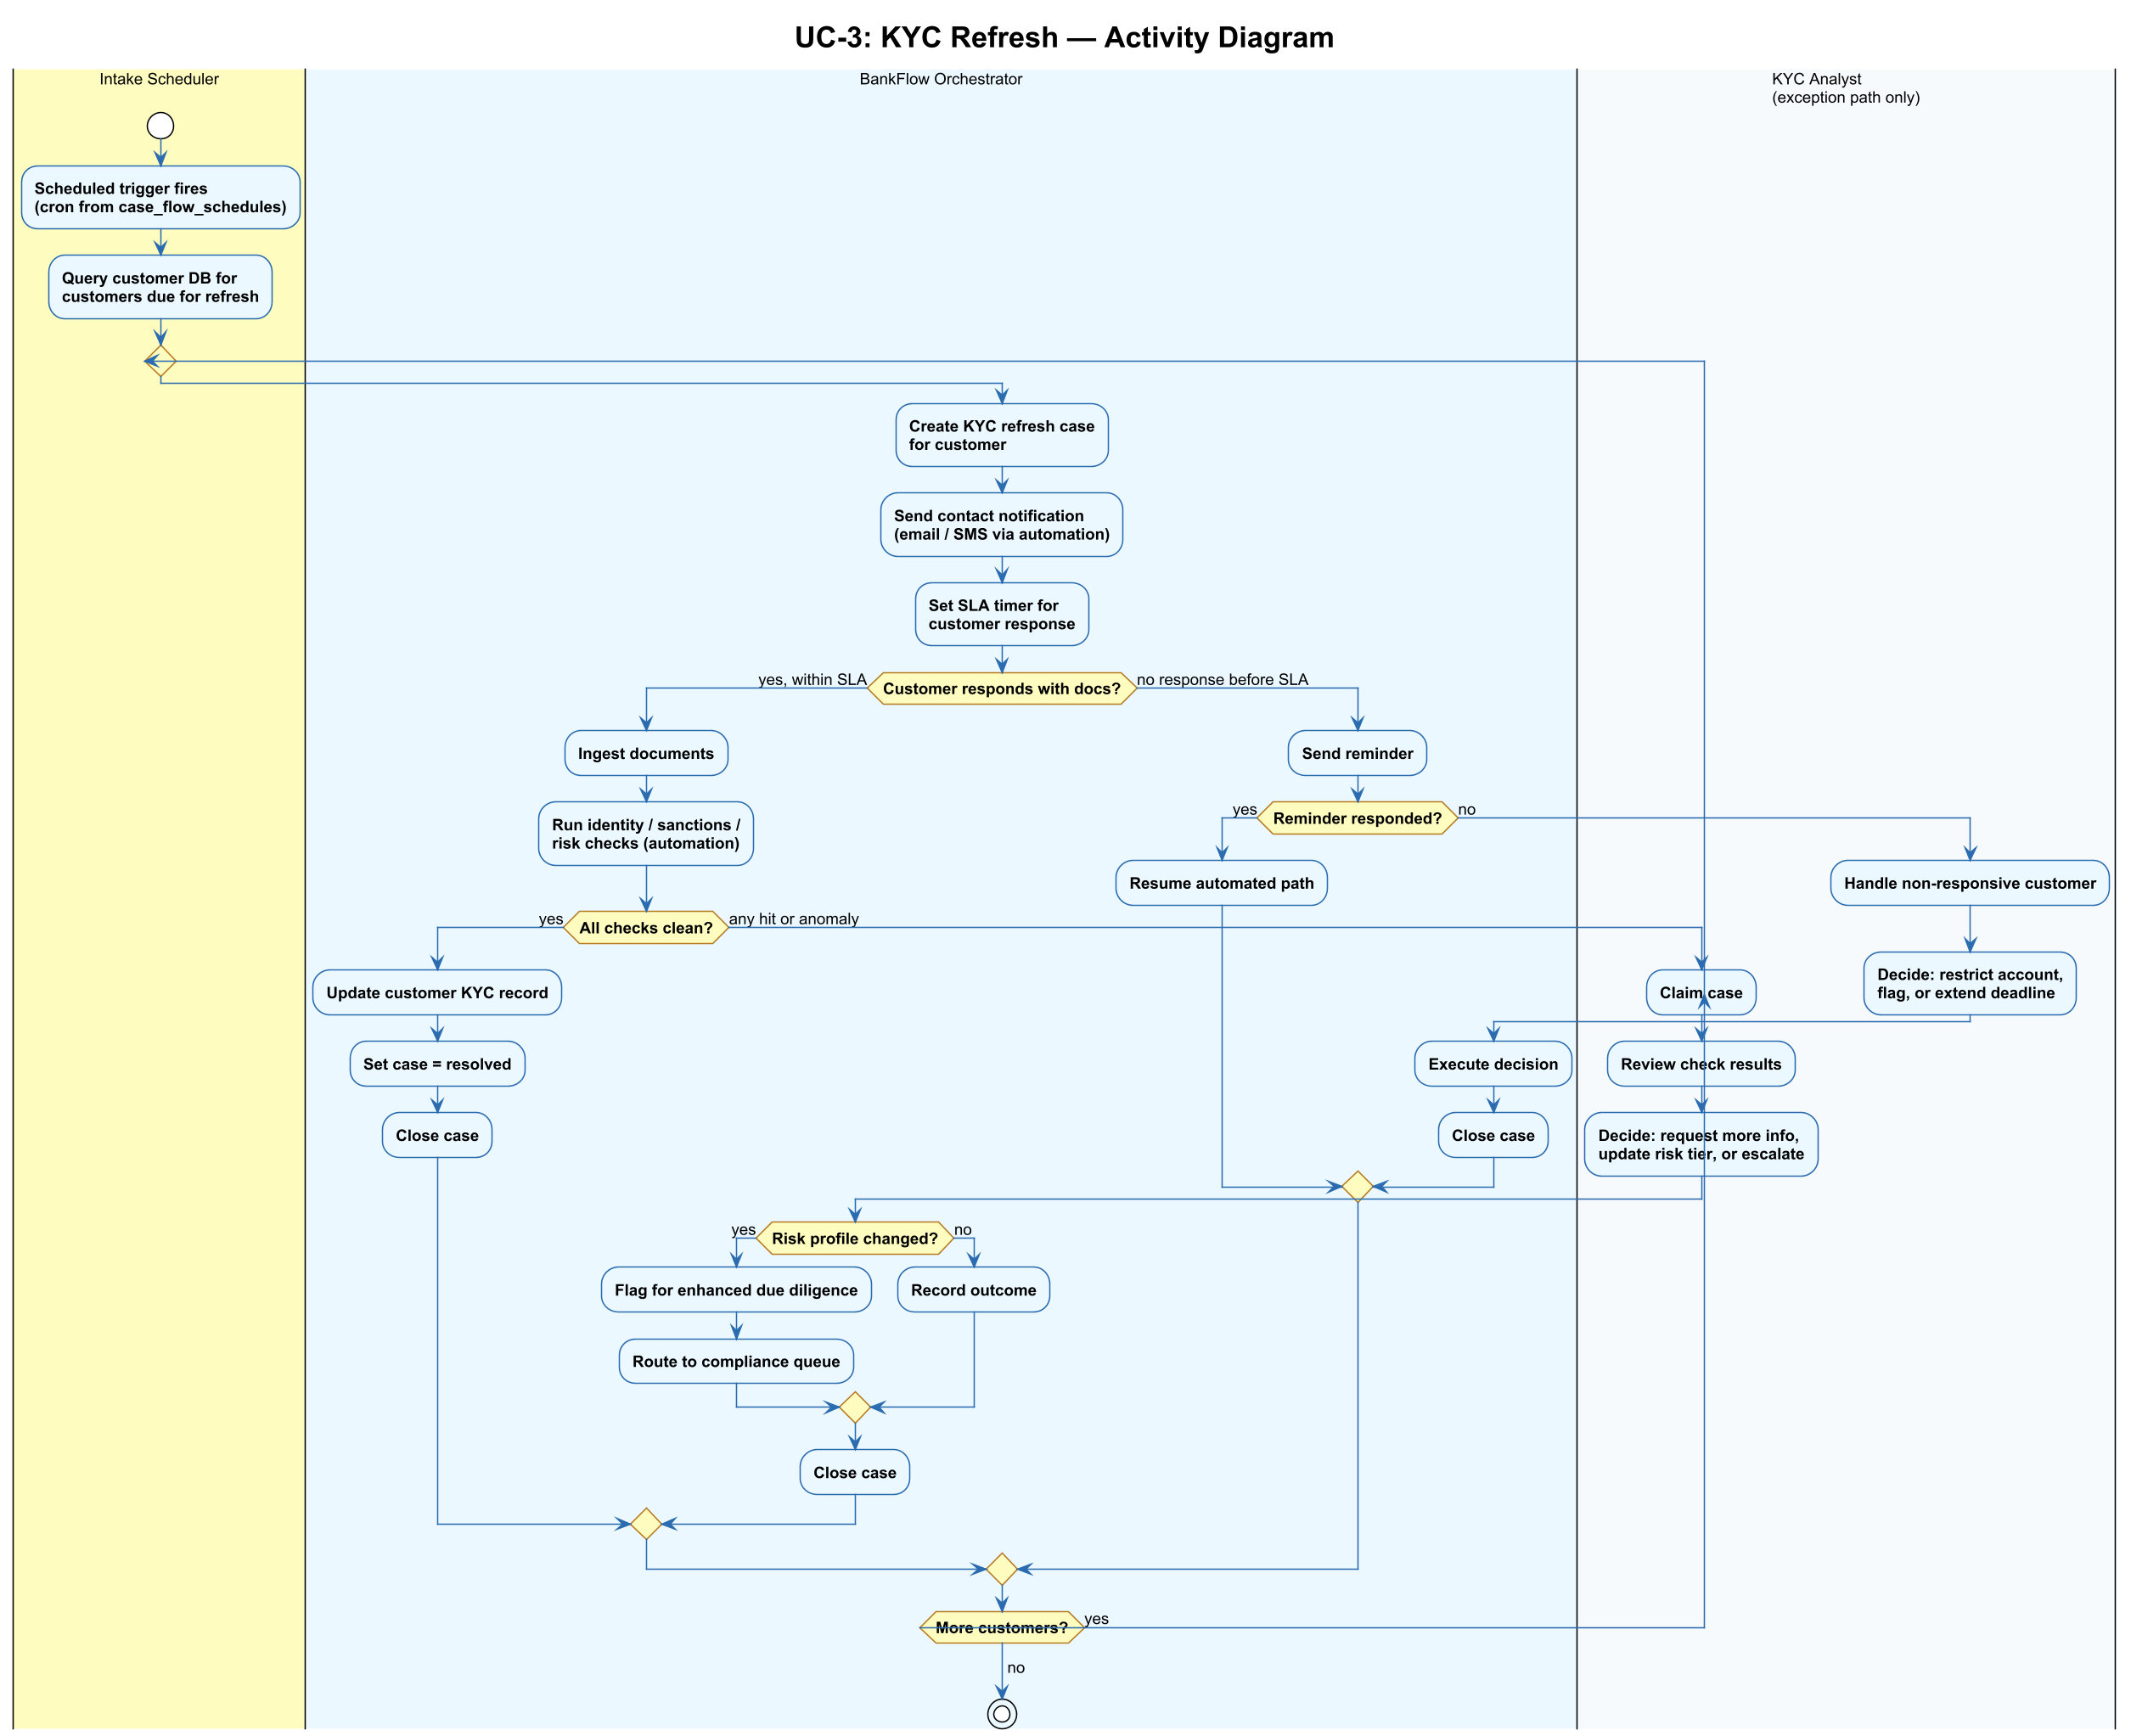
Figure 7 — KYC Refresh Activity Diagram

4.3.4 UC-4: Dormant Account Flagging
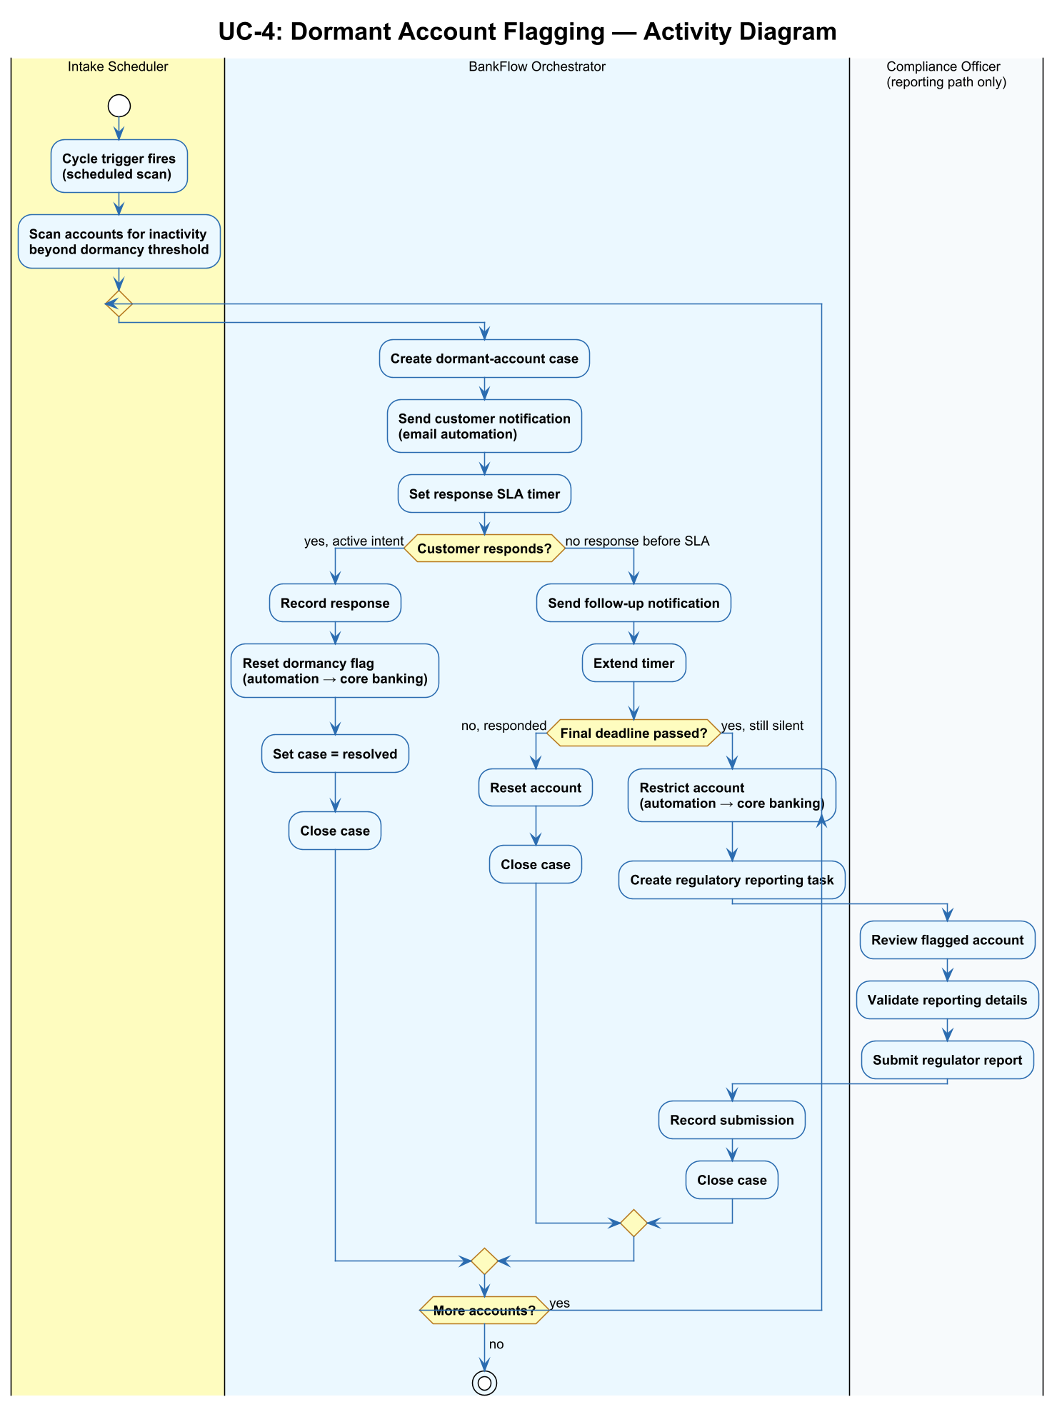
Figure 8 — Dormant Account Flagging Activity Diagram

4.3.5 UC-5: Regulatory Report Generation
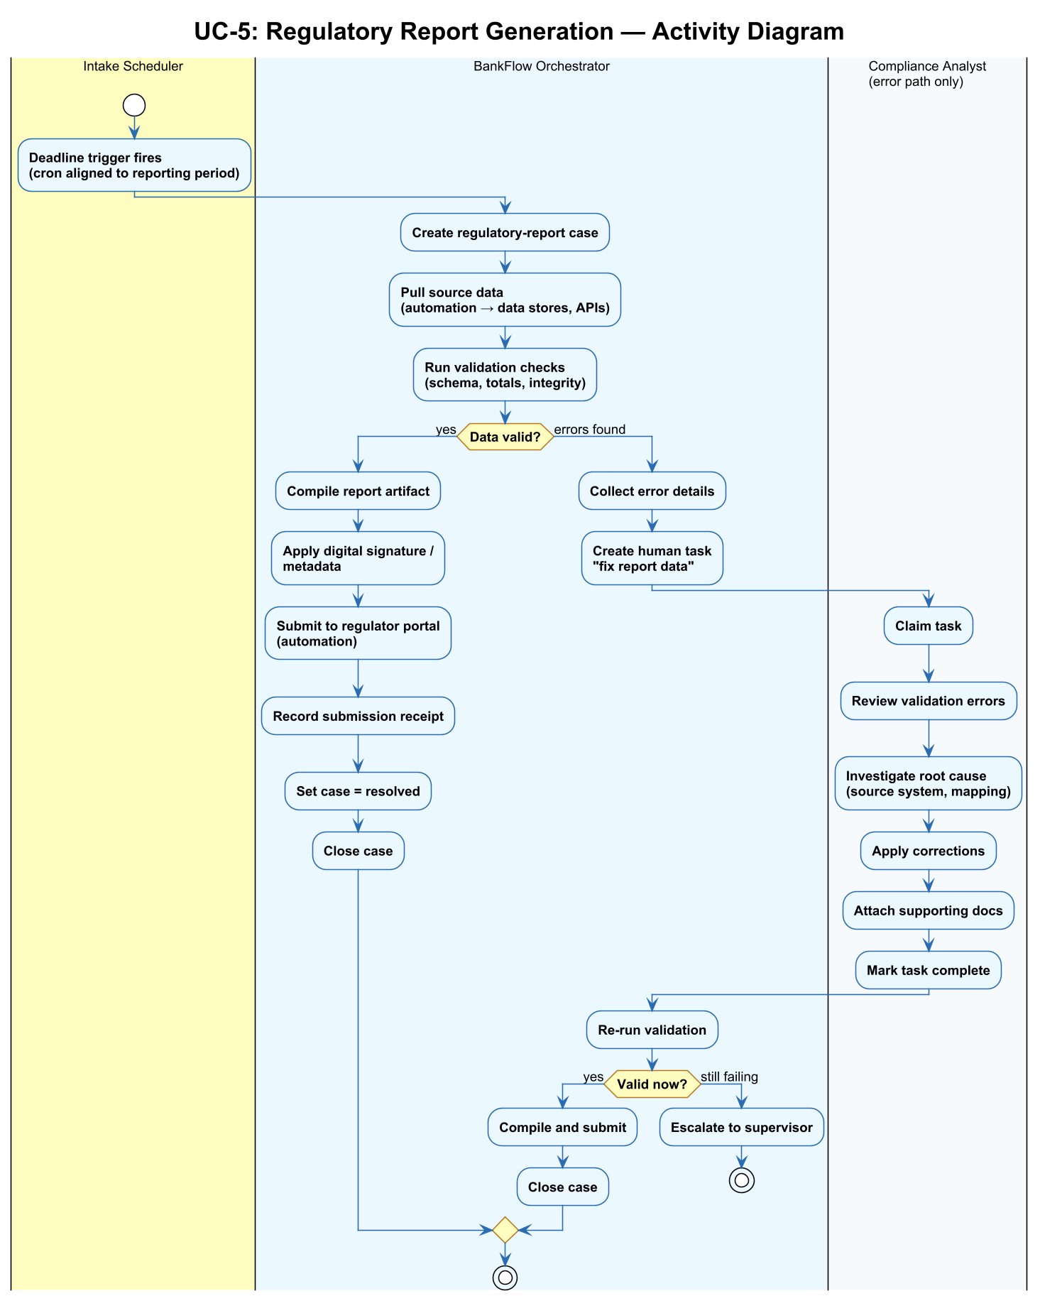
Figure 9 — Regulatory Report Generation Activity Diagram

4.4 Sequence Diagrams
The sequence diagrams below show the backend collaborations that implement the activity diagrams. They focus on the interactions between the case orchestrator, the service layer, the database, and the n8n automation worker.

4.4.1 Case Intake and Orchestration Start
This sequence covers the end-to-end flow from the moment an intake request is accepted to the point where the orchestrator is either waiting on a human task or continuing to the next automation node.
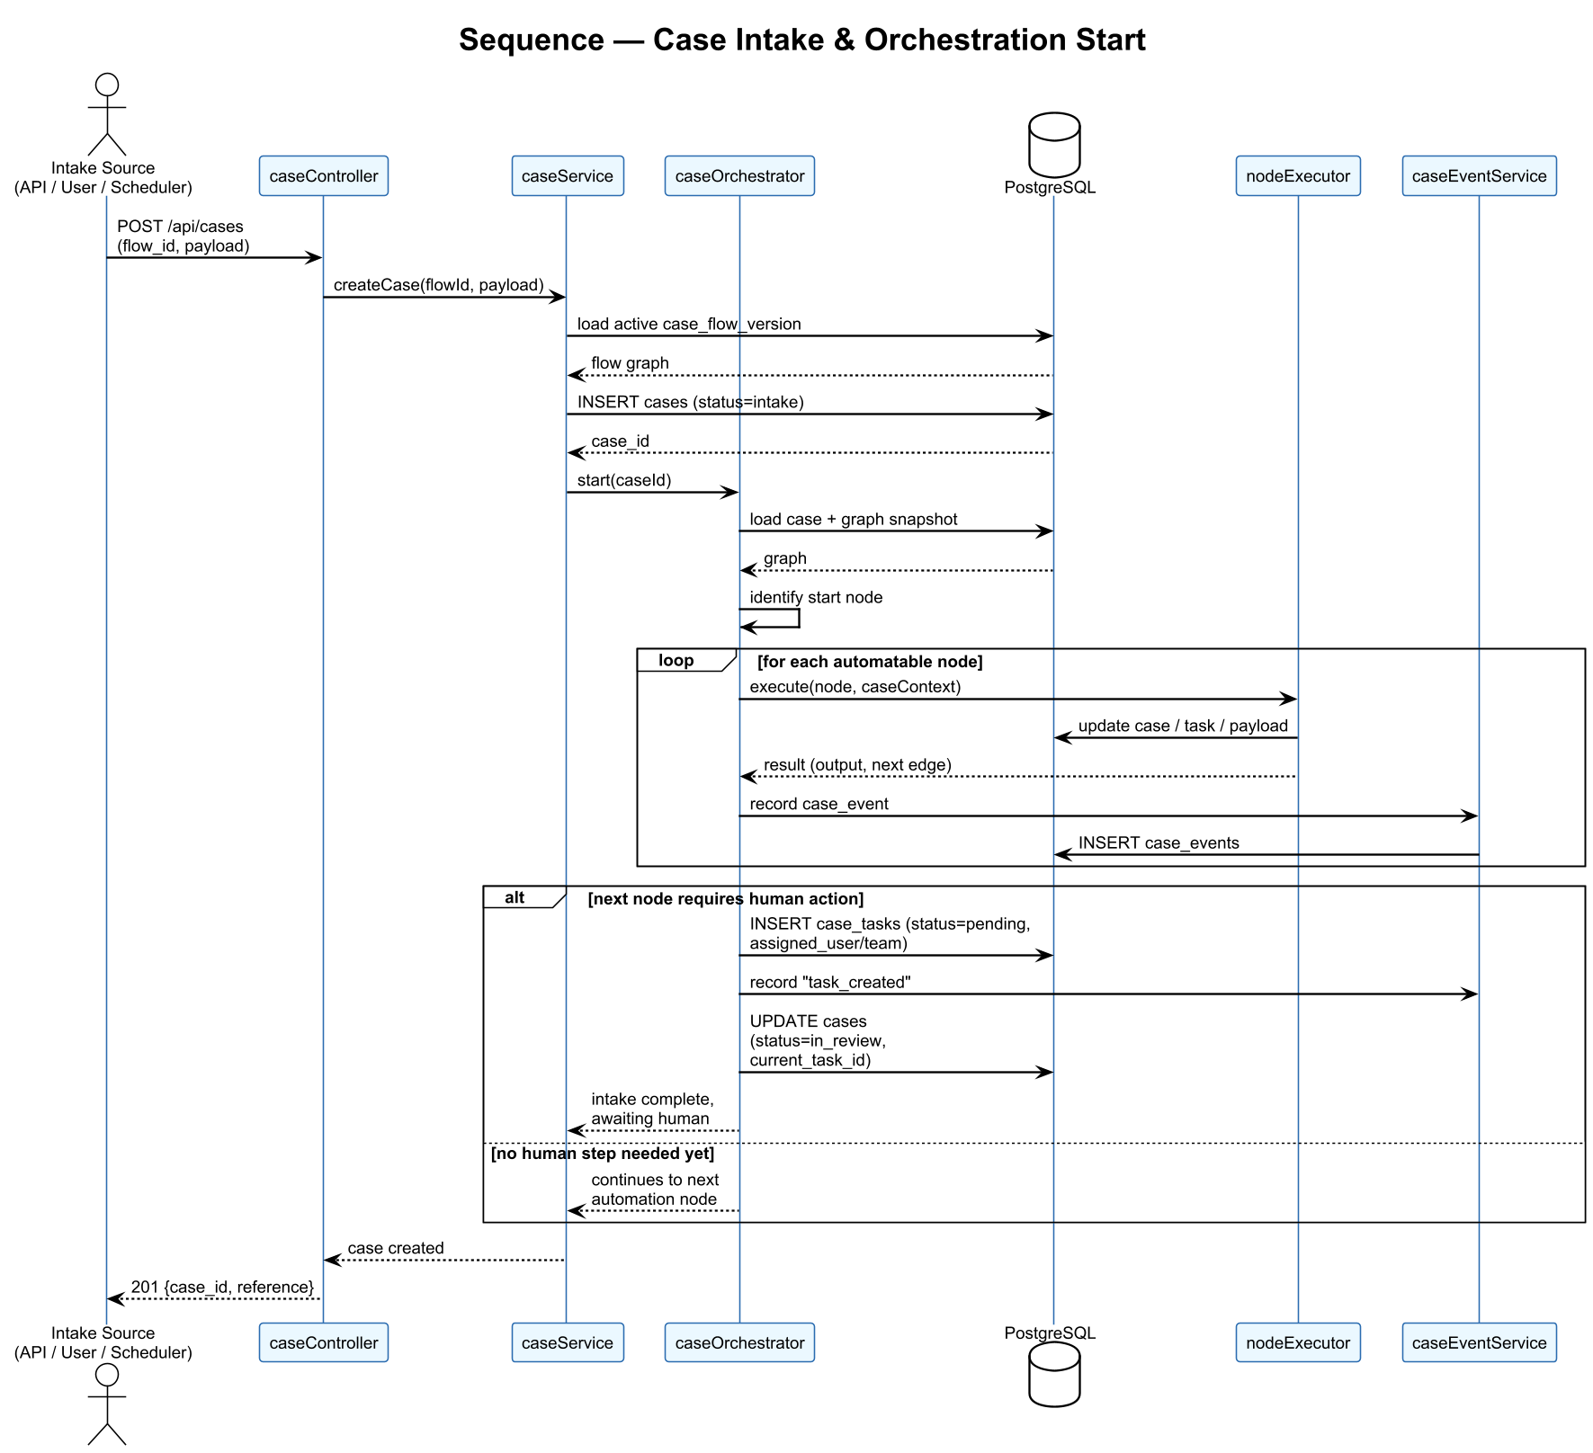
Figure 10 — Case Intake and Orchestration Start

4.4.2 Human Task Claim, Completion, and Approval
Shows how a task is claimed, how completion drives the orchestrator to the next node, and how the orchestrator creates an approval task that blocks progression until a decision is recorded.
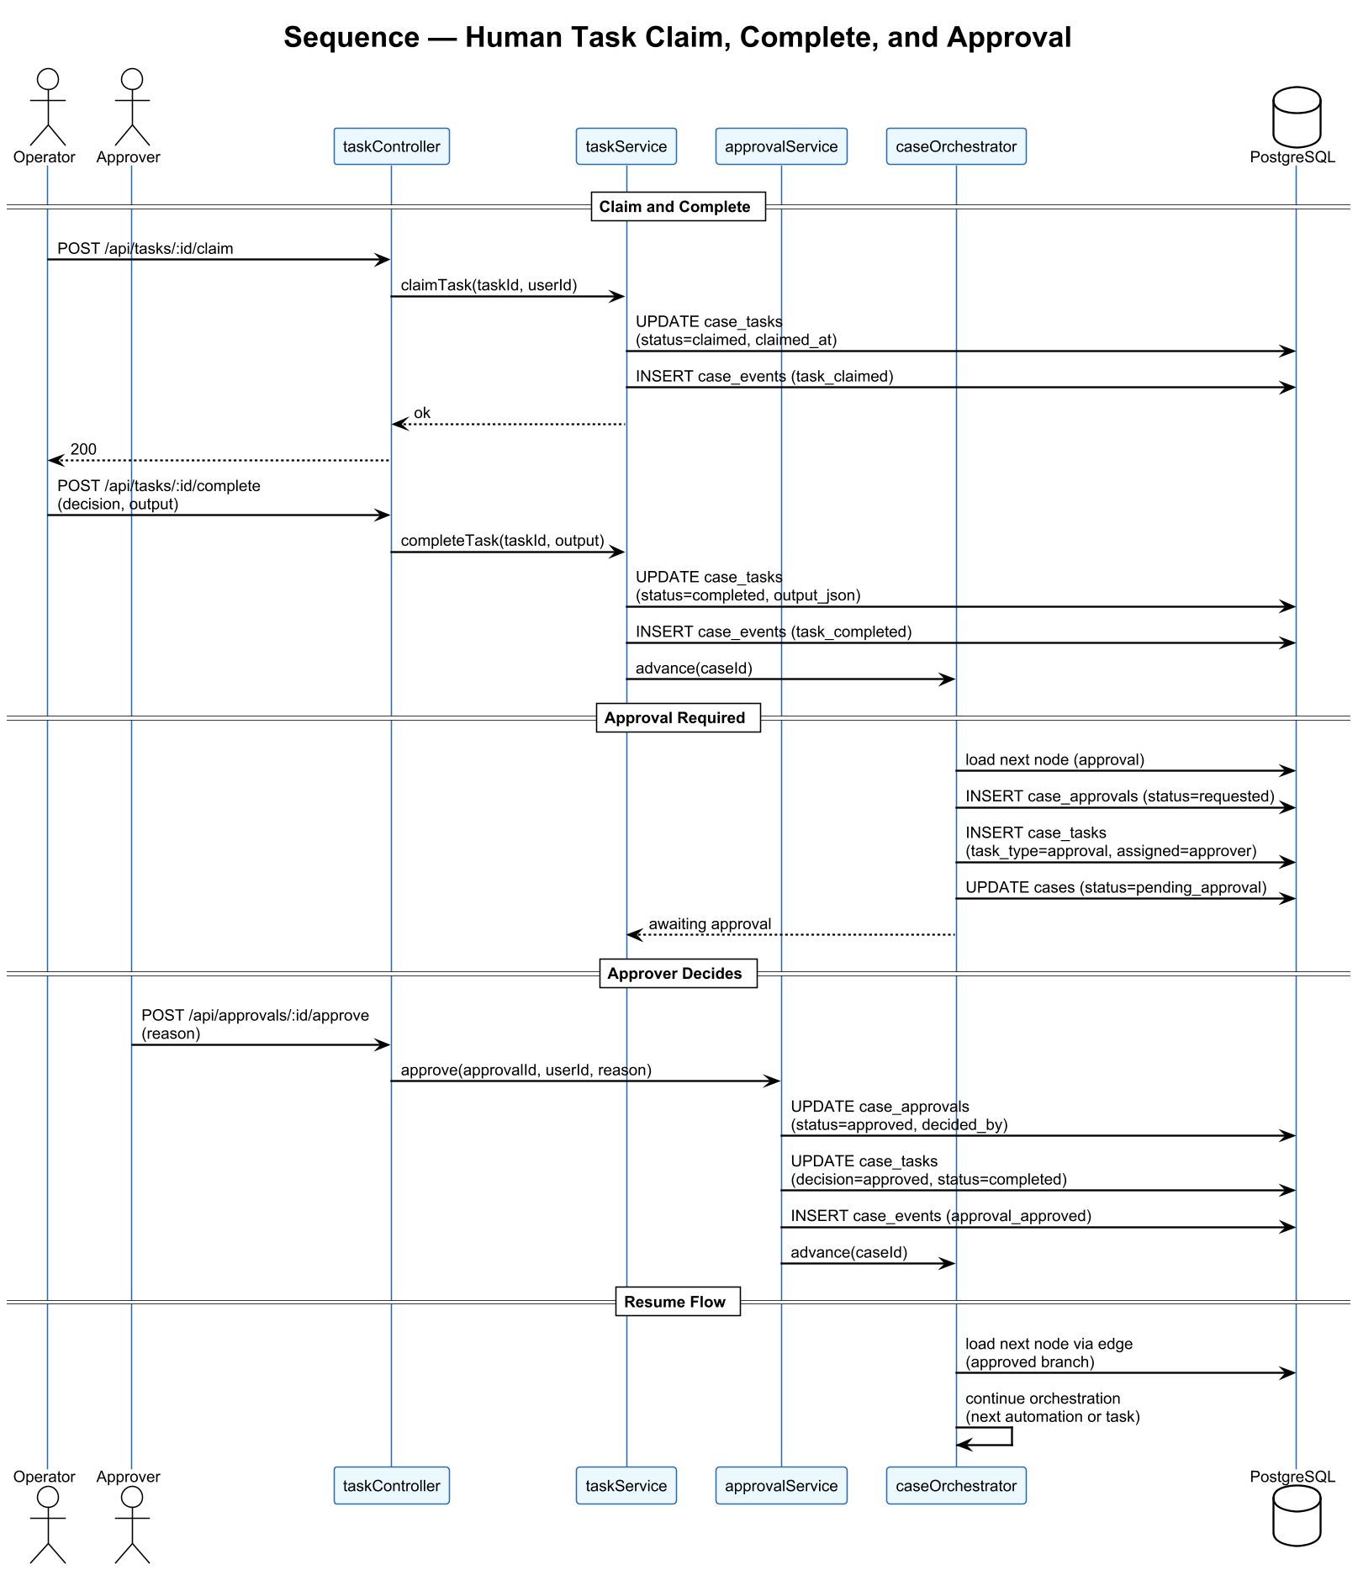
Figure 11 — Human Task Claim, Completion, and Approval

4.4.3 SLA Breach and Escalation
Shows the periodic SLA scheduler detecting overdue tasks, recording an escalation, updating case status, and notifying the escalation target through an automation call.
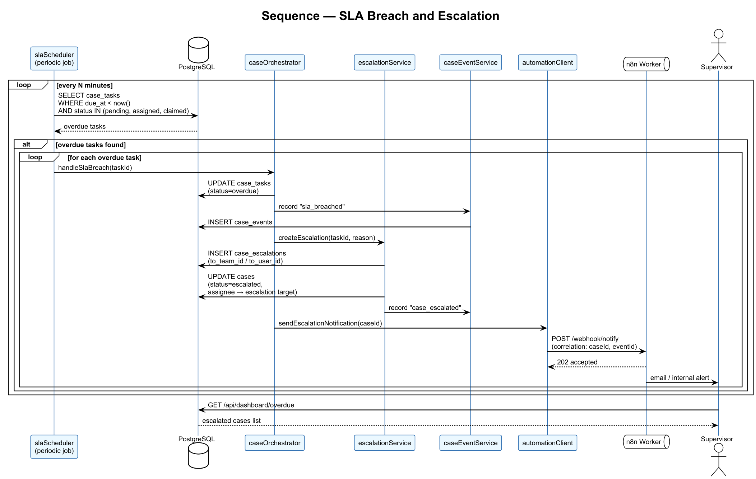
Figure 12 — SLA Breach and Escalation

4.4.4 Scheduled Intake with n8n Automation
Shows the intake scheduler evaluating due schedules, creating cases from the resulting target set, and using correlation identifiers to match n8n automation results back to the exact case event that triggered them.
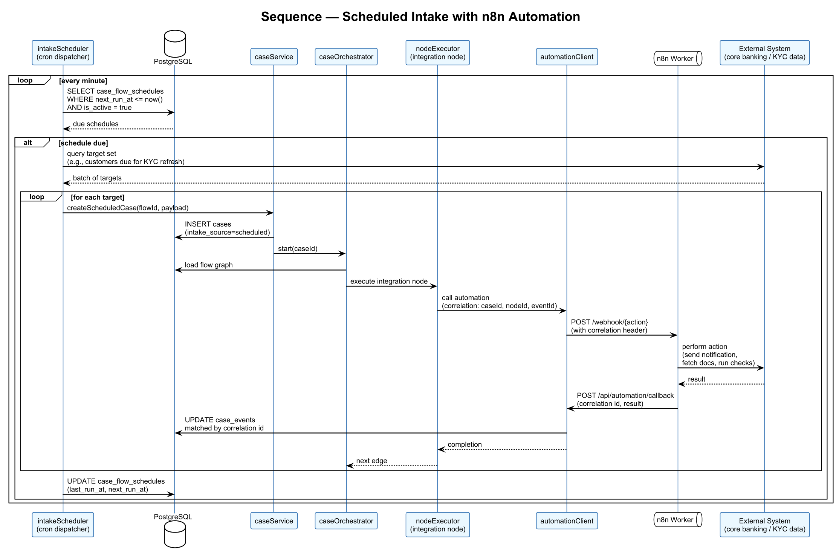
Figure 13 — Scheduled Intake with n8n Automation

4.5 Deployment Diagram
BankFlow is deployed as a Docker Compose stack for development and demonstration. The stack contains the frontend (nginx serving the Vite bundle), the backend (Express with embedded orchestrator and schedulers), PostgreSQL, n8n, and a shared volume for uploaded documents. No credentials are committed to source control; all configuration is provided through environment variables.
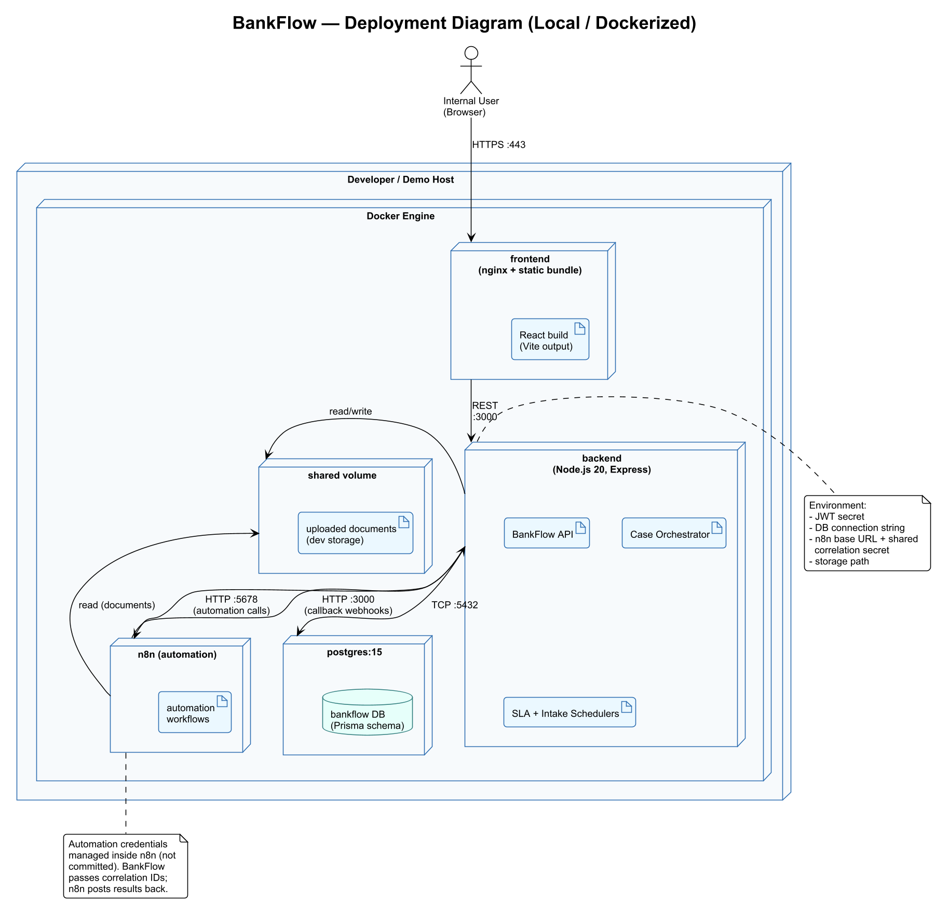
Figure 14 — BankFlow Deployment Diagram

5. Graphical User Interface Design
The BankFlow interface is organized around four primary sections that match the way operations teams actually use the platform: a Dashboard for supervisors and oversight, an Operations section for operators and approvers doing daily work, a Flow Design section for designers authoring and publishing flows, and an Administration section for platform administrators.

5.1 GUI Hierarchy
The hierarchy below shows the top-level navigation and the screens reachable from each section. It is designed so that an operator processing tasks and a designer authoring a flow never need to compete for screen real estate.
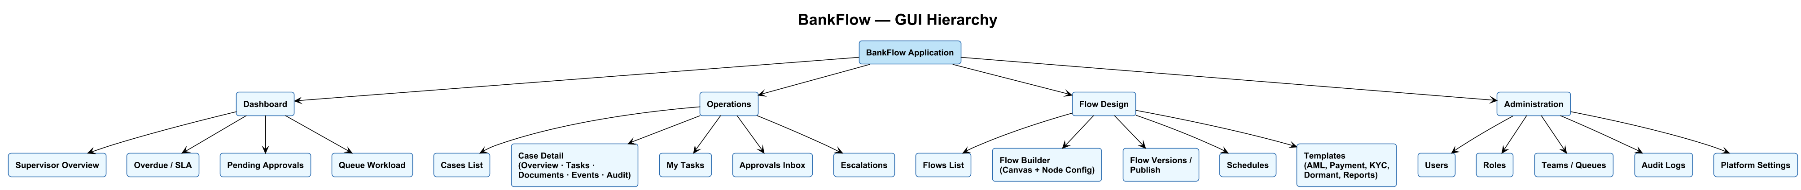
Figure 15 — BankFlow GUI Hierarchy

Top-Level Navigation
Dashboard
- Supervisor overview: active cases, state distribution, SLA heatmap
- Overdue and SLA breach view
- Pending approvals summary
- Queue workload distribution
Operations
- Cases list — filter by type, status, queue, assignee, priority
- Case detail — Overview, Tasks, Documents, Events, Audit tabs
- My Tasks — personal inbox of assigned and claimable work
- Approvals Inbox — pending approvals for the signed-in user or their role
- Escalations — cases that have been escalated to the user or their team
Flow Design
- Flows list — all case flows with status and owner
- Flow Builder — canvas plus node configuration panel
- Flow Versions and Publish — version history and publish controls
- Schedules — manage cron schedules for scheduled-intake flows
- Templates — seeded templates for AML, payment exceptions, KYC refresh, dormant accounts, and regulatory reports
Administration
- Users
- Roles
- Teams and Queues
- Audit Logs
- Platform Settings

5.2 Output Interfaces
Output interfaces are the screens and components through which BankFlow presents information to users. They are organized around the operational mental model of cases, tasks, and timelines.
Case-Centric Views
- Case list with live status and ownership columns
- Case detail header showing status, priority, assignee, team, current step, and SLA state
- Case timeline with event types, actors, and timestamps
- Task detail panels for human work, including input data and required output fields
- Approval decision view with supporting context and required comment fields
- Document listing per case with type, uploader, and upload time
Supervisor and Oversight Views
- Dashboard widgets for active cases by queue, overdue work, pending approvals, and escalations
- Queue workload view broken down by assignee and status
- SLA heatmap highlighting case types or queues running hot
Design-Time Views
- Flow canvas with nodes, edges, and execution branching visible at a glance
- Node configuration preview showing the typed configuration surface for each node kind
- Flow validation messages rendered inline on the canvas
Cross-Cutting Output
- Status badges for case and task state (intake, in review, pending approval, escalated, resolved, closed, cancelled)
- Confirmation and error toasts that summarize the action without leaking internals
- Audit log rendering for administrators with filter by actor, entity type, and action

5.3 Input Interfaces
Input interfaces are where users submit information to BankFlow. They prioritize validation, explicit confirmation for high-impact actions, and minimal friction for routine operational work.
Case Operator Inputs
- Claim, complete, and reassign task actions
- Data capture forms driven by case flow node configuration
- Document upload with file type and size validation
- Decision and comment fields on human review tasks
Approver Inputs
- Approve and reject actions with required reason fields where configured
- Escalation trigger when a supervisor must intervene manually
Designer Inputs
- Drag-and-drop node placement on the builder canvas
- Node configuration forms typed per node kind
- Edge configuration with labels and condition expressions
- Publish action that creates a new immutable flow version
- Schedule editor for cron expressions and timezone
Administrator Inputs
- User create, update, and deactivate forms
- Role and team assignment UI
- Platform settings including document storage path and n8n connection details
Cross-Cutting Input Controls
- Search and filter bars on all list pages
- Date pickers on SLA due dates, schedules, and reporting deadlines
- Toggle switches for activating or pausing flows, schedules, and users

