Comand: site:jmjardiners.com
Result: OK
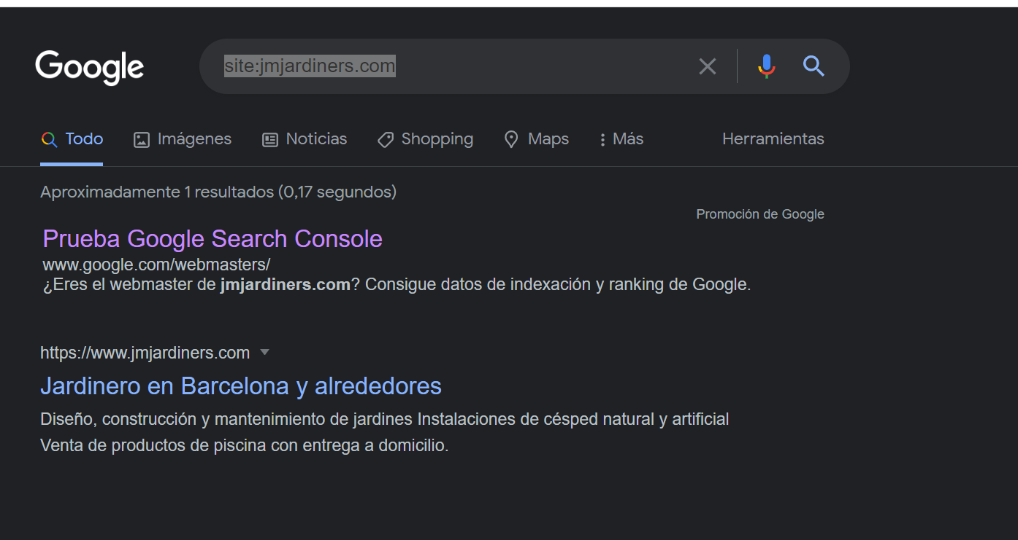

Comand: cache:jmjardiners.com
Result: ERROR

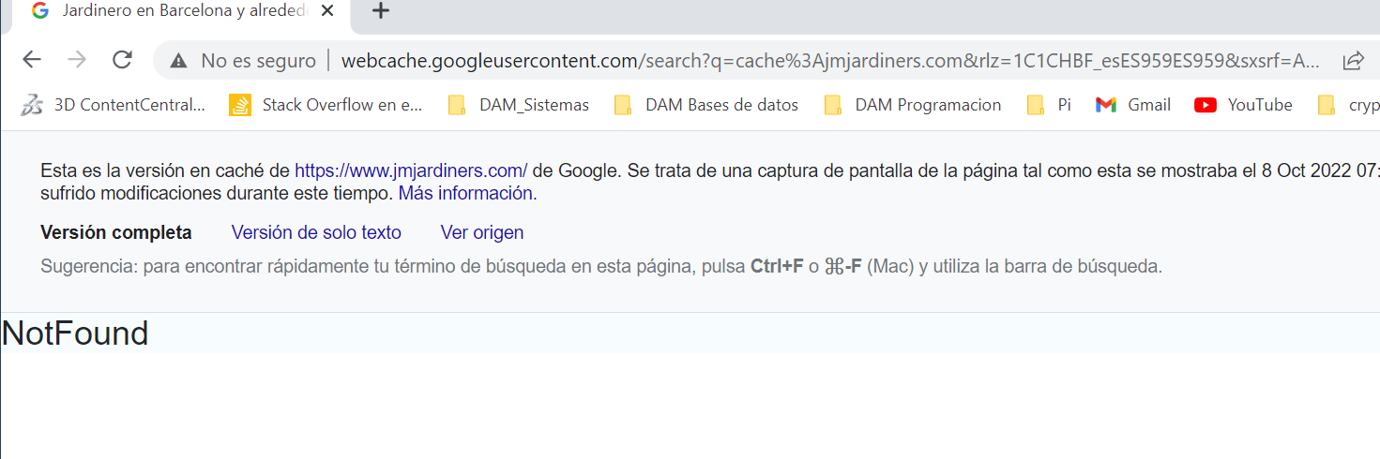
Install Live server extension en VS code

