|  |  |  |  |
| --- | --- | --- | --- |
| **CS102** | **Spring 2017/18** | Project Group | 2F |
| Instructor: | **David Davenport** |  |  |
| Assistant: | Sepehr Bakhshi |  |  |

|  |  |  |
| --- | --- | --- |
| **Criteria** | **TA/Grader** | **Instructor** |
| Presentation |  |  |
|  |  |  |
|  |  |  |
|  |  |  |
| Overall |  |  |

~ Bilkent Companion ~

6 Bugz

Sahra Karakoç, Elif Kurtay, Cansu Moran,

Öykü Irmak Hatipoğlu, Atakan Dönmez, Yusuf Ardahan Doğru

|  |
| --- |
| UIDesign Report  ( version 1 )  9 April 2019 |

# Introduction

University has always been one of the most dynamic environments; containing young people full of energy that actively spends their time at the campus. It is often that these students feel the need to reach out to other students, for a number of reasons. Among Bilkent students, being able to reach out to each other is a need which has already caused some of them to create bunch of groups on social media platforms including Facebook, Instagram and even Twitter. Students try to use these platforms to sell and buy things, especially books and search for their lost iteems/return some found objects. However, all of these entries are messily distributed on social media and lack organization which makes it harder for students to actually do what they want. Since these platforms are big, messy and therefore hard to navigate through, most of the targeted items do not reach to other students who need them. Therefore, we propose an application where Bilkent students can connect to each other through forums that are organized with sections like “Sell/Buy” or “Lost\Found”.

We will make an Android application whose target users will be Bilkent students. Single phone application to have some of the requirements that would be a beneficial companion to a Bilkent student. The application consists of many links that connect to user to the desired actions. There are 4 links on the main menu: Lost & Found, Buy/Sell, Settings, ChatRoom. In each page, there is a “back” button and a navigation drawer to display different parts of the app, making it easy to access the desired part of the app.

# Details

All pages except the sign-in and main menu page have a navigation drawer that displays different parts offered in the menu consisting of Lost/Found, Buy/Sell, Chatroom and Settings, to help the user navigate through different sections easily. The navigation drawer icon is displayed in the upper left corner of the app, where the Android conventions require it to be. The users can go to the previous page they have visited simply by clicking the Android back button in their device itself, independent from the application.

## 2.1. Sign In, Sign Up and Forget my Password

Sign in page is the first page of the application that is displayed when the user opens the app. Sign in page includes two text bars, one for email address and one for password and three buttons, Sign-Up, Forgot Password and Enter. If the user is entering the application for the first time, sign up page will be the page they are required to go to create an account. Sign up page requires information including name, surname, Bilkent webmail, password and security questions and their answers to recover password. After the user has been signed up, the user will be navigated to the sign in page that asks the user for their mail address and the password that they have picked in the sign up page. There is also a forgot my password option which asks the previously decided security questions to reset password.

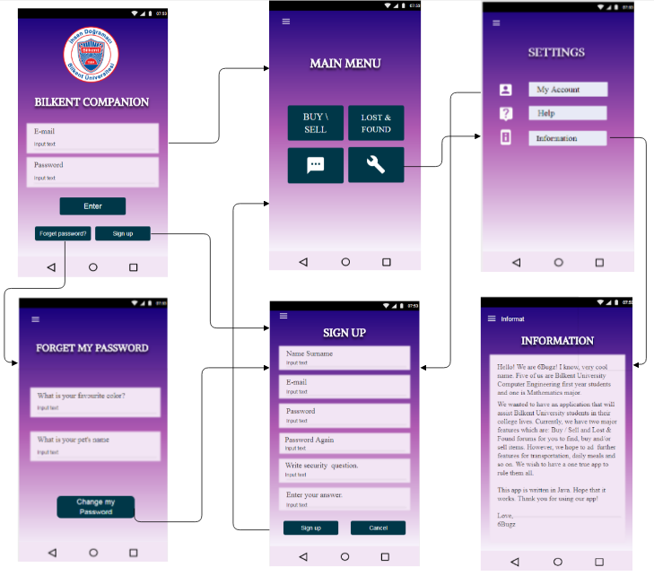

## Main Menu

When the users log in, they will be passed on to the main menu. Main menu includes all the options offered inside the application which are Buy/Sell, Lost/Found platforms as well as the option to go to Chatroom and Settings. The menu is displayed inside the navigation drawer in the following pages.

## Lost/Found Page

The lost found page includes options for both people who have lost their belongings and people who have found someone’s belongings. People who have found something in the campus can click on the add button(displayed by a plus icon) on the upper right corner of the Lost/Found page to be directed into Found item entry page. People who have lost something on the other hand, can select a category of their item and approximate their time of loss to narrow down their search. Categories are “Course Material, Technology, and Money”. We included categories to narrow down the search process as some people may not enter any hashtags for the items they found. By clicking the “Let’s Find” button displayed on the bottom of the Lost/Found page, the users can view the Found items entries which has been filtered according to the category and time of loss they have chosen on the Lost/Found page.

## Found Entry Page

When the users click the plus icon on the Lost/Found page, they are directed into found item entry page where they can create a new entry for the object they have found. This page includes:

* + The categories to picked for the item
  + The properties of the item
  + Where the item has been found
  + The photo of the item

After finishing the entry and adding the item, the user will be sent to the page where all the found item entries in that category are displayed. If the person who has made an entry clicks on the item they have uploaded, they are navigated to an editing page which has the same options and layout as the “add an item” page but only a delete option is added to delete the entry after the item has found its owner.

## 2.5 Found Item Entries

The people who have lost something, after they have picked a category and narrowed down their search by selecting a time of loss in the Lost/Found page will be navigated to this page when they click “Let’s Find” button on Lost/Found page. This page includes all the entries that have been done by the users who have found an item in the campus. On the top of the page, the magnifier icon allows users to filter the entries by typing specifically the features of their lost item. If the users think they have found their item, they can click on the item displayed on this page to connect with the person who has found the item through a chatroom.

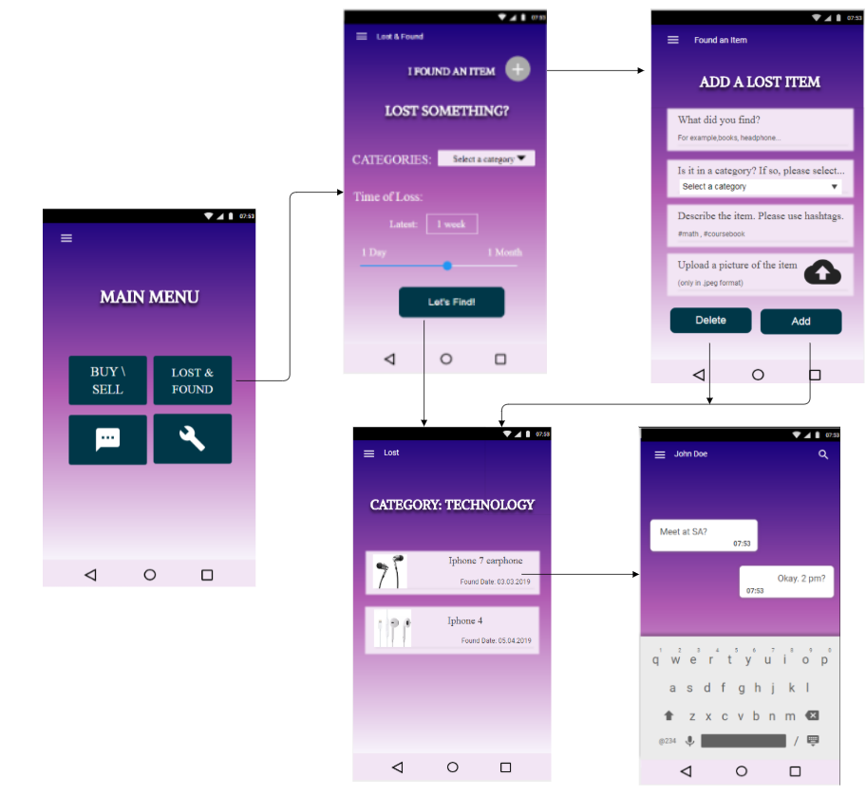

## 2.6 Chatrooms

Users who have found something and made an entry in the found page can be connected by clicking on the item they have found. This way, the person who have found the object and the person who has lost the item can discuss the details of the object further and if it is indeed their item and maybe they can pick somewhere to meet and the finder may give the lost item to its owner. All the chats that the user has started are displayed inside the chatroom option that is displayed on the menu. Therefore, when the user clicks on item, they go into a chat with the person who has found something privately but separately, all of their contacts they have talked earlier are displayed on the chatroom option.

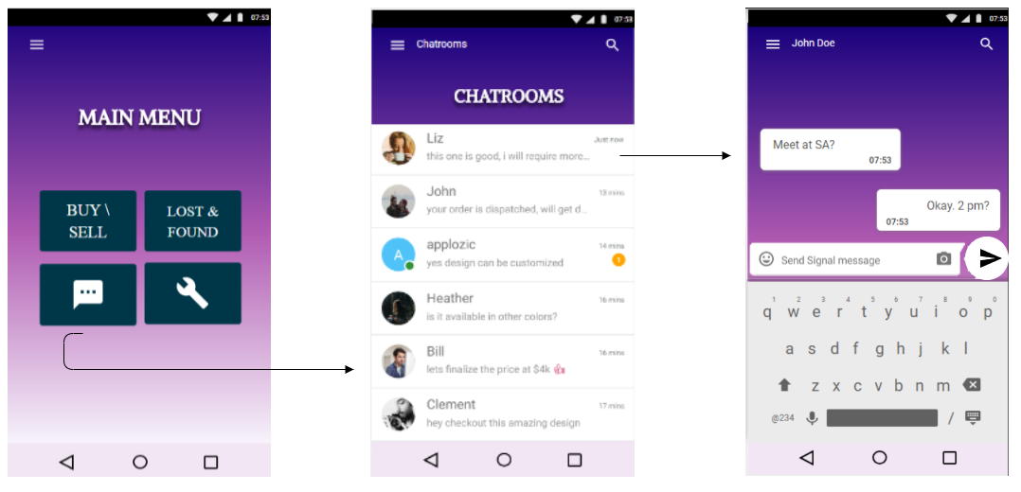

## 2.7 Buy/Sell

Buy/Sell option has similar design and layout to the Lost/Found option. Only differences are that instead of limiting the time loss, the users can limit the price range to narrow down their search and state the item’s condition. In addition, the categories seller may choose are “Course Material, Technology, and Clothing”, slightly different than Lost/Found. We included categories to help user narrow down their search process as some entries may not have any hash tags.

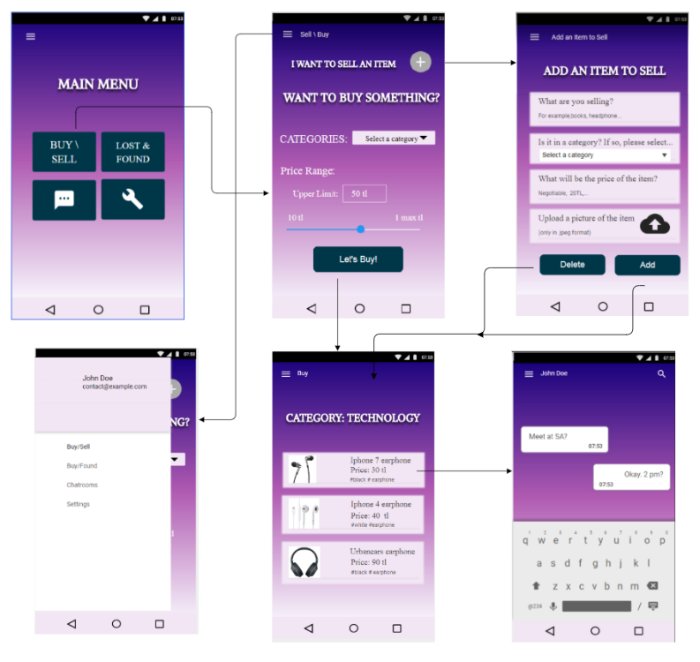

## 2.8 Settings

Settings include options to manage profile (named as My Profile), help and information about the application and the developers. Help option is aimed to explain the app to help the user showing them how to use the app and descriptions of the features of the app. My profile option has the same layout as the sign in page, on this option, the user may edit their profile pages. Therefore, the user can change anything they have entered on the sign in page later on with this option.



# Summary & Conclusions

This application will be the perfect tool for the student of the Bilkent University by collecting some of the needed and wanted features (Lost & Found and Buy/Sell) in one mobile phone application. Rather than searching different platforms for their needs, hopefully, student will be able to find solution to their problems much easier and faster, making them keep up with the dynamic environment of university.

There are a few projects that display various features about Bilkent like an application for showing the cafeteria menu (Bilmenu) or a website that is called IEEE Schedular which is helps students to arrange their programs. However, there isn’t an application that will manage the sell / buy and lost & found problems in bilkent by using a forum. Hence our project will be extremely helpful for the students who lost their belongings and want to sell or buy something from another student.

We designed the UI in way that it is very intuitive to the users as the lost/found and buy/sell parts have very similar structures. This allows the users to the get used to the layout of the app and they can easily navigate in the app. Also there are always indication as to where you are in the app and buttons are available on most pages to quickly and easily switch between different pages of the app.

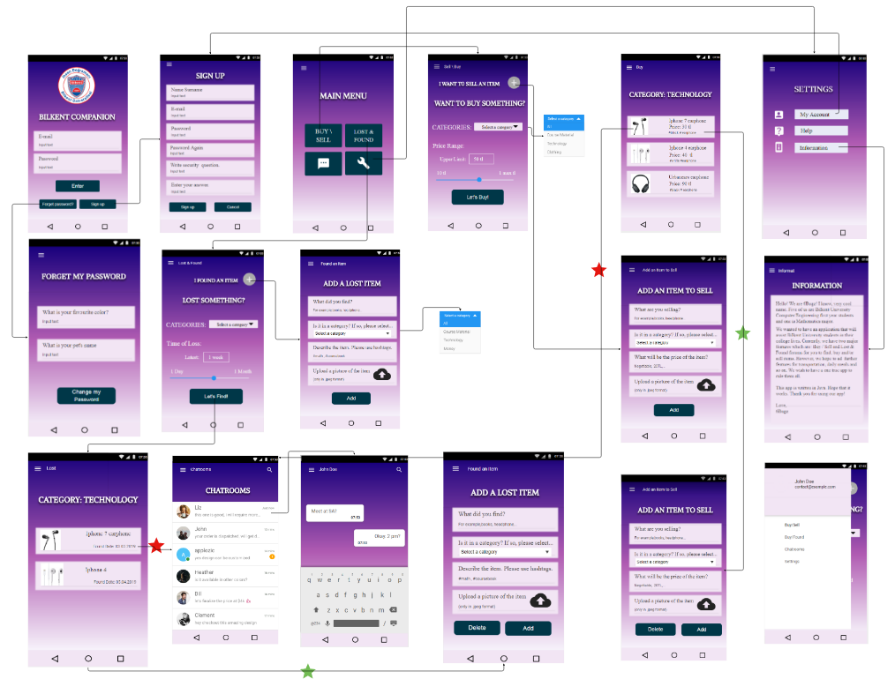

In the previous image, we have a global history board of our application. The red starts represent the users who did not post the entry. When a “red star” user, non-owner, presses on an entry, they are directed to the chat page with the owner of the entry. On the other side, the green stars represent the user who posted the entry. When the “green star” user presses on their own entry, they are directed to the “edit” page of their items where they can either delete the whole post or change an information about their item.