# File permissions in Linux

## Project description

In this project we’ll be using Linux commands to change user authorization via file permissions. The goal of this demonstration is to show how changing access permissions can increase and maintain the security of a system.

## Check file and directory details

The command [ls -l] was used to display the files in the directory [ls] and their permissions and additional information and permissions [-l].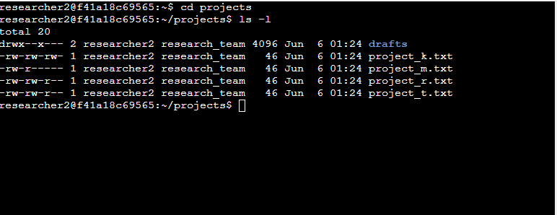

## Describe the permissions string

[In the first line (drafts) the first character references the file type ‘d’ for directory and ‘- ‘for a normal file. The 2nd through 4th characters represents the user permissions of read (r), write (w), and execute (x) in that order or, a ‘- ‘for the lack of said permission the corresponding location. The 5th through 7th are the group permissions of read, write, and execute. The last three characters represent the category of other in the same order of read, write, execute as well.

## Change file permissions

Once again, the ‘ls -l’ command is used to see the files and their permissions. The command ‘chmod o-w project_k.txt’ was used to change the permissions of the owner so they would not have write access. ‘ls -l was used again to view these changes.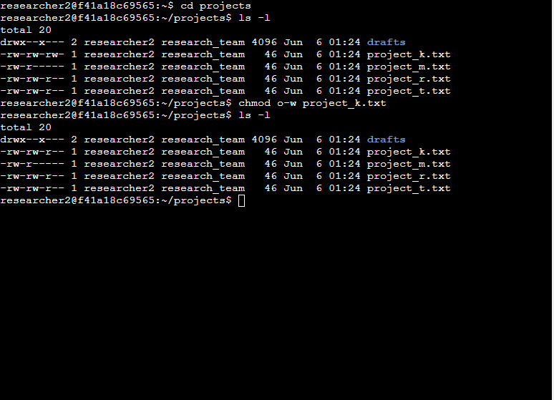

## Change file permissions on a hidden file

File permissions were changed once again but this time of hidden files the process is the same as above apart from using ‘ls -la’ to access hidden files and their permissions. ‘chmod u-w,g-w,g+r .project_x.txt’ was used to remove write access from the user and groups (u-w, g-w) as well as give read permission to the group (g+r). This is followed by ‘.project_x.txt’ to designate the file for which we want to change permissions. 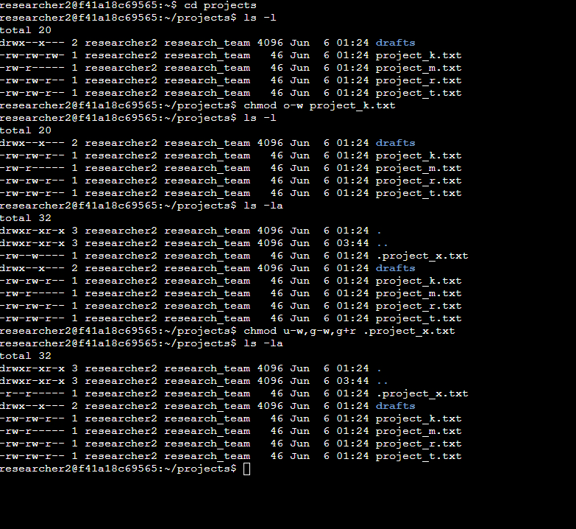

## Change directory permissions

Lastly, we demonstrate changing directory permissions by listing the name of a directory instead of a particular file ‘chmod g-x drafts’ where ‘g-x’ is used to remove read permissions from the group and ‘drafts’ signifies the ‘drafts’ directory.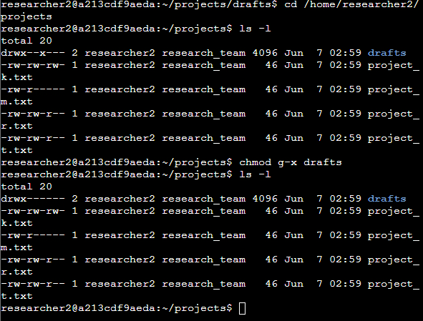

## Summary

In this project we have checked file details and permissions using ‘ls -l’ and ‘ls -la’, changed file permissions for users, groups, and others (chmod) for both normal and hidden files. We have also change dire tory permissions by listing a directory name instead for a file name. All these practices apply a measure of security by applying the concept of *least privilege*.