# 配置项选择思路

* 所管理的代码量小一点的
* 尽量找不depend或者select过多其他配置项的
* 定义了新的全局变量或者在全局结构体变量加了新成员的

例如：Enable rseq() system call配置项既依赖于HAVE_RSEQ配置，并且会自动开启MEMBARRIER配置，不便于统计。

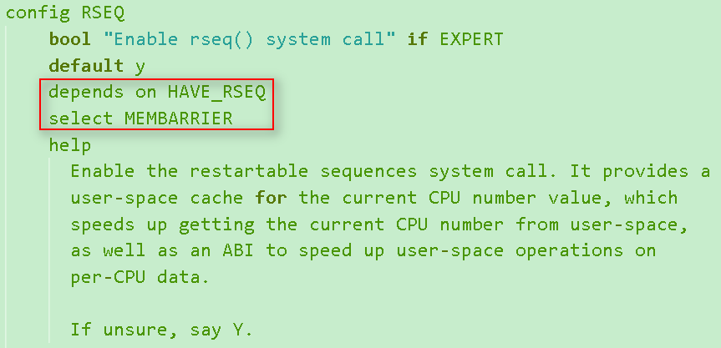

# file systems->ext4 debugging support

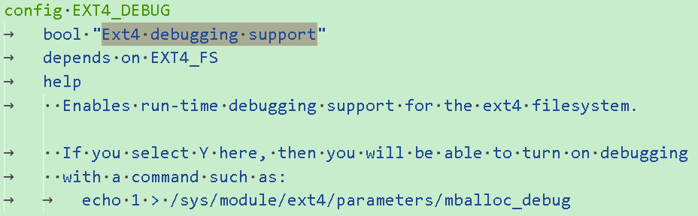

# 配置项管理的源码

**#ifdef** CONFIG_EXT4_DEBUG

        ext4_warning(inode->i_sb, "Inode (%ld) finished: extent logical block %llu,"

                 " len %u; IO logical block %llu, len %u",

                 inode->i_ino, (**unsigned** **long** **long**)ee_block, ee_len,

                 (**unsigned** **long** **long**)map->m_lblk, map->m_len);

**#endif**

**#ifdef** CONFIG_EXT4_DEBUG

**ushort** ext4_mballoc_debug __read_mostly;

module_param_named(mballoc_debug, ext4_mballoc_debug, **ushort**, **0**644);

MODULE_PARM_DESC(mballoc_debug, "Debugging level for ext4's mballoc");

**#endif**

**#ifdef** CONFIG_EXT4_DEBUG

**static** **void** ext4_mb_show_ac(**struct** ext4_allocation_context *ac)

{

**struct** super_block *sb = ac->ac_sb;

    ext4_group_t ngroups, i;

**if** (!ext4_mballoc_debug ||

        (EXT4_SB(sb)->s_mount_flags & EXT4_MF_FS_ABORTED))

**return**;

    ext4_msg(ac->ac_sb, KERN_ERR, "Can't allocate:"

            " Allocation context details:");

    ext4_msg(ac->ac_sb, KERN_ERR, "status %d flags %d",

            ac->ac_status, ac->ac_flags);

    ext4_msg(ac->ac_sb, KERN_ERR, "orig %lu/%lu/%lu@%lu, "

            "goal %lu/%lu/%lu@%lu, "

            "best %lu/%lu/%lu@%lu cr %d",

            (**unsigned** **long**)ac->ac_o_ex.fe_group,

            (**unsigned** **long**)ac->ac_o_ex.fe_start,

            (**unsigned** **long**)ac->ac_o_ex.fe_len,

            (**unsigned** **long**)ac->ac_o_ex.fe_logical,

            (**unsigned** **long**)ac->ac_g_ex.fe_group,

            (**unsigned** **long**)ac->ac_g_ex.fe_start,

            (**unsigned** **long**)ac->ac_g_ex.fe_len,

            (**unsigned** **long**)ac->ac_g_ex.fe_logical,

            (**unsigned** **long**)ac->ac_b_ex.fe_group,

            (**unsigned** **long**)ac->ac_b_ex.fe_start,

            (**unsigned** **long**)ac->ac_b_ex.fe_len,

            (**unsigned** **long**)ac->ac_b_ex.fe_logical,

            (**int**)ac->ac_criteria);

    ext4_msg(ac->ac_sb, KERN_ERR, "%d found", ac->ac_found);

    ext4_msg(ac->ac_sb, KERN_ERR, "groups: ");

    ngroups = ext4_get_groups_count(sb);

**for** (i = 0; i < ngroups; i++) {

**struct** ext4_group_info *grp = ext4_get_group_info(sb, i);

**struct** ext4_prealloc_space *pa;

        ext4_grpblk_t start;

**struct** list_head *cur;

        ext4_lock_group(sb, i);

        list_for_each(cur, &grp->bb_prealloc_list) {

            pa = list_entry(cur, **struct** ext4_prealloc_space,

                    pa_group_list);

            spin_lock(&pa->pa_lock);

            ext4_get_group_no_and_offset(sb, pa->pa_pstart,

                             NULL, &start);

            spin_unlock(&pa->pa_lock);

            printk(KERN_ERR "PA:%u:%d:%u \n", i,

                   start, pa->pa_len);

        }

        ext4_unlock_group(sb, i);

**if** (grp->bb_free == 0)

**continue**;

        printk(KERN_ERR "%u: %d/%d \n",

               i, grp->bb_free, grp->bb_fragments);

    }

    printk(KERN_ERR "\n");

}

**#else**

**#ifdef** CONFIG_EXT4_DEBUG

**extern** **ushort** ext4_mballoc_debug;

**#define** mb_debug(n, fmt, ...)                                           \

**do** {                                    \

**if** ((n) <= ext4_mballoc_debug) {                \

        printk(KERN_DEBUG "(%s, %d): %s: " fmt,         \

               __FILE__, __LINE__, __func__, ##__VA_ARGS__);    \

    }                               \

} **while** (0)

**#else**

# 源码分析

新增代码行数：77

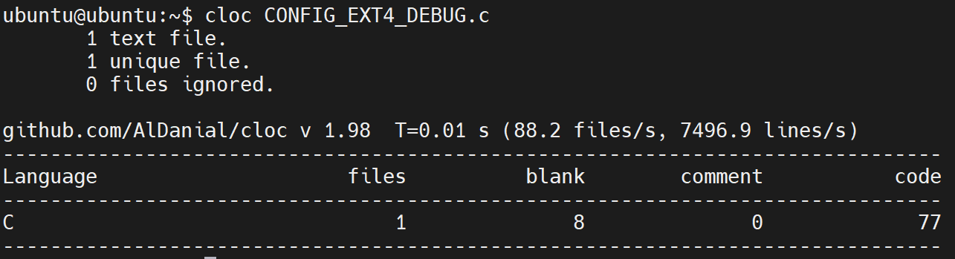

读写语句行数占新增代码行数比例：2/77

有两句对ext4_mballoc_debug全局变量的读操作

**if** (!ext4_mballoc_debug ||

        (EXT4_SB(sb)->s_mount_flags & EXT4_MF_FS_ABORTED))

和

**if** ((n) <= ext4_mballoc_debug) {                \

# CFG分析

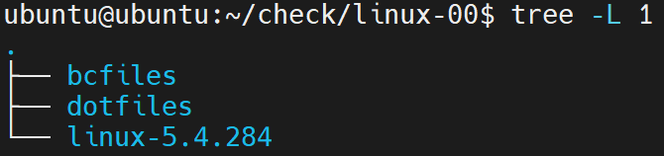

* bcfiles：存储所有bc文件
* dotfiles：存储所有dot文件

# 先获得默认配置的linux的bc和dot文件

export WLLVM_BC_STORE=/pathto/bcfiles

export LLVM_COMPILER=clang

make CC=wllvm defconfig

make CC=wllvm LLVM=1 -j8

在bcfiles下运行下面脚本，用来生成dot文件

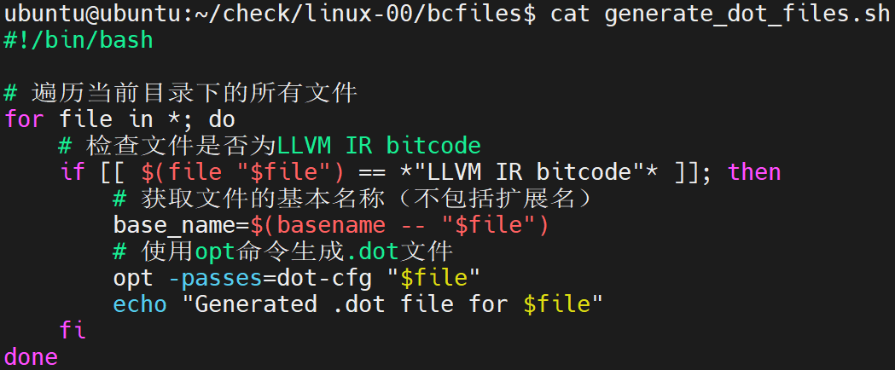

生成dot文件后，移到dotfiles下，运行下面脚本，做统计

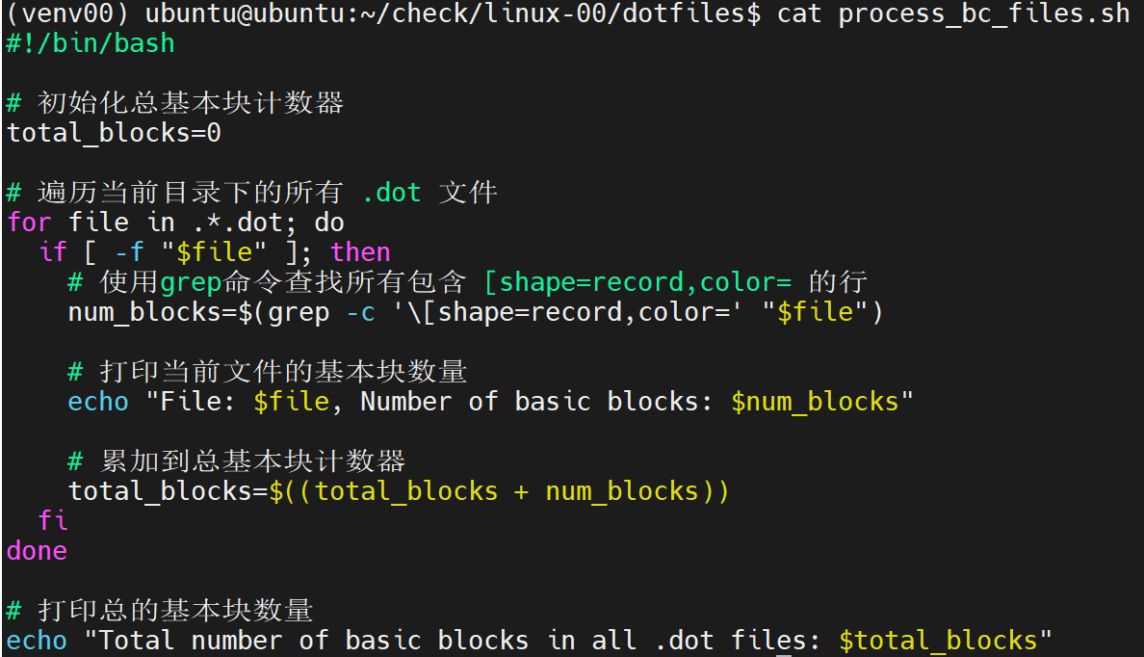 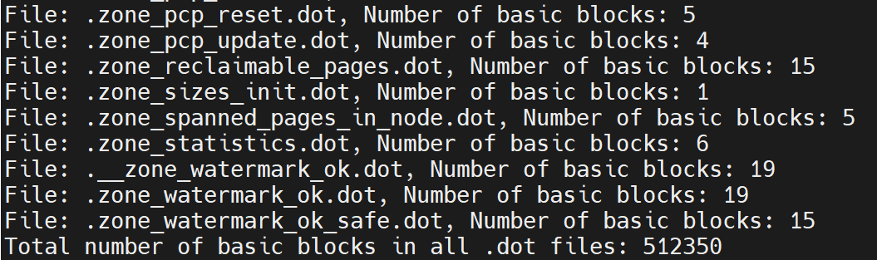

# 打开ext4 debugging support配置项，重新编译

make CC=wllvm menuconfig

make CC=wllvm LLVM=1 -j8

# 再生成dot文件，并统计