// HACKER SNAKE GAME //
Running a Java Spring Boot Application in Docker
Step-by-Step Documentation with Screenshots
Tech Stack
Java 21 | Spring Boot 3 | Maven | Docker | AWS EC2
GitHub: github.com/rohith2002/java-docker-app
May 2026

Overview
This document walks through the complete process of cloning a Java Spring Boot application from GitHub, building it into a Docker image, running it as a container on an AWS EC2 server, and accessing the Hacker Snake game in a browser.

- Matrix rain background animation
- Glowing neon hacker aesthetic with CRT scanlines
- Score tracking, levelling, and particle burst effects
- WASD, Arrow Keys, and on-screen button controls

Prerequisites
- AWS EC2 instance (Ubuntu) with a public IP
- Docker installed on the EC2 instance
- Git installed on the EC2 instance
- Port 8080 open in the EC2 Security Group inbound rules

STEP 1 Clone the Repository from GitHub
SSH into your EC2 instance and run the git clone command to download the project source code from GitHub.

git clone https://github.com/rohith2002/java-docker-app.git
ls

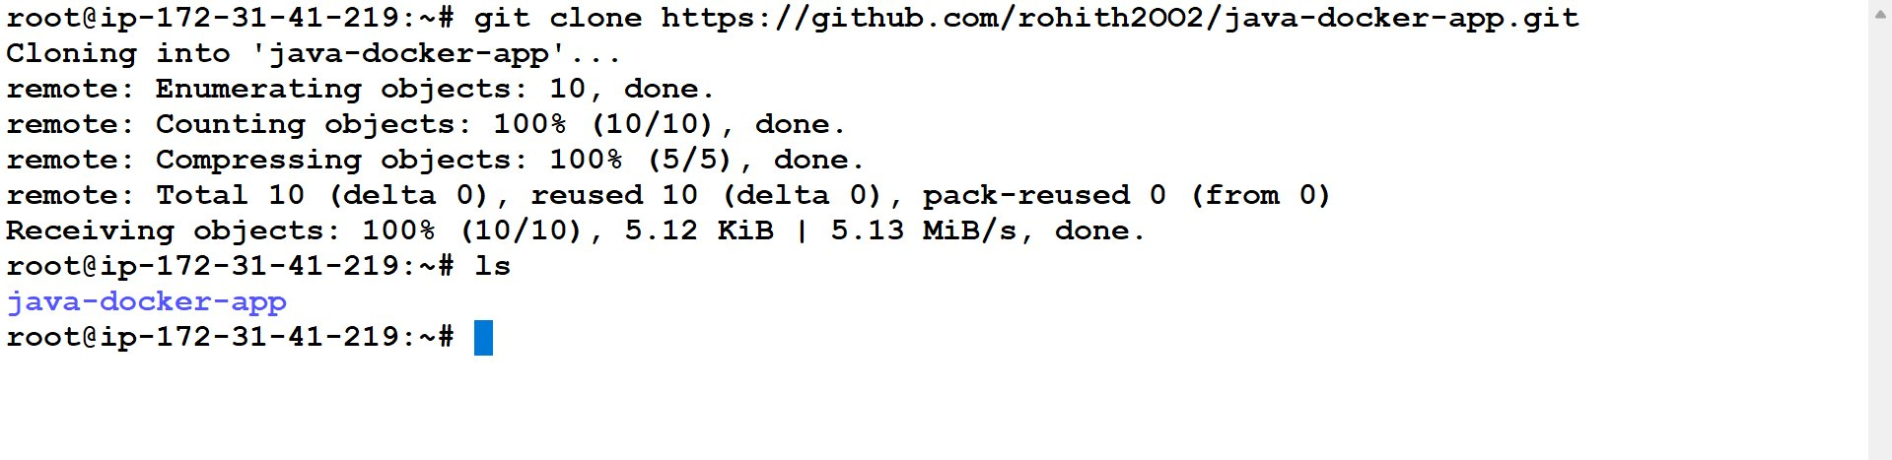
Screenshot 1 — git clone downloading the repo, ls confirming the java-docker-app folder was created
Note: The remote lines show GitHub counting and compressing objects. A fast transfer speed (5.13 MiB/s) means good network connectivity from the EC2 instance.

STEP 2 Verify the Project Structure
Navigate into the project folder and run tree to confirm App.java, pom.xml, and Dockerfile are all present.

cd java-docker-app
tree .

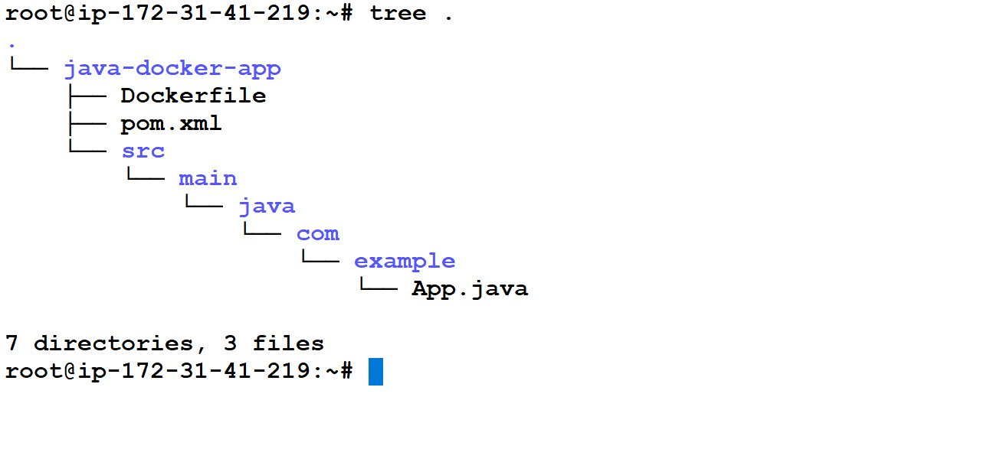
Screenshot 2 — tree . showing the full Maven project structure with 7 directories and 3 files
Note: The path src/main/java/com/example/App.java follows the standard Maven convention. If this structure is wrong, mvn package will fail.

STEP 3 Understanding the Dockerfile
Before building, it is important to understand what the Dockerfile does. This project uses a two-stage (multi-stage) build — one of the best practices in Docker for Java applications.

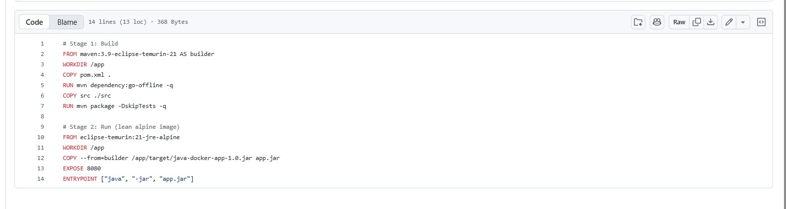
Screenshot 3 — The Dockerfile as seen on GitHub, showing the two-stage build with 14 lines

Line-by-Line Explanation

Dockerfile Line | What it Does
STAGE 1: BUILD
FROM maven:3.9-... AS builder | Pull Maven + JDK 21 image. Named "builder" so Stage 2 can reference it.
WORKDIR /app | Set /app as the working directory inside the container.
COPY pom.xml . | Copy only pom.xml first — enables Docker layer caching for dependencies.
RUN mvn dependency:go-offline -q | Download all Maven dependencies. Cached unless pom.xml changes.
COPY src ./src | Copy the Java source code into the container.
RUN mvn package -DskipTests -q | Compile the code and package it into a fat JAR file in /app/target/.
STAGE 2: RUN
FROM eclipse-temurin:21-jre-alpine | Fresh minimal image — only the JRE, no JDK or Maven. Alpine = tiny.
WORKDIR /app | Set working directory in the new clean image.
COPY --from=builder /app/target/*.jar app.jar | Copy ONLY the compiled JAR from Stage 1. Nothing else comes across.
EXPOSE 8080 | Document that the container listens on port 8080.
ENTRYPOINT ["java","-jar","app.jar"] | The command that runs when the container starts.

Why Multi-Stage Builds?
A single-stage Docker build would put everything — JDK, Maven, source code, and the compiled JAR — into one large final image. Multi-stage builds solve this by separating the build environment from the run environment.

Single-stage Build | Two-stage Build (Ours)
Includes full JDK (~300MB) | Only JRE-alpine (~80MB)
Includes Maven (~150MB) | No Maven in final image
Includes source code | No source code exposed
Final image ~600MB+ | Final image ~200MB
Slower to push/pull | Faster deployment
Security risk: tools exposed | Minimal attack surface

Note: The two-stage build produces a ~200MB image instead of ~600MB. This means faster docker pull times, less disk usage on the server, and a smaller attack surface since build tools are never in production.

How the Layers Work
Docker caches each layer. When you change only App.java and rebuild, Docker reuses the cached layers for FROM, WORKDIR, COPY pom.xml, and RUN mvn dependency:go-offline — only recompiling from COPY src onwards. This makes rebuilds very fast.

- pom.xml copied first — dependencies cached independently of source code
- Source code copied after — only invalidates cache from this layer onwards
- Stage 2 copies only the compiled JAR — no build tools leak into the final image

STEP 4 Build the Docker Image
Run docker build from inside the project folder. Docker reads the Dockerfile and executes all 11 steps — Stage 1 compiles the JAR, Stage 2 packages it into the lean runtime image.

docker build -t java-docker-app .

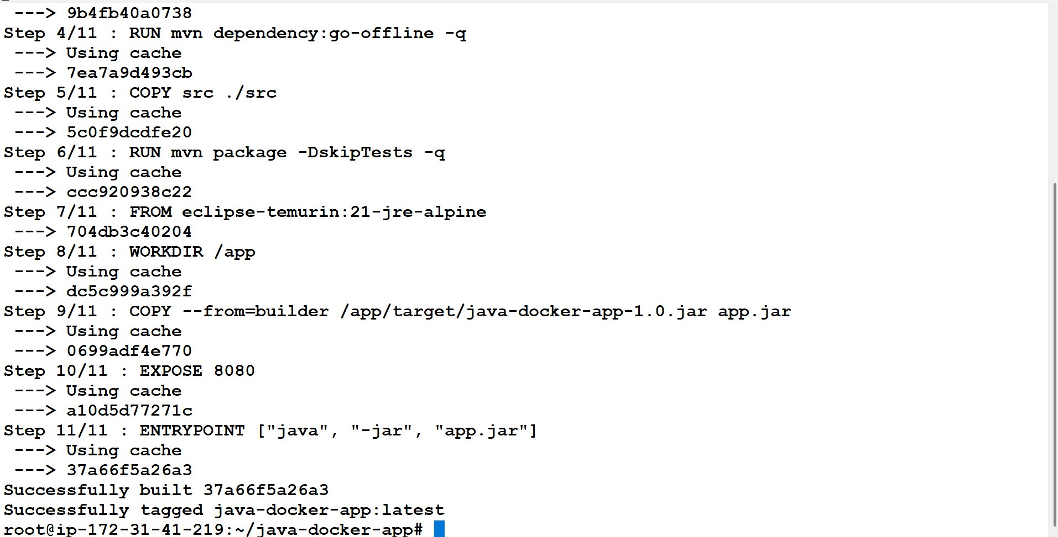
Screenshot 4 — docker build completing all 11 steps, successfully tagged as java-docker-app:latest
Note: Steps showing "Using cache" mean Docker reused a previously built layer. This is the caching benefit of copying pom.xml before the source code.

STEP 5 Run the Docker Container
Start the container in detached mode so it runs in the background. The --name flag assigns a readable name, and -p 8080:8080 maps the host port to the container port.

docker run -itd --name java-cont -p 8080:8080 java-docker-app
docker ps

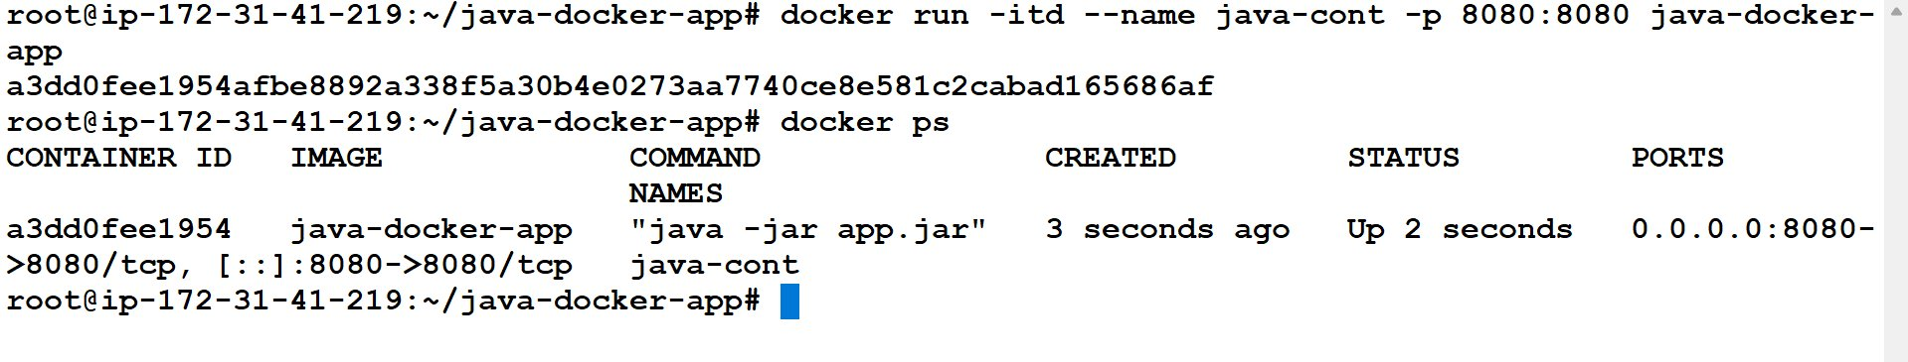
Screenshot 5 — Container started and docker ps showing STATUS "Up 2 seconds" with port 8080 mapped
Note: The long hex string printed after docker run is the full container ID. Use the first 12 characters shown in docker ps to stop or inspect the container.

STEP 6 Access the Game — Boot Screen
Open a browser and go to your EC2 public IP on port 8080. The Hacker Snake boot screen loads with the Matrix rain animation, game title, and BOOT SYSTEM button.

http://<your-ec2-public-ip>:8080

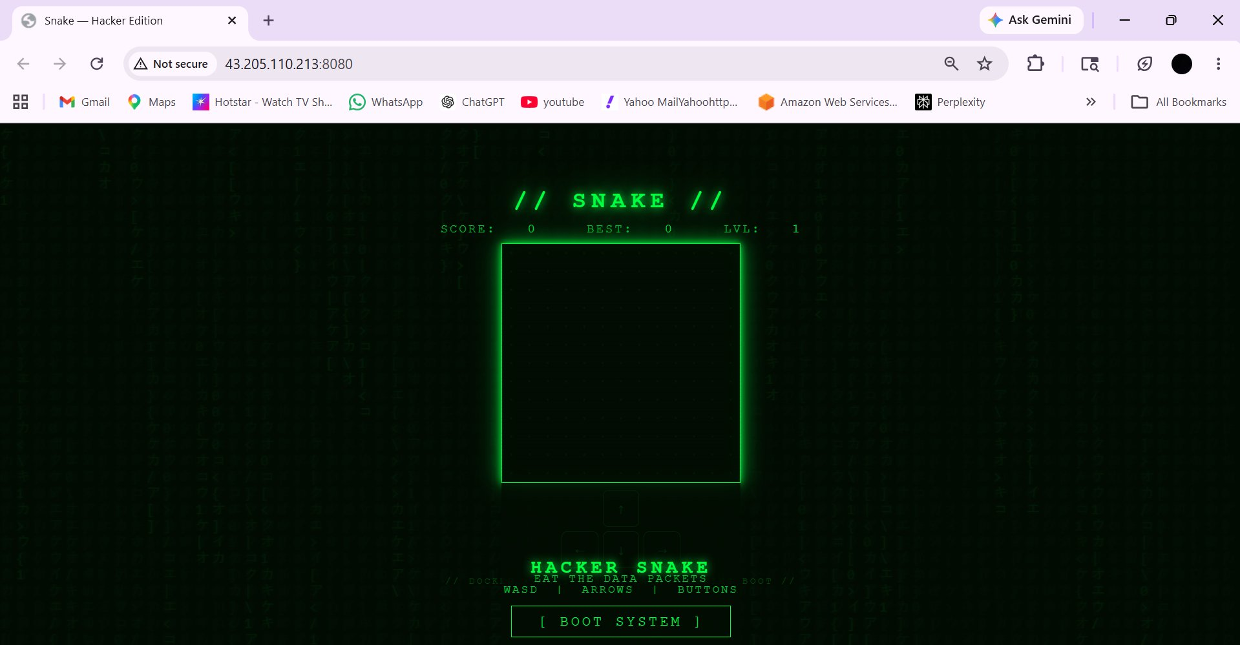
Screenshot 6 — Browser showing the Hacker Snake boot screen served from Docker on port 8080
Note: If the page does not load, check that port 8080 is open in your EC2 Security Group inbound rules and confirm docker ps shows the container running.

STEP 7 Play — Game Running in Docker
Click [ BOOT SYSTEM ] to start. Use WASD, Arrow Keys, or the on-screen buttons to control the snake. Eat the glowing {} data packets to grow and score points.

- Score: +10 x current level per packet eaten
- Speed increases every 100 points as the level goes up
- Particle burst effect on each packet eaten
- Game over shows "// SYSTEM BREACH //" with a REBOOT option

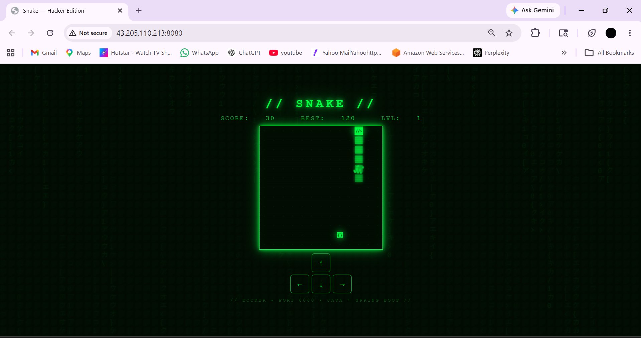
Screenshot 7 — Snake game running inside Docker, score 30, best 120, with on-screen control buttons visible

Useful Docker Commands

View running containers
docker ps

Follow container logs
docker logs -f java-cont

Stop and remove the container
docker stop java-cont && docker rm java-cont

Rebuild after code changes
docker stop java-cont && docker rm java-cont
docker build -t java-docker-app .
docker run -itd --name java-cont -p 8080:8080 java-docker-app

List all images
docker images

Summary
The following steps were completed to run the Hacker Snake Java application in Docker on AWS EC2:

- Cloned the repository from GitHub using git clone
- Verified the project structure with tree .
- Understood the two-stage Dockerfile and its benefits
- Built the Docker image using docker build
- Started the container in detached mode on port 8080
- Accessed the game boot screen in the browser
- Played the Hacker Snake game running inside Docker on AWS EC2

