Amazon CloudWatch
EC2 CPU Anomaly Detection Alarm
Step-by-Step Lab Guide with Screenshots

Author | Rohith
Date | 14 May 2026
Region | Asia Pacific (Mumbai) — ap-south-1
Instance | cloudwatch-test-server (i-01a40324b5ecc8c41)
AWS Service | Amazon CloudWatch — AI Operations
Task Type | EC2 CPU Anomaly Detection Alarm

Overview & Real-World Use Case
This guide documents the end-to-end creation of an Amazon CloudWatch Anomaly Detection Alarm on an EC2 instance. Instead of using a fixed static threshold (e.g., alert at 80% CPU), we use CloudWatch's built-in machine learning to automatically learn the normal CPU behavior of the server and only alert when something genuinely unusual occurs.

Real-World Scenario
An EC2 web server running a Node.js API experiences variable traffic — busy during business hours and quiet at night. A static 80% CPU alarm would fire false alerts every night. With anomaly detection, CloudWatch's ML model learns that low CPU at night is normal and stays silent — but fires immediately if CPU unexpectedly spikes to 100% at 2am (indicating an attack or runaway process).

What This Lab Covers
- Launch EC2 instance (cloudwatch-test-server)
- Select CPUUtilization metric in CloudWatch
- Configure Anomaly Detection conditions
- Set up SNS email notification
- Stress-test the CPU to trigger the alarm
- Receive real alarm email from AWS
- Use CloudWatch Investigate (GenAI RCA) feature

Step 1: Launch EC2 Instance
Since no active EC2 instances existed, a new t2.micro instance was launched using the AWS Free Tier.

- Service: EC2
- Instance name: cloudwatch-test-server
- AMI: Amazon Linux 2023 (free tier eligible)
- Instance type: t2.micro (750 hrs/month free)
- Region: Asia Pacific (Mumbai)

💡 t2.micro is free tier eligible — no charges for the first 750 hours per month. Always stop or terminate the instance after testing.

Step 2: Select Metric in CloudWatch
Navigate to CloudWatch > Alarms > All Alarms > Create Alarm > Select Metric. In the metric browser, navigate to EC2 > Per-Instance Metrics and search for CPUUtilization for the new instance.

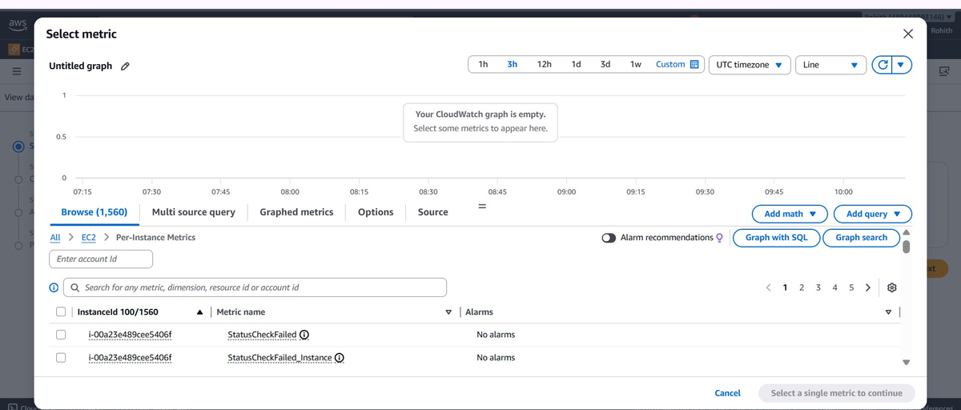
Screenshot 1 — CloudWatch Select Metric dialog showing EC2 Per-Instance Metrics

What to do on this screen
- Type CPUUtilization in the search box to filter the list
- Check the checkbox next to i-01a40324b5ecc8c41 → CPUUtilization
- Click Select a single metric to continue (bottom right)

💡 The instance ID i-01a40324b5ecc8c41 corresponds to the cloudwatch-test-server created in Step 1. Namespace shown as AWS/EC2, Statistic: Average, Period: 5 minutes.

Step 3: Configure Anomaly Detection Conditions
On the Conditions page, switch from Static threshold to Anomaly Detection. This tells CloudWatch to use its ML model instead of a fixed percentage.

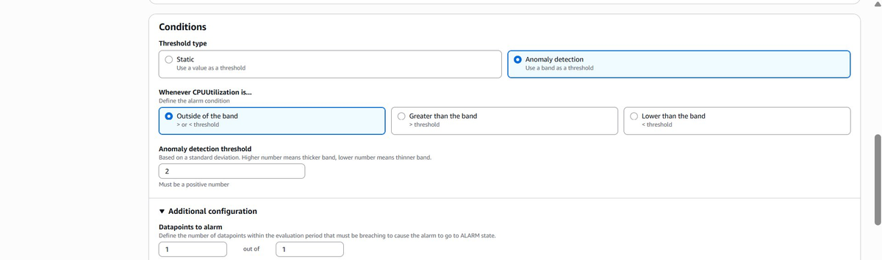
Screenshot 2 — Conditions page: Anomaly detection selected, threshold set to 2

Settings configured

Threshold type | Anomaly detection (not Static)
Whenever CPUUtilization is | Outside of the band
Anomaly detection threshold | 2 (standard deviations)
Datapoints to alarm | 1 out of 1
Missing data treatment | Treat missing data as missing

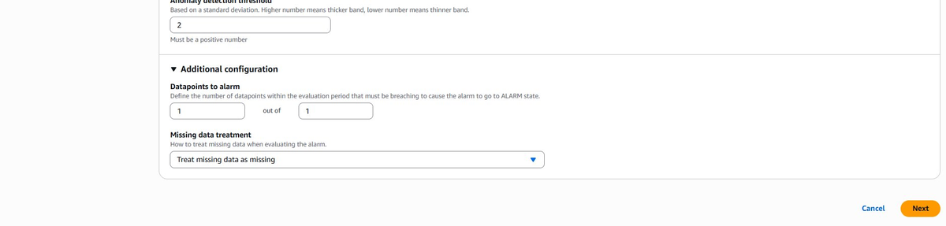
Screenshot 3 — Additional configuration: Datapoints to alarm and missing data treatment

💡 A threshold of 2 means the alarm fires if CPU deviates more than 2 standard deviations from its learned normal. Higher = wider tolerance band, fewer false alarms.

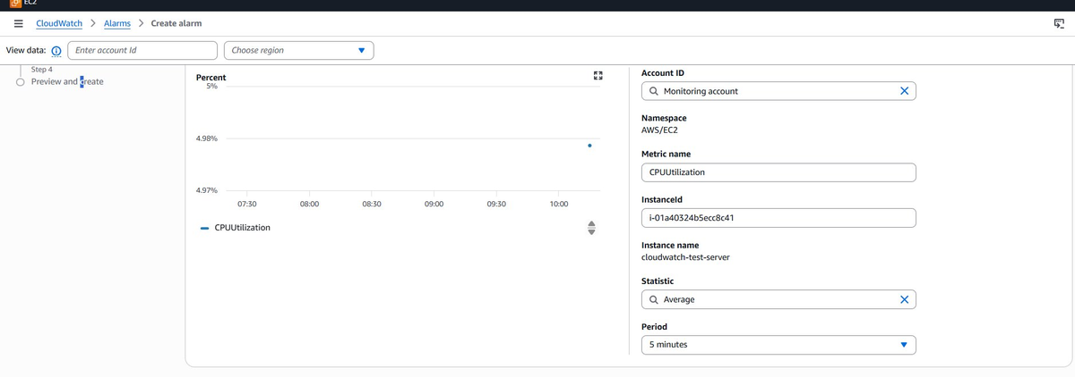
Screenshot 4 — Metric confirmed: cloudwatch-test-server, CPUUtilization, Average, 5 minutes period

Step 4: Alarm Created Successfully
After configuring the SNS notification and naming the alarm EC2-CPUAnomaly-cloudwatch-test-server, the alarm was created. The initial state shows Insufficient data which is expected for a newly created instance — the ML model needs time to collect baseline data.

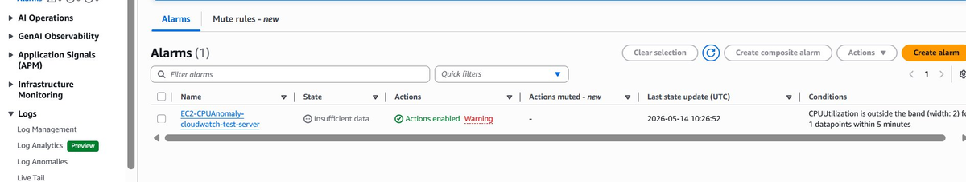
Screenshot 5 — Alarm created: EC2-CPUAnomaly-cloudwatch-test-server with Insufficient data state

Alarm name | EC2-CPUAnomaly-cloudwatch-test-server
State | Insufficient data (normal for new instances)
Condition | CPUUtilization is outside the band (width: 2)
Evaluation | 1 datapoint within 5 minutes
Actions | Enabled — SNS email notification

💡 The Warning badge next to Actions enabled means the SNS email subscription is pending confirmation. Check inbox and confirm the subscription email from AWS.

Step 5: SNS Email Subscription
After creating the alarm, an AWS SNS subscription confirmation email was sent. Due to Gmail's automatic link pre-fetching (a security feature), the unsubscribe link was auto-clicked. This was resolved by re-subscribing directly via SNS console.

Screenshot 6 — Gmail inbox showing both Subscription Confirmation and Unsubscribe Confirmation emails

Why Gmail auto-unsubscribed
Gmail's security scanner pre-fetches all links in incoming emails to check for malicious content. This accidentally triggered the unsubscribe link within seconds of the confirmation email arriving.

Fix applied
- Navigated to SNS > Topics > ec2-cpu-anomaly-alerts > Create Subscription
- Re-entered email address as the endpoint
- Right-clicked the confirmation link in the new email
- Opened in an Incognito window to prevent auto-fetching

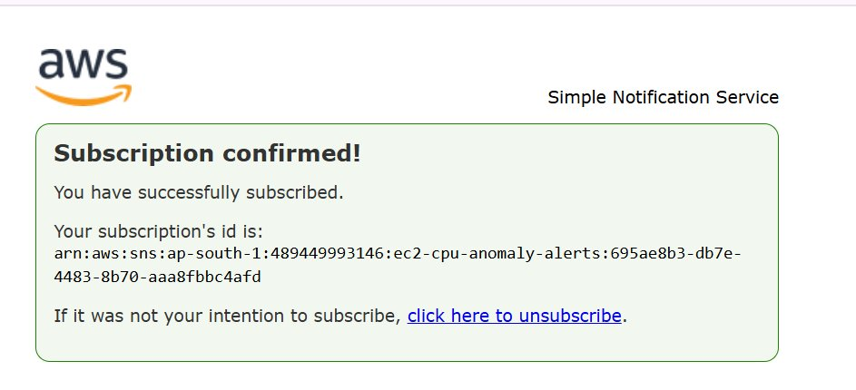
Screenshot 7 — Subscription Confirmed page showing successful SNS subscription

✅ Subscription confirmed! SNS topic: arn:aws:sns:ap-south-1:489449993146:ec2-cpu-anomaly-alerts

Step 6: CPU Stress Test
To test the alarm, the EC2 instance was connected via EC2 Instance Connect (browser-based SSH) and a CPU stress command was executed to push CPU utilization to 100%.

Command used
yes > /dev/null & yes > /dev/null & yes > /dev/null & yes > /dev/null &

This spawns 4 background processes that consume 100% of available CPU cycles. Results were visible in CloudWatch within 5 minutes.

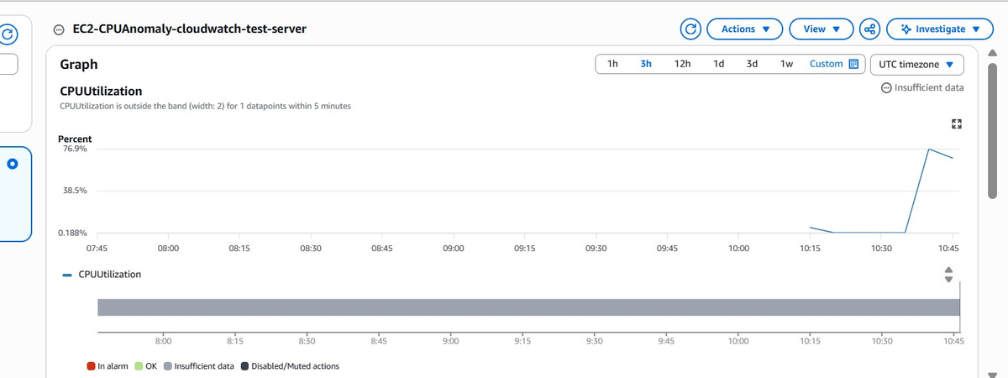
Screenshot 8 — CloudWatch graph showing CPU spike from ~0.188% to 76.9% after stress command

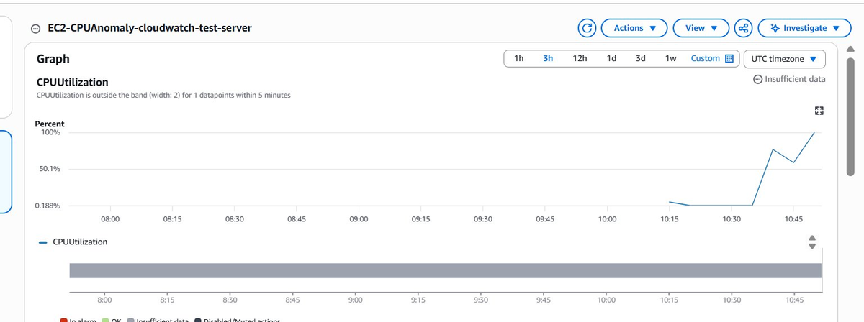
Screenshot 9 — CPU utilization reaching 100% — well above the normal baseline

💡 The graph clearly shows the flat baseline (0.188%) from 07:45 to 10:15, then the sharp spike to 100% at 10:30 onwards after the stress command was run.

Step 7: Switch to Static Threshold to Force Trigger
Since the anomaly detection model requires several hours of baseline data before it can classify deviations as ALARM, the threshold type was temporarily changed to Static with a threshold of 5% to immediately trigger the alarm while CPU was at 100%.

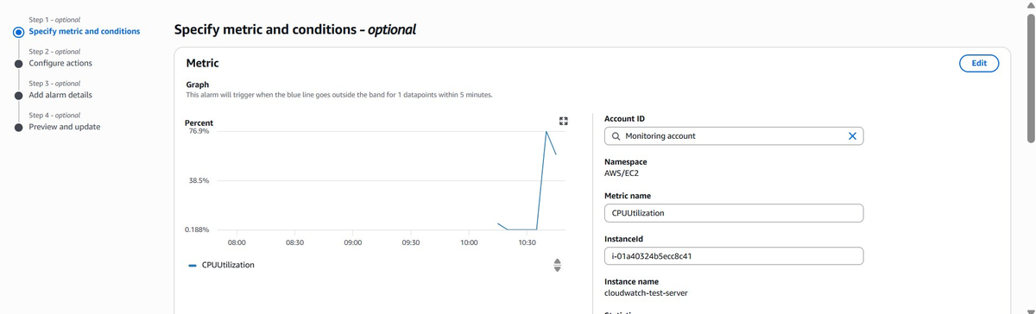
Screenshot 10 — Edit alarm: Conditions page showing current metric and Anomaly detection setting

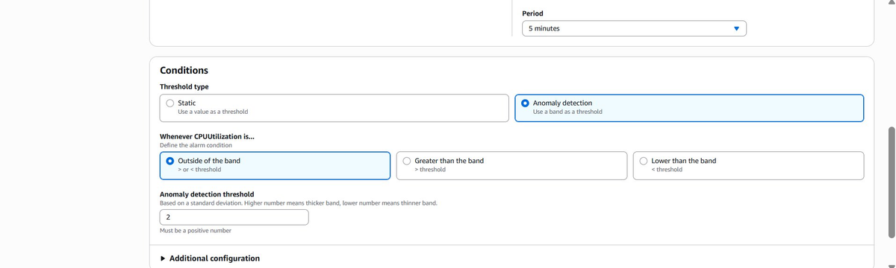
Screenshot 11 — Switching from Anomaly detection to Static threshold

Change made
Threshold type | Changed from Anomaly detection → Static
Condition | Greater than
Threshold value | 5 (percent)
Reason | Force immediate ALARM trigger while CPU is at 100%

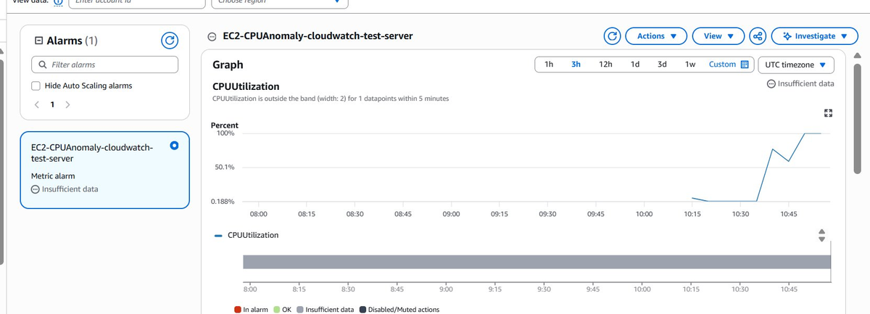
Screenshot 12 — Updated alarm showing red dashed threshold line at 5% with CPU well above it

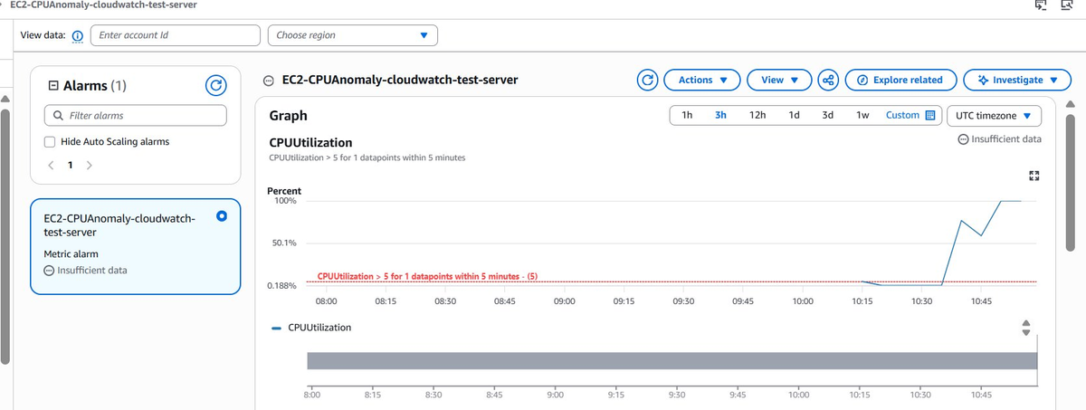
Screenshot 13 — Alarm condition updated: CPUUtilization > 5 for 1 datapoints within 5 minutes

💡 The red dashed horizontal line at 5% is the static threshold. The blue CPU line is already at ~100%, so the alarm will trip on the very next 5-minute evaluation cycle.

Step 8: Alarm Triggered — Email Received
Within 5 minutes of saving the static threshold, the CloudWatch alarm entered ALARM state and the SNS notification was delivered to the registered email address.

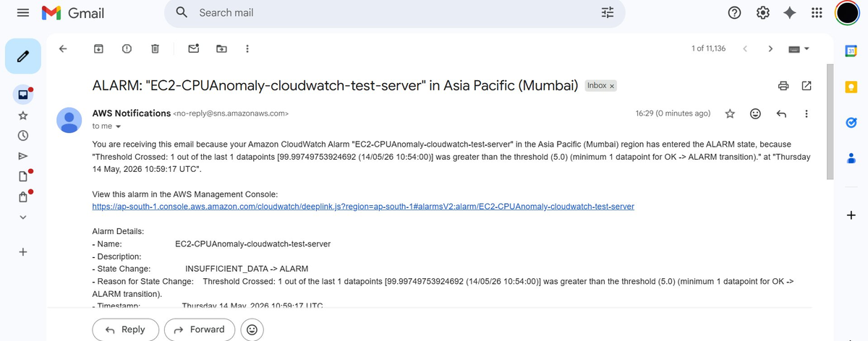
Screenshot 14 — AWS alarm notification email received in Gmail inbox

Alarm email details
Alarm name | EC2-CPUAnomaly-cloudwatch-test-server
Region | Asia Pacific (Mumbai)
State change | INSUFFICIENT_DATA → ALARM
CPU value detected | 99.99749753924692%
Threshold crossed | Greater than 5.0%
Timestamp | Thursday 14 May 2026, 10:59:17 UTC
Datapoints | 1 out of the last 1 datapoints breached

✅ End-to-end alarm pipeline verified: EC2 CPU spike → CloudWatch detection → SNS notification → Email delivered

Step 9: CloudWatch Investigate (GenAI AI Operations)
After the alarm fired, the built-in Investigate button (powered by CloudWatch AI Operations / GenAI) was clicked to perform automated root cause analysis.

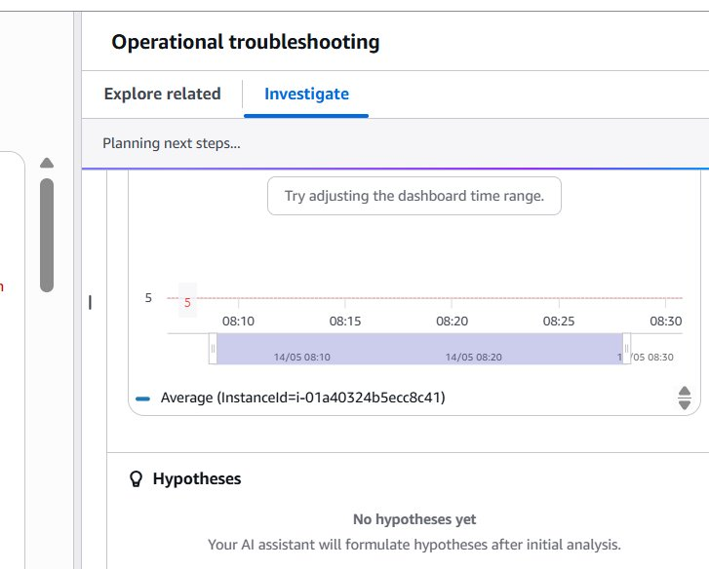
Screenshot 15 — CloudWatch Investigate panel showing AI-powered operational troubleshooting in progress

What CloudWatch Investigate does
- Analyzes telemetry data: metrics, logs, deployment events, AWS Health events, CloudTrail changes, X-Ray traces
- Generates AI-powered hypotheses for the root cause
- Surfaces related metrics and correlated signals
- Suggests remediation actions via AWS Systems Manager runbooks
- Creates incident reports with 5-Whys analysis

💡 The panel shows Planning next steps... while the GenAI engine analyzes the spike. Hypotheses populate within 30–60 seconds and provide structured root cause analysis automatically.

Summary — What Was Accomplished

Step 1 | Launched EC2 t2.micro instance (cloudwatch-test-server)
Step 2 | Selected CPUUtilization metric in CloudWatch
Step 3 | Configured Anomaly Detection conditions (threshold: 2)
Step 4 | Alarm created — EC2-CPUAnomaly-cloudwatch-test-server
Step 5 | SNS email subscription confirmed
Step 6 | CPU stressed to 100% using yes > /dev/null commands
Step 7 | Switched to Static threshold (5%) to force trigger
Step 8 | Alarm email received — INSUFFICIENT_DATA → ALARM
Step 9 | CloudWatch Investigate (GenAI RCA) explored

Key Takeaways
- Anomaly detection is smarter than static thresholds — it adapts to your workload's natural patterns
- The ML model improves over 2 weeks of data collection — accuracy increases over time
- SNS + CloudWatch enables real-time alerting for any AWS metric breach
- CloudWatch Investigate provides GenAI-powered root cause analysis at no extra cost
- Always stop or terminate test EC2 instances after labs to avoid unnecessary charges

💡 To restore anomaly detection: Actions > Edit > Switch back to Anomaly detection threshold > Update alarm. The ML model continues learning in the background.

