AWS Route 53
Private Hosted Zone
Step-by-Step Implementation Guide

Project: rohithportfolio.xyz
Date: May 15, 2026
Region: US East (N. Virginia)

Overview
This document covers the end-to-end setup of an AWS Route 53 Private Hosted Zone integrated with a custom VPC. Internal DNS records are configured so EC2 instances can resolve each other by domain name instead of hardcoded private IP addresses — a real-world pattern used by companies like Netflix and Amazon for internal service discovery.

Architecture Summary:
- VPC: my-vpc (10.0.0.0/16)
- Public Subnet: pub-subnet (10.0.1.0/24) — App Server
- Private Subnet: pvt-subnet (10.0.2.0/24) — DB Server
- Public Hosted Zone: rohithportfolio.xyz (internet-facing)
- Private Hosted Zone: rohithportfolio.xyz (VPC-internal only)

Step 1 — Create Custom VPC
Navigate to AWS Console → VPC → Your VPCs → Create VPC. A custom VPC named my-vpc was created with CIDR block 10.0.0.0/16.
VPC Name | my-vpc
VPC ID | vpc-003ec539db53d76c1
IPv4 CIDR | 10.0.0.0/16
State | Available

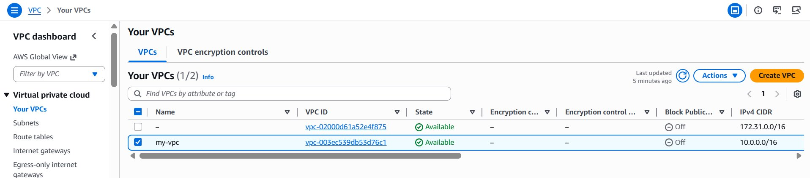
Figure 1: VPC Dashboard showing my-vpc (vpc-003ec539db53d76c1) in Available state

Step 2 — Create Public and Private Subnets
Two subnets were created inside my-vpc — one public for the App Server and one private for the DB Server.
Public Subnet | pub-subnet — 10.0.1.0/24 — us-east-1
Private Subnet | pvt-subnet — 10.0.2.0/24 — us-east-1

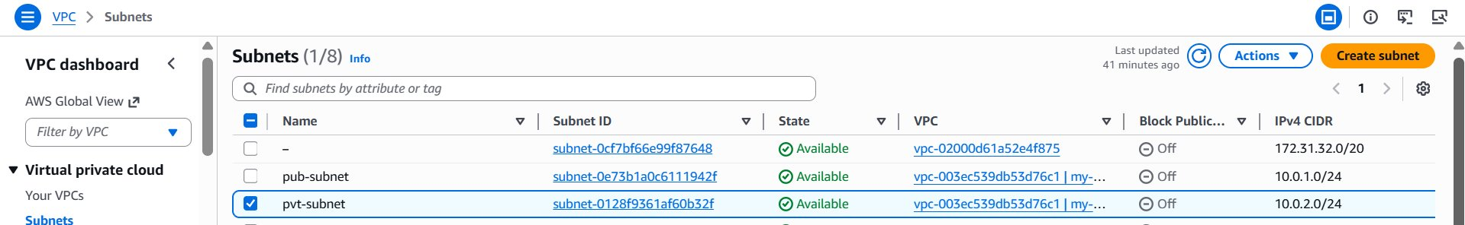
Figure 2: Subnets — pub-subnet (10.0.1.0/24) and pvt-subnet (10.0.2.0/24) inside my-vpc

Step 3 — Create Route Tables
Two route tables were created: pub-RT for the public subnet (with internet gateway route) and pvt-RT for the private subnet. Each was explicitly associated with its respective subnet.
pub-RT | Associated with pub-subnet — routes 0.0.0.0/0 to IGW
pvt-RT | Associated with pvt-subnet — local routes only

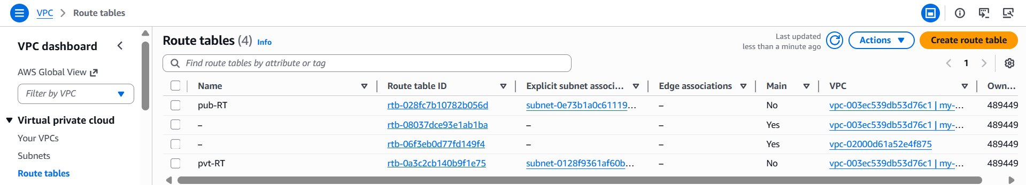
Figure 3: Route Tables — pub-RT and pvt-RT associated with their subnets

Step 4 — Create and Attach Internet Gateway
An Internet Gateway named my-igw was created and attached to my-vpc. This allows the App Server in the public subnet to be reachable from the internet.
IGW Name | my-igw
IGW ID | igw-073d65244459d119c
Attached VPC | vpc-003ec539db53d76c1 | my-vpc
State | Attached

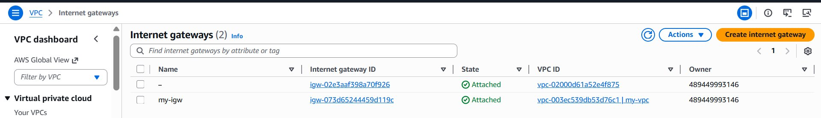
Figure 4: Internet Gateway my-igw attached to my-vpc

Step 5 — Launch Two EC2 Instances
Two EC2 instances were launched inside my-vpc: rohith-app-server in the public subnet (with public IP) and rohith-db-server in the private subnet (no public IP).
App Server | rohith-app-server — Public IP: 13.222.7.129 — Private IP: 10.0.1.85
DB Server | rohith-db-server — No Public IP — Private IP: 10.0.2.71
Instance Type | t3.micro
Status | Running — 3/3 checks passed

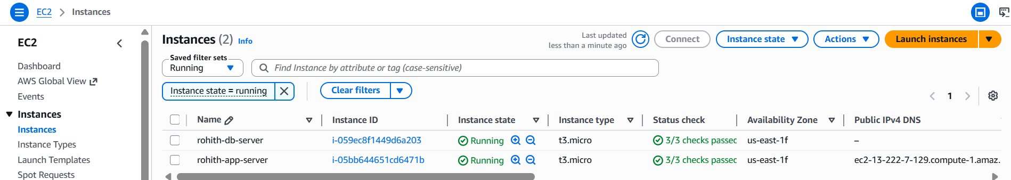
Figure 5: Both EC2 instances running — App Server (public) and DB Server (private)

Step 6 — Create Public and Private Hosted Zones
Two hosted zones were created in Route 53 with the same domain name rohithportfolio.xyz — one Public (for internet traffic) and one Private (for VPC-internal DNS resolution).
Important: While creating the Private hosted zone, the VPC association is done immediately during the creation process itself. Under 'VPCs to associate with the hosted zone', select the region and choose my-vpc (vpc-003ec539db53d76c1). This links the private zone to your VPC at creation time — no separate association step is needed afterward.
Public Zone | rohithportfolio.xyz — ID: Z02669832920ZJKOQ0ELO
Private Zone | rohithportfolio.xyz — ID: Z05324937XY2MNWFQDWX
VPC Associated (at creation) | vpc-003ec539db53d76c1 (my-vpc) — US East (N. Virginia)

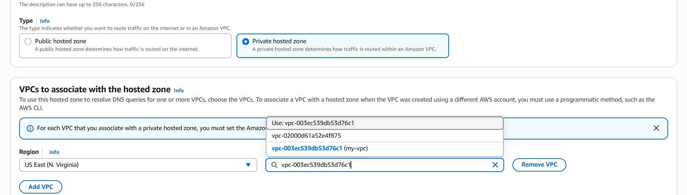
Figure 6a: VPC association done during Private Hosted Zone creation — select my-vpc (vpc-003ec539db53d76c1)

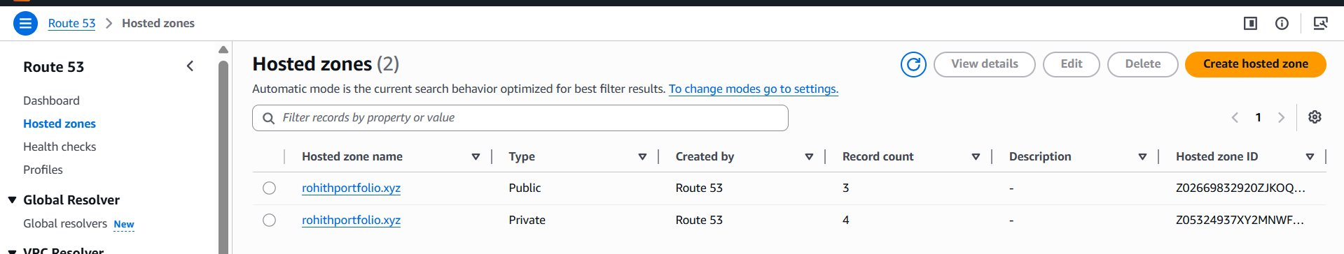
Figure 6b: Route 53 Hosted Zones — Public and Private zones for rohithportfolio.xyz created successfully

Step 7 — Add DNS Records in Private Hosted Zone
Two A records were added in the Private hosted zone mapping internal domain names to private EC2 IP addresses. These records are only resolvable from within the VPC.
app.rohithportfolio.xyz | A Record → 10.0.1.85 (App Server private IP)
database.rohithportfolio.xyz | A Record → 10.0.2.71 (DB Server private IP)
TTL | 60 seconds

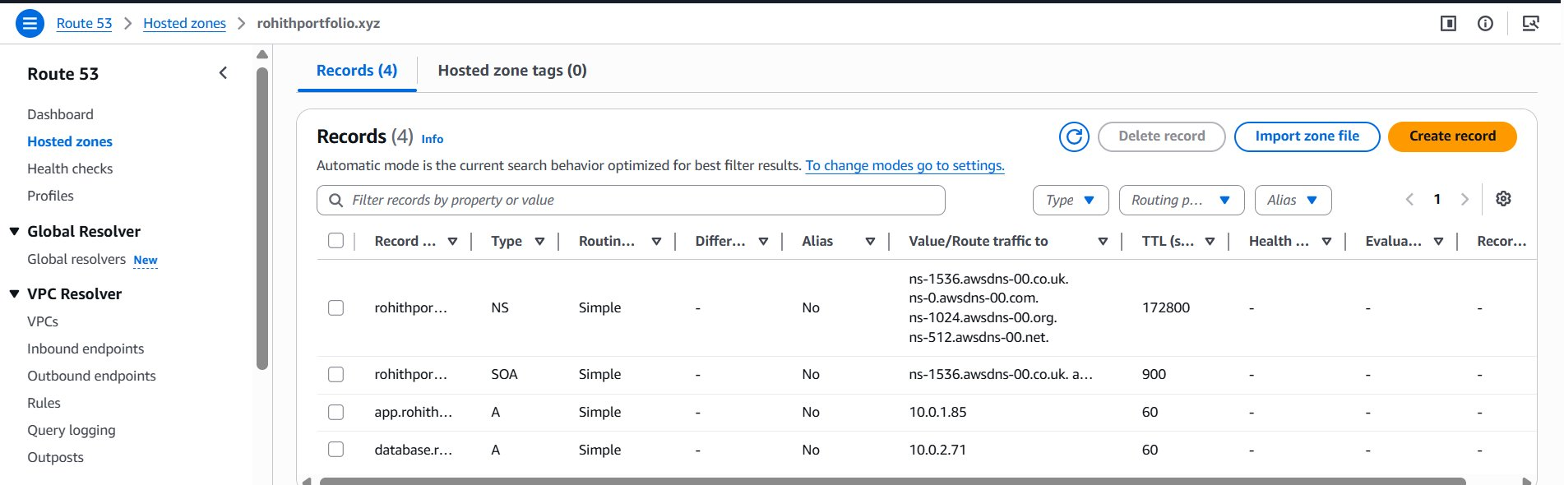
Figure 7: Private Hosted Zone records — app and database A records pointing to private IPs

Step 8 — Add DNS Records in Public Hosted Zone
The Public hosted zone was configured with an A record pointing to the App Server's public IP address, making the website reachable from the internet. The NS records from Route 53 were also noted for updating in GoDaddy.
rohithportfolio.xyz | A Record → 13.222.7.129 (App Server public IP)
Nameservers | ns-3.awsdns-00.com, ns-1050.awsdns-03.org, ns-780.awsdns-33.net, ns-1786.awsdns-31.co.uk

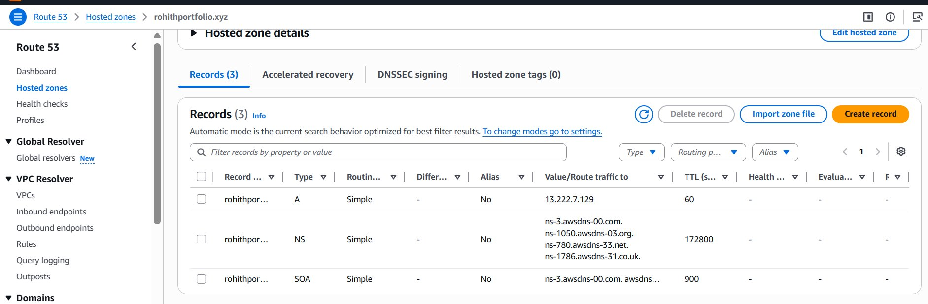
Figure 8: Public Hosted Zone records — A record pointing to EC2 public IP

Step 9 — Update Nameservers in GoDaddy
The four Route 53 nameservers from the Public hosted zone were copied and updated in GoDaddy's DNS settings under Custom Nameservers. This delegates DNS authority for rohithportfolio.xyz to AWS Route 53.
NS 1 | ns-3.awsdns-00.com
NS 2 | ns-1050.awsdns-03.org
NS 3 | ns-780.awsdns-33.net
NS 4 | ns-1786.awsdns-31.co.uk

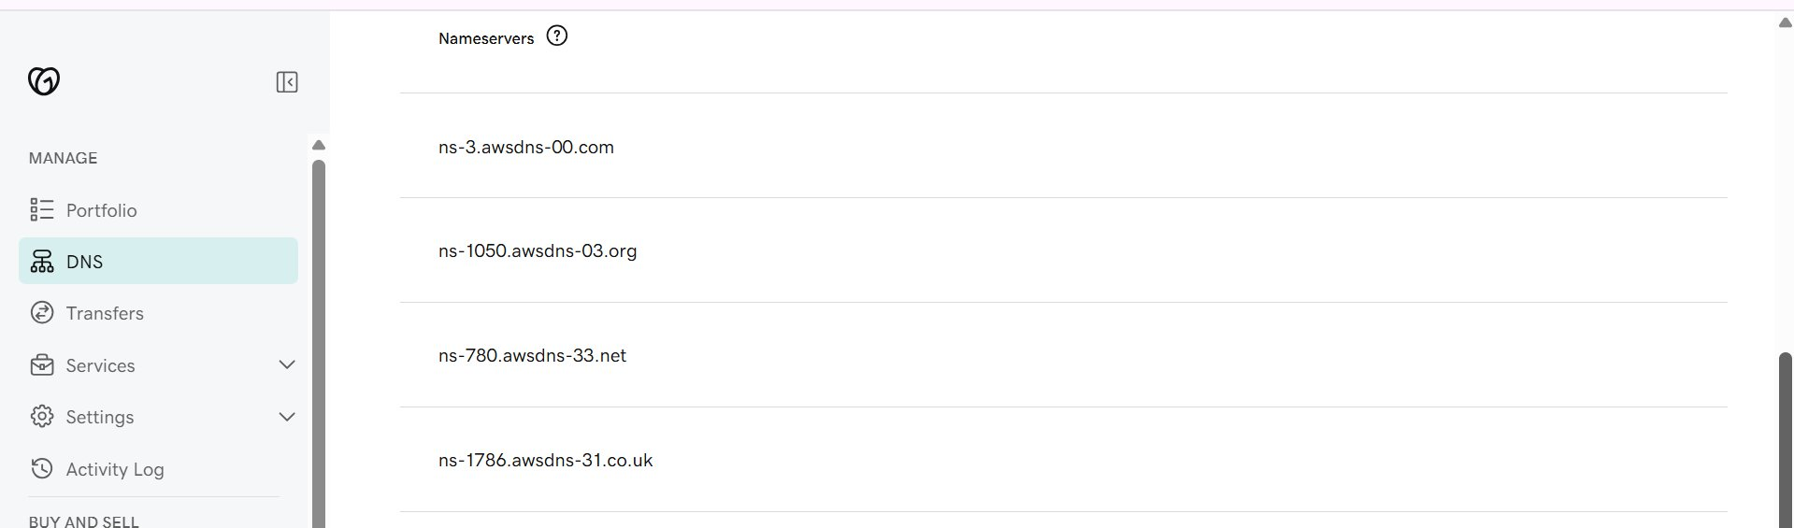
Figure 9: GoDaddy DNS — Custom nameservers updated to Route 53 nameservers

Step 10 — Verify VPC Association & DNS Settings
After creating the Private hosted zone, verify that my-vpc is correctly associated by going to Route 53 → Hosted Zones → click Private zone → Edit. The VPC section should show vpc-003ec539db53d76c1 (my-vpc). Also confirm that DNS Resolution and DNS Hostnames are both enabled in the VPC settings — these are required for Route 53 private DNS to function inside the VPC.
Check 1 | Route 53 Private Zone → Edit → VPC shows vpc-003ec539db53d76c1 (my-vpc)
Check 2 | VPC Console → my-vpc → DNS Resolution: Enabled
Check 3 | VPC Console → my-vpc → DNS Hostnames: Enabled

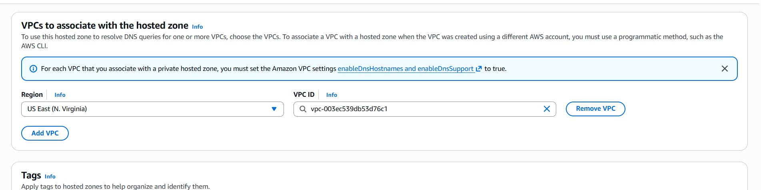
Figure 10: Verifying VPC association — my-vpc correctly linked to Private Hosted Zone

Step 11 — Verify Private DNS Resolution
From inside the App EC2 server, nslookup commands were run to verify that private DNS records resolve correctly. The VPC DNS resolver (10.0.0.2) successfully returned private IP addresses for both records.
Test Results:
- database.rohithportfolio.xyz → 10.0.2.71 (RESOLVED inside VPC)
- app.rohithportfolio.xyz → 10.0.1.85 (RESOLVED inside VPC)
- app.rohithportfolio.xyz via 8.8.8.8 → SERVFAIL (NOT accessible from internet — CORRECT)

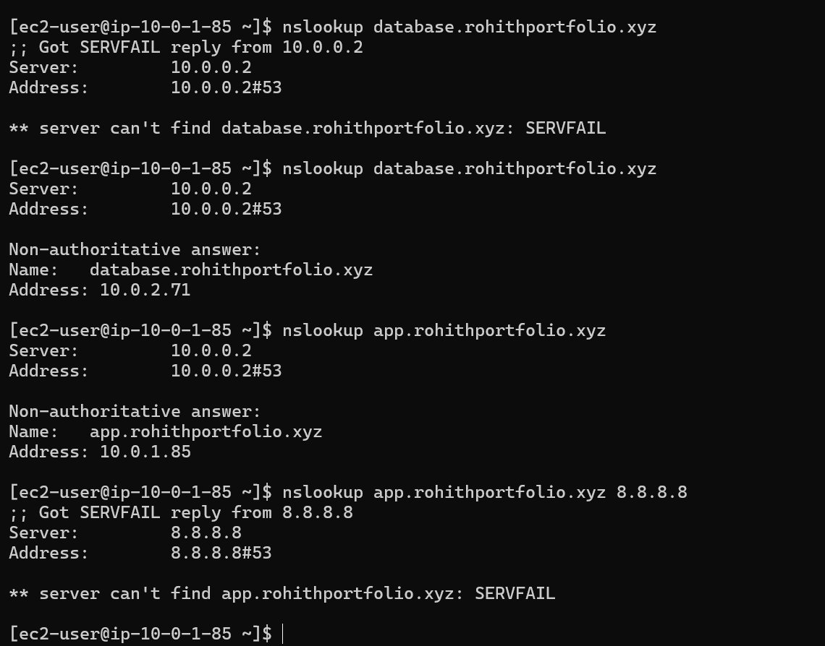
Figure 11: nslookup output — Private DNS resolves inside VPC; SERVFAIL from public internet confirms privacy

Summary
The Route 53 Private Hosted Zone was successfully configured. The setup demonstrates real-world internal service discovery using domain names instead of hardcoded IP addresses.

Key Outcomes:
- Custom VPC with public and private subnets created
- Internet Gateway and Route Tables configured for proper routing
- App Server (public) and DB Server (private) EC2 instances launched
- Public Hosted Zone configured for internet-facing DNS
- Private Hosted Zone configured for internal VPC DNS
- app.rohithportfolio.xyz resolves to 10.0.1.85 inside VPC only
- database.rohithportfolio.xyz resolves to 10.0.2.71 inside VPC only
- Private records are NOT accessible from the public internet (confirmed)

Real World Value: Instead of hardcoding IP addresses in application code, internal services use domain names. If an IP address changes, only the Route 53 record needs updating — no application code changes required.

