AWS SSM Session Manager
Private EC2 Access Setup Guide
Step-by-Step Documentation with Screenshots
Region: ap-south-1 (Mumbai) | Platform: Amazon Linux 2023

What This Guide Covers
Step | Task | Resources Created
Step 1 | Create VPC | SSM-vpc, Private Subnet, Route Table
Step 2 | Endpoint Security Group | ssm-endpoint-sg
Step 3 | EC2 Security Group | ssm-ec2-sg
Step 4 | VPC Endpoints | ssm, ssmmessages, ec2messages
Step 5 | IAM Role | EC2-SSM-Role
Step 6 | Launch Private EC2 | ssm-private-ec2
Step 7 | Connect via SSM | Session Manager Shell

💡 No SSH keys, No Bastion Host, No Public IP, No Inbound ports required — 100% Secure!

Step 1: Create VPC

Create a new VPC using the 'VPC and more' option which auto-generates all required networking resources including private subnet and route table.

Configuration Settings
Setting | Value
Resources to create | VPC and more
Name tag | SSM
IPv4 CIDR | 10.0.0.0/16 (65,536 IPs)
IPv6 CIDR | No IPv6 CIDR block
Tenancy | Default
Availability Zones | 1
Public Subnets | 0 (None required)
Private Subnets | 1
NAT Gateways | None
VPC Endpoints | None (created manually)
DNS Hostnames | ✅ Enable
DNS Resolution | ✅ Enable

💡 DNS Hostnames and DNS Resolution must both be enabled for VPC Endpoints to work correctly.

Screenshot: VPC Creation Form
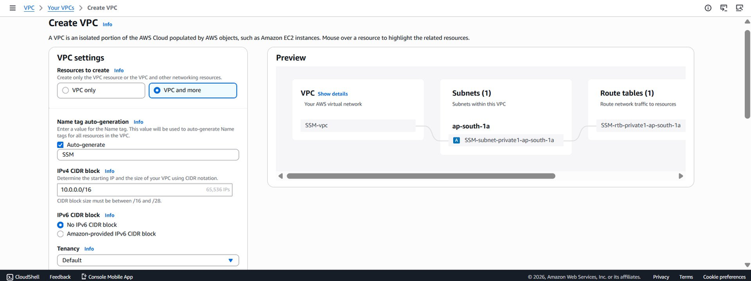
Figure 1.1 — VPC creation form with SSM name and 10.0.0.0/16 CIDR

Screenshot: VPC Network Settings
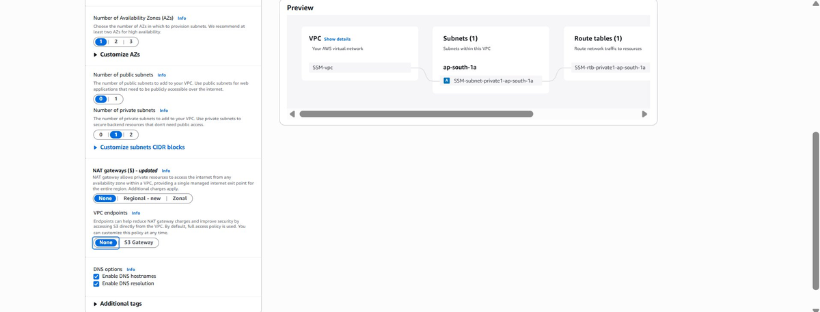
Figure 1.2 — No public subnets, 1 private subnet, No NAT Gateway, DNS enabled

Screenshot: VPC Created Successfully
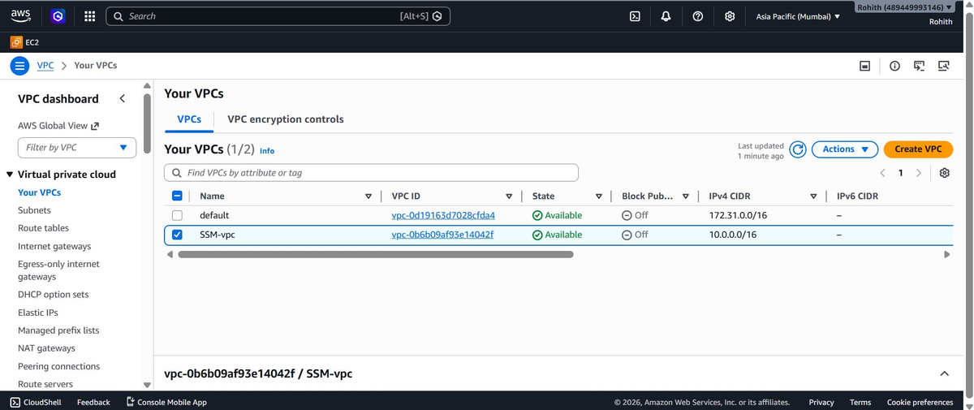
Figure 1.3 — SSM-vpc created and available with CIDR 10.0.0.0/16

Auto-Generated Resources
Resource | Auto-Generated Name
VPC | SSM-vpc
Private Subnet | SSM-subnet-private1-ap-south-1a
Route Table | SSM-rtb-private1-ap-south-1a

Step 2: Create Endpoint Security Group
Create a dedicated security group for the VPC Endpoints. This controls what traffic is allowed to reach the endpoints.

Security Group Configuration
Setting | Value
Name | ssm-endpoint-sg
Description | Security group for SSM VPC Endpoints
VPC | SSM-vpc (vpc-0b6b09af93e14042f)

Inbound Rules
Type | Protocol | Port | Source | Purpose
HTTPS | TCP | 443 | 10.0.0.0/16 | Allow EC2 to reach endpoints

Outbound Rules
Type | Protocol | Port | Destination
All traffic | All | All | 0.0.0.0/0

💡 Source is set to VPC CIDR (10.0.0.0/16) so only resources inside the VPC can communicate with the endpoints.

Screenshot: Endpoint SG Created
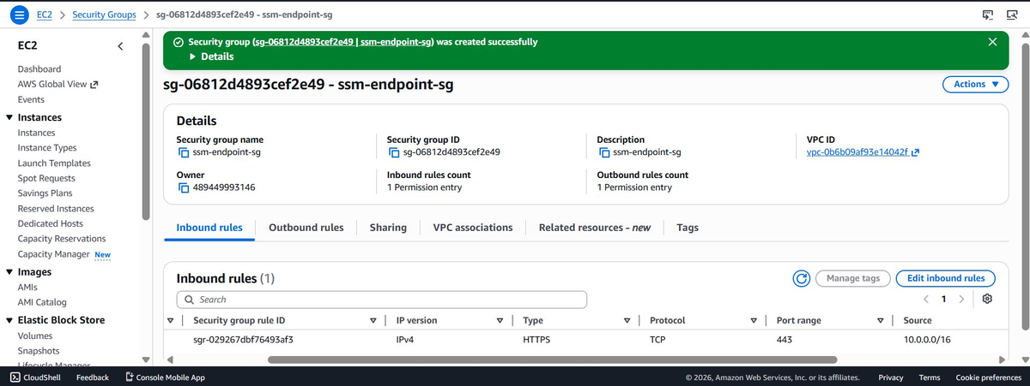
Figure 2.1 — ssm-endpoint-sg created with HTTPS inbound from VPC CIDR

Step 3: Create EC2 Security Group

Create a security group for the private EC2 instance. The EC2 only needs outbound access — no inbound rules are required since SSM agent initiates all connections outward.

Security Group Configuration
Setting | Value
Name | ssm-ec2-sg
Description | Security group for private EC2 with SSM
VPC | SSM-vpc (vpc-0b6b09af93e14042f)

Inbound Rules
Type | Protocol | Port | Source
None | — | — | No inbound rules required

Outbound Rules
Type | Protocol | Port | Destination | Purpose
HTTPS | TCP | 443 | 0.0.0.0/0 | Connect to SSM VPC Endpoints
DNS (UDP) | UDP | 53 | 0.0.0.0/0 | DNS resolution for endpoints
DNS (TCP) | TCP | 53 | 0.0.0.0/0 | DNS resolution for endpoints

💡 DNS ports (53) are critical — without them the SSM Agent cannot resolve endpoint hostnames and will silently fail.

Screenshot: EC2 SG Outbound Rules
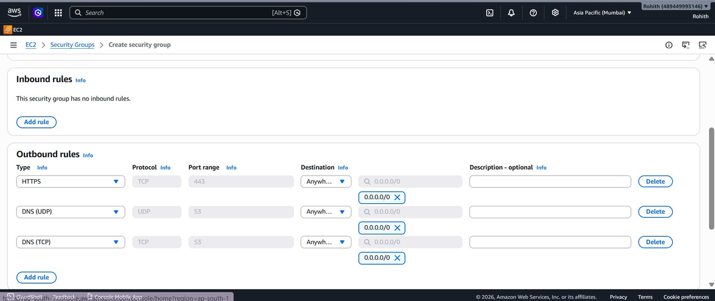
Figure 3.1 — EC2 SG outbound rules: HTTPS 443, DNS UDP 53, DNS TCP 53

Screenshot: EC2 SG Created
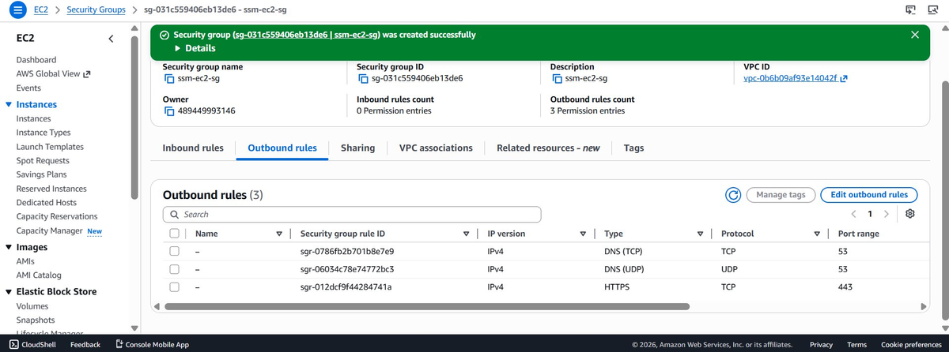
Figure 3.2 — ssm-ec2-sg created with 0 inbound and 3 outbound rules

Step 4: Create VPC Endpoints

Create 3 Interface VPC Endpoints to allow the private EC2 to communicate with AWS SSM services without internet access. All endpoints must be in the same VPC and subnet as the EC2 instance.

Endpoints to Create
Endpoint Name | Service Name | Type
ssm-endpoint | com.amazonaws.ap-south-1.ssm | Interface
ssmmessages-endpoint | com.amazonaws.ap-south-1.ssmmessages | Interface
ec2messages-endpoint | com.amazonaws.ap-south-1.ec2messages | Interface

Common Settings for All 3 Endpoints
Setting | Value
Service Category | AWS Services
VPC | SSM-vpc (vpc-0b6b09af93e14042f)
Subnet | SSM-subnet-private1-ap-south-1a
Security Group | ssm-endpoint-sg
Private DNS | ✅ Enable

💡 Private DNS must be enabled on all endpoints so the SSM Agent can resolve AWS service hostnames to private IPs inside the VPC.

Screenshot: SSM Endpoint Created
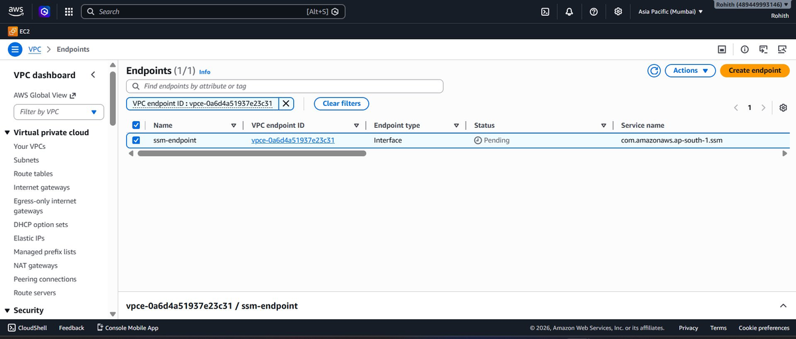
Figure 4.1 — ssm-endpoint created (status: Pending → Available)

Screenshot: SSMMessages Endpoint Created
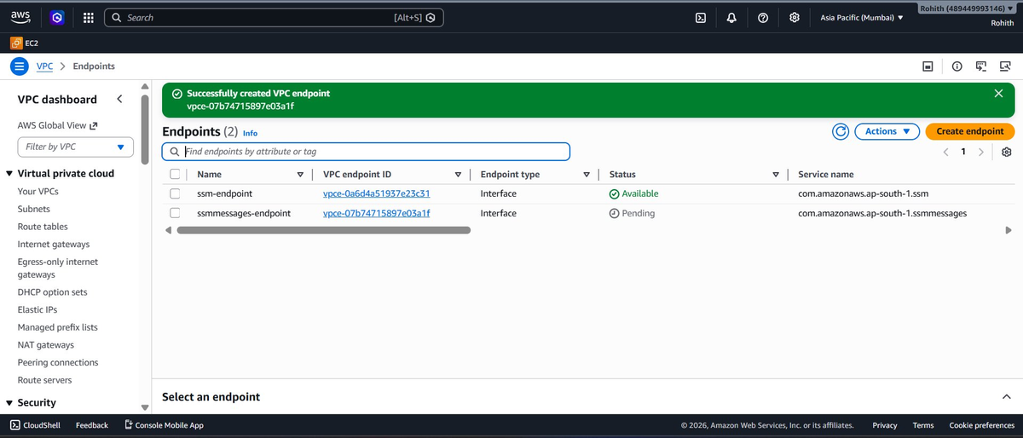
Figure 4.2 — ssmmessages-endpoint created alongside ssm-endpoint

Screenshot: All 3 Endpoints Available
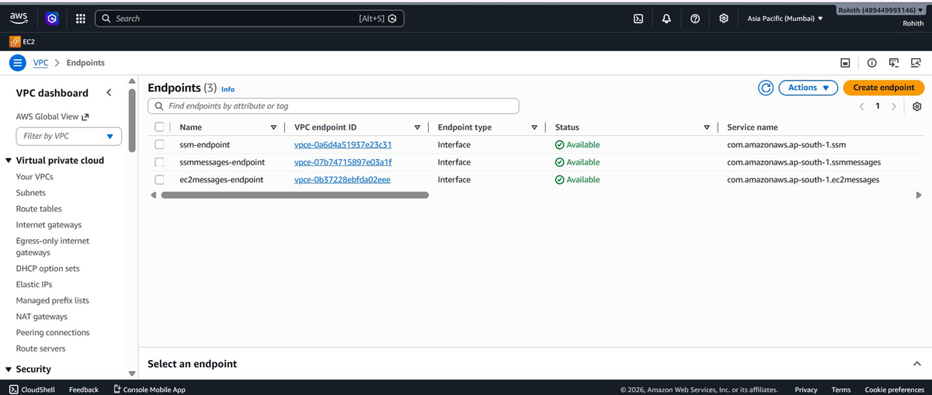
Figure 4.3 — All 3 endpoints showing Available status

Step 5: Create IAM Role

Create an IAM role that grants the EC2 instance permission to communicate with AWS Systems Manager service.

Role Configuration
Setting | Value
Trusted Entity Type | AWS Service
Use Case | EC2
Role Name | EC2-SSM-Role
Description | Allows EC2 to communicate with SSM Session Manager

Attached Policy
Policy Name | Type | Purpose
AmazonSSMManagedInstanceCore | AWS Managed | Grants SSM Agent permissions to register and communicate with SSM service

💡 AmazonSSMManagedInstanceCore is an AWS managed policy that includes all minimum permissions required for Session Manager, Run Command, and Patch Manager.

Screenshot: IAM Role Created
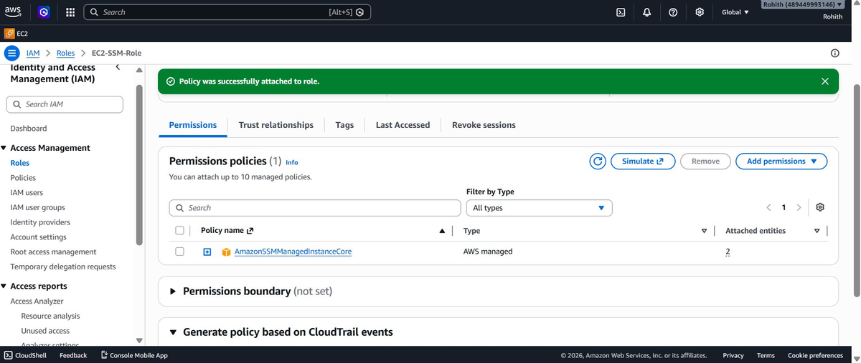
Figure 5.1 — EC2-SSM-Role with AmazonSSMManagedInstanceCore policy attached

Step 6: Launch Private EC2 Instance

Launch a private EC2 instance with no public IP address. The instance will use SSM Agent to register with Systems Manager through the VPC endpoints.

Instance Configuration
Setting | Value
Name | ssm-private-ec2
AMI | Amazon Linux 2023 (ami-09ed39e30153c3bf9)
Instance Type | t3.micro
Key Pair | Proceed without key pair (not needed)
VPC | SSM-vpc (vpc-0b6b09af93e14042f)
Subnet | SSM-subnet-private1-ap-south-1a
Auto-assign Public IP | Disable
Security Group | ssm-ec2-sg
IAM Instance Profile | EC2-SSM-Role

User Data Script (Advanced Details)
Add this script in the User Data field under Advanced Details:
#!/bin/bash
sudo yum install -y amazon-ssm-agent
sudo systemctl enable amazon-ssm-agent
sudo systemctl start amazon-ssm-agent

💡 The User Data script ensures SSM Agent is installed and started immediately on boot — critical for the instance to register with SSM.

Screenshot: Network Settings
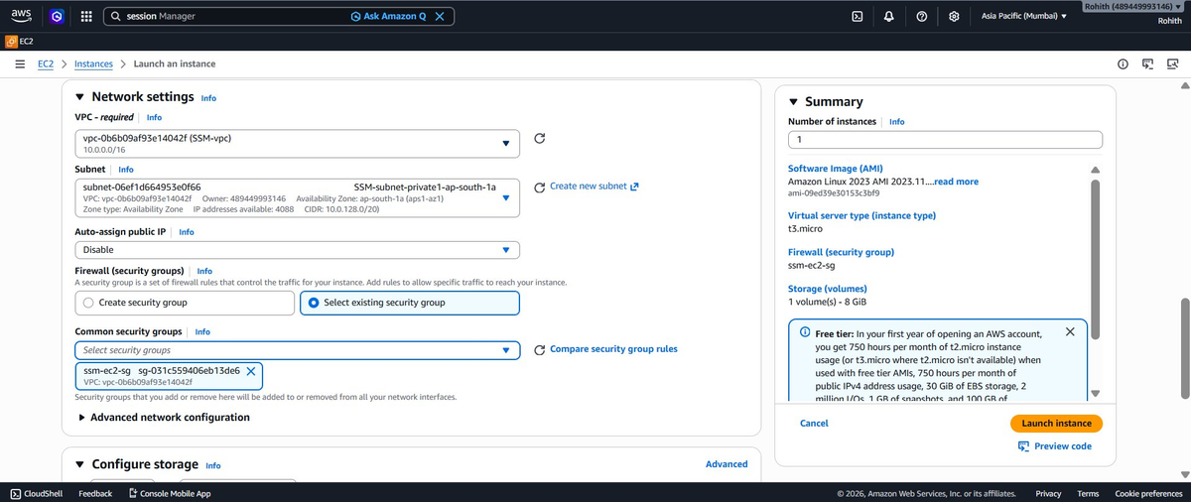
Figure 6.1 — EC2 network settings: SSM-vpc, private subnet, Public IP disabled, ssm-ec2-sg

Screenshot: IAM Instance Profile
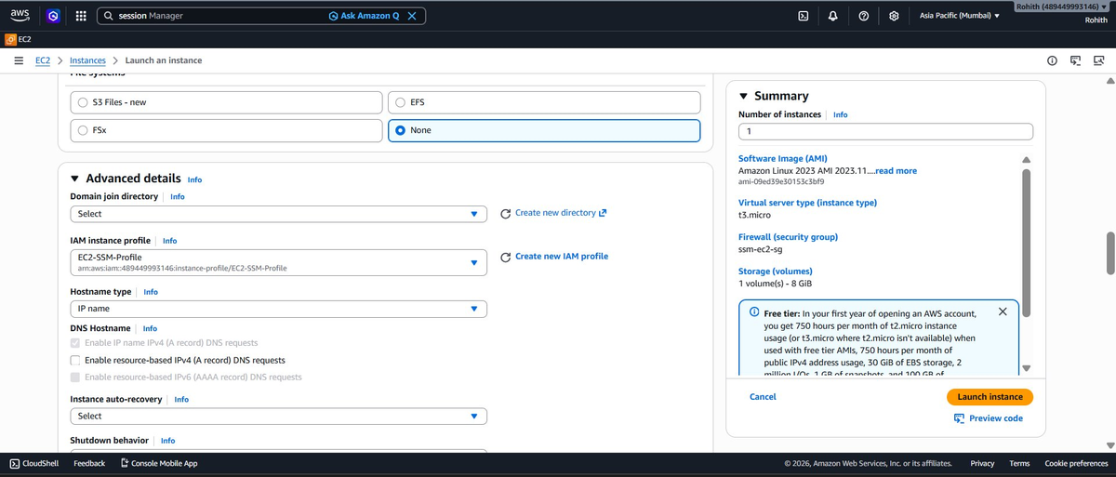
Figure 6.2 — EC2-SSM-Profile selected as IAM instance profile

Screenshot: User Data
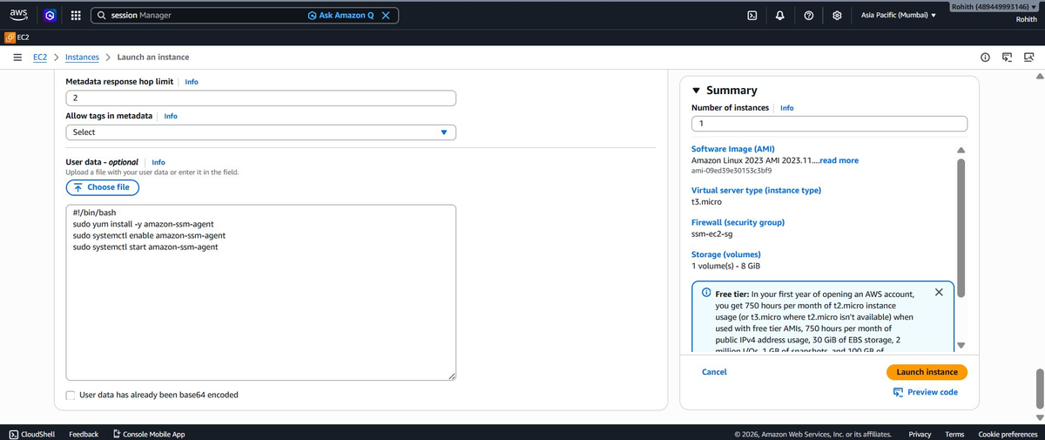
Figure 6.3 — SSM Agent install script in User Data field

Screenshot: Instance Running
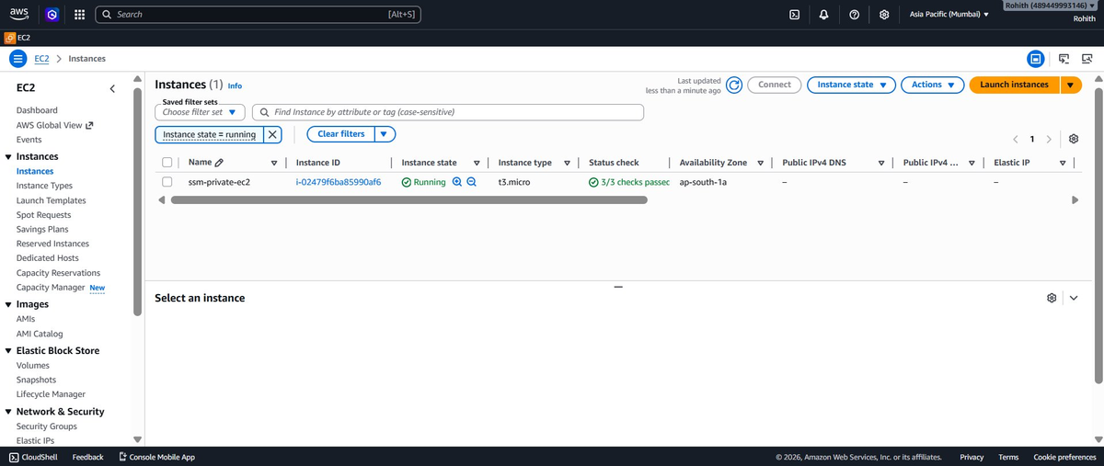
Figure 6.4 — ssm-private-ec2 running with 3/3 status checks passed, no public IP

Step 7: Connect via Session Manager

After the instance is running, wait 3-5 minutes for the SSM Agent to register, then connect using Session Manager — no SSH or bastion host needed.

How to Connect (Console)
- Go to AWS Systems Manager → Session Manager
- Click Start session
- Select your instance ssm-private-ec2 from the Target instances list
- Click Start session
- A new browser tab opens with an interactive shell connected to your private EC2
How to Connect (CLI)
aws ssm start-session \
--target i-02479f6ba85990af6 \
--region ap-south-1

Screenshot: Session Manager Console
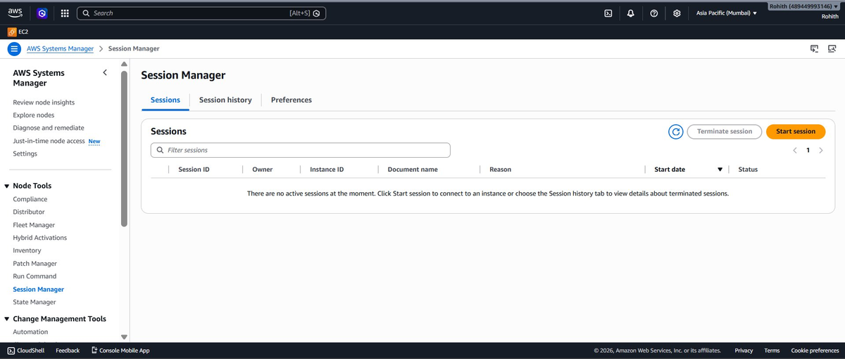
Figure 7.1 — AWS Session Manager console showing Start session option

Screenshot: Instance Visible in SSM
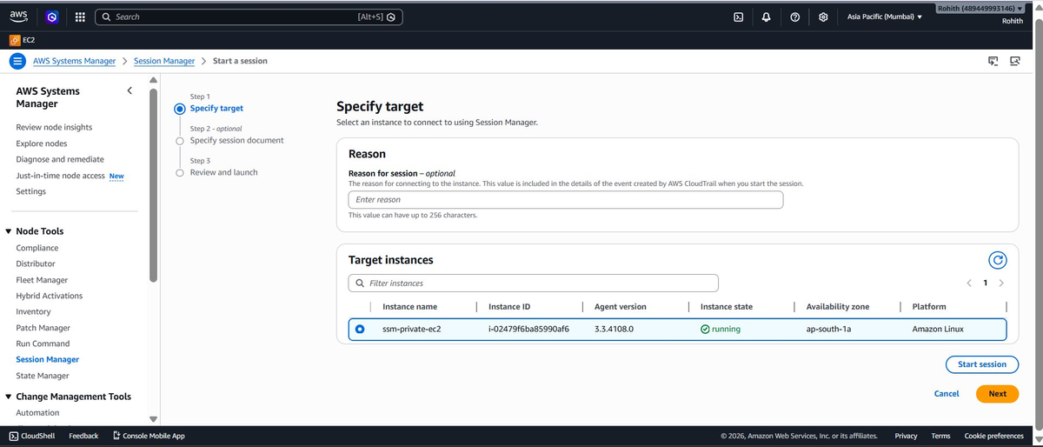
Figure 7.2 — ssm-private-ec2 registered and visible with Agent version 3.3.4108.0

Screenshot: Shell Connected
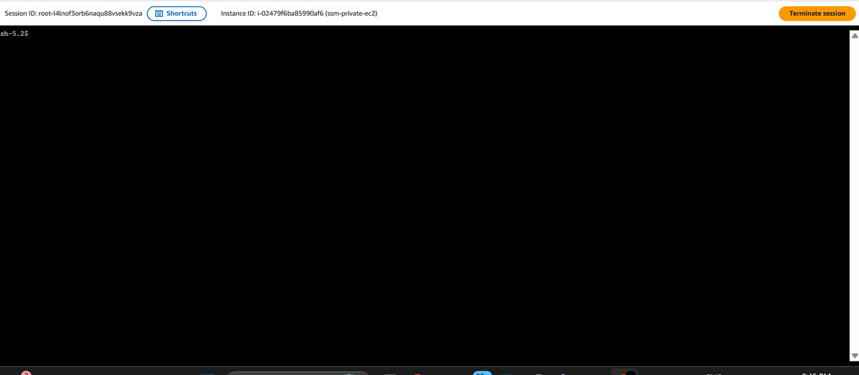
Figure 7.3 — Active shell session on private EC2 via Session Manager

Detail | Value
Session ID | root-l4lnof3orb6naqu88vsekk9vza
Instance | ssm-private-ec2 (i-02479f6ba85990af6)
Agent Version | 3.3.4108.0
Platform | Amazon Linux 2023
Shell | sh-5.2$

Summary & Architecture

Complete Setup Checklist
Step | Task | Key Resource | Status
1 | Create VPC | SSM-vpc (10.0.0.0/16) | ✅ Complete
2 | Endpoint Security Group | ssm-endpoint-sg (inbound 443) | ✅ Complete
3 | EC2 Security Group | ssm-ec2-sg (outbound 443, 53) | ✅ Complete
4 | VPC Endpoints (3) | ssm, ssmmessages, ec2messages | ✅ Complete
5 | IAM Role | EC2-SSM-Role + AmazonSSMManagedInstanceCore | ✅ Complete
6 | Private EC2 | ssm-private-ec2 (no public IP) | ✅ Complete
7 | SSM Connection | Session Manager Shell | ✅ Complete

Security Group Rules Reference
ssm-endpoint-sg (VPC Endpoints)
Direction | Protocol | Port | Source/Destination
Inbound | TCP | 443 | 10.0.0.0/16 (VPC CIDR)
Outbound | All | All | 0.0.0.0/0

ssm-ec2-sg (EC2 Instance)
Direction | Protocol | Port | Source/Destination
Inbound | None | — | No inbound rules
Outbound | TCP | 443 | 0.0.0.0/0 (HTTPS to endpoints)
Outbound | UDP | 53 | 0.0.0.0/0 (DNS)
Outbound | TCP | 53 | 0.0.0.0/0 (DNS)

Architecture Diagram
┌─────────────────────────────────────────────────────┐
│ SSM-vpc (10.0.0.0/16) │
│ │
│ ┌─────────────────────────────────────────────┐ │
│ │ SSM-subnet-private1-ap-south-1a │ │
│ │ │ │
│ │ ┌──────────────┐ ┌──────────────────┐ │ │
│ │ │ ssm-private │443 │ VPC Endpoints │ │ │
│ │ │ -ec2 │───▶│ ssm │ │ │
│ │ │ │53 │ ssmmessages │ │ │
│ │ │ ssm-ec2-sg │───▶│ ec2messages │ │ │
│ │ │ EC2-SSM-Role │ │ ssm-endpoint-sg │ │ │
│ │ └──────────────┘ └────────┬─────────┘ │ │
│ └────────────────────────────── │ ──────────┘ │
└────────────────────────────────── │ ─────────────┘
│
AWS SSM Service
│
Your Local Machine
(aws ssm start-session)

Key Lessons Learned
Issue | Root Cause | Fix
Instance not in SSM | S3 Gateway endpoint missing from route table | Add S3 endpoint + associate route table
Custom SG not working | DNS ports (53) not allowed outbound | Add UDP/TCP 53 outbound rules
SSM agent not starting | Agent failed on first boot silently | Add User Data script to force start
Endpoints not working | Private DNS not enabled on endpoints | Enable Private DNS on all 3 endpoints

💡 The most critical and commonly missed step is ensuring the S3 Gateway endpoint is linked to the private subnet's route table. Amazon Linux 2023 requires S3 access on first boot for SSM Agent initialization.

