Real-Time Go
Stage 1 — WebSocket Chat Room
Technical Documentation & Implementation Guide

Technologies Used
Go • gorilla/websocket • Docker • Docker Compose • AWS EC2
GitHub Repository: github.com/rohith2OO2/realtime-go
May 2026

1. Project Overview
This document covers Stage 1 of the Real-Time Go workshop — a live WebSocket chat room built with Go and deployed using Docker on AWS EC2. Students open multiple browser tabs and observe messages appearing instantly across all tabs without any page refresh.

1.1 What is a WebSocket?
HTTP is a request-response protocol — the browser asks, the server replies, connection closes. WebSocket upgrades that connection to a persistent, full-duplex channel where both sides can send data at any time.

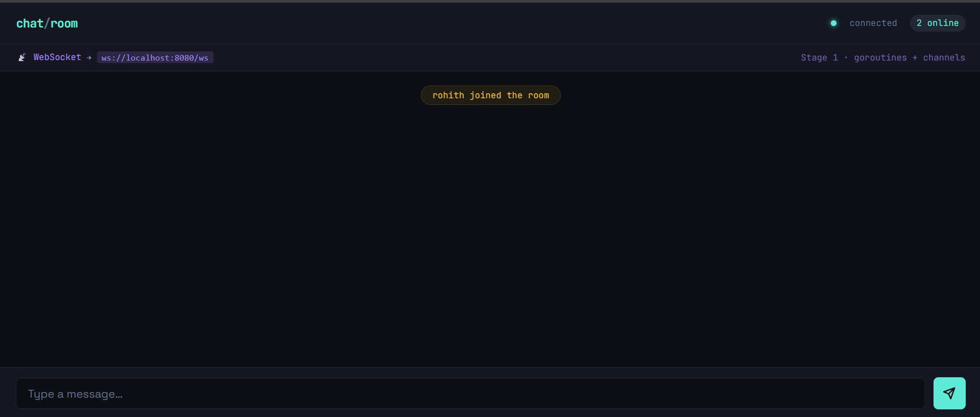
Fig 1 — Chat room after first user connects. WebSocket endpoint visible in the dev bar.

1.2 Key Go Concepts
- Goroutines — lightweight threads spawned per client connection (readPump + writePump)
- Channels — safe message passing between goroutines without locks
- Hub pattern — single goroutine owns the client map, receives all events via channels
- sync.Mutex — protects the shared clients map from concurrent access
- select statement — multiplexes over multiple channels non-blocking

2. Architecture

2.1 System Design
The server follows the Hub pattern — a single hub goroutine is the only owner of the connected clients map. All register, unregister, and broadcast events flow through channels into the hub. Clients never touch each other directly.

Flow:
Browser Tab 1 ──WS──► Go Server (Hub) ──WS──► Browser Tab 2
▲ ▲
register broadcast
chan chan

2.2 Per-Client Goroutines
Each connected client spawns exactly two goroutines:
- readPump — blocks on conn.ReadMessage(), pushes received messages to hub.broadcast
- writePump — blocks on client.send channel, writes messages to the WebSocket
This separation keeps reads and writes fully independent. A slow reader doesn't block a writer.

2.3 Docker Architecture
docker-compose up --build

chat-server container
├── Go binary (chatserver)
├── PORT 8080 exposed
└── ./client mounted as volume (live reload)

3. GitHub Repository
All source code is hosted at: github.com/rohith2OO2/realtime-go

3.1 Repository Structure
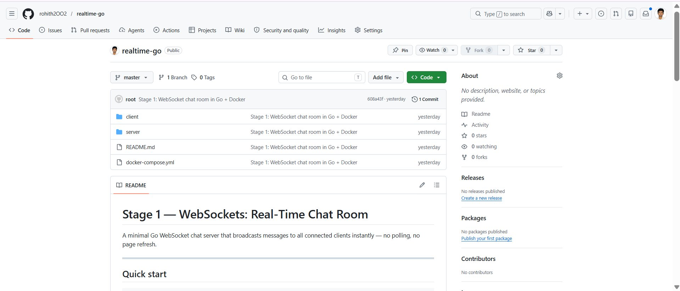
Fig 2 — GitHub repository showing client/, server/, README.md and docker-compose.yml

3.2 File Map
realtime-go/
├── client/
│ └── index.html ← single-file chat UI (HTML + CSS + JS)
├── server/
│ ├── main.go ← Go WebSocket server (Hub, Client, pumps)
│ ├── go.mod ← Go module definition
│ ├── go.sum ← dependency checksums
│ └── Dockerfile ← multi-stage build
├── docker-compose.yml ← service wiring
└── README.md ← setup + teaching exercises

4. Server Code — main.go
The entire backend is in a single main.go file (~180 lines). It defines three core types: Message, Client, and Hub.

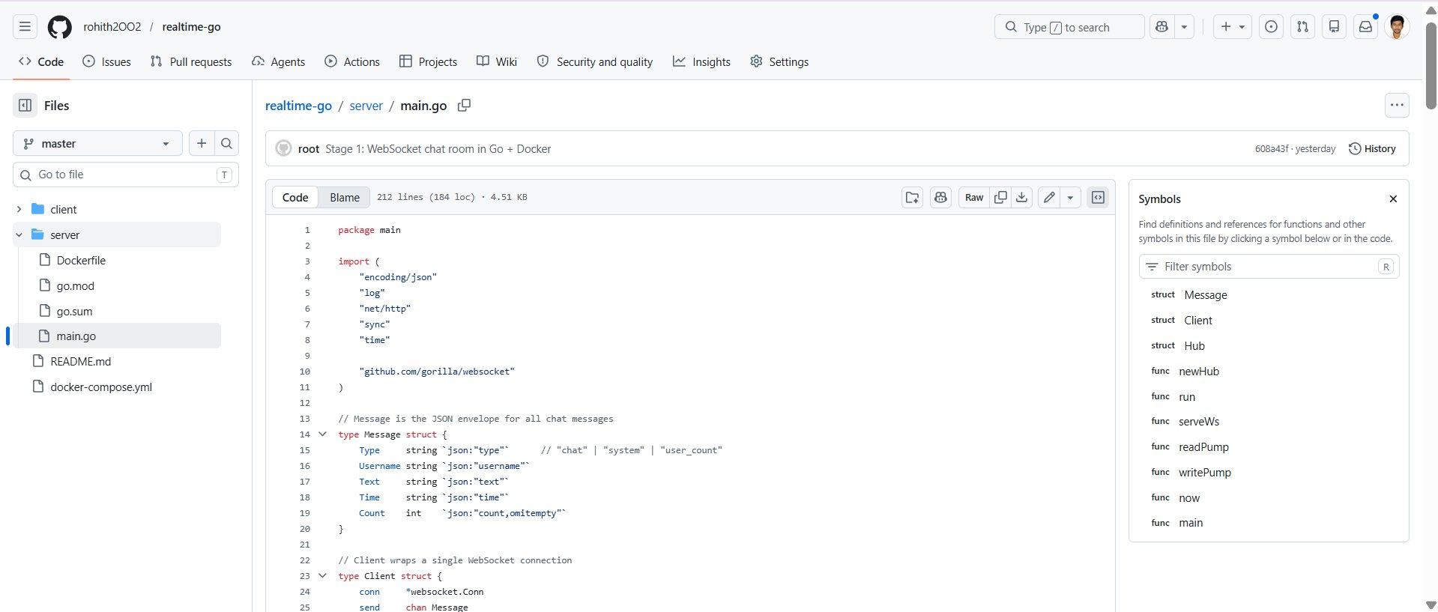
Fig 3 — main.go open in GitHub. Symbols panel shows all structs and functions.

4.1 Message struct
JSON envelope for all communication between server and browser:
Type string // "chat" | "system" | "user_count"
Username string // set by server, not trusted from client
Text string // message body
Time string // HH:MM timestamp
Count int // online user count (system messages only)

4.2 Hub — the broadcast engine
The Hub owns all connected clients and routes every event:
register chan *Client // new connection arrived
unregister chan *Client // connection closed
broadcast chan Message // message to send to everyone
clients map[*Client]bool

4.3 readPump & writePump
Every connected client gets exactly two goroutines:
- readPump blocks on conn.ReadMessage() and forwards to hub.broadcast
- writePump blocks on client.send channel and calls conn.WriteJSON()
- A 54-second ticker in writePump sends WebSocket pings to detect dead connections
- Slow clients are dropped (default: branch in hub.run) to prevent blocking the broadcast loop

5. Dockerfile — Multi-Stage Build
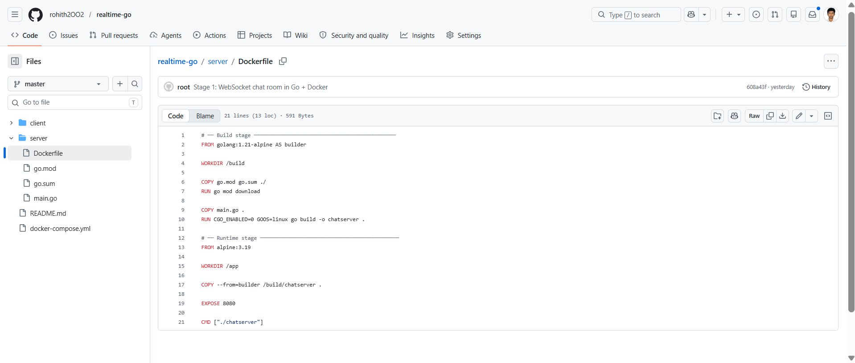
Fig 4 — Dockerfile with builder stage (golang:1.21-alpine) and runtime stage (alpine:3.19)

5.1 Why multi-stage?
Stage 1 (builder) uses the full Go toolchain image (~300MB) to compile the binary. Stage 2 (runtime) copies only the compiled binary into a minimal Alpine image (~10MB). The final image ships no Go compiler, no source code — only the executable.

5.2 Build steps explained
- FROM golang:1.21-alpine AS builder — full Go environment for compilation
- COPY go.mod go.sum ./ — copy dependency files first (Docker cache optimization)
- RUN go mod download — download dependencies into layer cache
- COPY main.go . — copy source code after deps (avoids re-downloading on code changes)
- RUN CGO_ENABLED=0 GOOS=linux go build -o chatserver — static binary, no libc needed
- FROM alpine:3.19 — fresh minimal runtime image
- COPY --from=builder /build/chatserver . — copy only the binary
- EXPOSE 8080 — document the port
- CMD ["./chatserver"] — start the server

6. Client — index.html
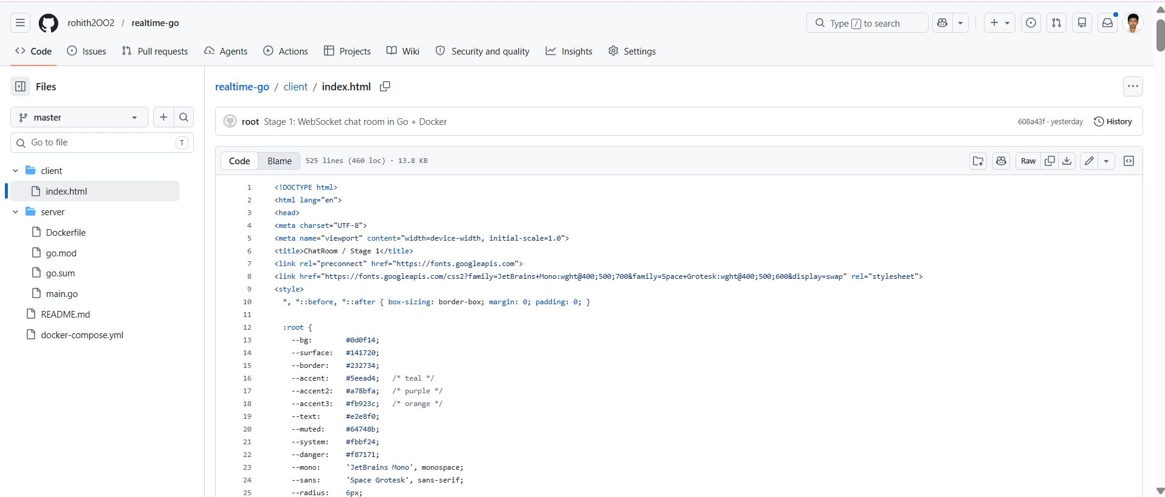
Fig 5 — index.html in GitHub (525 lines). CSS variables define the dark terminal theme.

6.1 Single-file architecture
The entire frontend is one HTML file containing HTML, CSS, and JavaScript. No build tools, no npm, no frameworks — students can open it directly in a browser or serve it via the Go server.

6.2 WebSocket client code
The JavaScript creates the WebSocket connection using the browser's native API:
const ws = new WebSocket('ws://localhost:8080/ws?username=rohith');

ws.onopen = () => setStatus(true);
ws.onmessage = (event) => renderMessage(JSON.parse(event.data));
ws.onclose = () => { setStatus(false); setTimeout(connect, 3000); };

Auto-reconnect is built in — if the server restarts, the client retries every 3 seconds.

6.3 Design system
- Dark terminal aesthetic — JetBrains Mono + Space Grotesk fonts
- Per-user avatar colours — 7 teal/purple/orange palette, assigned on first message
- System messages — amber pill badges for join/leave events
- Live online count — updates in the header on every system message

7. docker-compose.yml
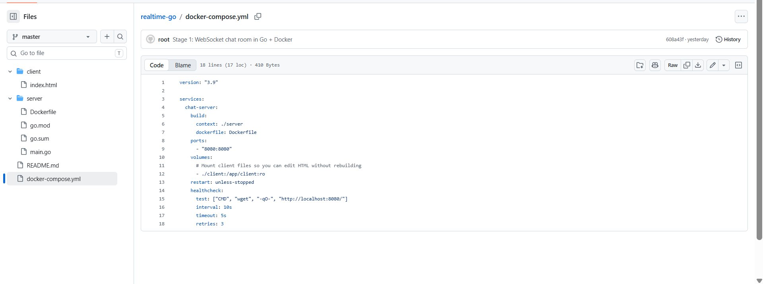
Fig 6 — docker-compose.yml showing service config, port mapping, volume mount and healthcheck

7.1 Key configuration explained
- build: ./server — Docker builds the image from the server/ Dockerfile
- ports: 8080:8080 — maps host port 8080 to container port 8080
- volumes: ./client:/app/client:ro — mounts client folder live; edit HTML, refresh browser — no rebuild
- restart: unless-stopped — auto-restarts the container if it crashes
- healthcheck — wget polls / every 10 seconds; container marked unhealthy after 3 failures

7.2 Run commands
# First run (builds image)
docker-compose up --build

# Background mode
docker-compose up -d

# Watch logs
docker-compose logs -f

# Stop
docker-compose down

8. Live Demo — Step by Step

8.1 Step 1 — User 'rohith' opens the login screen
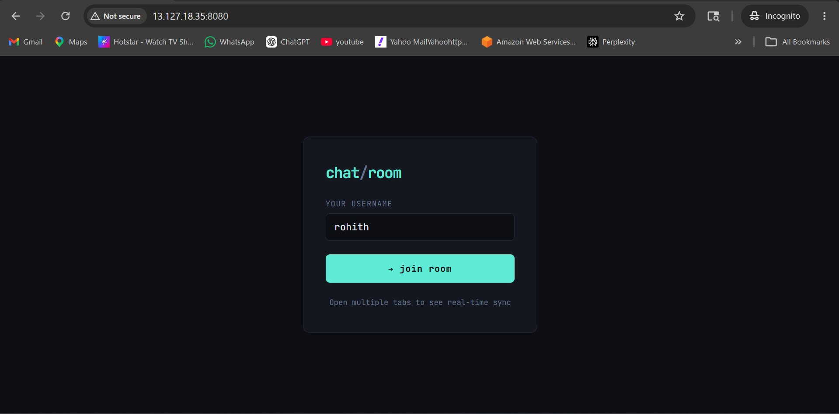
Fig 7 — Login screen at 13.127.18.35:8080. User enters 'rohith' as username.

8.2 Step 2 — Second tab: user 'ajith' joins
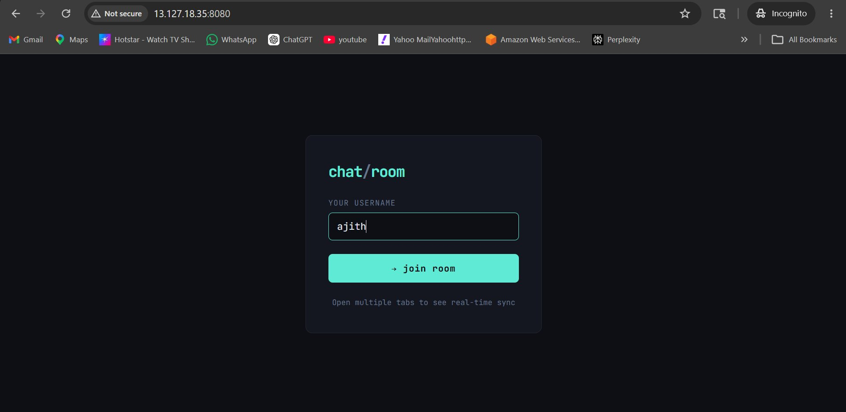
Fig 8 — Second browser tab opened in Incognito. User enters 'ajith'.

8.3 Step 3 — Both users in the room
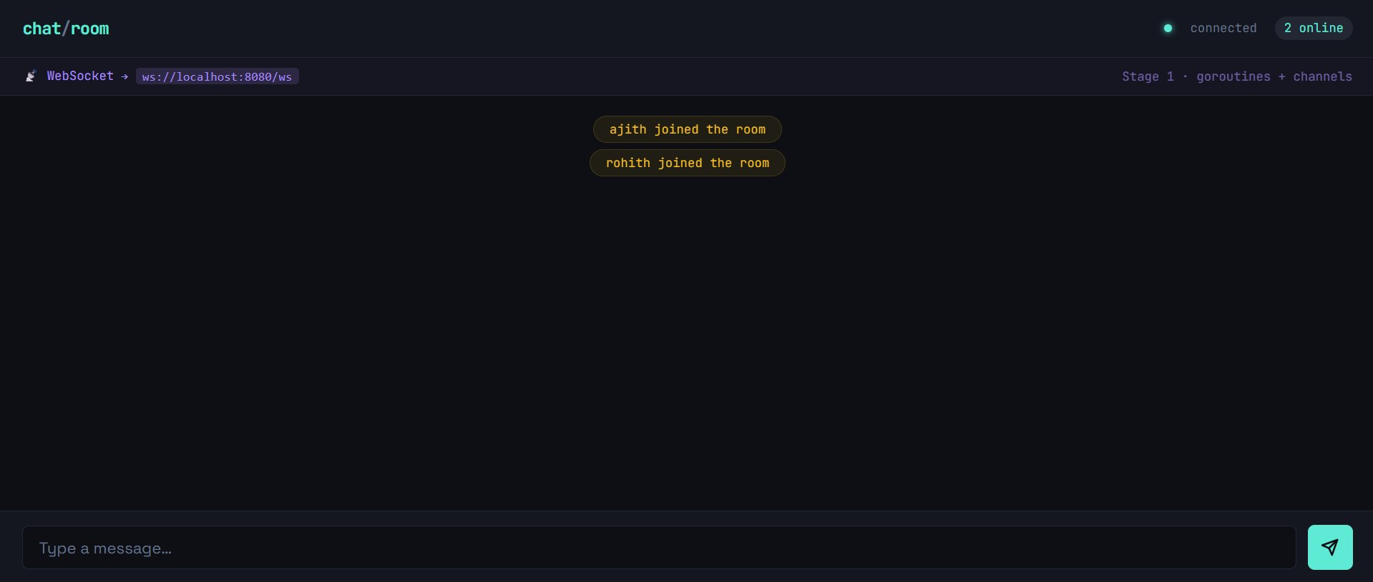
Fig 9 — Both join events broadcast to all tabs. Online count shows '2 online'.
The system messages 'ajith joined the room' and 'rohith joined the room' are broadcast to all connected tabs instantly via the Hub's broadcast channel.

8.4 Step 4 — rohith sends a message
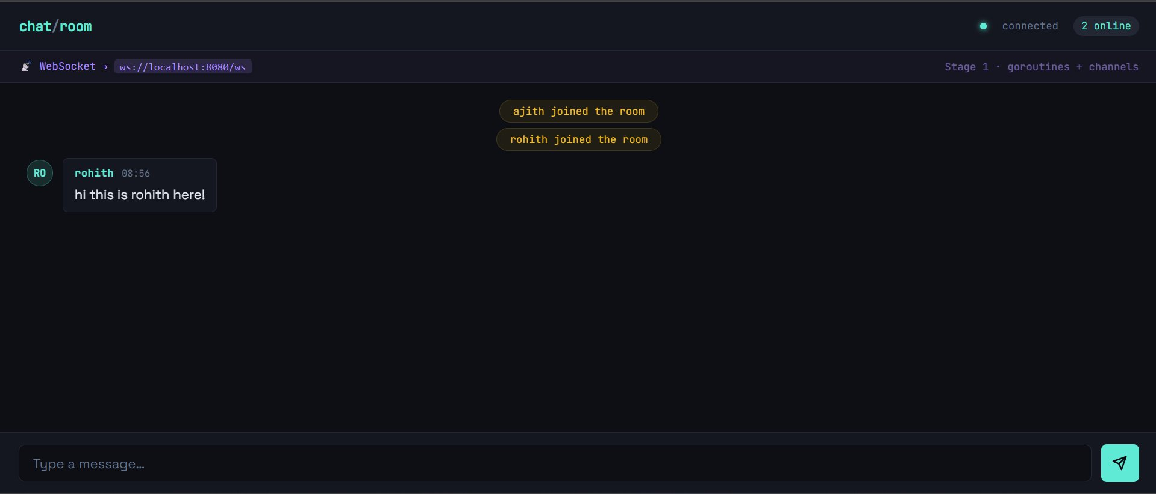
Fig 10 — rohith sends 'hi this is rohith here!' — appears instantly in both tabs.

8.5 Step 5 — ajith replies (real-time sync proven)
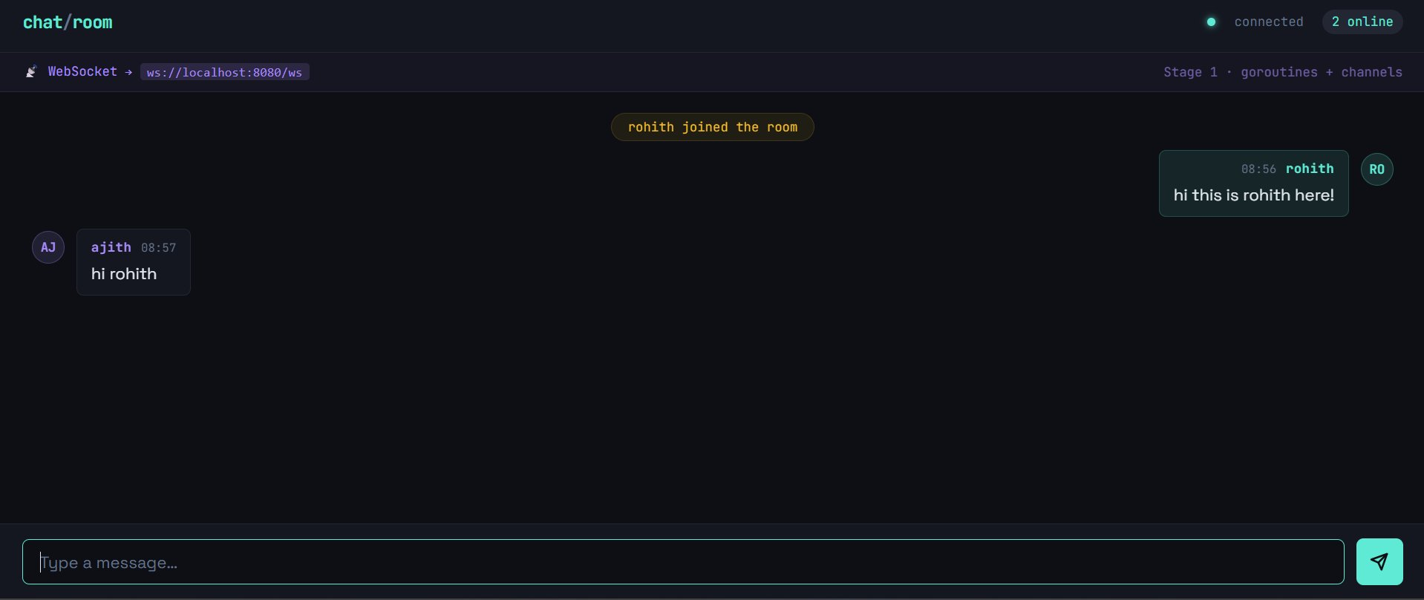
Fig 11 — ajith's tab shows rohith's message on the right and ajith's reply 'hi rohith' on the left.
This screenshot proves real-time bidirectional sync — rohith's message appears on the right (as sent by this client) and ajith's reply appears on the left, all without any page refresh.

9. Student Exercises
Five progressive exercises that build on the running server:

Exercise 1 — Count goroutines (Easy)
Add a /debug endpoint to the server that returns runtime.NumGoroutine(). Open 5 tabs and watch the count go up. Close tabs and watch it fall.
http.HandleFunc("/debug", func(w http.ResponseWriter, r *http.Request) {
fmt.Fprintf(w, "goroutines: %d", runtime.NumGoroutine())
})

Exercise 2 — Break slow client protection (Medium)
In hub.run(), comment out the default: branch that drops slow clients. Then write a client that reads very slowly. What happens to the other users?

Exercise 3 — Typing indicators (Medium)
Send {"type":"typing"} on keydown. Broadcast it. Show 'Alice is typing...' in the UI. Clear it after 2 seconds of no keydown.

Exercise 4 — Message history (Medium-Hard)
Add a []Message slice to Hub (with mutex). On new client register, send the last 20 messages before the welcome system message.

Exercise 5 — Multiple rooms (Hard)
Create a map[string]*Hub keyed by room name. Add ?room=general to the WebSocket URL. The login screen gets a room selector dropdown.

10. Summary
Stage 1 demonstrates how WebSockets enable real-time communication using Go's concurrency model. The Hub pattern, goroutine-per-client design, and channel-based message passing form a robust, race-free architecture.

Item | Detail
Language | Go 1.21
WebSocket Library | github.com/gorilla/websocket v1.5.1
Server Port | 8080
Concurrency Model | 2 goroutines per client (readPump + writePump)
Message Format | JSON — type, username, text, time, count
Docker Base Image | golang:1.21-alpine (builder) + alpine:3.19 (runtime)
Client | Single HTML file — no frameworks, no build tools
Deployment | AWS EC2 via docker-compose
GitHub Repo | github.com/rohith2OO2/realtime-go

