Name: Parmindar Singh NN: 38

List of (charts of) functional dependencies:

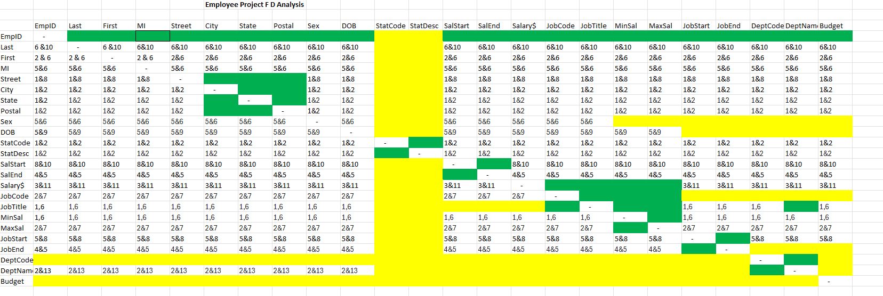

A Logical Data Model (LDM), and a corresponding Physical Data Model (PDM):

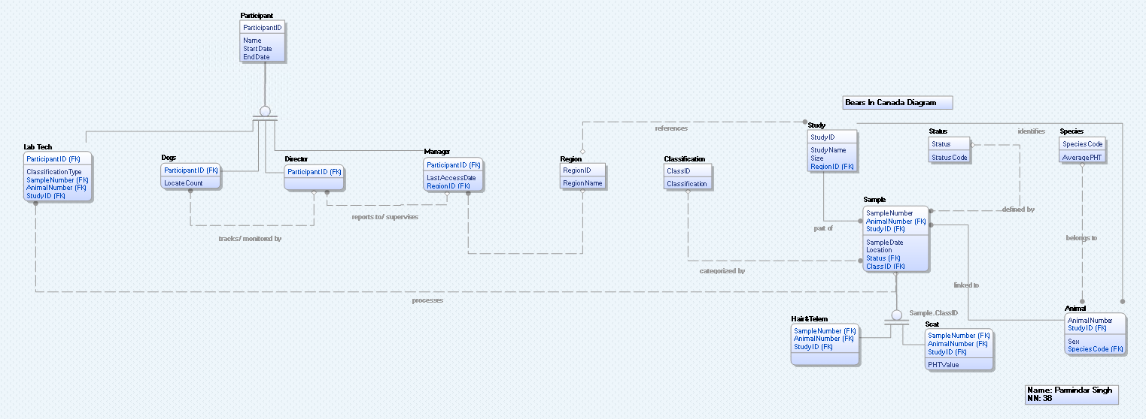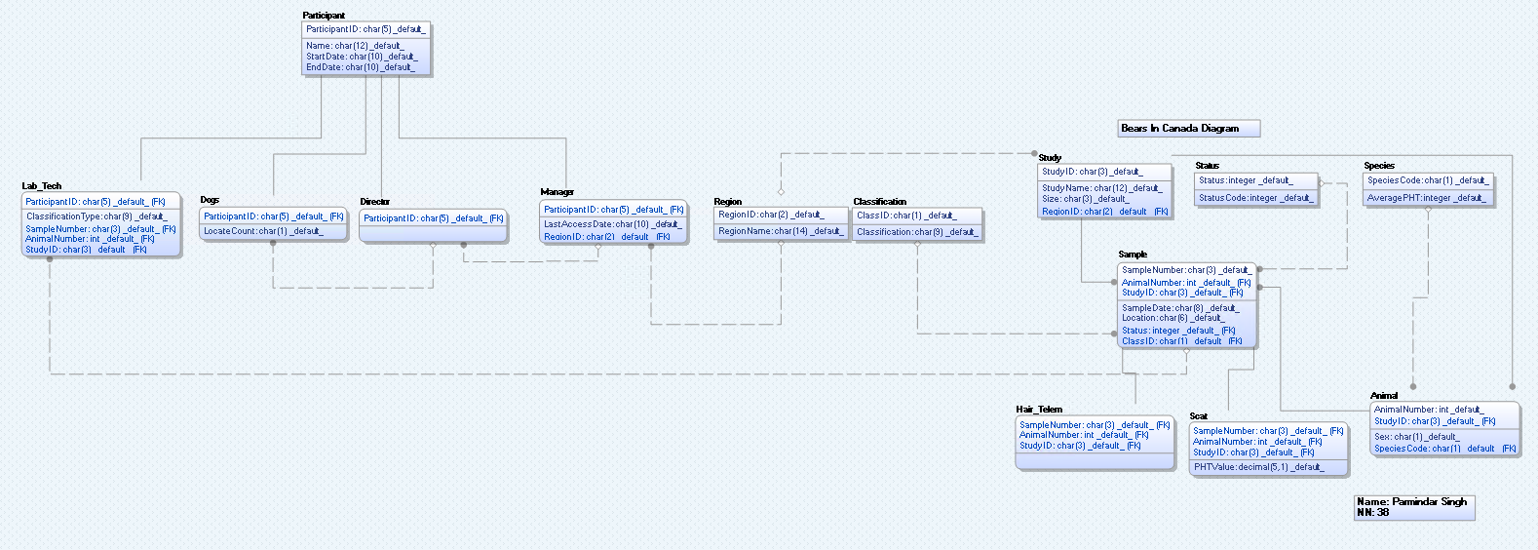

**RDD generated by Erwin:**

CREATE TABLE Region

(

RegionID char(2) NOT NULL ,

RegionName char(14) NULL ,

Size char(3) NULL ,

PRIMARY KEY CLUSTERED (RegionID ASC)

)

go

CREATE TABLE Study

(

StudyID char(3) NOT NULL ,

StudyName char(12) NULL ,

Size char(3) NULL ,

RegionID char(2) NULL ,

PRIMARY KEY CLUSTERED (StudyID ASC),

FOREIGN KEY (RegionID) REFERENCES Region(RegionID)

)

go

CREATE TABLE Classification

(

ClassID char(1) NOT NULL ,

Classification char(9) NULL ,

PRIMARY KEY CLUSTERED (ClassID ASC)

)

go

CREATE TABLE Status

(

Status integer NOT NULL ,

StatusCode integer NULL ,

PRIMARY KEY CLUSTERED (Status ASC)

)

go

CREATE TABLE Species

(

SpeciesCode char(1) NOT NULL ,

AveragePHT decimal(5,1) NULL ,

Description char(12) NULL ,

PRIMARY KEY CLUSTERED (SpeciesCode ASC)

)

go

CREATE TABLE Animal

(

AnimalNumber int NOT NULL ,

StudyID char(3) NOT NULL ,

Sex char(1) NULL ,

SpeciesCode char(1) NULL ,

PRIMARY KEY CLUSTERED (AnimalNumber ASC,StudyID ASC),

FOREIGN KEY (StudyID) REFERENCES Study(StudyID),

FOREIGN KEY (SpeciesCode) REFERENCES Species(SpeciesCode)

)

go

CREATE TABLE Sample

(

SampleNumber char(3) NOT NULL ,

AnimalNumber int NOT NULL ,

StudyID char(3) NOT NULL ,

SampleDate char(8) NULL ,

Location char(6) NULL ,

Status integer NULL ,

ClassID char(1) NULL ,

PRIMARY KEY CLUSTERED (SampleNumber ASC,AnimalNumber ASC,StudyID ASC),

FOREIGN KEY (StudyID) REFERENCES Study(StudyID),

FOREIGN KEY (ClassID) REFERENCES Classification(ClassID),

FOREIGN KEY (Status) REFERENCES Status(Status),

FOREIGN KEY (AnimalNumber,StudyID) REFERENCES Animal(AnimalNumber,StudyID)

)

go

CREATE TABLE Participant

(

ParticipantID char(5) NOT NULL ,

Name char(12) NULL ,

StartDate char(10) NULL ,

EndDate char(10) NULL ,

PRIMARY KEY CLUSTERED (ParticipantID ASC)

)

go

CREATE TABLE Dogs

(

ParticipantID char(5) NOT NULL ,

LocateCount char(1) NULL ,

PRIMARY KEY CLUSTERED (ParticipantID ASC),

FOREIGN KEY (ParticipantID) REFERENCES Participant(ParticipantID)

)

go

CREATE TABLE Scat

(

SampleNumber char(3) NOT NULL ,

AnimalNumber int NOT NULL ,

StudyID char(3) NOT NULL ,

PHTValue decimal(5,1) NULL ,

ParticipantID char(5) NULL ,

PRIMARY KEY CLUSTERED (SampleNumber ASC,AnimalNumber ASC,StudyID ASC),

FOREIGN KEY (SampleNumber,AnimalNumber,StudyID) REFERENCES Sample(SampleNumber,AnimalNumber,StudyID),

FOREIGN KEY (ParticipantID) REFERENCES Dogs(ParticipantID)

)

go

CREATE TABLE Manager

(

ParticipantID char(5) NOT NULL ,

LastAccessDate char(10) NULL ,

RegionID char(2) NULL ,

PRIMARY KEY CLUSTERED (ParticipantID ASC),

FOREIGN KEY (ParticipantID) REFERENCES Participant(ParticipantID),

FOREIGN KEY (RegionID) REFERENCES Region(RegionID)

)

go

CREATE TABLE Lab_Tech

(

ParticipantID char(5) NOT NULL ,

ClassificationType char(9) NULL ,

PRIMARY KEY CLUSTERED (ParticipantID ASC),

FOREIGN KEY (ParticipantID) REFERENCES Participant(ParticipantID)

)

go

CREATE TABLE Hair_Telem

(

SampleNumber char(3) NOT NULL ,

AnimalNumber int NOT NULL ,

StudyID char(3) NOT NULL ,

PRIMARY KEY CLUSTERED (SampleNumber ASC,AnimalNumber ASC,StudyID ASC),

FOREIGN KEY (SampleNumber,AnimalNumber,StudyID) REFERENCES Sample(SampleNumber,AnimalNumber,StudyID)

)

go

CREATE TABLE Director

(

ParticipantID char(5) NOT NULL ,

PRIMARY KEY CLUSTERED (ParticipantID ASC),

FOREIGN KEY (ParticipantID) REFERENCES Participant(ParticipantID)

)

Go

**Questions:**

1.What is the largest physiological health value observed for a black bear?  
SELECT MAX(S.PHTValue) AS LargestPHTValue

FROM Scat S

JOIN Animal A ON S.AnimalNumber = A.AnimalNumber AND S.StudyID = A.StudyID

JOIN Species Sp ON A.SpeciesCode = Sp.SpeciesCode

WHERE Sp.SpeciesCode = 'B';  
  


2. For each animal, list all its sample classifications in chronological (date) order.

SELECT

A.AnimalNumber,

A.StudyID,

S.SampleNumber,

S.SampleDate,

S.ClassID,

C.Classification

FROM

Sample S

JOIN

Animal A ON S.AnimalNumber = A.AnimalNumber AND S.StudyID = A.StudyID

JOIN

Classification C ON S.ClassID = C.ClassID

ORDER BY

A.AnimalNumber,

S.SampleDate;  
  
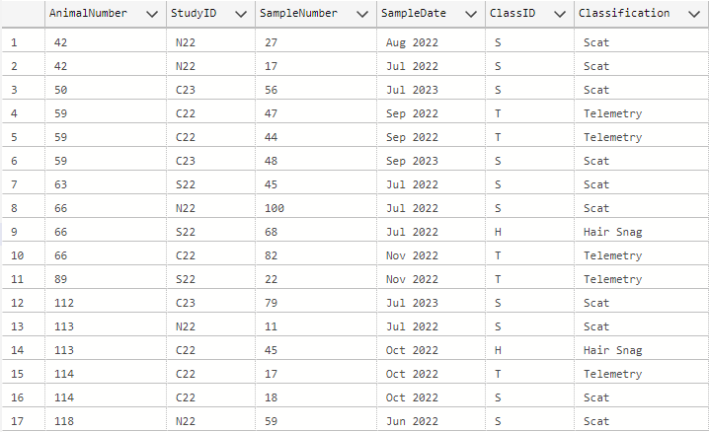

3. In what region is the central 2022 study and what size grid pattern is used on that study

SELECT DISTINCT

R.RegionName,

S.Size AS GridPattern

FROM

Study S

JOIN

Region R ON S.RegionID = R.RegionID

JOIN

Sample Sa ON S.StudyID = Sa.StudyID

WHERE

S.StudyID = 'C22' AND

YEAR(CAST(Sa.SampleDate AS DATE)) = 2022;

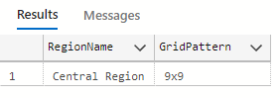

4. List the animals that are within 5 units of their average physiological health value

SELECT DISTINCT

A.AnimalNumber,

A.StudyID,

A.Sex,

A.SpeciesCode,

S.AveragePHT,

Sc.PHTValue

FROM

Animal A

JOIN

Species S ON A.SpeciesCode = S.SpeciesCode

JOIN

Scat Sc ON A.AnimalNumber = Sc.AnimalNumber

WHERE

ABS(Sc.PHTValue - S.AveragePHT) <= 5;

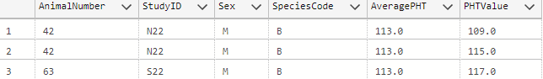

5. List the sample information for the Central 2022 Studies made in September 2022 and in November 2022

SELECT

S.SampleNumber,

S.AnimalNumber,

S.StudyID,

S.SampleDate,

S.Location,

S.Status,

S.ClassID

FROM

Sample S

JOIN

Study St ON S.StudyID = St.StudyID

WHERE

St.StudyName LIKE '%Central 2022%'

AND (S.SampleDate LIKE 'Sep 2022%' OR S.SampleDate LIKE 'Nov 2022%');

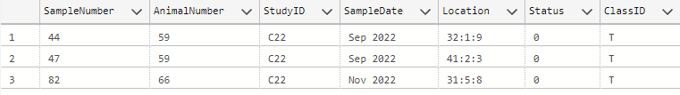

6. List the name of managers and their last access to the database

SELECT

P.Name AS ManagerName,

M.LastAccessDate

FROM

Manager M

JOIN

Participant P ON M.ParticipantID = P.ParticipantID;

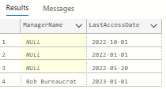

7. List the study name, animal, animal species code, sample number and date found for samples that were found in the central region in cell number 40?

SELECT

st.StudyName,

a.AnimalNumber,

a.SpeciesCode,

s.SampleNumber,

s.SampleDate

FROM Sample s

JOIN Study st ON s.StudyID = st.StudyID

JOIN Animal a ON s.AnimalNumber = a.AnimalNumber AND s.StudyID = a.StudyID

WHERE st.RegionID = 'CR'

AND s.Location LIKE '40:%';  
  
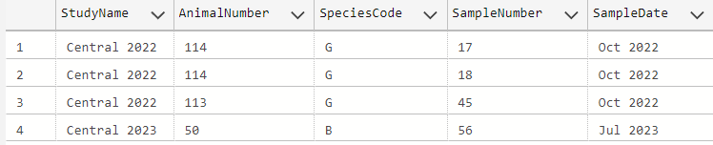

8. Who (Name and ID) manages the Central Region?

SELECT p.ParticipantID, p.Name

FROM Participant p

JOIN Manager m ON p.ParticipantID = m.ParticipantID

WHERE m.RegionID = 'CR';

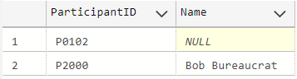

9. Who (Name and ID) has access data on South Region Sample Data?

SELECT p.ParticipantID, p.Name

FROM Participant p

JOIN Manager m ON p.ParticipantID = m.ParticipantID

JOIN Study st ON m.RegionID = st.RegionID

WHERE st.RegionID = 'SR';



10. List the name of each dog and the number of scat sample found by that dog

SELECT

P.Name AS DogName,

COUNT(S.SampleNumber) AS ScatSampleCount

FROM

Dogs D

JOIN

Participant P ON D.ParticipantID = P.ParticipantID

JOIN

Scat S ON P.ParticipantID = S.ParticipantID

GROUP BY

P.Name;

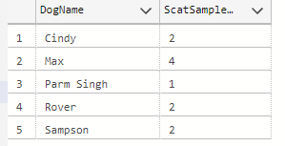

11. List the sample analyzed by P2045

SELECT DISTINCT

lt.ParticipantID,

lt.ClassificationType

FROM Lab_Tech lt

WHERE lt.ParticipantID = 'P2045';



12. List the names of the dogs that worked in each study

SELECT

st.StudyName,

p.Name AS DogName

FROM Scat sc

JOIN Participant p ON sc.ParticipantID = p.ParticipantID

JOIN Study st ON sc.StudyID = st.StudyID

WHERE p.ParticipantID LIKE 'D%';

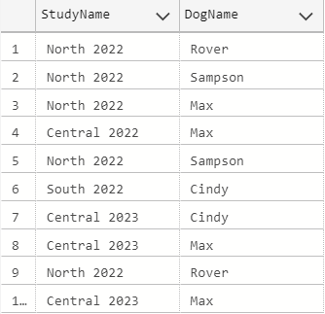

13. List the IDs and names of participants who analyzed telemetry samples.

SELECT DISTINCT

p.ParticipantID,

p.Name

FROM Participant p

JOIN Lab_Tech lt ON p.ParticipantID = lt.ParticipantID

WHERE lt.ClassificationType = 'Telemetry';

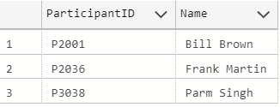

**Select * all tables:**

SELECT * FROM Region;

SELECT * FROM Study;

SELECT * FROM Classification;

SELECT * FROM Status;

SELECT * FROM Species;

SELECT * FROM Animal;

SELECT * FROM Sample;

SELECT * FROM Participant;

SELECT * FROM Dogs;

SELECT * FROM Scat;

SELECT * FROM Manager;

SELECT * FROM Lab_Tech;

SELECT * FROM Hair_Telem;

SELECT * FROM Director;

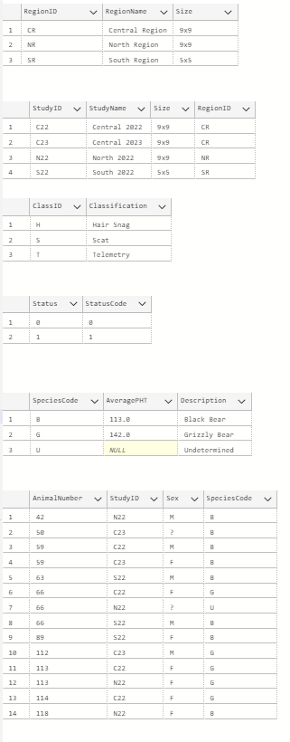

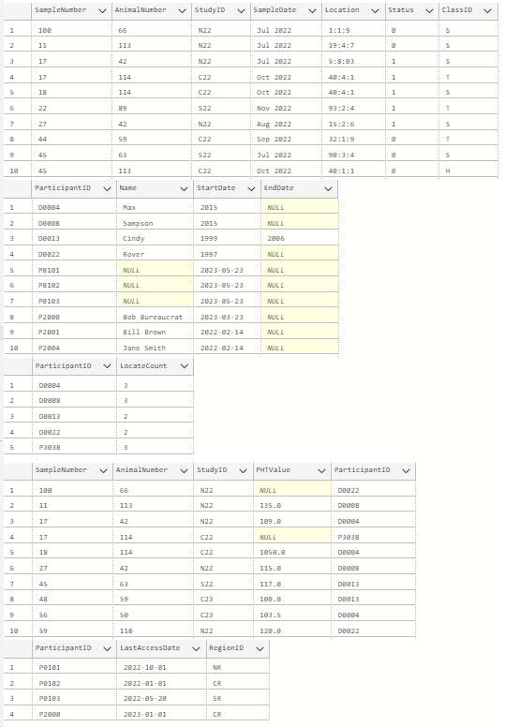

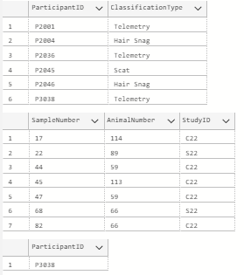

All Insert Statements:

Region Table:  
INSERT INTO Region (RegionID, RegionName, Size) VALUES

('NR', 'North Region', '9x9'),

('SR', 'South Region', '5x5'),

('CR', 'Central Region', '9x9');

Study Table:  
INSERT INTO Study (StudyID, StudyName, Size, RegionID) VALUES

('N22', 'North 2022', '9x9', 'NR'),

('S22', 'South 2022', '5x5', 'SR'),

('C22', 'Central 2022', '9x9', 'CR'),

('C23', 'Central 2023', '9x9', 'CR');

Classification Table:  
INSERT INTO Classification (ClassID, Classification) VALUES

('S', 'Scat'),

('H', 'Hair Snag'),

('T', 'Telemetry');

Status Table:  
INSERT INTO Status (Status, StatusCode) VALUES

(1, 1), -- Sample exists

(0, 0); -- Sample Used Up

Species Table

INSERT INTO Species (SpeciesCode, AveragePHT, Description) VALUES

('B', 113.0, 'Black Bear'),

('G', 142.0, 'Grizzly Bear'),

('U', NULL, 'Undetermined');

Animal Table:  
INSERT INTO Animal (AnimalNumber, StudyID, Sex, SpeciesCode) VALUES

(42, 'N22', 'M', 'B'),

(89, 'S22', 'F', 'B'),

(59, 'C22', 'M', 'B'),

(113, 'C22', 'F', 'G'),

(59, 'C23', 'F' ,'B'),

(50, 'C23', '?', 'B'),

(118, 'N22', 'F', 'B'),

(112, 'C23', 'M', 'G'),

(66, 'C22', 'F', 'G'),

(66, 'N22', '?', 'U'),

(66, 'S22', 'M', 'B'),

(113, 'N22', 'F', 'G');

(63, 'S22', 'M', 'B');

(114, 'C22', 'F', 'G');  
(114, 'C22', '?', 'G');

Sample Table:  
INSERT INTO Sample (SampleNumber, AnimalNumber, StudyID, SampleDate, Location, Status, ClassID) VALUES

('17', 42, 'N22', 'Jul 2022', '5:8:03', 1, 'S'),

('22', 89, 'S22', 'Nov 2022', '93:2:4', 1, 'T'),

('44', 59, 'C22', 'Sep 2022', '32:1:9', 0, 'T'),

('45', 113, 'C22', 'Oct 2022', '40:1:1', 0, 'H'),

('47', 59, 'C22', 'Sep 2022', '41:2:3', 0, 'T'),

('48', 59, 'C23', 'Sep 2023', '34:4:4', 1, 'S'),

('56', 50, 'C23', 'Jul 2023', '40:1:1', 1, 'S'),

('59', 118, 'N22', 'Jun 2022', '7:1:2', 1, 'S'),

('79', 112, 'C23', 'Jul 2023', '32:5:5', 1, 'S'),

('82', 66, 'C22', 'Nov 2022', '31:5:8', 0, 'T'),

('100', 66, 'N22', 'Jul 2022', '1:1:9', 0, 'S'),

('68', 66, 'S22', 'Jul 2022', '80:3:2', 0, 'H'),

('27', 42, 'N22', 'Aug 2022', '15:2:6', 1, 'S'),

('11', 113, 'N22', 'Jul 2022', '19:4:7', 0, 'S'),

('45', 63, 'S22', 'Jul 2022', '90:3:4', 0, 'S'),

('17', 114, 'C22', 'Oct 2022', '40:4:1', 1, 'T'),

('18', 114, 'C22', 'Oct 2022', '40:4:1', 1, 'S');

Participant Table:

INSERT INTO Participant (ParticipantID, Name, StartDate, EndDate) VALUES

('P2001', 'Bill Brown', '2022-02-14', NULL),

('P2004', 'Jane Smith', '2022-02-14', NULL),

('P2036', 'Frank Martin', '2020-08-15', '2022-01-01'),

('P2045', 'Anne Dough', '2021-06-12', NULL),

('P2046', 'Mike Green', '2020-10-28', NULL),

('P3038', 'Parm Singh', '2024-12-06', NULL),

('D0004', 'Max', 2022-06-01, NULL),

('D0008', 'Sampson', 2022-02-05, NULL),

('D0013', 'Cindy', 2021-12-10, 2022-02-14),

('D0022', 'Rover', 2022-05-20, NULL),

('P2000', 'Bob Bureaucrat', '2023-03-23', NULL),

('P0101', NULL, '2023-05-23', NULL),

('P0102', NULL, '2023-03-23', NULL),

('P0102', NULL, '2023-03-23', NULL),

('P0103', NULL, '2023-03-23', NULL);

Dogs Table:

INSERT INTO Dogs (ParticipantID, LocateCount) VALUES

('D0004', '3'),

('D0008', '3'),

('D0013', '2'),

('D0022', '2');

Scat Table:  
INSERT INTO Scat (SampleNumber, AnimalNumber, StudyID, PHTValue, ParticipantID) VALUES

('17', 42, 'N22', 109.0, 'D0004'),

('48', 59, 'C23', 100.0, 'D0013'),

('56', 50, 'C23', 103.5, 'D0004'),

('59', 118, 'N22', 120, 'D0022'),

('79', 112, 'C23', 135, 'D0004'),

('100', 66, 'N22', NULL , 'D0022'),

('27', 42, 'N22', 115.0, 'D0008'),

('11', 113, 'N22', 135.0, 'D0008'),

('45', 63, 'S22', 117.0, 'D0013'),

('17', 114, 'C22', NULL, 'P3038'),

('18', 114, 'C22', 1050, 'D0004');

Manager Table:  
INSERT INTO Manager (ParticipantID, LastAccessDate, RegionID) VALUES

('P2000', '2023-01-01', 'CR'),

('P0101', '2022-10-01', 'NR'),

('P0102', '2022-01-01', 'CR'),

('P0103', '2022-05-20', 'SR');

Lab_Tech Table:  
INSERT INTO Lab_Tech (ParticipantID, ClassificationType) VALUES

('P2036', 'Telemetry'),

('P2046', 'Hair Snag'),

('P2045', 'Telemetry'),

('P2001', 'Telemetry’),

('P2004', 'Hair Snag’),

('P3038', 'Telemetry’);

Hair_Telem Table:  
INSERT INTO Hair_Telem (SampleNumber, AnimalNumber, StudyID) VALUES

('45', 113, 'C22'),

('44', 59, 'C22'),

('47', 59, 'C22'),

('68', 66, 'S22'),

('82', 66, 'S22'),

('17', 114, 'C22'),

('22', 89, 'S22');

Director Table:  
INSERT INTO Director (ParticipantID) VALUES

('P3038');

Appendix of old LDM & PDMs:

