

主人公、配角、有无对话

1.

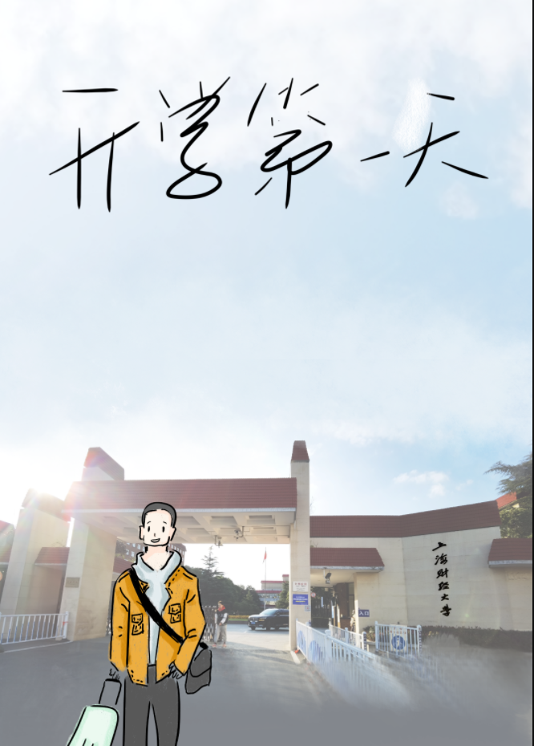

NULL

[http://m.qpic.cn/psc?/V54DWESa0sRAoU0aTodf0ZH2Ht0OfYHO/45NBuzDIW489QBoVep5mccdJHBZKhge57HusqXzZheLXQuzByEfaOTlc*NExCHRFqlhosFucGlUJ09McSj.rTx8Yb8RHBZHqe1jLsChV2xg!/b&bo=OARABgAAAAADZzg!&rf=viewer_4](http://m.qpic.cn/psc?/V54DWESa0sRAoU0aTodf0ZH2Ht0OfYHO/45NBuzDIW489QBoVep5mccdJHBZKhge57HusqXzZheLXQuzByEfaOTlc*NExCHRFqlhosFucGlUJ09McSj.rTx8Yb8RHBZHqe1jLsChV2xg!/b&bo=OARABgAAAAADZzg!&rf=viewer_4)

0

0

0

2. 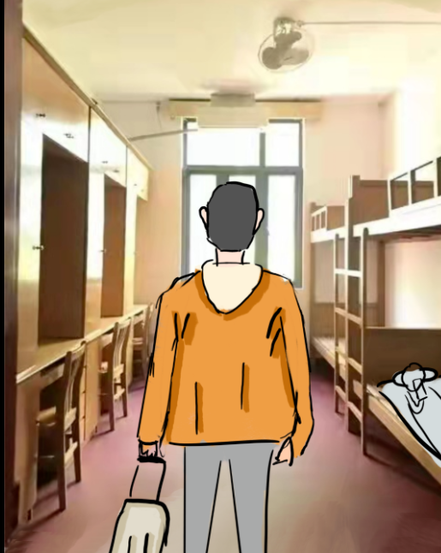

你来到宿舍：

<http://m.qpic.cn/psc?/V54DWESa0sRAoU0aTodf0ZH2Ht0OfYHO/45NBuzDIW489QBoVep5mccdJHBZKhge57HusqXzZheKrYAqJhCtY9cRcoIjTpV1FoXs0OCze2TgtEzB6f687msya1D9cAgPFNmFRkR7Kvjg!/b&bo=OATABgAAAAADZ7g!&rf=viewer_4>

0

0

0

3.

hello，hello！哈哈哈哈，我先冲个凉去！这天儿太热 了！

<http://m.qpic.cn/psc?/V54DWESa0sRAoU0aTodf0ZH2Ht0OfYHO/45NBuzDIW489QBoVep5mcYmm1YUEkI3MtVPwFTxfft65YJzSzWO.E7SAHS8LkrQ1WDkWCNKkLMOUD99keC9cyH289b4k29dlZ0RjdGfqh10!/b&bo=OATABgAAAAADZ7g!&rf=viewer_4>

0

1

1

4.

hello,hello，你快去吧" ( 内心os：woccc!这哥们好帅！鼻血表情，花痴表情 )

6.

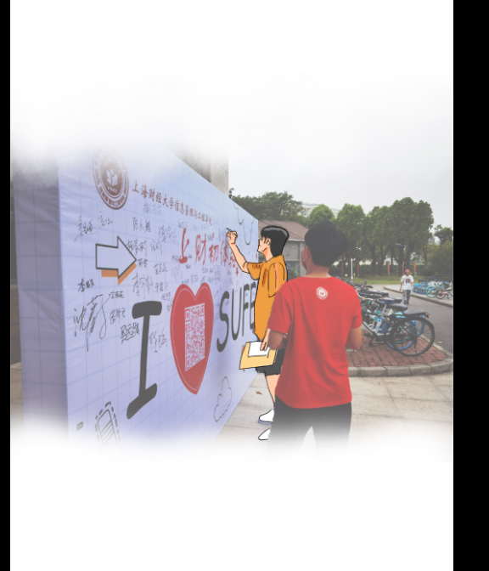

<http://m.qpic.cn/psc?/V54DWESa0sRAoU0aTodf0ZH2Ht0OfYHO/45NBuzDIW489QBoVep5mcccEaESJQw93fGNsOpR9Gohq1QCp2MLNrGmLTvdCGBA3xNW1gEzACgB1Ij66HZ8BbBV0KAxX0zwJkUZAGqlxfqE!/b&bo=OATABgAAAAADZ7g!&rf=viewer_4>

4.

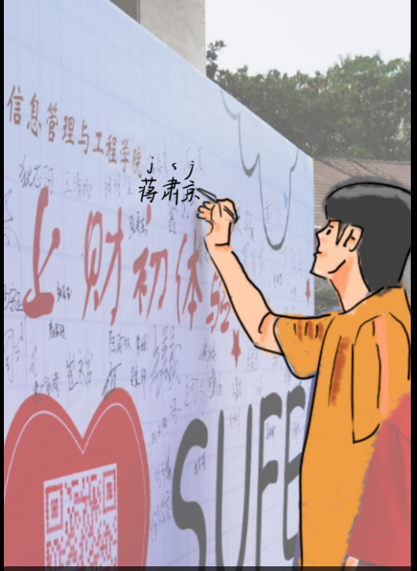

[http://m.qpic.cn/psc?/V54DWESa0sRAoU0aTodf0ZH2Ht0OfYHO/45NBuzDIW489QBoVep5mcYwzHq3KuUc4wb1K2hS0dOwb7qmsQdGyfFJr*QwOrwXbnUDFJm8OAhmr59j1FEOSXSjUb*CvMfOwxkmrWBQ2nxs!/b&bo=OATABgAAAAADZ7g!&rf=viewer_4](http://m.qpic.cn/psc?/V54DWESa0sRAoU0aTodf0ZH2Ht0OfYHO/45NBuzDIW489QBoVep5mcYwzHq3KuUc4wb1K2hS0dOwb7qmsQdGyfFJr*QwOrwXbnUDFJm8OAhmr59j1FEOSXSjUb*CvMfOwxkmrWBQ2nxs!/b&bo=OATABgAAAAADZ7g!&rf=viewer_4)

5.

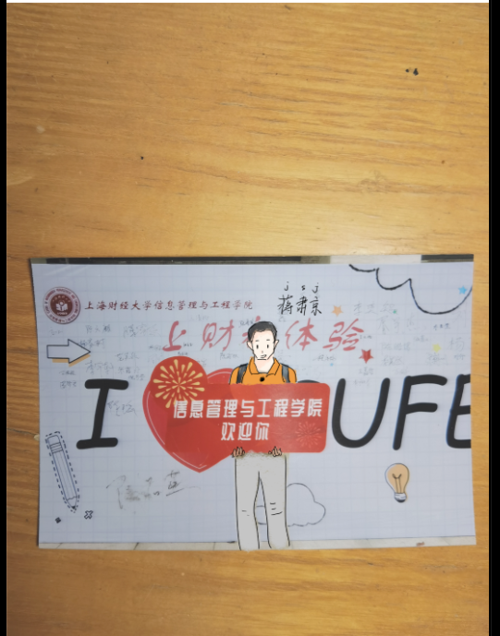

[http://m.qpic.cn/psc?/V54DWESa0sRAoU0aTodf0ZH2Ht0OfYHO/45NBuzDIW489QBoVep5mcWA12E*bP.AHN512zRaX65We15OsLHNkCKkCgQqdJbivGIm5F5JY*YYOvB.3*Lr4gwwXvwAEIbm0kgInQa4j2Kc!/b&bo=OATABgAAAAADh1g!&rf=viewer_4](http://m.qpic.cn/psc?/V54DWESa0sRAoU0aTodf0ZH2Ht0OfYHO/45NBuzDIW489QBoVep5mcWA12E*bP.AHN512zRaX65We15OsLHNkCKkCgQqdJbivGIm5F5JY*YYOvB.3*Lr4gwwXvwAEIbm0kgInQa4j2Kc!/b&bo=OATABgAAAAADh1g!&rf=viewer_4)