The e-commerce problem statement

E-commerce provides an easy way to sell products to a large customer base. However, there is a lot of competition among multiple e-commerce sites. When users land on an e-commerce site, they expect to find what they are looking for quickly and easily. Also, users are not sure about the brands or the actual products they want to purchase. They have a very broad idea about what they want to buy. Many customers nowadays search for their products on Google rather than visiting specific e-commerce sites. They believe that Google will take them to the e-commerce sites that have their product.

The purpose of any e-commerce website is to help customers narrow down their broad ideas and enable them to finalize the products they want to purchase. For example, suppose a customer is interested in purchasing a mobile. His or her search for a mobile should list mobile brands, operating systems on mobiles, screen size of mobiles, and all other features as facets. As the customer selects more and more features or options from the facets provided, the search narrows down to a small list of mobiles that suit his or her choice. If the list is small enough and the customer likes one of the mobiles listed, he or she will make the purchase.

The challenge is also that each category will have a different set of facets to be displayed. For example, searching for books should display their format, as in paperpack or hardcover, author name, book series, language, and other facets related to books. These facets were different for mobiles that we discussed earlier. Similarly, each category will have different facets and it needs to be designed properly so that customers can narrow down to their preferred products, irrespective of the category they are looking into.

The takeaway from this is that categorization and feature listing of products should be taken care of. Misrepresentation of features can lead to incorrect search results. Another takeaway is that we need to provide multiple facets in the search results. For example, while displaying the list of all mobiles, we need to provide facets for a brand. Once a brand is selected, another set of facets for operating systems, network, and mobile phone features has to be provided. As more and more facets are selected, we still need to show facets within the remaining products.

USE CASE DIAGRAM

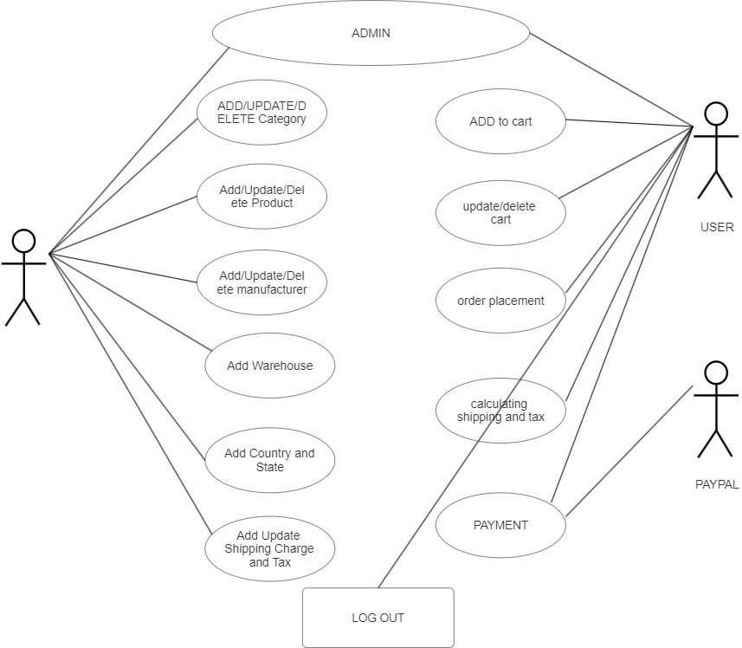

DFD LEVEL 0

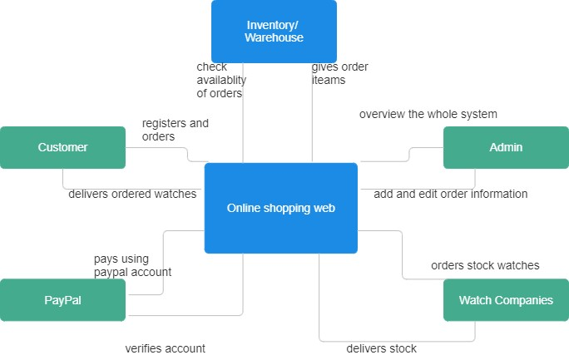

DFD Level 1

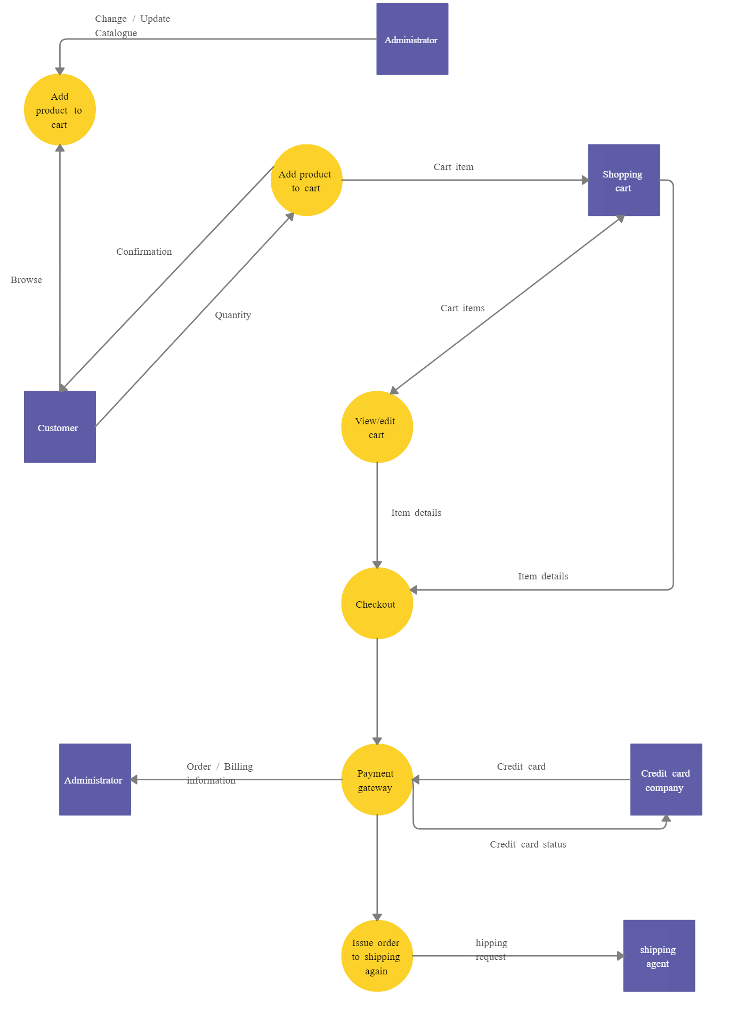

Class Diagram

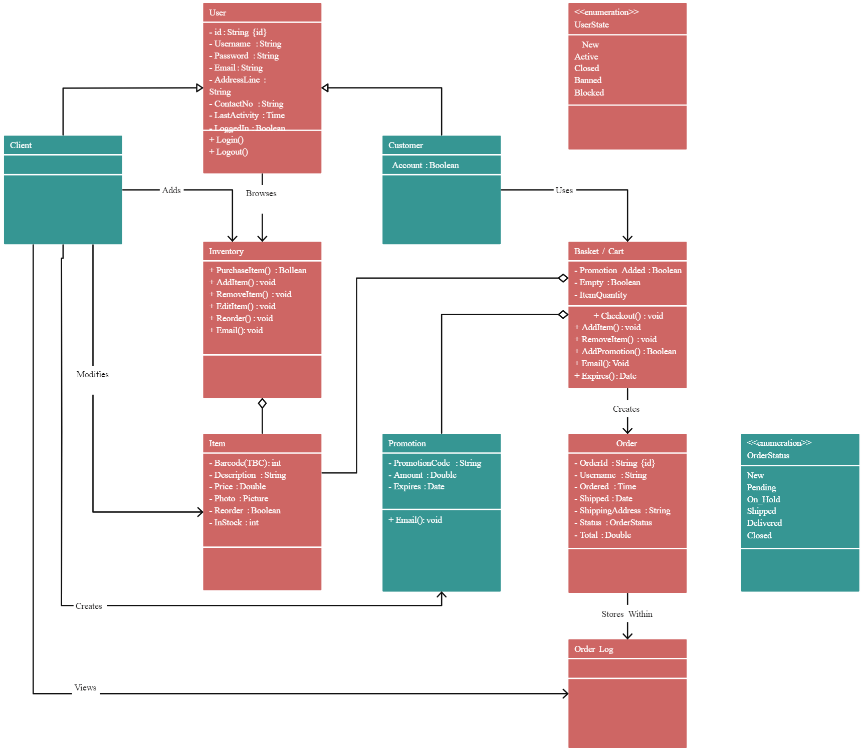

Sequence Diagram

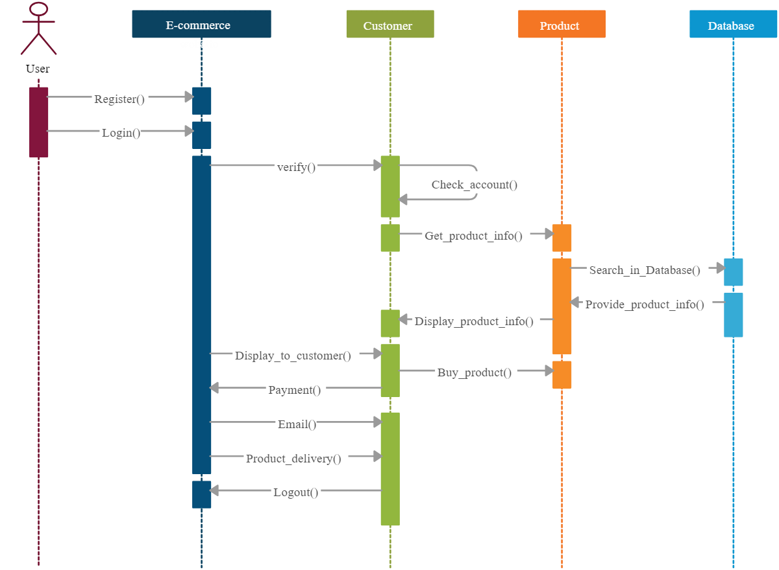

Deployment Diagram

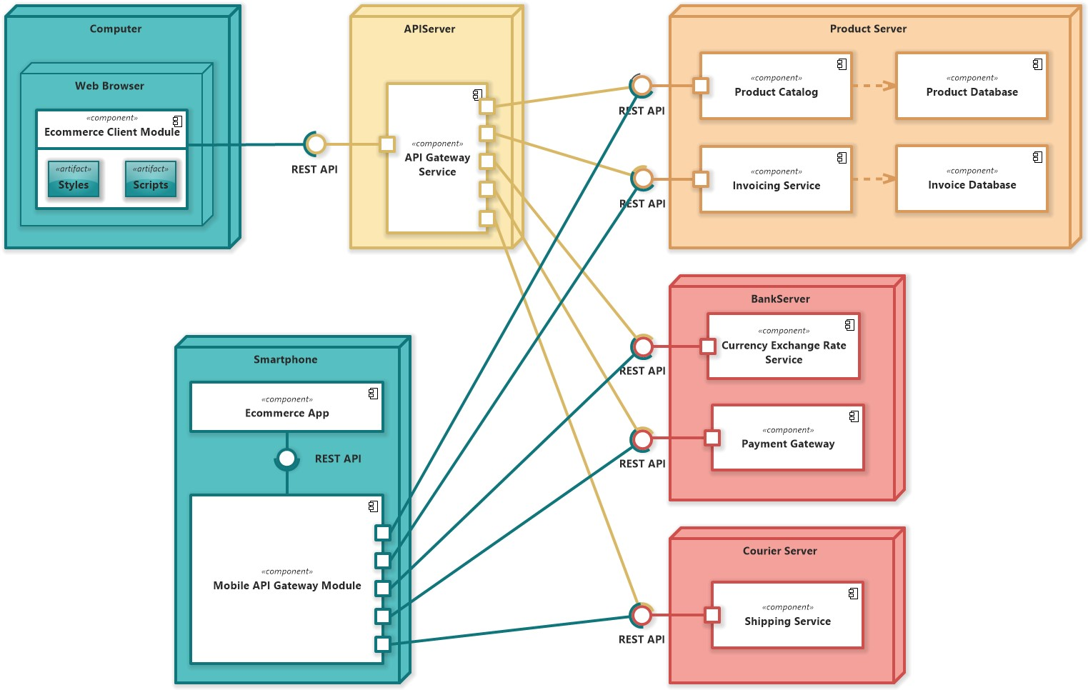

# Component Diagram

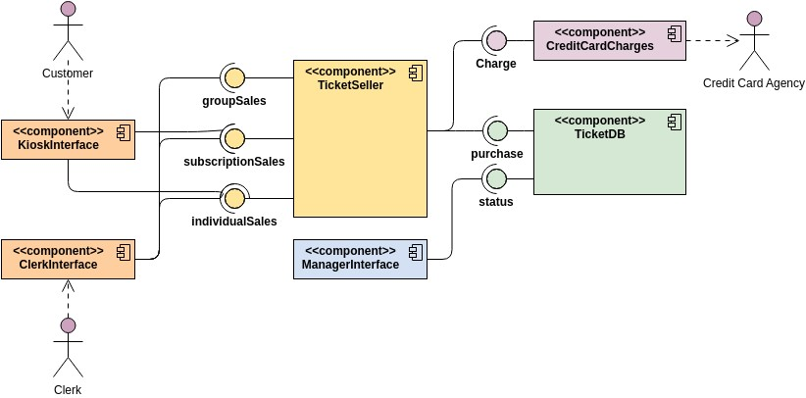

Software Requirement Specification (SRS)

Creating a Software Requirements Specification (SRS) for an e-commerce system involves detailing the system's functional and non-functional requirements, user interactions, system behavior, and constraints. Here's an outline you can follow:

1. **Introduction**:
   * **Purpose of the document**: This section explains why the SRS is being created, its intended audience, and its importance in guiding the development of the ecommerce system.
   * **Scope of the e-commerce system**: Describes what the system will and will not do, including its boundaries and functionalities.
   * **Definitions, acronyms, and abbreviations**: Provides a list of terms used throughout the document along with their meanings to ensure clarity and consistency.
   * **References**: Includes any external documents or standards that the SRS references or is based upon.
2. **Overall Description**:
   * **Product perspective**: Describes how the e-commerce system fits into the larger context of the organization's infrastructure or ecosystem.
   * **Product functions**: Lists and describes the main functionalities and features that the e-commerce system will provide to its users.
   * **User characteristics**: Defines the types of users who will interact with the system (e.g., customers, administrators) and their respective roles and permissions.
   * **Operating environment**: Specifies the hardware, software, and network requirements needed to run the e-commerce system effectively.
   * **Design and implementation constraints**: Identifies any limitations or constraints that may impact the design or implementation of the system.
   * **Assumptions and dependencies**: States any assumptions made during the requirements gathering process and dependencies on external factors or systems.
3. **Specific Requirements**:
   * + **External Interface Requirements**:
     + **User interfaces**: Describes the design and functionality of the user interfaces, such as the website interface for customers and the admin interface for system administrators.
     + **Hardware interfaces**: Specifies any hardware devices (e.g., barcode scanners, printers) that the system must interface with.
     + **Software interfaces**: Details the integration points with external software systems (e.g., payment gateways, shipping APIs) that the e-commerce system interacts with.
     + **Communication interfaces**: Specifies the protocols and standards used for communication between different system components and external systems.
     + **Functional Requirements**:
     + **Registration and login**: Describes the processes for user registration, authentication, and login.
     + **Product browsing**: Specifies how users can search, filter, and view products on the e-commerce platform.
     + **Shopping cart**: Defines the functionalities related to adding/removing items, managing quantities, and handling the shopping cart during the purchase process.
     + **Checkout process**: Details the steps involved in the checkout process, including address entry, payment methods, and order confirmation.
     + **Order management**: Describes how users can view their order history, track orders, and manage their account.
     + **Admin functionalities**: Specifies the functionalities available to system administrators, such as managing products, orders, users, and generating reports.
     + **Non-Functional Requirements**:
     + **Performance requirements**: Includes metrics for response times, throughput, and scalability to ensure the system performs efficiently under various loads.
     + **Security requirements**: Specifies measures for data encryption, secure authentication, access control, and compliance with data protection regulations.
     + **Reliability requirements**: Defines the system's availability, fault tolerance, and backup/recovery mechanisms to ensure continuous operation.
     + **Usability requirements**: Describes the user interface's intuitiveness, accessibility features, and support for different devices and browsers.
     + **Legal and regulatory requirements**: Ensures the system complies with relevant laws, regulations, and industry standards related to e-commerce operations.
4. **System Models**:
   * **Use case diagram**: Illustrates the interactions between users (actors) and the system to accomplish various tasks or goals.
   * **Data flow diagram**: Represents the flow of data and processes within the system, showing how information moves through different components.
   * **Class diagram**: If applicable (e.g., for object-oriented designs), depicts the system's class structure and relationships between classes.
5. **Appendices**:
   * **Glossary**: Provides definitions of terms used in the SRS to ensure a common understanding among stakeholders.
   * **Change log**: Records changes made to the SRS over time, including revisions, additions, and deletions.
   * **References**: Lists any external documents, standards, or sources of information referenced in the SRS for further reading or clarification.

State Chart / Activity Diagram

