TALLINNA TÖÖSTUSHARIDUSKESKUS

„Auto Rent Database“  
Aruanne andmebaas

Õpilane: Darja Suhhanova  
Õpetaja: Irina Merkulova

Tallinn  
2023

**Contents:**

Subject: 3

Objects: 3

Actions: 3

Goals: 3

Data Schema: 3

SQL queries for creating tables 4

Filled tables – screenshots 6

Show related tables using SELECT …. INNER JOIN 7

Diagram of related tables from the server 8

Users and their permissions 9

Checking user activity 9

Creating triggers 10

Triggers for Car table 12

Triggers for Client table 13

Triggers for Agreement table 14

Procedure: 16

Table 1: Users and their permissions 8

# Subject:

AutoRent

# Objects:

Client, employee, car_model, car_make, car_type, car_class, car, agreement (contract), rent duration,

# Actions:

A car has a make, model, type, and class.  
A car can be rented, where the rental has a duration and distance traveled.  
A client rents a car.  
An employee fills in the contract details and notes the car's condition after the deal is completed.

# Goals:

1. Management of clients
2. Management of cars
3. Management of contracts and condition of cars

# Data Schema:

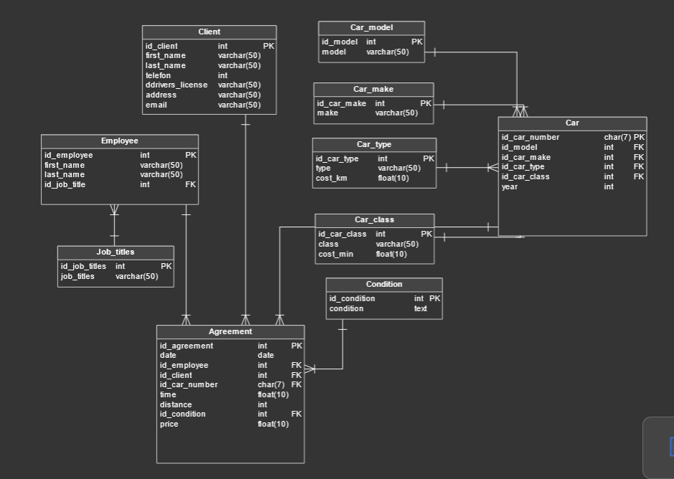

Picture Data Schema

# SQL queries for creating tables

-- Table: Agreement

CREATE TABLE Agreement (

id_agreement int NOT NULL,

date_ date NOT NULL,

id_employee int NOT NULL,

id_client int NOT NULL,

id_car_number char(7) NOT NULL,

time_ float(10) NOT NULL,

distance int NOT NULL,

id_condition int NOT NULL,

price float(10) NOT NULL,

CONSTRAINT Agreement_pk PRIMARY KEY (id_agreement)

);

-- Table: Car

CREATE TABLE Car (

id_car_number char(7) NOT NULL,

id_model int NOT NULL,

id_car_make int NOT NULL,

id_car_type int NOT NULL,

id_car_class int NOT NULL,

car_year int NOT NULL,

CONSTRAINT Car_pk PRIMARY KEY (id_car_number)

);

-- Table: Car_class

CREATE TABLE Car_class (

id_car_class int NOT NULL,

class varchar(50) NOT NULL,

cost_min float(10) NOT NULL,

CONSTRAINT Car_class_pk PRIMARY KEY (id_car_class)

);

-- Table: Car_make

CREATE TABLE Car_make (

id_car_make int NOT NULL,

make varchar(50) NOT NULL,

CONSTRAINT Car_make_pk PRIMARY KEY (id_car_make)

);

-- Table: Car_model

CREATE TABLE Car_model (

id_model int NOT NULL,

model varchar(50) NOT NULL,

CONSTRAINT Car_model_pk PRIMARY KEY (id_model)

);

-- Table: Car_type

CREATE TABLE Car_type (

id_car_type int NOT NULL,

car_type varchar(50) NOT NULL,

cost_km float(10) NOT NULL,

CONSTRAINT Car_type_pk PRIMARY KEY (id_car_type)

);

-- Table: Client

CREATE TABLE Client (

id_client int NOT NULL,

first_name varchar(50) NOT NULL,

last_name varchar(50) NOT NULL,

telefon int NOT NULL,

drivers_license varchar(50) NOT NULL,

client_address varchar(50) NOT NULL,

email varchar(50) NOT NULL,

CONSTRAINT Client_pk PRIMARY KEY (id_client)

);

-- Table: Condition

CREATE TABLE Condition (

id_condition int NOT NULL,

condition text NOT NULL,

CONSTRAINT Condition_pk PRIMARY KEY (id_condition)

);

-- Table: Employee

CREATE TABLE Employee (

id_employee int NOT NULL,

first_name varchar(50) NOT NULL,

last_name varchar(50) NOT NULL,

id_job_title int NOT NULL,

CONSTRAINT Employee_pk PRIMARY KEY (id_employee)

);

-- Table: Job_titles

CREATE TABLE Job_title (

id_job_title int NOT NULL,

job_title varchar(50) NOT NULL,

CONSTRAINT Job_titles_pk PRIMARY KEY (id_job_title)

);

-- foreign keys

ALTER TABLE Agreement ADD CONSTRAINT Agreement_Car

FOREIGN KEY (id_car_number)

REFERENCES Car (id_car_number);

-- Reference: Agreement_Client (table: Agreement)

ALTER TABLE Agreement ADD CONSTRAINT Agreement_Client

FOREIGN KEY (id_client)

REFERENCES Client (id_client);

-- Reference: Agreement_Condition (table: Agreement)

ALTER TABLE Agreement ADD CONSTRAINT Agreement_Condition

FOREIGN KEY (id_condition)

REFERENCES Condition (id_condition);

-- Reference: Agreement_Employee (table: Agreement)

ALTER TABLE Agreement ADD CONSTRAINT Agreement_Employee

FOREIGN KEY (id_employee)

REFERENCES Employee (id_employee);

-- Reference: Car_Car_class (table: Car)

ALTER TABLE Car ADD CONSTRAINT Car_Car_class

FOREIGN KEY (id_car_class)

REFERENCES Car_class (id_car_class);

-- Reference: Car_Car_make (table: Car)

ALTER TABLE Car ADD CONSTRAINT Car_Car_make

FOREIGN KEY (id_car_make)

REFERENCES Car_make (id_car_make);

-- Reference: Car_Car_model (table: Car)

ALTER TABLE Car ADD CONSTRAINT Car_Car_model

FOREIGN KEY (id_model)

REFERENCES Car_model (id_model);

-- Reference: Car_Car_type (table: Car)

ALTER TABLE Car ADD CONSTRAINT Car_Car_type

FOREIGN KEY (id_car_type)

REFERENCES Car_type (id_car_type);

-- Reference: Employee_Job_titles (table: Employee)

ALTER TABLE Employee ADD CONSTRAINT Employee_Job_title

FOREIGN KEY (id_job_title)

REFERENCES Job_title (id_job_title);

# Filled tables – screenshots

Picture Table: car_class

Picture Table: car_make

Picture Table: car_model

Picture Table: car_type

Picture Table: Client

Picture Table: Job_titles

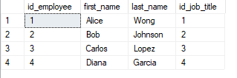

Picture Table: Employee

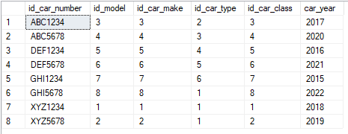

Picture Table: Car

Picture Table: Agreement

Picture Table: Condition

# Show related tables using SELECT …. INNER JOIN

Picture : related tables

SELECT

a.id_agreement,

a.date_,

e.last_name as Employee,

cl.last_name as ClientLastName,

a.id_car_number as CarNumber,

a.time_ AS TimeH,

a.distance AS DistanceKM,

co.condition as ConditionRank,

(a.distance * ct.cost_km) + (a.time_ * cc.cost_min) AS calculated_price

FROM

Agreement a

INNER JOIN Car c ON a.id_car_number = c.id_car_number

INNER JOIN Car_type ct ON c.id_car_type = ct.id_car_type

INNER JOIN Car_class cc ON c.id_car_class = cc.id_car_class

INNER JOIN Employee e ON a.id_employee = e.id_employee

INNER JOIN Client cl ON a.id_client = cl.id_client

INNER JOIN Condition co ON a.id_condition = co.id_condition;

# Diagram of related tables from the server

Picture : Diagram of related tables

# 

# Users and their permissions

Director – Full permissions (SELECT, UPDATE, INSERT) on all tables.

Salesman – SELECT and INSERT permissions on specific tables.

Manager Full permissions (SELECT, UPDATE, INSERT) on specific tables.

|  |  |  |  |
| --- | --- | --- | --- |
| Tabel | director (admin) | manager | salesman |
| Agreement | SELECT, INSERT, UPDATE, DELETE | SELECT, UPDATE, INSERT | SELECT, INSERT |
| Client | SELECT, INSERT, UPDATE, DELETE | SELECT, UPDATE, INSERT | SELECT, INSERT |
| Car | SELECT, INSERT, UPDATE, DELETE | SELECT, UPDATE, INSERT | SELECT |
| Condition | SELECT, INSERT, UPDATE, DELETE |  |  |
| Car_class | SELECT, INSERT, UPDATE, DELETE |  |  |
| Car_model | SELECT, INSERT, UPDATE, DELETE |  |  |
| Car_make | SELECT, INSERT, UPDATE, DELETE |  |  |
| Car_type | SELECT, INSERT, UPDATE, DELETE |  |  |
| logi | SELECT, INSERT, UPDATE, DELETE |  |  |

Table : Users and their permissions

GRANT SELECT, UPDATE, INSERT ON andmebaasinimi.Laps TO tootaja

# Checking user activity

# Creating triggers

1. A screenshot of a computer

   Description automatically generatedCreate triggers to track user actions.

Picture Triggers: Car, Agreement, Client

1. Create one table named **logi** that records the activity of all created triggers on all important (related) tables and can be viewed only by the admin (in my case director).

Picture 15 Triggers: Logi is visible only to the director

In this table **logi**, the following is displayed:

1. **Date/time** (insertions, deletions, and updates of records in some important tables (at least two tables)),
2. the username of the user who performed the action (using the function **USER()**)
3. A screenshot of a computer

   Description automatically generatedand all data from the affected table using the function **concat()**

Picture Triggers: Table 'logi'

Triggers for Car table

Picture Trigger: Car_INSERT

Picture Trigger: Car_UPDATE

Picture Trigger: Car_DELETE

Triggers for Client table

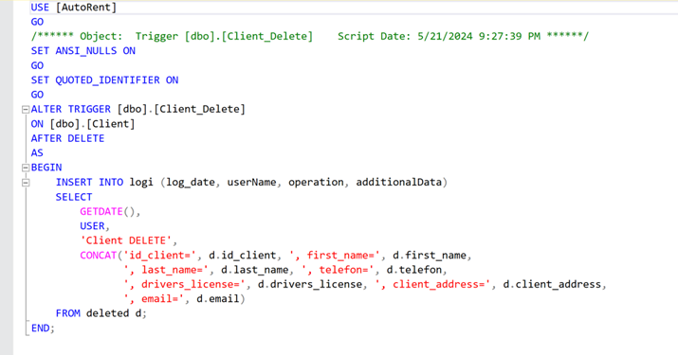

Picture Trigger: Client_DELETE

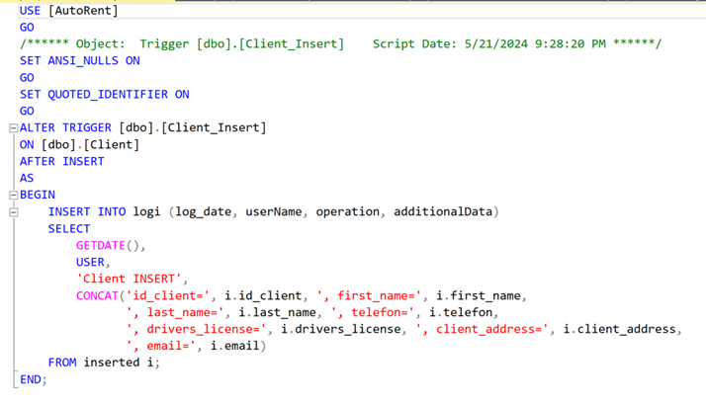

Picture Trigger: Client_INSERT

Picture Trigger: Client_UPDATE

## Triggers for Agreement table

Picture Trigger: Agreement_DELETE

Picture Trigger: Agreement_INSERT

Picture Trigger: Agreement_UPDATE

create trigger ClientRentsCar

ON Agreement

AFTER INSERT

AS

BEGIN

INSERT INTO logi (log_date, userName, operation, additionalData)

SELECT

GETDATE(),

USER,

'Client rents a car!',

CONCAT('id_agreement=', i.id_agreement, c.first_name, ' ', c.last_name,

' , tel-number:', c.telefon, ', Car number: ', i.id_car_number)

FROM inserted i

INNER JOIN Client c

ON i.id_client = c.id_client;

END;

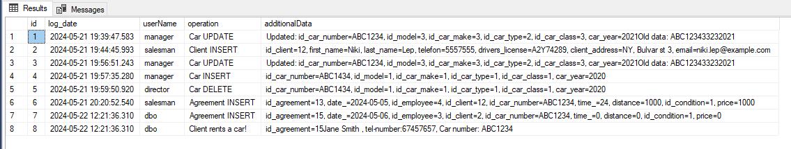

Picture 26. : Client rents a car

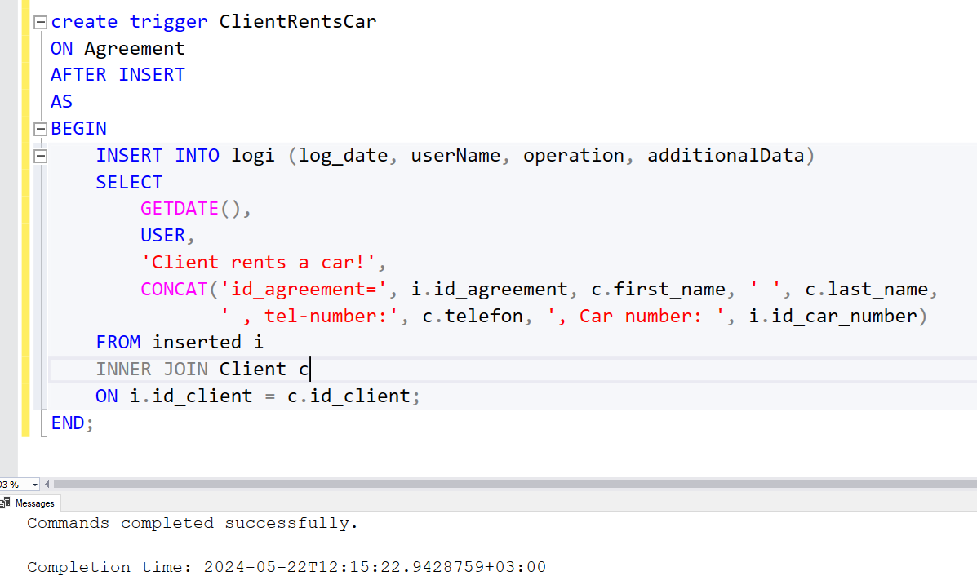

Picture 26. Trigger: Client rents a Car

# Procedure:

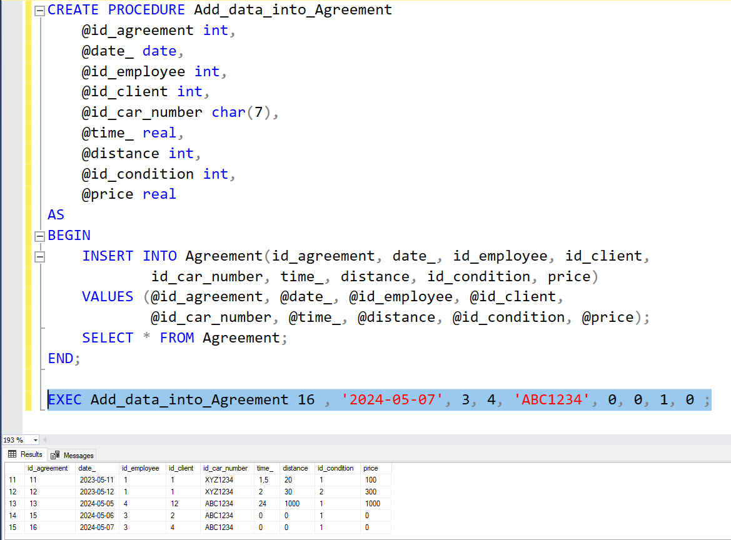

Picture 27 Procedure: Add_data_into_Agreement

CREATE PROCEDURE Add_data_into_Agreement

@id_agreement int,

@date_ date,

@id_employee int,

@id_client int,

@id_car_number char(7),

@time_ real,

@distance int,

@id_condition int,

@price real

AS

BEGIN

INSERT INTO Agreement(id_agreement, date_, id_employee, id_client,

id_car_number, time_, distance, id_condition, price)

VALUES (@id_agreement, @date_, @id_employee, @id_client,

@id_car_number, @time_, @distance, @id_condition, @price);

SELECT * FROM Agreement;

END;