# 《人权宣言》

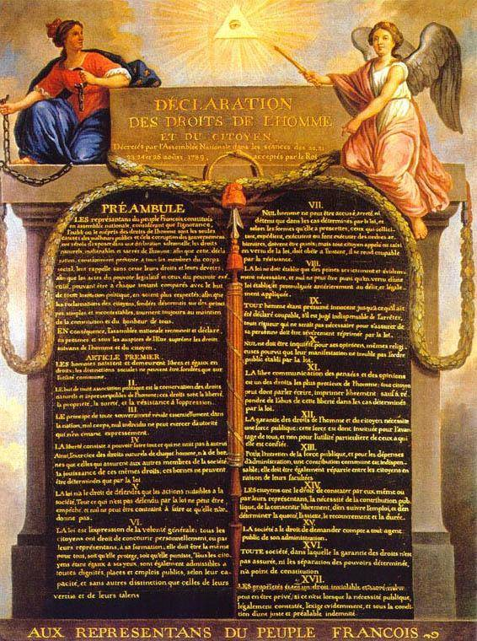

英文版

**Declaration of the Rights of Man and of Citizens by The National Assembly of France**

The representatives of the people of FRANCE, formed into a NATIONAL ASSEMBLY, considering that ignorance, neglect, or contempt of human rights, are the sole causes of public misfortunes and corruptions of Government, have resolved to set forth in a solemn declaration, these natural, imprescriptible, and inalienable rights: that this declaration being constantly present to the minds of the members of the body social, they may be forever kept attentive to their rights and their duties; that the acts of the legislative and executive powers of Government, being capable of being every moment compared with the end of political institutions, may be more respected; and also, that the future claims of the citizens, being directed by simple and incontestable principles, may always tend to the maintenance of the Constitution, and the general happiness.

For these reasons the NATIONAL ASSEMBLY doth recognize and declare, in the presence of the Supreme Being, and with the hope of his blessing and favour, the following sacred rights of men and of citizens:

**One:**  
　　Men are born, and always continue, free and equal in respect of their rights. Civil distinctions, therefore, can be founded only on public utility.

**Two:**  
　　The aim of all political associations is the preservation of the natural and imprescriptible rights of man; and these rights are liberty, property, security, and resistance of oppression.

**Three:**  
　　The nation is essentially the source of all sovereignty; nor can any individual, or any body of men, be entitled to any authority which is not expressly derived from it.

**Four:**  
　　Political liberty consists in the power of doing whatever does not injure another. The exercise of the natural rights of every man, has no other limits than those which are necessary to secure to every other man the free exercise of the same rights; and these limits are determinable only by the law

**Five:**  
　　The law ought to prohibit only actions hurtful to society. What is not prohibited by the law should not be hindered; nor should anyone be compelled to that which the law does not require

**Six:**  
　　The law is an expression of the will of the community. All citizens have a right to concur, either personally or by their representatives, in its formation. It should be the same to all, whether it protects or punishes; and all being equal in its sight, are equally eligible to all honours, places, and employments, according to their different abilities, without any other distinction than that created by their virtues and talents

**Seven:**  
　　No man should be accused, arrested, or held in confinement, except in cases determined by the law, and according to the forms which it has prescribed. All who promote, solicit, execute, or cause to be executed, arbitrary orders, ought to be punished, and every citizen called upon, or apprehended by virtue of the law, ought immediately to obey, and renders himself culpable by resistance.

**Eight:**  
　　The law ought to impose no other penalties but such as are absolutely and evidently necessary; and no one ought to be punished, but in virtue of a law promulgated before the offence, and legally applied.

**Nine:**  
　　Every man being presumed innocent till he has been convicted, whenever his detention becomes indispensable, all rigour to him, more than is necessary to secure his person, ought to be provided against by the law.

**Ten:**  
　　No man ought to be molested on account of his opinions, not even on account of his religious opinions, provided his avowal of them does not disturb the public order established by the law.

**Eleven:**  
　　The unrestrained communication of thoughts and opinions being one of the most precious rights of man, every citizen may speak, write, and publish freely, provided he is responsible for the abuse of this liberty, in cases determined by the law.

**Twelve:**  
　　A public force being necessary to give security to the rights of men and of citizens, that force is instituted for the benefit of the community and not for the particular benefit of the persons to whom it is intrusted.

**Thirteen:**  
　　A common contribution being necessary for the support of the public force, and for defraying the other expenses of government, it ought to be divided equally among the members of the community, according to their abilities.

**Fourteen:**  
　　Every citizen has a right, either by himself or his representative, to a free voice in determining the necessity of public contributions, the appropriation of them, and their amount, mode of assessment, and duration.

**Fifteen:**  
　　Every community has a right to demand of all its agents an account of their conduct.

**Sixteen:**  
　　Every community in which a separation of powers and a security of rights is not provided for, wants a constitution.

**Seventeen:**  
　　The right to property being inviolable and sacred, no one ought to be deprived of it, except in cases of evident public necessity, legally ascertained, and on condition of a previous just indemnity.

中文版

**1789年人权和公民权宣言**

（1789年8月26日制宪国民会议颁布）

序言

组成国民会议的法兰西人民的代表们，相信对于人权的无知、忽视与轻蔑乃是公共灾祸与政府腐化的唯一原因，乃决定在一个庄严的宣言里，呈现人类自然的、不可让渡的与神圣的权利，以便这个永远呈现于社会所有成员之前的宣言，能不断地向他们提醒他们的权利与义务；以便立法权与行政权的行动，因能随时与所有政治制度的目标两相比较，从而更受尊重；以便公民们今后根据简单而无可争辩的原则所提出的各种要求，总能导向宪法的维护和导向全体的幸福。

因此，国民会议在上帝面前及其庇护之下，承认并且宣布如下的人权和公民权。

正文

第一条　人生来就是而且始终是自由的，在权利方面一律平等。社会差别只能建立在公益基础之上 。

第二条　一切政治结合均旨在维护人类自然的和不受时效约束的权利。这些权利是自由、财产、安全与反抗压迫。

第三条　整个主权的本原根本上乃存在于国民（La Nation）。任何团体或任何个人皆不得行使国民所未明确授予的权力。

第四条　自由是指能从事一切无害于他人的行为；因此，每一个人行使其自然权利，只以保证社会上其他成员能享有相同的权利为限制。此等限制只能以法律决定之。

第五条　法律仅有权禁止有害于社会的行为。凡未经法律禁止的行为即不得受到妨碍，而且任何人都不得被强制去从事法律所未要求的行为。

第六条　法律是公意（la volonté générale）的表达。每一个公民皆有权亲自或由其代表去参与法律的制订。法律对于所有的人，无论是施行保护或是惩罚都是一样的。在法律的眼里一律平等的所有公民皆能按照他们的能力平等地担任一切公共官职、职位与职务，除他们的德行和才能以外不受任何其他差别。

第七条　除非在法律所确定情况下并按照法律所规定的程序，任何人均不受控告、逮捕与拘留。凡请求发布、传送、执行或使人执行任何专断的命令者，皆应受到惩罚；但任何根据法律而被传唤或逮捕的公民则应当立即服从，抗拒即属犯罪。

第八条　法律只应设立确实必要和明显必要的刑罚。任何人均不应遭受刑罚，除非根据在犯法前已经通过并且公布的法律而合法地受到处罚。

第九条　所有人直到被宣告有罪之前，均应被推定为无罪，而即使判定逮捕系属必要者，一切为羁押人犯身体而不必要的严酷手段，都应当受到法律的严厉制裁。

第十条　任何人不应为其意见甚至其宗教观点而遭到干涉，只要它们的表达没有扰乱法律所建立的公共秩序。

第十一条　自由交流思想与意见乃是人类最为宝贵的权利之一。因此，每一个公民都可以自由地言论、著作与出版，但应在法律规定的情况下对此项自由的滥用承担责任。

第十二条　人权和公民权的保障需要公共的武装力量。这一力量是为了全体的福祉而不是为了此种力量所托付的人的个人利益而设立的。

第十三条　为了公共武装力量的维持和行政的开支，公共赋税是不可或缺的。赋税应在全体公民之间按其能力平等地分摊。

第十四条　所有公民都有权亲身或由其代表决定公共赋税的必要性，自由地加以批准，知悉其用途，并决定税率、税基、征收方式和期限。

第十五条　社会有权要求一切公务人员报告其行政工作。

第十六条　一切社会，凡权利无保障或分权未确立，均无丝毫宪法之可言。

第十七条　财产是不可侵犯与神圣的权利，除非合法认定的公共需要对它明白地提出要求，同时基于公正和预先补偿的条件，任何人的财产皆不可受到剥夺。

**参考：**

* [美国独立宣言(中英对照)](https://chegva.com/2872.html)
* [英国《大宪章》中英对照](https://chegva.com/3258.html)
* [人权宣言](https://baike.baidu.com/item/%E4%BA%BA%E6%9D%83%E5%AE%A3%E8%A8%80/909435?fr=aladdin)
* [法国大革命以后的《人权宣言》](https://baijiahao.baidu.com/s?id=1616577771894878786&wfr=spider&for=pc)