西 安 邮 电 大 学
（计算机学院）

课内实验报告

实 验： 数据库上的基本操作

课程 | ： | 数据库原理及应用A
班 级 | ： | 软件1502班
学号 | ： | 04153056
学生姓名 | ： | 刘洋
任课教师 | ： | 孟彩霞

一、 实验目的及SPJ表中，用SELECT语句完成第二章习题10中的（1）~（2）的查询

1.学会使用T－SQL语句对数据库表进行插入、修改和删除数据操作。
2.了解数据更新操作时要注意数据完整性。
3.掌握SQL的查询语句（SELECT语句）的使用方法。本实验要求掌握简单表的数据查询、数据排序和多表操作时数据连接查询的操作方法。
4.进一步掌握SELECT语句的使用方法，通过实验能够熟练地使用SELECT语句。本实验要求掌握嵌套查询和统计查询的操作方法。

二、实验内容
1：分别使用T—SOL语句和企业管理器，项数据库JWGL，Mareket,数据库TSGL中的各张表输入一些记录；
2：使用T-SOL语句进行插入，修改和删除记录的操作
3.在数据库JWGL中的Student，Course，SC完成第三章中例3.10-例3.28中例题的查询操作。
4.在数据库Market的Customers,Goods,Orders中完成第三章习题6中的(1)~(4)
5.在数据库SPJ中的S,P,J6.在数据库JWGL中的Student,Course,SC中完成第三章例3.35~3.39的查询
7.在数据库SPJ的S,P,J及SPJ中用SELECT查询语句完成第二章习题10中（3）的查询。
8.在数据库JWGL的Student，Course，SC中完成第三章例3.40~3.47的操作
9.在数据库Market的Customers，Goods，Orders中完成第三章习题6中（6）~（9）的查询。
10.在数据库SPJ中的S,P,J及SPJ中，用SELECT查询语句完成第二章习题10中（4）~（5）的查询。
11.在数据库TSGL的图书，读者，借阅3个表中，用SELECT完成以下查询
(1)查询人民邮电出版社的各类图书的平均价格
(2)使用嵌套查询完成查询借了书的读者信息
(3)统计目前借了书的读者人数。
（4）统计过期未还的图书册数
三、实验环境
Wampmanger Mysql 集成环境
四、实验前准备

五、实验步骤
打开工具，连接数据库。
插入数据
六、实验结果
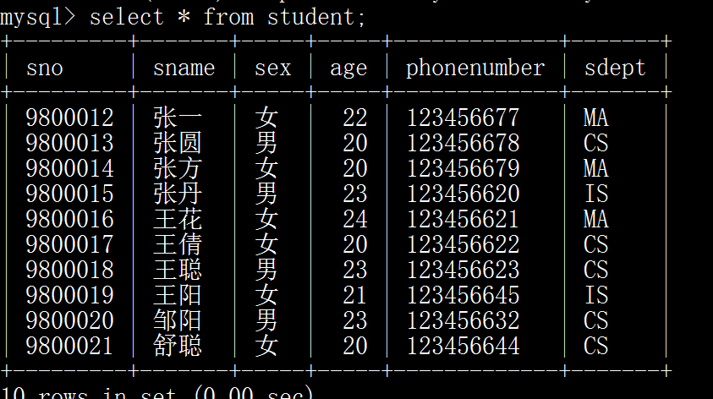

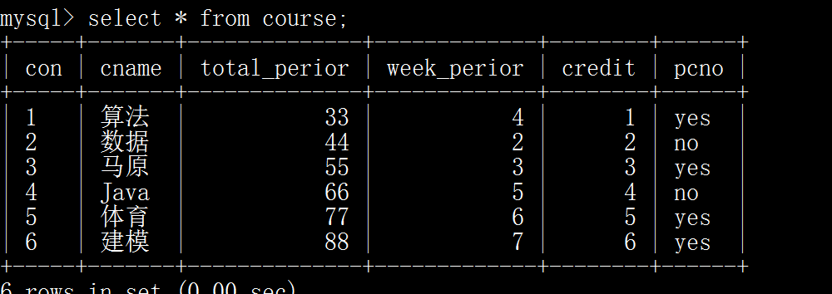

3.
3.10到3.28
SELECT Sno,Sname,Sdept
FROM Student;

SELECT *
FROM Student;

SELECT Sname,2017-Age
FROM Student;

SELECT Sname,'YEAR" of Birth',2017-Age
FROM Student;

SELECT Sname,2017-Age Birthday
FROM Student;

SELECT Sno,Sname,LOWER(Sdept)
FROM Student;

SELECT DISTINCT Sno
FROM SC;

SELECT Sno,Sname
From Student
WHERE Sdept='CS';

SELECT Sno
FROM SC
WHERE Grade<60;

SELECT Sno
FROM SC
WHERE Grade>=60;

SELECT Sname,Sdept,Sex
FROM Student
WHERE Age BETWEEN 20 and 23;

SELECT Sname,Age
FROM Student
WHERE Sdept IN('CS','MA','IS');

SELECT Sname,Age
FROM Student
WHERE Sdept='CS' OR Sdept='MA' OR Sdept='IS';

SELECT Sname,Age
FROM Student
WHERE Sdept NOT IN('CS','IS');

SELECT *
FROM Student
WHERE Sdept LIKE 'IS';

SELECT Sname,Sno,Sex
FROM Student
WHERE Sname LIKE '张丹%';

SELECT Cno,Credit
FROM Course
WHERE Cname LIKE 'DB\_Design' ESCAPE '\';

SELECT Sno,Cno
FROM SC
WHERE Grade IS NULL;

SELECT Sname,Sno,Sex
FROM Student
WHERE Sdept='CS' AND Age<23;

SELECT Sno,Grade
FROM SC
WHERE Cno='1'
ORDER BY Grade DESC;

SELECT *
FROM Student
ORDER BY Sdept,Age DESC;

4.
6.(1)~6.(4)
SELECT *
FROM Customers
WHERE City='西安';

SELECT GoodsName,Price,0.25*Price Discount
FROM goods ORDER BY Price;

SELECT GoodsName,Price
FROM goods
WHERE GoodsName LIKE '%方便面%';

SELECT GoodsName,Price,`Storage`
FROM goods
WHERE `Storage` BETWEEN 10 AND 50;

SELECT CName,GoodsName,Price,Quantity,OrderSum
FROM customers,goods,orders
WHERE customers.CustomerID=orders.CustomerID
AND goods.GoodsId=orders.GoodId AND
Orderdate BETWEEN '2017.5.1' AND '2017.12.31';

5.
10(1)~10(2)
SELECT Sno FROM spj WHERE Jno='1';
SELECT Sno FROM spj where Jno='1' and Pno='1';

6.
3.35~3.39
SELECT student.*,sc.*
FROM student,sc
WHERE student.Sno=sc.Sno;

SELECT student.Sno,Sname,Sex,Age,Sdept,Cno,Grade
FROM student,sc
WHERE student.Sno=sc.Sno;

SELECT First.Cno,Second.Cno FROM course First,course Second
WHERE `First`.Cno=`Second`.Cno;

SELECT student.Sno,Sname,Sex,Age,Sdept,Cno,Grade
FROM student LEFT OUTER JOIN SC ON student.Sno=sc.Sno;

SELECT student.Sno,Sname FROM student,course,SC WHERE student.Sno=sc.Sno AND sc.Cno=course.Cno AND Cname='数据' AND Grade>0;

7.
10(3)
SELECT Jno FROM J WHERE Jno NOT IN (SELECT Jno FROM spj,S,P WHERE spj.Sno=S.Sno
AND spj.Pno=P.Pno AND City='天津' AND Color='红');
8.
3.40~3.47
SELECT Sname
FROM student
WHERE Sno IN (SELECT Sno FROM sc WHERE Cno='1');

SELECT Sno,Sname
FROM student
WHERE Sdept=(SELECT Sdept FROM student WHERE Sname='张圆');

SELECT Sname,Age
FROM student
WHERE Sdept<> 'CS' AND Age < ANY (SELECT Age FROM student WHERE Sdept='CS');

SELECT Sname,Age
FROM student
WHERE Sdept<> 'CS' AND Age < (SELECT MAX(Age) FROM student WHERE Sdept='CS');

SELECT Sno,Cno
FROM sc x
WHERE Grade >= (SELECT AVG(Grade) FROM sc y WHERE y.Cno=x.Cno);

SELECT Sname
FROM student
WHERE EXISTS
(SELECT * FROM sc WHERE Sno=student.Sno AND Cno='3');

SELECT Sname
FROM student
WHERE NOT EXISTS (SELECT * FROM course
WHERE NOT EXISTS (SELECT * FROM sc WHERE Sno=student.Sno AND Cno=course.Cno));

SELECT DISTINCT Sno FROM sc SCX
WHERE NOT EXISTS
(SELECT * FROM sc SCY WHERE SCY.Sno='9800012'
AND NOT EXISTS (SELECT * FROM sc SCZ WHERE SCZ.Sno=SCX.Sno AND SCZ.Sno=SCY.Cno));

SELECT Sno
FROM sc WHERE Cno='1'
UNION
SELECT Sno FROM sc WHERE Cno='2';

9.
6(6)~6(9)
SELECT OrderID,GoodId,CustomerID
FROM orders
WHERE Quantity>1 GROUP BY Orderdate;

SELECT *
FROM orders
WHERE CustomerID IN
(SELECT CustomerID FROM customers WHERE City='重庆');

SELECT *
FROM orders
WHERE CustomerID NOT IN (SELECT CustomerID FROM customers
WHERE City='天津');

SELECT customers.CustomerID,Cname,City,OrderID,GoodId,Quantity,OrderSum,Orderdate FROM customers LEFT OUTER JOIN orders
ON customers.CustomerID=orders.OrderID WHERE City='西安';

10.
10(4)~10(5)
SELECT Jno FROM J WHERE Jno NOT IN (SELECT Jno FROM spj,S,P WHERE spj.Sno=S.Sno
AND spj.Pno=P.Pno AND City='天津' AND Color='红');

SELECT DISTINCT Pno FROM spj WHERE Sno='s1' UNION
SELECT Jno FROM spj WHERE Pno='p1' AND Jno IN (SELECT Jno FROM spj WHERE Pno='p2');

11.
SELECT Bkid,AVG(Price) FROM book WHERE BPublish='人民' GROUP BY BKid;
SELECT * FROM reader WHERE ReaderID IN (SELECT ReaderID FROM ledread);
SELECT COUNT(DISTINCTD ReaderID) FROM ledread;

- 实验总结

通过这个实验对复杂查询和数据库操作有了更深的认识，在以后能更加熟练运用。对知识的理解和掌握有了更大帮助，下次更改图形界面进行操作。

