***JMTi***

**INSTITUT TEKNIKAL JEPUN-MALAYSIA (JMTI)**

**REPORTING WRITING:QUESTIONNAIRE**

**JABATAN TEKNOLOGI MEKANIKAL**

**BAHAGIAN TEKNOLOGI KEJURUTERAAN MEKATRONIK**

**Diploma Teknologi Kejuruteraan Mekatronik**

**FUNDAMENTAL ENGLISH**

**( DMC 2117 )**

**SEMESTER 2 (2020)**

**CLASS : TKM 2A**

|  |  |  |
| --- | --- | --- |
| **No.** | **Student Name** | **Matrix No.** |
| **1** | LIM WIKY | M12219124 |
| **2** | KHOR ZHENG YONG | M12219060 |
| **3** | AMIRUL AFIQ BIN ABDUL RAHIM | M12219211 |
| **4** | ABDUL RAHIM BIN HAMAT | M12219155 |

**Appreciation**

Alhamdulillah, thanks to Allah we can successfully prepare this report despite many

challenges and trials that we face and time constraints. However, we are also grateful to be

able to complete this report in the allotted time.

We would like to thank our English teacher, Puan Noor Hafizah Binti Mohamed Ismail,

for her guidance and suggested the best way for us to complete this report.

In addition, we have conducted various research and studies from various sources to

complete this task, especially from the respondents who has given good cooperation so that we

can receive information to complete this report.

**Chapter 1**

**Introduction**

**1.1 Background of study**

The background study of this research is based on the students of JMTi sourcing for meals within the campus on daily basis with 2 sources, the cafeteria in main building of JMTi and *dewan makan*. The targeted respondents will be mainly students who live in dormitory of JMTi. It is known that cafeteria in JMTi has a shorter operation hour compared to a regular cafeteria. It is also little known that students would rather order food online than eat in dewan makan when the café is closed. The aim of this case study is to promote awareness and eliminate the struggles students living in dormitory had faced.

**1.2 Research objectives**

The purpose of the research is to find out if students want the operation hour of cafeteria to be extended.

The research objectives of this study are:

* To find out if students are satisfied with either or both food sources prepared
* To distinguish the reasons students prefer either of the sources
* To get a solid suggestion on how long the operation hour will be extended

**1.3 Research hypothesis**

The hypothesis we came up is:

Students agree on extending the operation hours of cafeteria in JMTi

**Chapter 2**

**Literature Review**

**2.1 Cafeteria**

A type of restaurant in which customers serve themselves from a counter and pay

before eating. Institutional Cafeterias are located close to the entrance so as to provide

convenience to the patrons. Cafeterias serving university dormitories are sometimes

called dining halls or dining commons. A [food court](https://en.wikipedia.org/wiki/Food_court) is a type of cafeteria found in

many [shopping malls](https://en.wikipedia.org/wiki/Shopping_mall) and [airports](https://en.wikipedia.org/wiki/Airport) featuring multiple food vendors or concessions, although a

food court could equally be styled as a type of [restaurant](https://en.wikipedia.org/wiki/Restaurant) as well, being more aligned with

public, rather than institutionalised, dining. Some institutions, especially schools, have food

courts with stations offering different types of food served by the institution itself (self-

operation) or a single contract management company, rather than leasing space to numerous

businesses. Some [monasteries](https://en.wikipedia.org/wiki/Monastery), [boarding schools](https://en.wikipedia.org/wiki/Boarding_school), and [older universities](https://en.wikipedia.org/wiki/Ancient_university) refer to their cafeteria

as a [refectory](https://en.wikipedia.org/wiki/Refectory).

**2.2 History of JMTI cafeteria**

JANUARY 2000 JMTI staff move to Penang. JMTI started operations on a permanent

Campus. From there, JMTI created a cafeteria to make it easier for students and lecturers to eat

both morning and afternoon. The cafe is open as early as 8 a.m. until 3 p.m. on every working

day.

JMTI cafeteria provides self-service dishes to customers. This gives students and lecturers no need to wait for orders and take a long time in the cafeteria. In the cafe there is also a space available for students to rest and study. This is one of the purposes of the cafe in JMTI opened apart from the dining hall.

**Chapter 3**

**Methodology**

**3.0 Introduction**

This chapter is about research methodology that describes how data is collected and analyzed properly. Objective of this chapter is to ensure the data can be conducted in an appropriate manner to better understanding and evaluate research results. This chapter contains research procedure, data collected, data analysis.

**3.1 Respondents**

The respondents targeted are students of JMTi that lives in dormitory regardless of their gender. The respondents are from 4 different departments and are ranged from semester 2 to semester 3 of 2020. There is a total respondent of 40 individuals and consist of 27 males and 13 females.

**3.2 Instruments**

The instrument that we chose to perform this study case is through online questionnaire made possible by google forms. We also used social media platform Whatsapps to distribute and spread our questionnaire.

**3.3 Research procedure**

We first think of the title and problem to carry out a case study. After some discussions and agreement, we then created an online questionnaire with the use of google forms. We created questions and options inside the form, later the online form link is generated and copied to our Whatsapps groups to distribute the links for respondents to complete the questionnaire. After that we collected the data and analyze it.

**Chapter 4**

**RESULT AND DISCUSSION**

**4.1 RESPONDENT FOR STUDENT’S SUGGESTION ON JMTI’S CAFETERIA OPERATION HOURS**

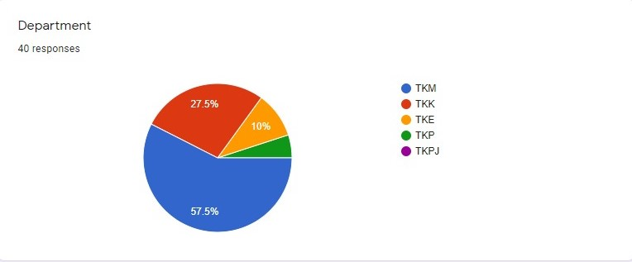

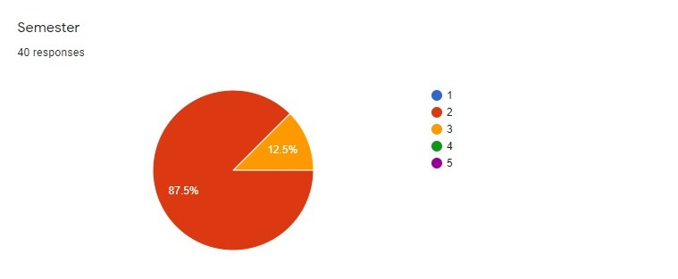

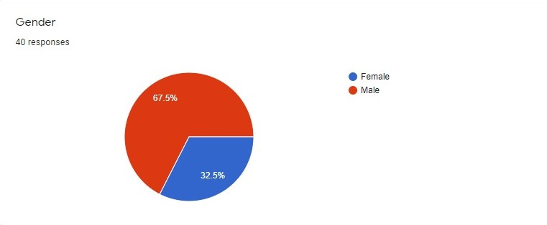

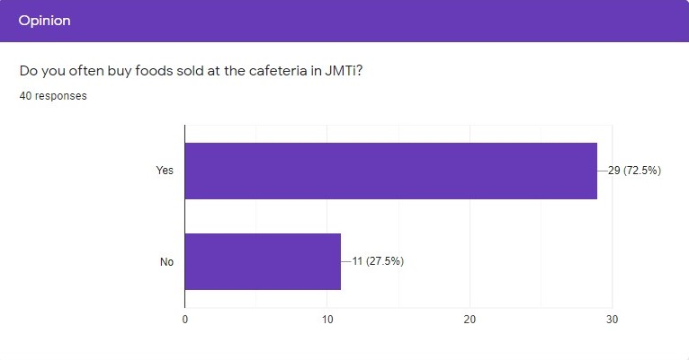

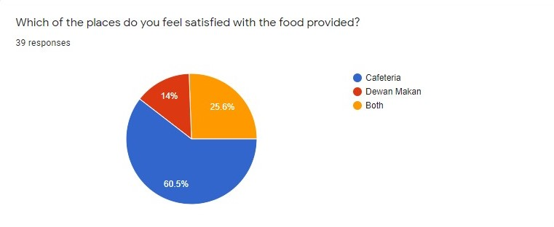

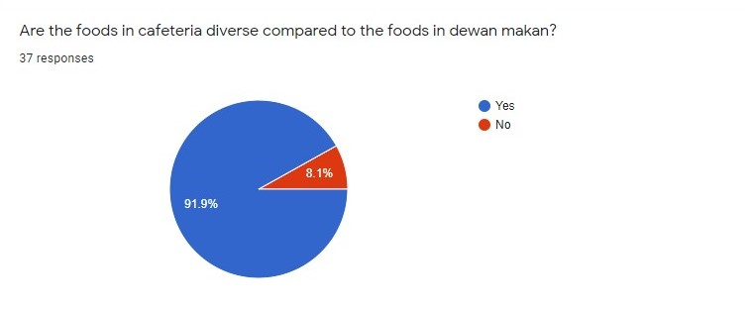

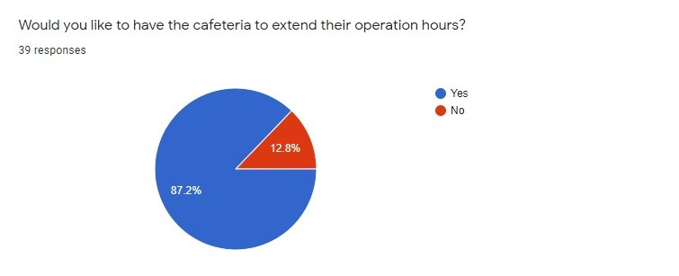

**4.2 RESULT**

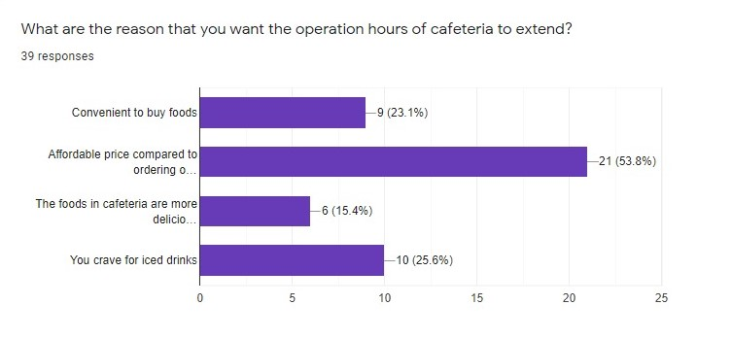

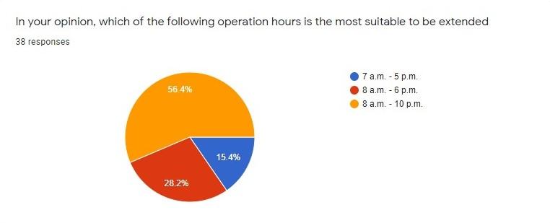

**Chapter 5**

**Conclusion**

**5.1 Conclusion**

In conclusion, we had collected data from 40 responders from different departments including semester 2 and 3. Most of our responder often buy foods sold at the cafeteria. It is because many of them feel more satisfied with the food provided at cafeteria and it is also the food in cafeteria are diverse compared with dewan makan. So we strongly prefer that the operation hours of the cafeteria to be extended so it will solve most of the JMTI’s student problem that what they going to eat at night. 87.2% of 39 respondents agreed on extending the cafeteria operation hours, thus our hypothesis is accepted.

**5.2 Limitation**

The limitation that impact us to getting more research is the final exam of our institute JMTI is around the corner, so most of them are focus on their final exam. Besides that it is also during the epidemic of Covic-19. This is because the SOP of the Covic-19 from government are restrict us to getting more research.

**5.3 Recommendation**

After we getting the result in the time that we are setting. The recommendation from most of the JMTI’s student is to extend the JMTI’s cafeteria operation hours. The cafeteria operation time that suggest from most of our responder is 8am to 10pm so that they will won’t worry about what to eat at night.

**References**

1. Puan Noor Hafizah Binti Mohamed Ismail, English subject teacher at Japan – Malaysia

Technical Institute (JMTI) who has given us guidance and reprimands.

1. The operational plan for cafeteria restaurant should be geared toward the nuts and

bolts of preparing food that customers can serve themselves, replenishing dishes as

they are drawn down, and providing minimal service to enhance the dining experience

and make the payment process smooth.

<https://smallbusiness.chron.com/operational-plan-cafeteria-restaurant-13053.html>

1. Restaurant operators happy about extended operating hours.

<https://www.nst.com.my/news/nation/2020/09/623551/restaurant-operators-happy->

about-extended-operating-hours.

**Appendix**