Sampling Frequency and Aliasing Experiment
MATLAB Laboratory Report
Purpose. To investigate how the sampling frequency affects a 7 kHz sinusoidal signal and to observe aliasing when the Nyquist condition is violated.
Theory. For a 7 kHz signal, the Nyquist criterion requires a sampling frequency of at least 14 kHz: f_s >= 2f_max = 14 kHz. Sampling below this limit causes the signal to appear at an incorrect lower frequency.

1. Results Table
24 kHz | 12 kHz | 7 kHz | No
16 kHz | 8 kHz | 7 kHz | No
12 kHz | 6 kHz | 5 kHz | Yes
8 kHz | 4 kHz | 1 kHz | Yes
Main observation: 24 kHz and 16 kHz preserve the original 7 kHz frequency. At 12 kHz, the signal aliases to 5 kHz; at 8 kHz, it aliases to 1 kHz.

2. Frequency Spectrum Figures
Figure 1. Spectrum at sampling frequency f_s = 24 kHz
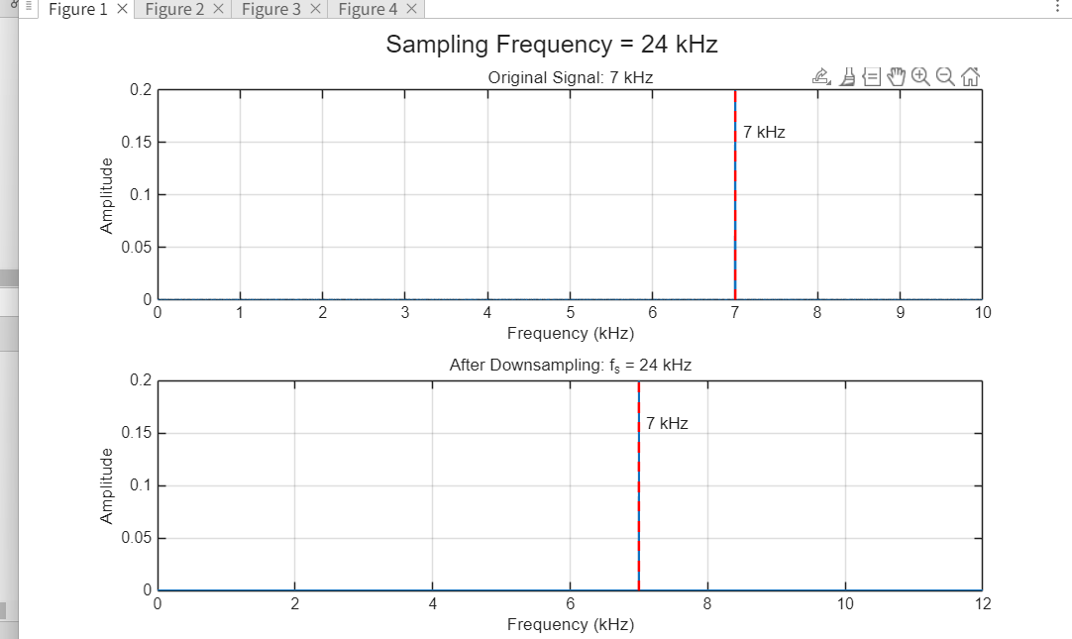
Observed peak: 7 kHz | Nyquist frequency: 12 kHz | Aliasing: No

Figure 2. Spectrum at sampling frequency f_s = 16 kHz
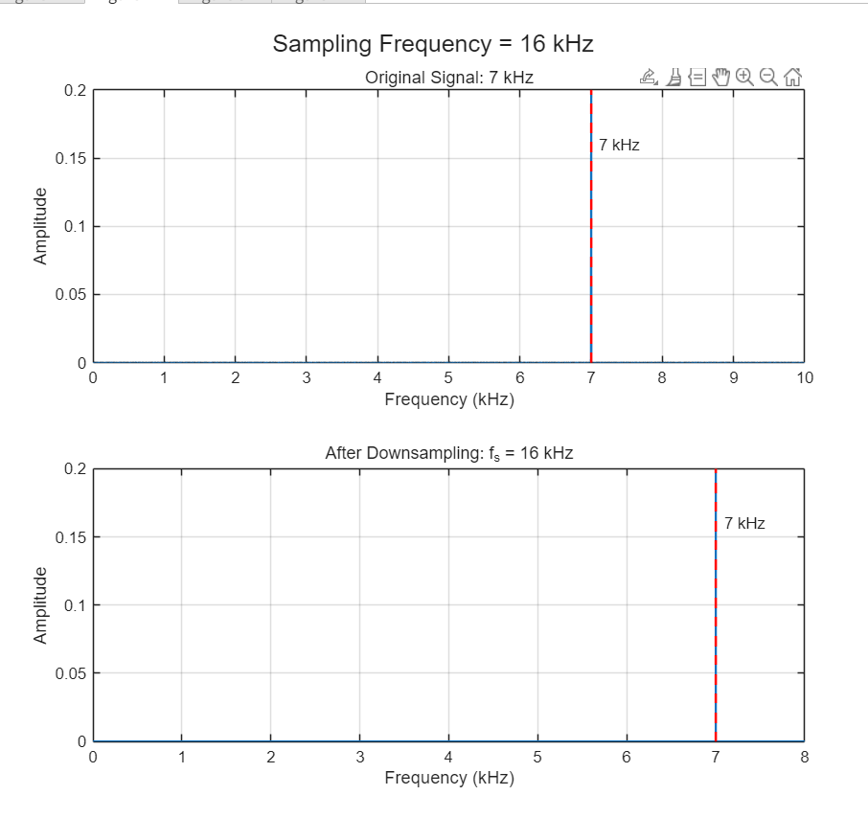
Observed peak: 7 kHz | Nyquist frequency: 8 kHz | Aliasing: No

Figure 3. Spectrum at sampling frequency f_s = 12 kHz
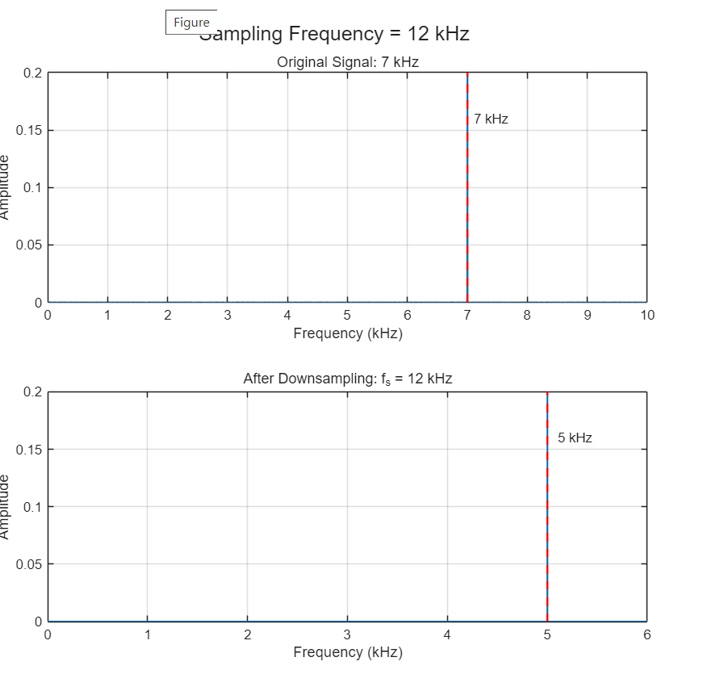
Observed peak: 5 kHz | Nyquist frequency: 6 kHz | Aliasing: Yes

Figure 4. Spectrum at sampling frequency f_s = 8 kHz
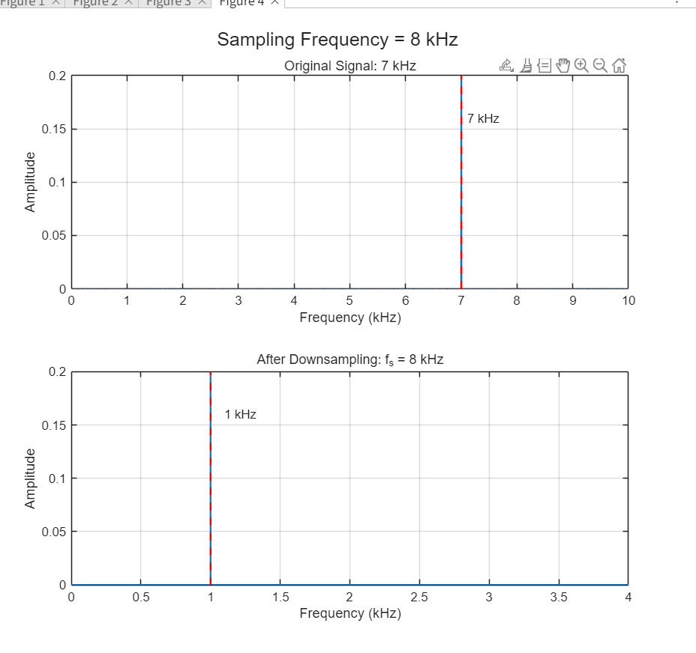
Observed peak: 1 kHz | Nyquist frequency: 4 kHz | Aliasing: Yes

3. Short Answers
1. Which sampling frequencies represented the 7 kHz signal correctly?
The 24 kHz and 16 kHz sampling frequencies represented the 7 kHz signal correctly because their Nyquist frequencies (12 kHz and 8 kHz) are above 7 kHz.
2. When did the 7 kHz signal appear as another frequency?
The 7 kHz signal appeared as another frequency when the sampling rate was reduced below 14 kHz. At 12 kHz sampling it appeared as 5 kHz, and at 8 kHz sampling it appeared as 1 kHz.
3. What happened when the Nyquist frequency became lower than 7 kHz?
Aliasing occurred. The 7 kHz component folded into a lower frequency within the observable frequency range, so the spectrum no longer showed the original 7 kHz tone.
4. Did the aliased signal sound different?
Yes. The apparent frequency changed, so the perceived pitch changed. The 12 kHz case sounded approximately like a 5 kHz tone, while the 8 kHz case sounded approximately like a 1 kHz tone.
5. Why can MATLAB not recover the original 7 kHz signal after aliasing?
After undersampling, different continuous-time frequencies can produce the same sampled data. The samples therefore do not uniquely identify the original 7 kHz tone, so MATLAB cannot recover it from the aliased samples alone.

4. Conclusion
This experiment confirms the Nyquist sampling theorem. A 7 kHz sinusoidal signal requires a sampling frequency of at least 14 kHz for correct representation. Sampling at 24 kHz and 16 kHz preserved the original 7 kHz frequency, while sampling at 12 kHz and 8 kHz caused aliasing. The aliased frequencies were 5 kHz and 1 kHz, respectively. Once aliasing occurs, the original frequency cannot be uniquely reconstructed from the sampled data because the frequency information has been folded into the observable band.

Aliasing calculations
At 12 kHz: |7 kHz - 12 kHz| = 5 kHz. At 8 kHz: |7 kHz - 8 kHz| = 1 kHz.

