20MCA133 WEB PROGRAMMING LAB

**LAB CYCLE**

**Course Outcomes**: After the completion of the course the student will be able to;

|  |  |
| --- | --- |
| CO 1 | Explore markup languages features and create interactive web pages using them |
| CO 2 | Learn and design client-side validation using scripting languages. |
| CO 3 | Design front-end web page and connect to the back-end databases |
| CO 4 | Do Client-side & Server-side scripting |
| CO 5 | Develop Web Applications |

**PROGRAM NO : 1**

# CYCLE1 – CO1 PROGRAMS

## BASIC TAGS

**Aim:** Create a simple HTML file to demonstrate the use of different tags. Set the title of the page as "College HTML Page". Within the body perform the following. [Moving text , Different heading tags (h1 to h6), Paragraph, Horizontal line, Line Break,

,Different Logical Style (<b>, sub>, <sup>...), Align tag, Placing image and formatting, use of html table]

Create a static webpage for your college with the following information:

(a) Name of college ( First level heading, text align = center, color = blue, use style atribute) (b)Add vision and mission of the college as scrolling text (color = green)

1. About us (Second level heading, background-color = red, color = white, use style atribute)
   1. Insert an image of your college. (Align image in center, width = 1000px, height = 300px)
   2. Add a brief description about your college. ( justified paragraph)
2. Courses Offered (Second level heading, background-color = red, color = white, use style atribute)
   1. Add a brief description about courses offered. ( justified paragraph) Add course details (Use HTML table)
   2. Contact us. (Second level heading, background-color = red, color = white) Address for Communication (Third level heading, color = blue)

Address of the college

Add Link to official website of the college.

#### Sample Output

Sree Narayana Gurukulam College of Engineering

**Vision : Empowering the masses to achieve economic and social freedom through technical and management education.**

**Mission : Prepare students for a career in industry, academia, R&D and government by developing necessary technical capabilities and interpersonal skills in them.**

[ scrolling text]

About Us

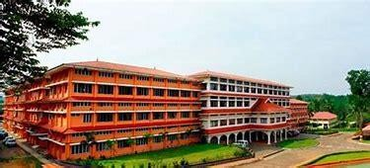

Sree Narayana Gurukulam College of Engineering widely known as SNGCE is a pioneer, self- financing educational institution established in the year 2002 to impart engineering and management education with the -state - of- art amenities to the deserving candidates. It is well managed by Sree Narayana Gurukulam Charitable Trust, a recognized charitable society comprising of eminent personalities from diverse spheres of activity across the world and flourishes under the wings of SNDP Kunnathunadu Union. SNGCE is approved by All India Council for Technical Education (AICTE) and affiliated to APJ Abdul Kalam Techno logical University (KTU). It is also an approved Research Centre of Kerala University of Fisheries and Ocean Studies (KUFOS).

### Courses Offered

All courses offered by SNGCE are affiliated to KERALA TECHNOLOGICAL UNIVERSITY (KTU) and approved by the All India Council for Technical Education (AICTE).The B. Tech programmes are of 8 semester (4 year) duration. The combined first and second semester courses are common for all branches. The M. Tech programmes are of 4 semester (2 year) duration, MBA and MCA programme is of 4 semester (2 year) duration

|  |  |  |
| --- | --- | --- |
| **UG** | | |
| **COURSE** | **DEPARTMENT** | **INTAKE** |
| B.Tech | Civil Engineering | 60 |
| Computer Science | 120 |
| Mechanical Engineering | 60 |
| Electrical & Electronics Engineering | 60 |
| Electronics & Communication  Engineering | 60 |
| Naval Architecture and Ship Building Engineering | 60 |

|  |  |  |  |
| --- | --- | --- | --- |
|  | **PG** | | |
| **COURSE** | **DEPARTMENT** | **SPECIALIZATION** | **INTAKE** |
| M.Tech | Civil Engineering |  |  |
| Computer Science |  |  |
| Mechanical Engineering |  |  |
| Electrical & Electronics Engineering |  |  |
| Electronics &  Communication Engineering |  |  |
| Naval Architecture and Ship  Building Engineering |  |  |
| MCA | MCA | Computer  Applications | 60 |
| MBA | MBA | Business  Administration |  |

### Contact Us

Address for Communication Kadayiruppu P.O Kolenchery Ernakulam District, Kerala .Pin 682311 Official Website

NB: Use paragraphs, Horizontal Line, Line Break and different logical styles wherever appropriate. Table used here is to created using HTML table. Use hyperlink to move to the official web address of the college. Label the hyperlink as Official Website.

## LINKING PAGES

#### PROGRAM NO: 2

**AIM :** Create a HTML file to link to different HTML pages (Image gallery, Time table of Gallery shows, Your Profile with sections) which contains images, tables, and also link within a page(profile).

**Sample Output**

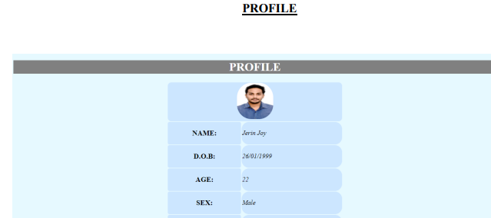

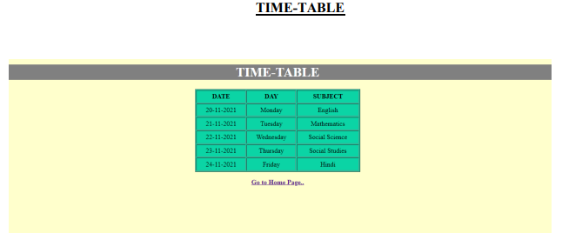

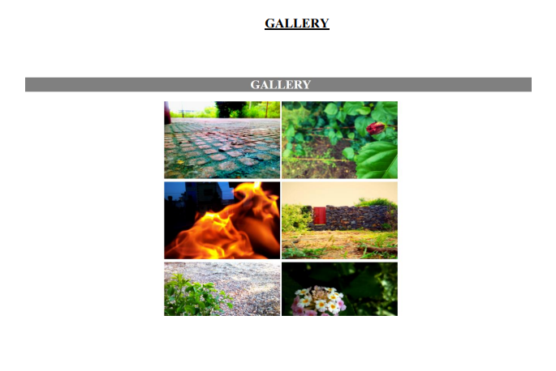

## FRAMES

#### PROGRAM NO: 3

**AIM:** Create a HTML web page file with different types of frames such as floating frame, navigation frame & mixed frame.

(i).Create an HTML page named as “mixedframe.html”. Divide the page into two columns of 25% & 75% size. In 25% display the image and divide the 75% into two rows. (50% & 50%). In the first 50% display the video file and other 50% the schedule created for webinars

#### Sample Output

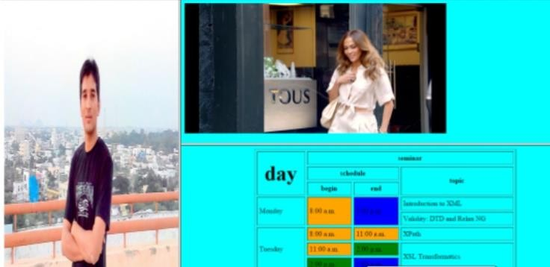

(ii).Create an HTML page named as “navigationframe.html”. Divide the page into two columns of 25%, 75% size. In 25% size call the hyperlink (with different category of mobile phones), and make the page to be get displayed on the other column when the link is clicked(a brief description of the phone selected).

(iii).Create an HTML page named as “floatingframes.html”. In this create a sample picture viewer as follows using Floating frames

**Sample Output**

**Picture Viewer** *First* | *Second| Third*

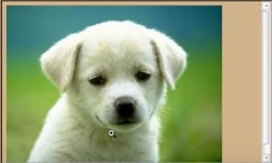

## CASCADING STYLE SHEETS (CSS)

#### PROGRAM NO: 4

**AIM:** Create a HTML file by applying the different styles using inline, external & internal style sheets

1. Using Internal style sheets, create a web page showing your biodata, with the following styles:
   1. Put your Name in <h1> tag, center aligned.
   2. Add following via <h2> tags, Personal Details, Educational Details, Hobbies. Put the respective contents below, in list format.
   3. Add contact details at the bottom including mail id and mobile number.
   4. Style all <h1> tags as red colored and center aligned and all <h2> tags as white colored with background color blue.
   5. Display <p> elements with a border
   6. Change the background color of the page to yellow
2. Using External Style Sheets, create a web page with following styles:
   1. Create different paragraphs defining different selectors in CSS. Each paragraph should be defined with appropriate labels for making styles of each selector
   2. Style each selector with unique font color, and background color
3. Create an html page named “Players.html”. Use Inline Style Sheets to create a table as shown below

**Sample Output**

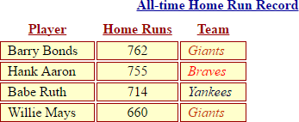

## REGISTRATIONFORM

**PROGRAM NO: 5**

**AIM :** Create a registration form using HTML. Use table to structure the elements.

**OUTPUT**

