This report encompasses various procedures involved in construction of a smart home model. One of the initial definitions of smart home is provided by Lutolf, defining it as “an integration of different services within a home by using a common communication system.” Moreover, it should assure „an economic, secure, and comfortable operation of the home and includes a high degree of intelligent functionality and flexibility.” (Lutolf, 1992) A fresher definition by Satpathy states, that “a home which is smart enough to assist the inhabitants to live independently and comfortably with the help of technology is termed as smart home. In a smart home, all the mechanical and digital devices are interconnected to form a network, which can communicate with each other and with the user to create an interactive space.” (Satpathy, 2006) We consider this definition more proper, as it emphasizes the role of network in smart home systems, in contrast to the vaguer term ‘common communication system’ used by Lutolf.

According to Zielonka, one of the major development trends related to smart homes are healthcare and quality of life, security in data management and optimal energy management and sustainability. Presumably, the trend of energy management and sustainability is intertwined with recently rising ecological trend (Zielonka, et al., 2021). However, the graph in Figure 1 shows, that advanced lightning and intelligent energy management are not among the hottest trends. Nevertheless, we recognize the importance of innovation in this sector, as it is financially and ecologically beneficial.

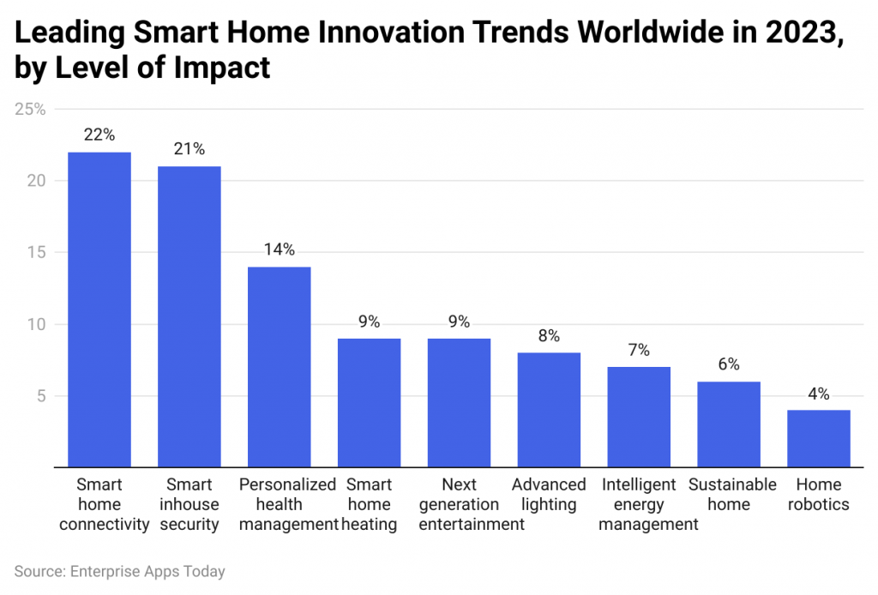

Figure : Graph of leading smart home innovation trends worldwide in 2023

Although lights with movement sensors are commonly used nowadays, they could benefit from integration to a centralized system, bringing everything ‘under one roof’. The main advantage of a system with centralized unit is its flexibility, as user would be able to manipulate light status manually inside the house as well as through communication with the centralized unit, for instance via a control panel. New features could be implemented, for example allowing the change of various thresholds according to user’s needs easily and any time.

Therefore, a centralized unit – seeduino was used for the model, accompanied by potentiometers to change properties of the light, buttons, which behave like switches, to change the status of light, PIR sensor to detect movement and to turn on light accordingly and LDR sensor, ensuring whether light is needed in certain outside brightness.

However, many challenges emerged during the design process. The most significant problems can be summarized in several ‘how to’ questions:

1. How to construct the house?
2. How to adjust intensity or color of the light?
3. How to assemble and integrate the circuits?
4. How to amplify current and reduce noise in circuits?
5. How to structure the control panel menu?

Following questions are answered in subsequent X sections. Third chapter includes detailed steps of the design process, where any decision is complemented by a justification. Fourth section concerns the final product, possibly deviating from the planned design. The fifth section contains analysis of the results and its comparison with design. Moreover, the sixth section provides concise conclusion of the whole project. References and appendices are placed in last two sections.